LPG Leakage Detector using Arduino with notification Alert and Sound Alarm

## Kanij Fatema Arpa, Nusrat Jahan, Mss. Rejowana Ferdowsy

Department of Computer Science and Engineering East West University, Dhaka, Bangladesh.

2018-1-60-211@std.ewubd.edu,2018-1-60-150@std.ewubd.edu,2018-1-60-[160@std.ewubd.edu.](mailto:160@std.ewubd.edu)

# Abstract

## Home fires have been taking place fre- quently and the threat to human lives and properties is growing in recent years. Most fire accidents are caused because of a poor-quality rubber tube or the regu- lator is not turned off when not in use. Liquid petroleum gas (LPG) is highly in- flammable and can burn even at some dis- tance from the source of leakage. There- fore, developing the gas leakage alert sys- tem is very essential. The main purpose of this project is to achieve a successful working prototype that is capable to de- tect the presence of gas leakage, which in this case, the Liquefied Petroleum Gas (LPG). The device should also perform automatic response with the implementa- tion of an alarm system and the emer- gency shut down valve once the leakage has occurred and detected. In addition to this, the authorized person will receive a message informing him about the leak- age. The essential part of this project is to make the best use of our knowledge of Arduino. We have used a gas sensor MQ- 6 to detect gas and nodeMcu esp8266 for our notification alert system. Hence, this project presents a gas leakage alert system to detect the gas leakage and to alarm the people onboard.

**Keywords: Fire Accidents; LPG; Ar- duino UNO; data transmission; sensors; nodeMCU**

1. **Introduction**

Gas leakage leads to various accidents resulting in both material loss and human injuries. The risk of

explosion, firing, suffocation is based on their physical properties such toxicity, flammability, etc. The number of deaths due to explosion of gas cylinders has been increasing in recent years. The LPG or propane is a flammable mixture of hydrocarbon gases used as fuel in many applications like homes, hostels, indus- tries, automobiles, vehicles because of its desirable properties which include high calorific value, less smoke, less soot, and meagre harm to the environment. Natural gas is another widely used fuel in homes. Both gases burn to produce clean energy, however there is a serious problem of their leakage. Being heavier than air, these gases do not disperse easily. It may lead to suffocation when inhaled and may lead to explosion. Our main objective of this project is to make an Arduino based project which will be helpful for our society. So that, people can be benefitted by our project idea and it can be implemented in future.

Our main goal is to make such a device with Arduino which will be able to detect the gas like Methane leak, Butane leak, and LPG leak. It will fabricate a sound alarm during gas outflow and rest the alarm once gas outflow is regulated and show status in an LCD using a 16×2 LCD component. We will also set up a notification centered Alert method send notification alert missives to restrict mobile number enter inside the Arduino program.

# Related Works

There are many previous researchers on the same project that we have done. We had taken ideas from some of them. Here I have given some of the research’s link so that we can compare our project with them.

## Other Projects and link on “LPG leakage detec- tor”:

1. Project of Rasika Joshi (EEE Engineer, India)-

https://maker.pro/arduino/projects/lpg-gas-leakage- detector-using-Arduino

1. Project of Mr. Alam (Engineer, Bangladesh)- https://how2electronics.com/gas-leakage-detector- gsm-arduino-sms-alert/comments
2. Project of Circuits today- [https://www.circuitstoday](http://www.circuitstoday.com/gas-leakage-detector-).com/g[as-leakage-detector](http://www.circuitstoday.com/gas-leakage-detector-)- using-arduino-with-sms-alert
3. Project of hIOTron IOT- [https://www.instructables.com/LPG-Gas-Leakage-](http://www.instructables.com/LPG-Gas-Leakage-) Detector-Using-Arduino/
4. Project of neven Projects- https://nevonprojects.com/iot-based-intelligent-

gas-leakage-detector-using-arduino

## We have compared our project with 2 projects from above.

**Differences:**

LPG if the gas leak reaches beyond the normal level. This proposed project will trigger the sound alarm. In addition, the authorized person will be informed about the leakage via notification alert. Thus, people can be saved from a potential explosion caused by gas leakage.

The LPG leakage detection and alert system presented in this paper is a simple yet reliable project. It is battery operated and hence portable. It is designed in such a way that it can also be operated with ac power supply.

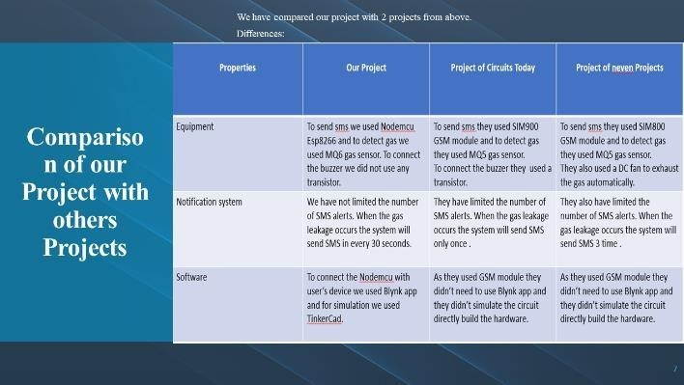To detect the LPG, MQ-6 gas sensor is employed. This sensor can be operated at 5V. The sensitivity of this sensor is very high and it has quick response time. It can detect the LPG concentration in the range of 200-10000ppm. The gas sensing layer of this sensor is made of Tin Dioxide (SnO2) and gold (Au) electrodes. The output of the gas sensor is given to LM358 dual operational amplifier where it is compared with the threshold value for gas density which is set using preset potentiometers and amplified. If the sensed voltage is greater than the preset threshold voltage, the operational amplifier output fires the driver circuit for LCD display and Buzzer. As a result, the LCD display will show warn message and the buzzer starts to produce alarm sound.

## Tools and Equipment Required

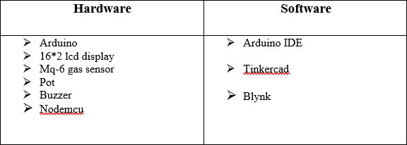

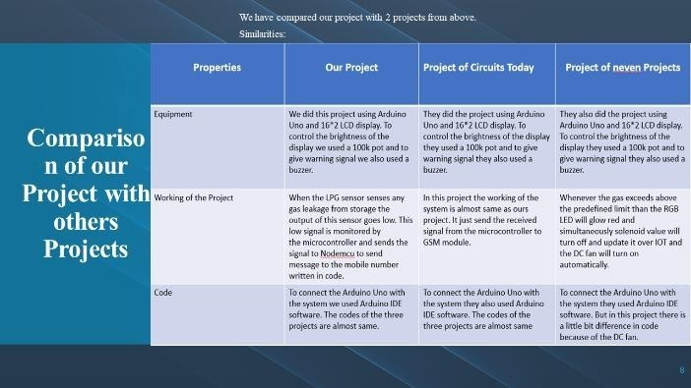**Supporting Material**

**Arduino UNO:**

1. **Proposed work**

Gas leak detection is the process of identifying poten- tially hazardous gas leaks by means of various sensors. The project entitled “LPG Leakage Detector using Arduino with notification Alert and Sound Alarm”, will be a great help in terms of preventing any danger caused by gas leakage. The purpose of this project is to detect the presence of LPG leakage as a part of a safety system. Apart from sound alarm, a notification alert will inform the authorized person.

Descriptively, we use a gas sensor to monitor the

The Arduino Uno is the microcontroller chip that is responsible for all function of our proposed project. It functions as the brain of this system. The chip works to control the hardware and the interface with the transmitter part.

## MQ6 Gas Sensor:

The MQ-6 module is used in gas leakage detecting equipment in family and industry, this module has high sensitivity to LPG, iso-butane, propane and LNG. The module gives out the concentration of the gases as a analog voltage equivalent to the concentration of the gases. The module also has an onboard comparator for comparing against an adjustable preset value and giving out a digital high or low. It can be easily interfaced with Arduino.

## Nodemcu:

NodeMcu is an open-source LUA based firmware developed for the ESP8266 wifi chip. NodeMcu Dev Kit/board consist of ESP8266 wifi enabled chip. It supports serial communication protocols i.e. UART, SPI, I2C, etc. Using such serial protocols, we can connect it with serial devices like I2C enabled LCD display, Magnetometer HMC5883, MPU-6050 Gyro meter + Accelerometer, RTC chips, GPS modules, touch screen displays, SD cards, etc.

## Arduino IDE:

Arduino IDE is an open-source software that is mainly used for writing and compiling the code into the Arduino Module. It is an official Arduino software, making code compilation too easy that even a common person with no prior technical knowledge can get their feet wet with the learning process.

## TinkerCAD:

Tinkercad is a browser-based 3D design and modeling program created to provide a way for a variety of users to create projects.

## Blynk:

Blynk is a Platform with IOS and Android apps to control Arduino, Raspberry Pi and the likes over the Internet. It’s a digital dashboard where we can build a graphic interface for our project by simply dragging and dropping widgets.

# Result analysis

We tested the system after simulation in tinkercad and also tested after implementing the hardware. Both testing results are given below:

**Testing in Tinkercad:** To test the circuit we had brought a gas source near the system. Then the result we got is given below:

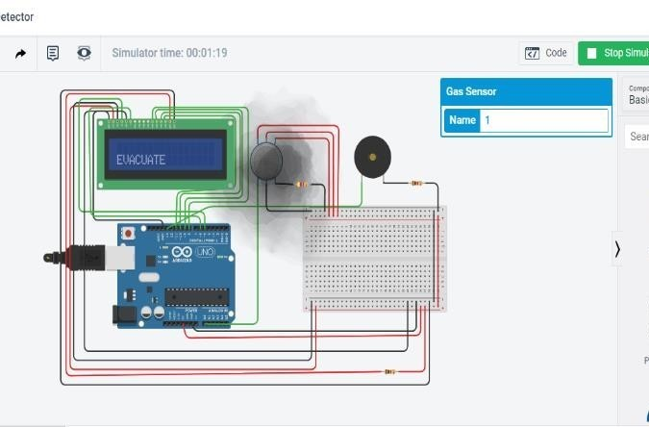

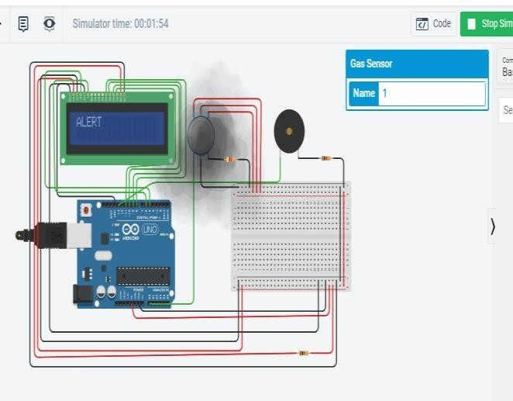

From the above figures we can see that when the gas value is greater than 30 the system will print on the display “Evacuate” and “Alert”.

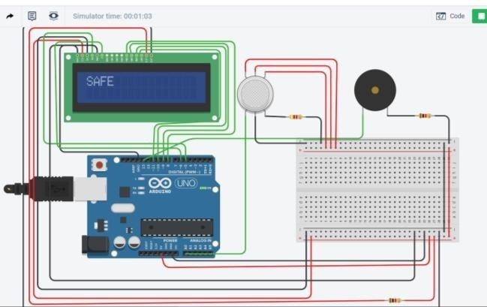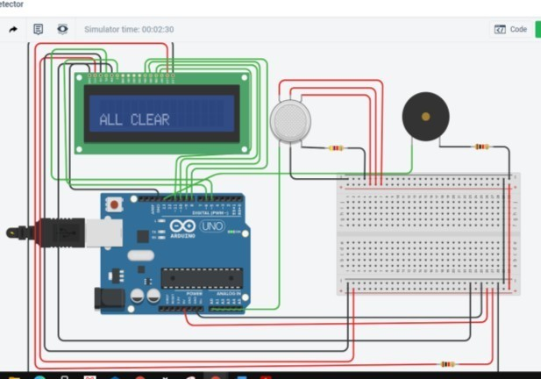

From the above figures we can see that when the gas is lower than 30 the system will print on the display “Safe” and All clear.

## Testing the Hardware:

To test the hardware we had brought a lighter as a gas source near the system. We had made a video of the testing of our system.

## Results and Discussions

After testing the hardware system, we can see that when we took a lighter near the sensor, it shows results

on LED display and the buzzer rang. Lighter contains Butane gas which is a form of LPG gas. So, we can say our system is responding to the LPG gas.

After showing results to LED display, our system also notifies us via nodemcu and through server to our mobile phone. As we explained earlier in the procedure, we have used blynk app and connected through server with an authentication code. This code is individual for each device. But we are not sure about the maximum gas density in which the sensor can actually sense the gas.

## Limitation of The System

Though our system generates Sound Alarm when gas outflow is noticed and transmits notification alert to consent person there are some limitations also. **Limitation are:**

1. Portable gas cooktop cannot be organized in this proposed project.
2. LPG hand wheel cannot be controlled in this proposed project.

# Future Work

For improvement in the future, some additional

and inadequate awareness of the people. Hence, LPG leakage detection is essential to prevent accidents and to save human lives. This paper presented LPG leakage detection and alert system. This system triggers LCD display and buzzer to alert people when LPG leakage is detected. This system is very simple yet reliable.

Therefore, the researchers concluded that the “LPG Leakage Detector Using Arduino with notification Alert and Sound Alarm” will help a lot in terms of preventing any danger caused by gas leakage and useful as part of safety to avoid the gas leak that can cause harmful result. It will also improve the safety of all users of Liquefied Petroleum Gas.

# 7 Reference

1. [https://www.youtube.com/watch?fbclid=IwAR19oKD-](http://www.youtube.com/watch?fbclid=IwAR19oKD-) 5r5- uFerqxx4SFfJ4-

VZLwTnqyBxDr7O6nvZFJwOyW2n5q0AP5Iv=McTKlKnR07 Qfeature=youtu.be

1. [https://www.youtube.com/watch?fbclid=IwAR39AUYUDQcSaeaitA](http://www.youtube.com/watch?fbclid=IwAR39AUYUDQcSaeaitA) Vp-XTTPW8Dla5FucaJjFXfhYQH-Haxgv=6oWI- xhAtrYfeature=youtu.be

feature could be added in order to make increase

1. [https://www.youtube.com/watch?fbclid=IwAR0VD5n3fiRbSC6RzE7](http://www.youtube.com/watch?fbclid=IwAR0VD5n3fiRbSC6RzE7)

the performance and capability of the circuit. Some

iJZvSoVCt3gBZ9Uv6IjLLyzE7gbUv=McTKlKnR07Qfeature=youtu.be

recommendations are briefly explained below:

## Various Gas Detection:

This model can only detect various combustible gasses at certain distance. By using our MQ-6 gas sensor, gasses like Sulphur, carbon Monoxide, Nitrogen Diox- ide and other gasses which are toxic and poisonous can only be detected by infrared at certain wavelength. The future improvement of this project will help to improve the functionality of this model.

## Performance of the circuit:

When the LPG has dispersed into the surrounding, its concentration will be decreased.Therefore, this model will not be able to detect the leakage appropriately. The design of this model has to be improved so that it can detect the leakage just as the leakage had occurred.

# 6 Conclusion

Gas leakage leads to severe accidents resulting in material losses and human injuries. Gas leakage occurs mainly due to poor maintenance of equipment

1. [https://www.youtube.com/w](http://www.youtube.com/watch?fbclid=IwAR1-)at[ch?fbclid=IwAR1-](http://www.youtube.com/watch?fbclid=IwAR1-) K3S85BSNfuRAM9bGsZVx-Ka MkPFl9uuyb0AEerEPcvQd8LMWjdwFmg4v=jCghjrUWPu4feature=y

# 8 Procedure and Code

1. At first, we had built the circuit and simulated the circuit in Tinker cad. The circuit we built in tinker cad is given below:

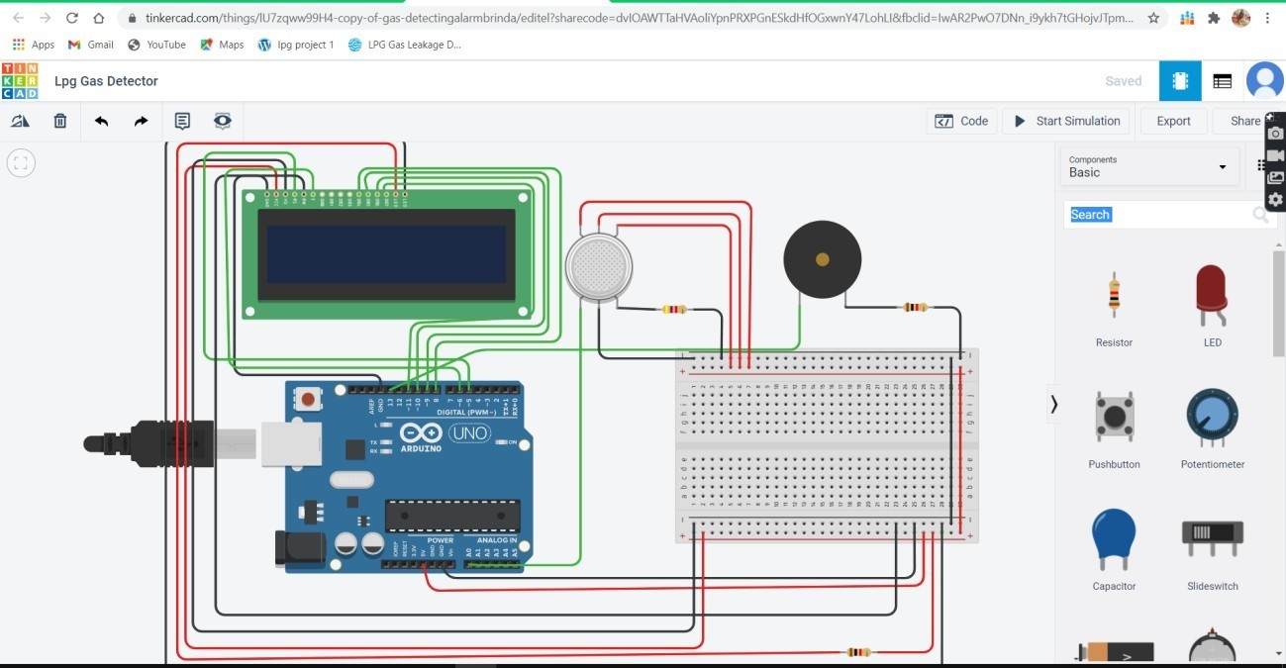

1. As shown in the schematic diagram above, it contains Arduino board, LPG GAS Sensor Module,

buzzer and 16x2 LCD module. Arduino controls the whole process of this system like reading LPG Gas sensor module output, sending message to LCD and activating buzzer. We can set sensitivity of this sensor module by inbuilt potentiometer placed on it.

1. LPG gas sensor module’s DO pin is directly connected to pin 14 (A0) of Arduino and Vcc and GND are connected to Vcc and GND of arduino. LPG gas sensor module consist a MQ6 sensor which detects LPG gas. This MQ6 sensor has a heater inside which needs some heater supply to heat up and it may takes up to 15 minute to get ready for detecting LPG gas. And a comparator circuit is used for converting Analog output of MQ6 in digital. A 16x2 LCD is connected with arduino in 4-bit mode. Control pin RS, RW and En are directly connected to arduino pin

-5, GND and -6. And data pin D4-D7 are connected to 8, -9, -10, -11 of arduino. A buzzer is connected with arduino pin number 13 through a 1 k resistor at its base.

1. Then we wrote the arduino code for the system. The code is given below:

include <SoftwareSerial.h> SoftwareSerial mySerial(9, 10); include <LiquidCrystal.h> LiquidCrystal lcd(5,6,8,9,10,11); int buzzer = 13;

int GASA0 = A0;

int gasvalue; void setup()

mySerial.begin(9600); Serial.begin(9600); pinMode(buzzer, OUTPUT); delay(5000); lcd.begin(16,2);

void loop()

int analogSensor = analogRead(GASA0); int gasvalue=(analogSensor-50)/10;

// Checks if it has reached the threshold value if (gasvalue >= 30)

tone(buzzer,HIGH); lcd.clear(); lcd.setCursor(0,0); lcd.print("ALERT"); delay(1000); lcd.clear(); lcd.setCursor(0,1);

lcd.print("EVACUATE"); delay(1000);

else

noTone(buzzer); lcd.clear(); lcd.setCursor(0,0); lcd.print("SAFE"); delay(1000); lcd.clear(); lcd.setCursor(0,1);

lcd.print("ALL CLEAR"); delay(1000);

delay(500);

1. Then we tested and debugged the system in tinkercad.
2. Then we had built the circuit in physical as like as the circuit we built in tinkercad. The circuit we had built in physical is given below.

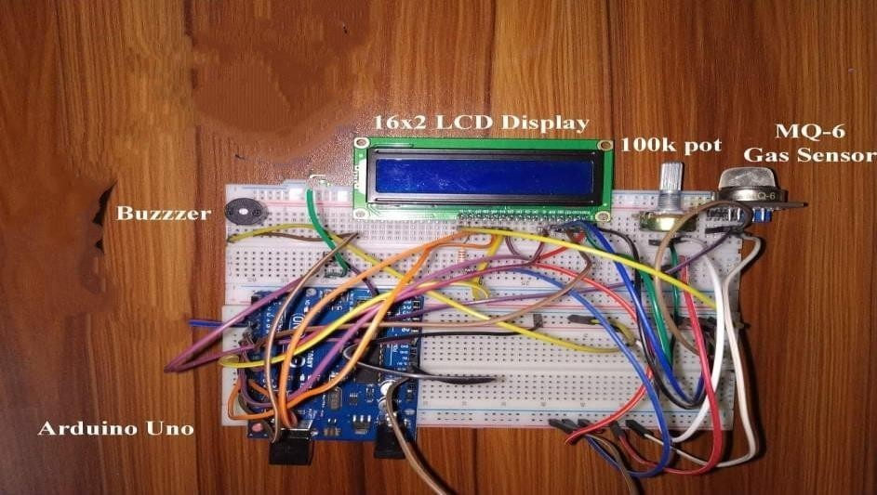

Figure: Circuit without nodemcu esp8266

1. As shown in the figure, here we connected a 100k pot with the circuit. We connected the pot to control the brightness of the display.
2. We uploaded the code (which we wrote in tinker- cad) to Arduino board using Arduino IDE. Then we tested and debugged the system again.
3. Then we constructed the nodemcu code and uploaded the code to nodemcu ESP8266.
4. After that we downloaded the Blynk app on the device (where we want to get the notification) and opened an ID on blynk app. After opening ID we selected notification module then connected the module with nodemcu’s A0 pin. Then we got an authentication code through mail. Then we connected the device with nodemcu by entering that specific authentication code at nodemcu ESP8266 code.
5. The message we want on the device is also uploaded to the nodemcu esp8266 code. The code is given below:

**Nodemcu esp8266 code:** define BLYNKPRINT Serial include <SoftwareSerial.h>

SoftwareSerial nodeMcu(3,2); include <ESP8266WiFi.h> include <BlynkSimpleEsp8266.h>

char auth[] = "1gsyzlcqCo5SpZzbObEYtxvv5wW- RkuN";

char ssid[] = "Friends Group";g char pass[] = "Friends@321"; int GASA0 = A0;

void setup() pinMode(GASA0, INPUT); nodeMcu.begin(9600); Serial.begin(9600);

Blynk.begin(auth, ssid, pass);

void loop()

int analogSensor = analogRead(GASA0); int gasvalue=(analogSensor-50)/10;

Serial.print("Pin A0: "); Serial.println(analogSensor); if (gasvalue >= 30)

Blynk.run();

Blynk.notify("Alert: Excess gas detected,open the windows ");

else

delay(100);

1. Then we connected the circuit with nodemcu ESP8266.

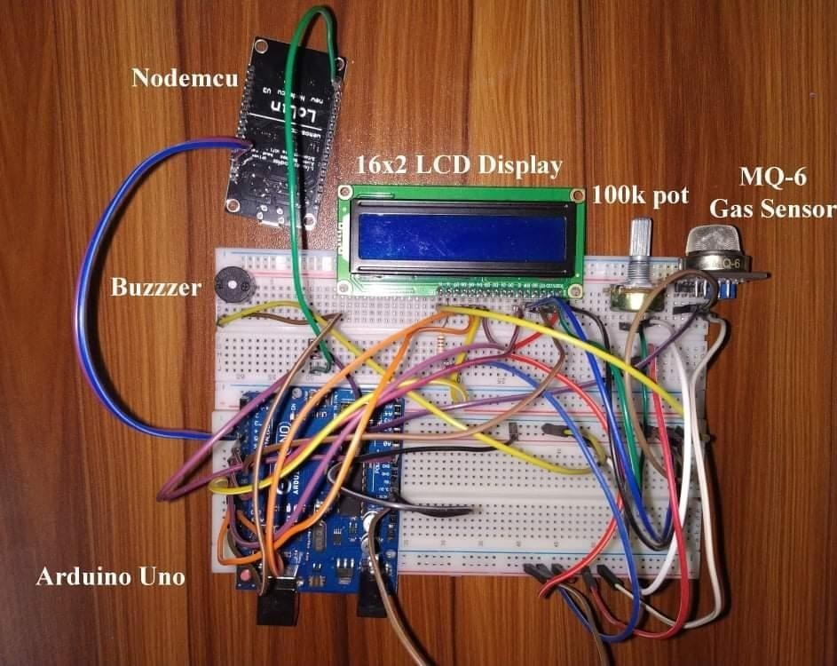

Figure: Circuit with nodemcu esp8266