Blockchain Platform Comparison and Recommendations

# Task Overview

Choose one platform from each category:  
  
- Public Blockchain: Ethereum  
- Private Blockchain: Hyperledger Fabric  
- Consortium Blockchain: Quorum  
  
The comparison includes technical aspects such as consensus mechanism, permission model, smart contract support, and use cases.

# Comparison Table

|  |  |  |  |  |  |  |  |  |
| --- | --- | --- | --- | --- | --- | --- | --- | --- |
| Blockchain Name | Type | Consensus Mechanism Used | Permission Model | Speed / Throughput (TPS) | Smart Contract Support | Token Support | Typical Use Case | Notable Technical Feature |
| Ethereum | Public | Proof of Stake (PoS – Ethereum 2.0) | Open | ~15–30 TPS | Yes (Solidity, Vyper) | Native (ETH) | Decentralized apps (DApps), NFTs, DeFi | EVM, large developer ecosystem |
| Hyperledger Fabric | Private | Pluggable (default: Raft) | Permissioned | ~1,000+ TPS | Yes (Go, Java, Node.js) | No native token | Enterprise supply chain, asset tracking | Modular architecture, private channels |
| Quorum | Consortium | Istanbul BFT / Raft | Permissioned | ~1,000+ TPS | Yes (Solidity) | Optional | Financial services, interbank networks | Privacy-enhanced Ethereum fork |

# Short Report and Recommendations

Ethereum, a public blockchain, leverages Proof of Stake and supports open participation, making it highly decentralized.   
However, its relatively lower throughput (~15–30 TPS) and public transparency make it less suited for enterprise-grade confidentiality.   
Its robust smart contract ecosystem (Solidity) and native token (ETH) make it ideal for DApps and decentralized finance (DeFi).



Hyperledger Fabric, on the other hand, is a private, permissioned blockchain platform with a modular architecture and pluggable consensus (like Raft).   
It supports private channels and offers significantly higher throughput (~1,000+ TPS), making it well-suited for enterprise use cases like supply chain management   
where participants are known and data privacy is crucial.

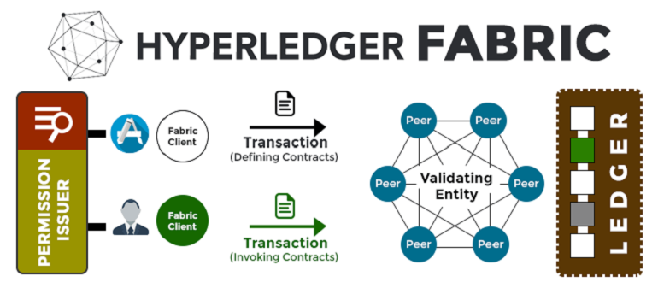

Quorum, a consortium blockchain built as a privacy-focused Ethereum fork, uses permissioned consensus mechanisms (Istanbul BFT or Raft)   
and combines Ethereum's smart contract support with enterprise privacy. It is ideal for financial services involving multiple trusted institutions,   
offering both privacy and performance.

## Recommendations and Justification

**1.A decentralized app? Ethereum**

**Why Ethereum?**

* **Open Participation & Decentralization:** Ethereum is a fully public blockchain, meaning anyone can join, validate, and deploy applications. This is essential for decentralized applications that rely on trustless environments.
* **Robust Smart Contract Ecosystem:** Ethereum supports Turing-complete smart contracts written in **Solidity** or **Vyper**, and it has the **Ethereum Virtual Machine (EVM)**, which allows developers to build complex logic with high flexibility.
* **Token Standards:** Ethereum supports a wide range of token standards like **ERC-20** (fungible), **ERC-721** (NFTs), and **ERC-1155** (multi-token), making it a go-to platform for DeFi, games, marketplaces, and NFT-based applications.
* **Security and Immutability:** Ethereum’s PoS-based consensus and wide network participation offer high resistance to censorship or manipulation.

**Best Fit**: When your DApp requires **public access, decentralization, token integration**, and **a well-established developer community**, Ethereum is unmatched.

**2. For a Supply Chain Among Known Partners: ➤ *Hyperledger Fabric***

**Why Hyperledger Fabric?**

* **Permissioned Network:** In a supply chain, participants (e.g., suppliers, manufacturers, retailers) are known entities. Hyperledger Fabric enforces access controls and identity management through **Certificate Authorities**, enabling strict permissioning.
* **Private Channels & Data Confidentiality:** Fabric allows the creation of **private channels** for subsets of participants. This means sensitive data (like prices or transactions) is only visible to relevant parties.
* **High Throughput:** Thanks to its modular consensus and transaction processing separation, Fabric can handle **1,000+ TPS**, suitable for real-time logistics tracking and high-volume systems.
* **Smart Contract Flexibility:** Supports **Chaincode** in familiar languages like **Go, Java, and Node.js**, reducing the learning curve for enterprise developers.

**Best Fit**: When building a blockchain network for **collaboration among trusted parties** with a need for **privacy, scalability, and role-based access**, Hyperledger Fabric is ideal.

**3. For an Inter-Bank Financial Application: ➤ *Quorum***

**Why Quorum?**

* **Consortium Control:** Quorum is designed for **consortiums**—multiple banks or financial institutions managing a shared ledger with mutual trust but private needs.
* **Enterprise-Grade Privacy:** It includes **private transaction support** and **Tessera**, which encrypts transaction data, ensuring that only authorized participants can view specific financial operations.
* **Ethereum Compatibility:** It supports **Solidity** smart contracts and the EVM, making it easy to migrate or reuse Ethereum-based infrastructure.
* **Pluggable Consensus:** With support for **Istanbul BFT** (low-latency, fast finality) and **Raft**, it achieves consensus quickly without the computational cost of PoW or the open nature of PoS.

**Best Fit**: When building a financial application like **cross-border payments, inter-bank settlements**, or **KYC-sharing networks** where **privacy, compliance, and performance** are critical, Quorum excels.