

**SQL**

**Mini Project**

**Shows & Movies**

**Management**

**Management System**

**Problem Statement**

**NETFLIX TV Shows and Movies Data**

analyze the data to find interesting facts

Developed & programmed by:

**Kanika Gupta**

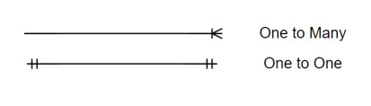

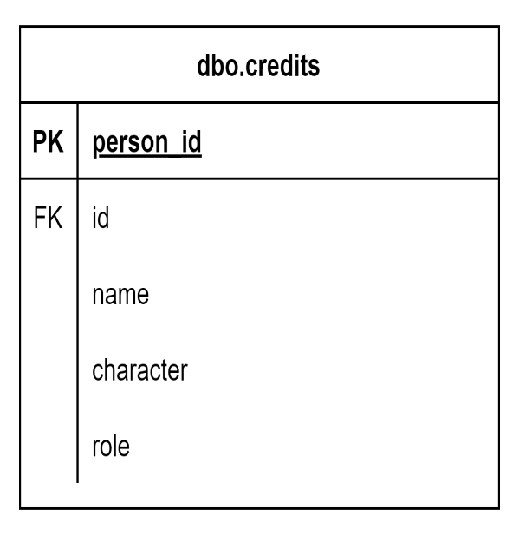 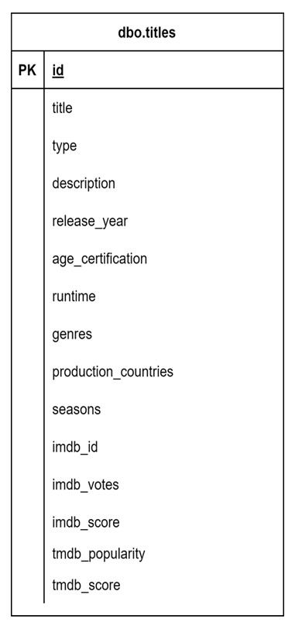

Entity Relationship (ER)

Diagram

Tables Creation DDL Commands

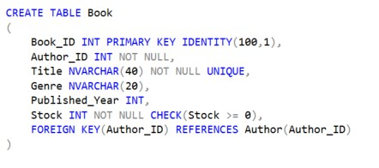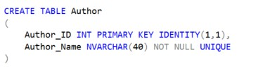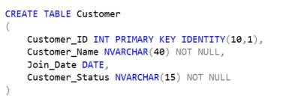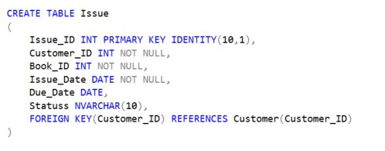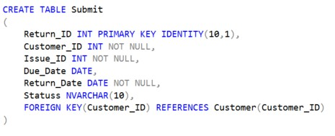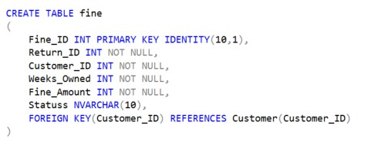

Here,s Case Questions

SELECT TOP 10 title

Problem 1 :

What were the top 10 movies according to IMDB score?

FROM dbo.titles

WHERE type='movie'

ORDER BY imdb_score DESC;

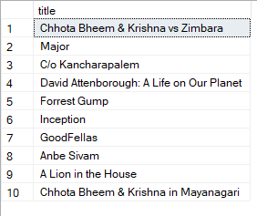

O

U

T

P

U

T

->->

Problem 2 :

What were the top 10 shows according to IMDB score?

SELECT TOP 10 title

FROM dbo.titles

WHERE type='show'

ORDER BY imdb_score DESC;

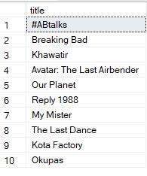

O

U

T

P

U

T

->->

SELECT TOP 10 title

Problem 3 :

What were the bottom 10 movies according to IMDB score?

FROM dbo.titles

WHERE type='movie'

ORDER BY imdb_score DESC;



O

U

T

P

U

T

->->

Problem 2 :

What were the top 10 shows according to IMDB score?

SELECT TOP 10 title

FROM dbo.titles

WHERE type='show'

ORDER BY imdb_score DESC;



O

U

T

P

U

T

->->

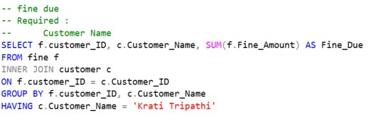

Result & Updates

Problem

4

:

**Query to**

**Display Fine Due for a Specific**

**Customer**

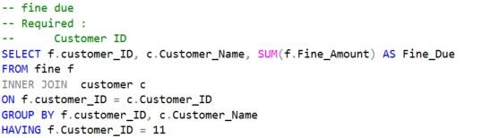

Result & Updates

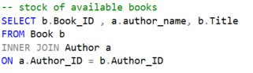

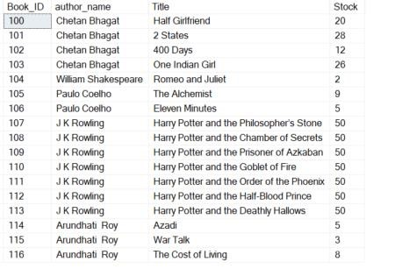

Result & Updates

Problem 5

:

**Query to Display Stock of Books Availability**

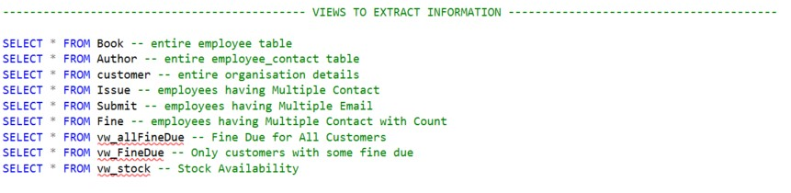

**Thank You**