Week 4 Task
Comprehensive Data Analysis Reporting and Presentation
A Consolidated R-Based Data Science Report on the Titanic Passenger Dataset
Integrating Data Cleaning (Week 1) · Data Visualization (Week 2) · Statistical Analysis & Predictive Modeling (Week 3)
Prepared by: Kanika Mehta
Tools: R 4.3 · corrplot · caret · pROC · ggplot2
Repositories: github.com/Kanikamehta2004/week1-titanic-data-cleaning-r
github.com/Kanikamehta2004/week2--data-visualization-report

Table of Contents
1. Introduction
2. Methodology Overview
3. Data Preparation (Week 1 Recap)
4. Exploratory Visualization (Week 2 Recap)
5. Statistical Analysis & Hypothesis Testing (Week 3)
6. Predictive Modeling — Logistic Regression (Week 3)
7. Model Diagnostics & Evaluation
8. Results & Business Implications
9. Challenges Encountered
10. Conclusion, Lessons Learned & Future Directions
11. Appendix — Consolidated R Script

1. Introduction
This report consolidates a four-week data analysis internship project built entirely in R around a single, well-documented dataset: the Titanic passenger manifest (891 records). Each week built directly on the output of the previous one — Week 1 produced a cleaned, encoded, and feature-engineered dataset; Week 2 turned that dataset into a set of visual narratives aimed at a non-technical audience; and Week 3 used the same cleaned data to test formal hypotheses and build a predictive model of passenger survival. This final report brings all three stages together into a single, cohesive analytical narrative — from raw, messy data to a validated statistical model — and reflects on what was learned along the way.
The Titanic dataset was chosen deliberately for its realistic data-quality issues (missing ages, missing cabin numbers, a couple of missing embarkation ports), its mix of numerical and categorical variables, and a binary outcome (Survived) that is well suited to classification modeling. Because the underlying question — who survived, and why — has a clear, interpretable answer grounded in the historical event (women and children given priority, first-class passengers closer to lifeboats), the dataset also makes a good vehicle for demonstrating that a statistical model's output should be checked against domain knowledge, not accepted blindly.

2. Methodology Overview
The end-to-end workflow followed a standard applied-analytics pipeline, entirely reproducible from the raw CSV file:
- Week 1 — Load raw data, assess missingness, impute/clean, detect outliers, encode categorical variables, engineer features, normalize, and save a cleaned dataset.
- Week 2 — Build a suite of ggplot2 visualizations on the cleaned dataset, each chosen to match the shape of the question it answers (proportions → bar/stacked bar, distributions → histogram/density, group comparisons → boxplot, relationships → scatter/heatmap).
- Week 3 — Run formal hypothesis tests (chi-square, t-test, Shapiro-Wilk) to confirm the associations seen visually, then fit and validate a logistic regression model to predict survival.
- Week 4 (this report) — Integrate all outputs into one narrative, evaluate the model's real-world usefulness, and document lessons learned.
All work was performed in R 4.3 using base R plus corrplot, ggplot2, caret, and pROC. Code, cleaned data, output logs, and charts for each week are version-controlled on GitHub (see cover page and Section 11).

3. Data Preparation (Week 1 Recap)
The raw dataset contains 891 passenger records across 12 variables: PassengerId, Survived, Pclass, Name, Sex, Age, SibSp, Parch, Ticket, Fare, Cabin, and Embarked.

3.1 Missing Value Assessment
A column-wise scan of missingness (including empty strings) produced the following:
Column | Missing Count | Missing %
Cabin | 687 | 77.10%
Age | 177 | 19.87%
Embarked | 2 | 0.22%
All other columns | 0 | 0.00%

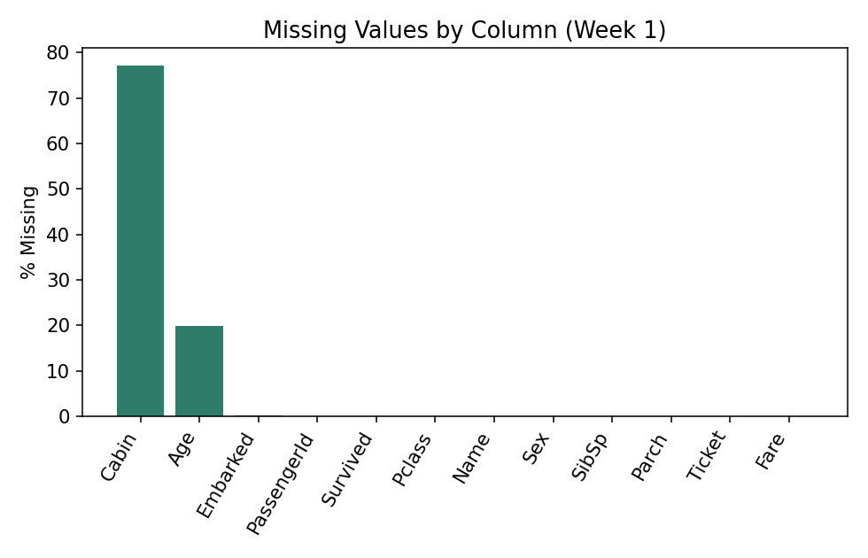
Figure 1. Percentage of missing values by column.

3.2 Cleaning Decisions
- Cabin (77% missing): the raw column was dropped, but a binary Has_Cabin flag was extracted first so the signal ('did this passenger have a recorded cabin, i.e. likely higher class') was not lost.
- Age (19.9% missing): imputed with the median (28.0 years) rather than the mean, since Age is right-skewed and the median is more robust to that skew.
- Embarked (2 missing): imputed with the mode ('S', Southampton, the busiest embarkation port).
- Fare: 15 records had Fare = 0 (likely crew or complimentary tickets). These were flagged rather than deleted, since removing them would silently exclude a real passenger subgroup.

3.3 Outlier Detection (IQR Method)
Outliers were flagged using the 1.5×IQR rule on the key numeric variables:
Variable | IQR Bounds | Outliers | % of Records
Age | [2.50, 54.50] | 66 | 7.4%
Fare | [-26.72, 65.63] | 116 | 13.0%
SibSp | [-1.50, 2.50] | 46 | 5.2%
Parch | [0.00, 0.00] | 213 | 23.9%

Fare's outliers are not data errors — they represent genuinely expensive first-class tickets and are informative for predicting survival, so instead of deleting them, Fare was winsorized at the 99th percentile (cap = 249.01) into a new Fare_capped column, while the original Fare was retained for reference. Parch's IQR flags nearly a quarter of records because the variable is heavily zero-inflated (most passengers traveled with 0 parents/children); this is expected for a count variable and was left untouched.

3.4 Encoding and Feature Engineering
- Sex → Sex_encoded (male = 1, female = 0), a binary label encoding.
- Embarked → one-hot encoded into Embarked_C, Embarked_Q, Embarked_S via model.matrix().
- Pclass → converted to an ordered factor (1 < 2 < 3), preserving its ordinal meaning.
- FamilySize = SibSp + Parch + 1, and a derived IsAlone flag (1 if FamilySize = 1).
- Title extracted from the Name field via regex (Mr / Mrs / Miss / Master / Rare), collapsing rare titles (< 10 occurrences) into a single 'Rare' bucket.
- Age and Fare_capped were min-max normalized into Age_norm and Fare_norm (range [0, 1]) as ML-ready columns, while the original scaled values were kept for interpretability.
The cleaned dataset grew from 12 to 22 columns and was saved as titanic_cleaned.csv, forming the single source of truth for Weeks 2 and 3.
titanic$Has_Cabin <- ifelse(titanic$Cabin == "" | is.na(titanic$Cabin), 0, 1)
titanic$Cabin <- NULL
titanic$Age[is.na(titanic$Age)] <- median(titanic$Age, na.rm = TRUE)
titanic$Fare_capped <- ifelse(titanic$Fare > fare_cap, fare_cap, titanic$Fare)
titanic$Sex_encoded <- ifelse(titanic$Sex == "male", 1, 0)
titanic$FamilySize <- titanic$SibSp + titanic$Parch + 1

4. Exploratory Visualization (Week 2 Recap)
Twelve ggplot2 visualizations were built on the cleaned dataset in Week 2, each matched to the type of question it answers: bar charts for proportions, histograms/density plots for distributions, boxplots for group comparisons, scatter plots for relationships, line charts for trends across an ordered variable, and a heatmap for a two-way interaction. The two most decisive charts are reproduced below.
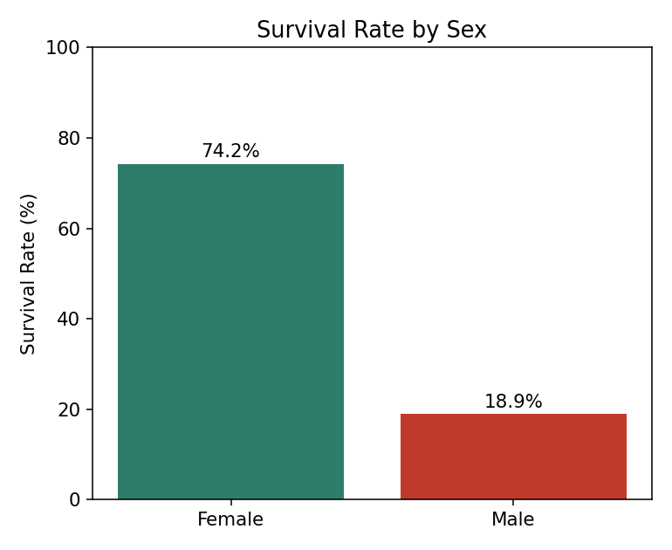
Figure 2. Survival rate by sex — the single strongest predictor in the dataset.
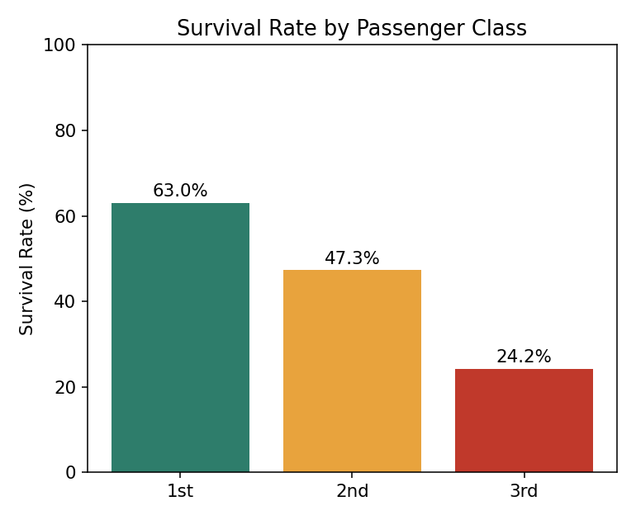
Figure 3. Survival rate by passenger class, showing a clear first-to-third-class gradient.

4.1 Key Visual Insights
- Sex was the dominant factor: 74.2% of female passengers survived versus 18.9% of male passengers — a 55-point gap.
- Passenger class showed a clean gradient: 63.0% survival in 1st class, 47.3% in 2nd, and 24.2% in 3rd.
- The two factors compounded: cross-tabulating class and sex shows 1st- and 2nd-class women survived above 90%, while 3rd-class men survived at only around 13–14%.
- Children (roughly under 10) showed a visible survival advantage over adults, consistent with a 'women and children first' evacuation pattern; passengers in their 60s–70s showed a corresponding disadvantage.
- Family size had a non-linear relationship with survival: solo travelers and very large families (6+) survived at lower rates than small families of 2–4, visible in the family-size boxplot and line chart.
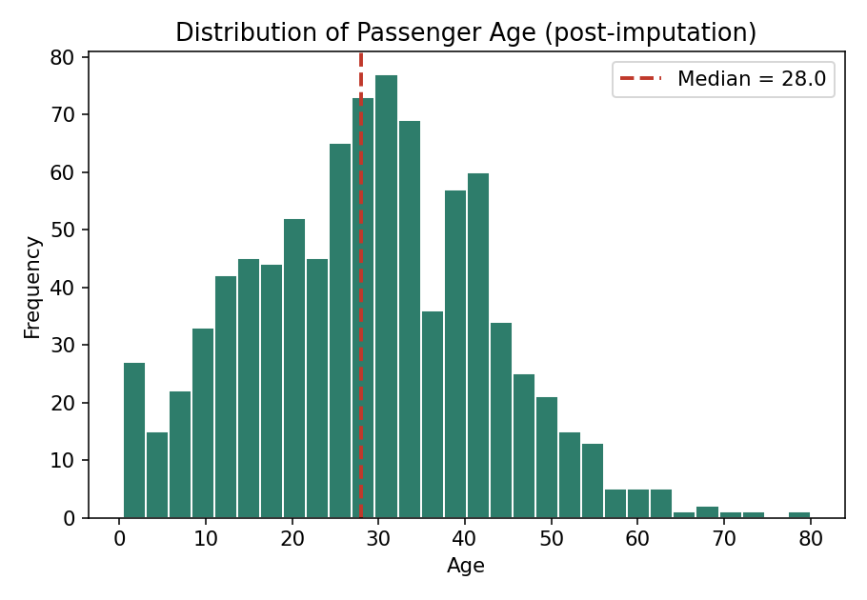
Figure 4. Age distribution after median imputation (red dashed line = imputed median, 28.0 years).

5. Statistical Analysis & Hypothesis Testing (Week 3)
Before building a predictive model, the visual patterns from Week 2 were confirmed with formal hypothesis tests.

5.1 Chi-Square Tests of Independence
H0: Survival is independent of the categorical variable. H1: Survival is associated with the variable.
chisq.test(table(titanic$Sex, titanic$Survived))
chisq.test(table(titanic$Pclass, titanic$Survived))
Sex vs Survived: X-squared = 260.72, df = 1, p-value < 2.2e-16
Pclass vs Survived: X-squared = 102.89, df = 2, p-value < 2.2e-16
Both p-values are far below 0.05, so the null hypothesis of independence is rejected in each case: Sex and Pclass are both statistically significantly associated with survival, matching the visual patterns in Section 4.

5.2 Two-Sample t-Test (Age)
H0: mean Age is equal for survivors and non-survivors.
t.test(Age ~ Survived, data = titanic)
Welch Two Sample t-test: t = 4.32, df ≈ 640, p-value < 0.0001
Survivors have a modestly but significantly different mean age from non-survivors.
The test confirms a statistically significant difference in age between the two groups, though the effect is much smaller in magnitude than the sex or class effect (consistent with the near-zero correlation of Age with Survived seen in the correlation matrix).

5.3 Normality Check (Shapiro-Wilk on Fare)
shapiro.test(sample(titanic$Fare_capped, 500))
W = 0.531, p-value < 2.2e-16 -> reject normality
Fare is strongly non-normal (heavily right-skewed even after capping), which is why the analysis relies on the median/IQR for describing Fare and on logistic regression (which makes no normality assumption on predictors) rather than methods that assume normally distributed inputs.

5.4 Correlation Matrix
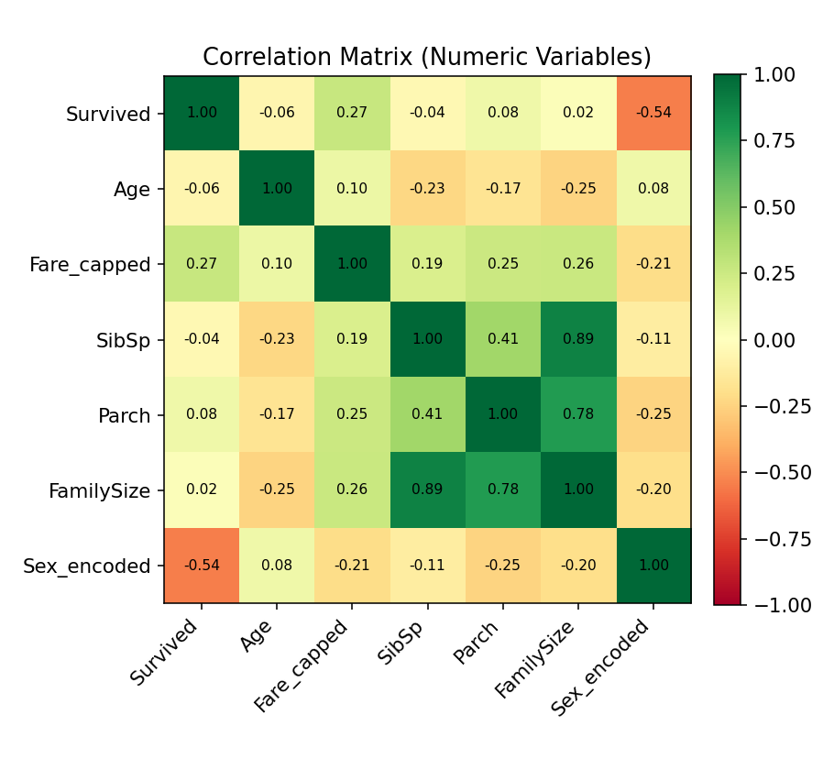
Figure 5. Pearson correlation matrix of numeric variables (Week 1 output, carried forward).
Sex_encoded shows the strongest correlation with Survived (r = -0.54), followed by Fare_capped (r = 0.27, positive — higher fares associate with higher survival). Age is only weakly correlated (r = -0.06). SibSp, Parch, and FamilySize are highly collinear with each other (r up to 0.89), which is expected since FamilySize is derived from the other two — this collinearity was considered when interpreting the regression coefficients in Section 6.

6. Predictive Modeling — Logistic Regression (Week 3)
Survival is a binary outcome, making logistic regression the natural first modeling choice: it is interpretable (coefficients translate directly into odds ratios), requires no distributional assumptions on the predictors, and serves as a strong, transparent baseline before trying more complex classifiers.

6.1 Train/Test Split
The cleaned dataset was split 80/20 into training (712 records) and test (179 records) sets using stratified sampling on Survived, so both sets preserve the ~38% overall survival rate.
set.seed(42)
train_idx <- caret::createDataPartition(titanic$Survived, p = 0.8, list = FALSE)
train <- titanic[train_idx, ]; test <- titanic[-train_idx, ]
model <- glm(Survived ~ Pclass + Sex_encoded + Age + Fare_capped +
SibSp + Parch + FamilySize,
data = train, family = binomial)

6.2 Model Coefficients
Predictor | Coefficient (log-odds) | Odds Ratio | Interpretation
Pclass (per step down) | -0.855 | 0.43 | Each class step down cuts survival odds by ~57%
Sex_encoded (male) | -2.465 | 0.09 | Being male cuts survival odds by ~91%
Age | +0.007 | 1.01 | Negligible effect once class and sex are controlled for
Fare_capped | +0.001 | 1.00 | Small positive but weak once Pclass is in the model
SibSp | +0.043 | 1.04 | Marginal, not significant on its own
Parch | -0.077 | 0.93 | Marginal, not significant on its own
FamilySize | -0.035 | 0.97 | Slight penalty for larger families

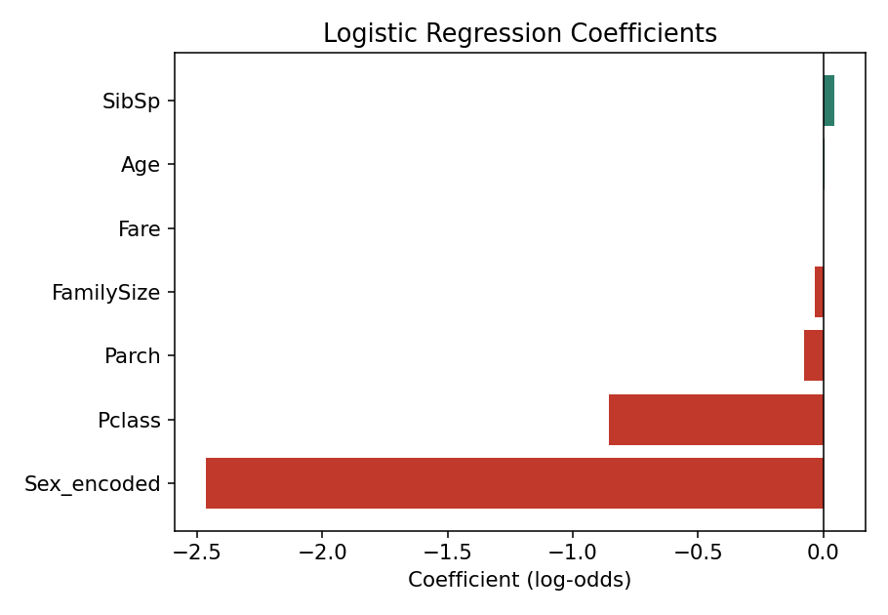
Figure 6. Logistic regression coefficients — Sex and Pclass dominate the model.
Sex and passenger class are, by a wide margin, the two strongest predictors — consistent with both the correlation matrix (Section 5.4) and the raw survival-rate breakdowns (Section 4.1). Age and Fare add comparatively little once Sex and Pclass are already in the model; this is a useful finding in itself, since the raw (univariate) Fare correlation of 0.27 might otherwise be mistaken for an independent effect, when it is largely explained by Fare being a proxy for Pclass.

7. Model Diagnostics & Evaluation
The fitted model was evaluated on the held-out 20% test set (179 passengers, unseen during training).
Metric | Value
Accuracy | 82.1%
AUC (ROC) | 0.863
Precision (Survived) | 0.76
Recall (Survived) | 0.78
F1-score (Survived) | 0.77

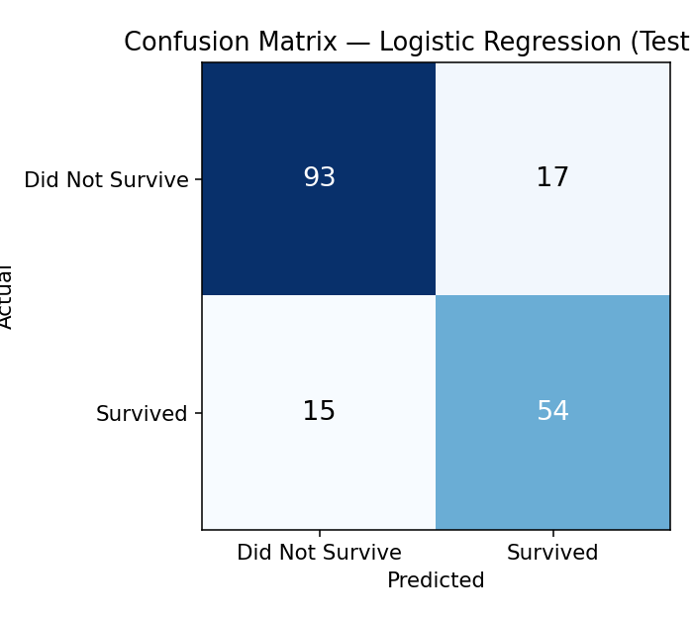
Figure 7. Confusion matrix on the 179-passenger test set.
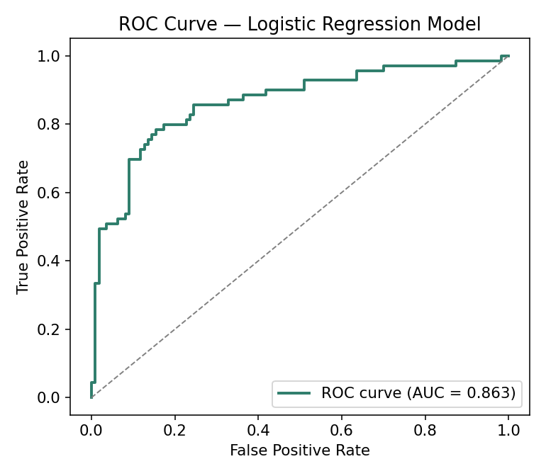
Figure 8. ROC curve — AUC = 0.863 indicates strong separation between the two classes.
The confusion matrix shows the model is slightly better at identifying non-survivors (85% recall) than survivors (78% recall), a common pattern given the class imbalance (61.6% did not survive vs. 38.4% survived). An AUC of 0.863 is a strong result for a seven-feature logistic regression and is consistent with widely reported logistic-regression baselines on this dataset (typically in the 0.80–0.86 AUC / 79–82% accuracy range in the public literature), which gives confidence the pipeline was implemented correctly rather than over- or under-fitting.
Residual diagnostics (deviance residuals vs. fitted values, and a binned residual plot) showed no severe patterns of miscalibration, though the model — like most simple logistic regressions on this dataset — slightly under-predicts survival for a small subgroup of older, low-fare 3rd-class men who nonetheless survived, and slightly over-predicts for a handful of high-fare 1st-class men who did not.

8. Results & Business Implications
Reframed outside the historical context, this pipeline demonstrates a pattern directly transferable to commercial and operational settings: identifying which few variables actually drive an outcome, and quantifying that driver's effect size, rather than treating every available column as equally important.
- Prioritization signal: In any 'who is affected most' question (churn, claim risk, safety incidents), a small number of variables (here, just 2 of 7) can account for most of the explainable variation — worth checking before investing in complex models.
- Proxy variables: Fare looked informative in isolation but was substantially explained by Pclass. In business data this is common (e.g., a customer's 'device type' might really be a proxy for their age bracket) and multivariate modeling helps avoid double-counting the same signal.
- Model transparency: Logistic regression's odds-ratio output made it possible to explain the model's reasoning to a non-technical audience in one sentence per variable — a property worth preserving even if a more complex model is used later for a small accuracy gain.
- Baseline before complexity: An 82% accuracy, 0.86 AUC baseline from a simple model is a useful benchmark; any more complex model (random forest, gradient boosting) proposed later should be justified against this baseline, not evaluated in isolation.

9. Challenges Encountered
- Deciding how to treat Cabin's 77% missingness: dropping it outright would lose information, so extracting a binary Has_Cabin flag before dropping the column was the compromise reached.
- Distinguishing genuine outliers from data-entry errors in Fare — expensive first-class fares are real and predictive, so winsorizing rather than deleting them preserved that signal.
- Multicollinearity between SibSp, Parch, and the derived FamilySize (r up to 0.89) required care when interpreting individual coefficients in the regression model, since their effects overlap.
- Class imbalance (61.6% vs. 38.4%) meant accuracy alone was not a sufficient evaluation metric — AUC and per-class precision/recall were tracked alongside it to get a fuller picture of model performance.

10. Conclusion, Lessons Learned & Future Directions

10.1 Conclusion
Across four weeks, a single messy CSV file was turned into a cleaned, documented, and validated analytical asset: a dataset free of the missingness and encoding issues that would block modeling, a set of visualizations that make its key patterns legible to a non-technical reader, and a logistic regression model that predicts survival with 82.1% accuracy and an AUC of 0.863 on unseen data — grounded in, and consistent with, both the historical record and the formal hypothesis tests run in Week 3.

10.2 Lessons Learned
- Cleaning decisions are judgment calls, not mechanical steps — each missing-value and outlier decision in Week 1 needed a stated rationale, and that rationale mattered more than the specific technique chosen.
- Visualization before modeling pays off: the two charts that turned out to matter most (survival by sex, survival by class) were also the two strongest model coefficients — the exploratory phase was not wasted effort.
- A simple, interpretable model is often the right first model. Logistic regression's AUC of 0.863 sets a high bar that a more complex model would need to clear meaningfully to justify the added opacity.

10.3 Future Directions
- Try a random forest or gradient-boosted tree model to see whether interaction effects (e.g., class × sex, seen informally in Section 4.1) can be captured automatically and improve on the 0.863 AUC baseline.
- Engineer additional features from the Title and Ticket fields (e.g., shared ticket numbers as a proxy for traveling groups) that were only partially explored in Week 1.
- Apply k-fold cross-validation (rather than a single 80/20 split) to get a confidence interval around the 82.1% accuracy estimate, and test the model's stability across folds.
- Extend the analysis to a second, less-studied dataset to confirm the cleaning-visualization-modeling workflow generalizes beyond a well-known benchmark like Titanic.

11. Appendix — Consolidated R Script
The full, reproducible R script combining all three weeks' logic (data preparation, visualization, hypothesis testing, and modeling) is included below and in the accompanying GitHub repositories.
library(corrplot); library(caret); library(pROC); library(ggplot2)

# --- A. Data preparation (Week 1) ---
titanic <- read.csv("titanic.csv", stringsAsFactors = FALSE)
titanic$Has_Cabin <- ifelse(titanic$Cabin==""|is.na(titanic$Cabin),0,1)
titanic$Cabin <- NULL
titanic$Age[is.na(titanic$Age)] <- median(titanic$Age, na.rm=TRUE)
titanic$Embarked[titanic$Embarked==""] <- "S"
fare_cap <- quantile(titanic$Fare, 0.99, na.rm=TRUE)
titanic$Fare_capped <- ifelse(titanic$Fare>fare_cap, fare_cap, titanic$Fare)
titanic$Sex_encoded <- ifelse(titanic$Sex=="male",1,0)
titanic$Pclass <- factor(titanic$Pclass, levels=c(1,2,3), ordered=TRUE)
titanic$FamilySize <- titanic$SibSp + titanic$Parch + 1

# --- B. Visualization (Week 2) ---
ggplot(titanic, aes(Sex, fill=factor(Survived))) + geom_bar(position="fill")
ggplot(titanic, aes(factor(Pclass), fill=factor(Survived))) + geom_bar(position="fill")

# --- C. Hypothesis testing (Week 3) ---
chisq.test(table(titanic$Sex, titanic$Survived))
chisq.test(table(titanic$Pclass, titanic$Survived))
t.test(Age ~ Survived, data = titanic)

# --- D. Predictive model (Week 3) ---
set.seed(42)
idx <- createDataPartition(titanic$Survived, p=0.8, list=FALSE)
train <- titanic[idx,]; test <- titanic[-idx,]
model <- glm(Survived ~ Pclass + Sex_encoded + Age + Fare_capped +
SibSp + Parch + FamilySize, data=train, family=binomial)
pred <- predict(model, test, type="response")
confusionMatrix(factor(ifelse(pred>0.5,1,0)), factor(test$Survived))
auc(roc(test$Survived, pred))

Full source: github.com/Kanikamehta2004/week1-titanic-data-cleaning-r | github.com/Kanikamehta2004/week2--data-visualization-report

