
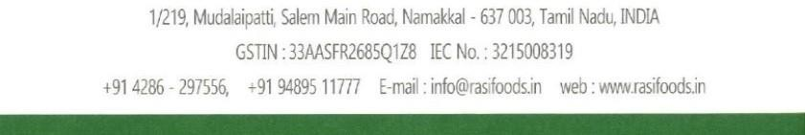
Proforma Invoice No:
037/26-27
P.o No:
Date :
Consignee Name
:
NESTO HYPERMARKET L.L.C
Address
:
Buyer (if other
:
NESTO HYPERMARKET L.L.C
than consignee)
:
Notify party
:
Address
:
Pre- Carriage by
Place of receipt :
Port of Loading :

Vessel/Flight No :
Port of discharge :
Final Destination:
Terms of payment
Country of final Destination:
$
Buyer's Order No
$
Marks & Nos
AIS
USD
CNF
1
x
40
'
EXPIRY DATE ( )
HSN CODE NO :
Amount chargeable (in words)
Total USD
USD
Bank Details
A/c Name : RASI FOODS
ermediate bank:
Int
A/C No : 17975500000264

Bank Name : FEDERAL BANK,
WIFT Correspon:
S
Branch : NAMAKKAL.
A/
c.No: ,
SWIFT : FDRLINBBIBD
Ro
uting Number:
Terms & Conditions:
Declaration
We declare that this invoice shows the actual price of the goods
Described and that all patriculars are true and correct.
Rasi Foodas reserves the right to cancel or
re-negotiate the order if the confirmation is delayed by 3 days
CONFIRMATION FOR PROFORMA INVOICE
Consignee Signatory
Exporter Signatory
WE HEREBY CONFIRM THE ABOVE PROFORMA
IN PRICE, BRAND,
Signature With Seal
Note : Kindly send us the stamped confirmation / purchase order - Valid for only 12 hours
Our Email ID : rasieggs@gmail.com, Contact person : Mr.T.Shanmugam, Contact No: +91 9488045777
TIN No: 33816306295 / CST No: 1329816 / GSTIN No:33AASFR2685Q1Z8

$

Y

a.. 4 % damages are normal for all EGG shipments
b.. We are not responsible for any demurrages & storage at the port of destination
c.. Any deviation in goods should be brought to our notice the moment containers are
discharged and destuffed.
d.. We are not be responsible for any claim due to following reasons.
Damages to goods when containers transported in trucks,When handled at the port by
cranes,Inconsistent cold chain after discharge of goods,
Goods are repacked by the buyers before distrubution,
CTNS

$

FEET REEFER
CONTAINER
Rate
Amount
USD
PACKED IN 30 EGGS IN A PAPER
TRAY 12 PAPER TRAYS IN ONE
EXPORT PAPER CARTON 360 EGGS
IN ONE EXPORT PAPER CARTON
FRESH WHITE SHEL
L TABLE
EN).
EGGS. (CHICK
1312
RASI
No. & kind of Pkgs
Description Of Go
ods
Quantity/No of
Container

100
% ADVANCE PAYMENT

TOTAL PAYMENT

SAME AS CONSIGNE

NAMAKKAL
BY SEA

PROFORMA INVOICE
037/26-27

TRN :
TRN :

