INTERNET OF THINGS-GROUP 4

**PUBLIC TRANSPORTATION AND OPTIMIZATION**

**STUDENT NAME :** A.KANIMOZHI

**REGISTER NUMBER:** 822621106007

**NM ID :** au822621106007

**COLLEGE CODE :** 8226

**COLLEGE NAME :** ARIFA INSTITUTE OF TECNOLOGY

**EMAIL ID :** kanimozhia49@gmail.com

**ABSTRACT:**

Public transport can play an important role in reducing usage of private vehicles by individuals which can, in turn, reduce traf*fi*c congestion, pollution, and usage of fossil fuel. But, for that public transport needs to be reliable. People should not have to wait for the bus for a long time without having any idea when the bus will come. Further, people should get a seat in the bus. To ensure this,

Efficientlyandaccuratelyschedulingandprovisioningofbusesisofparamountimportan ce.Infact, nowadays buses are scheduled as per the need. But these scheduling is beingdonemanuallyinIndia.Oursurveyshowsthattherearemanyalgorithmsproposedi n the literature for scheduling and provisioning of buses. There is a need to tailor these algorithms for Indian scenario. We present a brief overview of these algorithmsinthispaper.Wealsoidentifyopenissueswhichneedtobeaddressed.

INTRODUCTION:

Withanincreaseinpopulation, thedemandforpublictransportservicealsoincreases. This situation pushes the public transport infrastructure to its limits inpeakhours.Thishasleadtothelatearrivalsofpublictransportattheirscheduled

Arrival time, anddeparturetime.Thebestschedulingalgorithmis one which leads to the decrease in waiting time of passengers while maintainingthe capacity of the passengers in public transport. Hence, Iota is the most emergingtechnologywhichhasbeenusedbypublictransportservices.

As per the survey of researchers, it has been concluded that all the present systems which are based on transportation system provide the service of

Or displays bus status. In transportation system, it is also important to maintain the schedule of buses. But due to traf*fi*c and many more parameters, schedules get disturbed. Usually, passengers have to wait for the buses because of bad scheduling, overcrowding, traf*fi*c congestion, and breakdowns. Overcrowding occurs because of not determining the correct frequency for demand and improper scheduling. Frequency relates to the number of trips which are needed to cope up with the passenger demand during a peak or *fi*xed period. Hence, it is important to have exact traf*fi*c information to notify the exact arrival and departure timings of buses. This information can be available by using GPS [2]. Along with these, it is also important to schedule buses according to the requirements of the public. The solution is to develop ef*fi*cient scheduling algorithm which can schedule the busesautomaticallybyanalyzingthehistoricaldata.

There are many scheduling algorithms available such as priority, round robin, *firstcomefirstserve, lastcomefirstserve, andmuchmore.Butthesealgorithmsared* enveloped for operating systems. Algorithms like genetic algorithm [3],

Greedyrandomizedadaptivesearchprocedure (GRASP) [4], tripfrequencyscheduling, a ND vehicle routing problem are such scheduling algorithms which either schedule the vehicles or *fi*nds proper routes for buses.

These algorithms have the drawback in terms of a number of jobs or vehicles. There is a need of scheduling

Algorithm which can schedule buses as per the requirement of passengers on proper time and proper routes. Some algorithms use heuristics to calculate the parameters

And schedule it accordingly. But these heuristics require same number of jobs with the same number of resources. Hence, if we use these algorithms for scheduling

Of buses, it will require the same number of buses with the same number of routes.

Itbecomescompulsorytohavethesamenumberofparameters.Hence, itisnecessaryto develop such algorithm which can even schedule one bus. We can use assign-mint

Problem to assign buses for required route with heuristics to schedule the buses as per the requirement and reschedule the buses which are not required forth

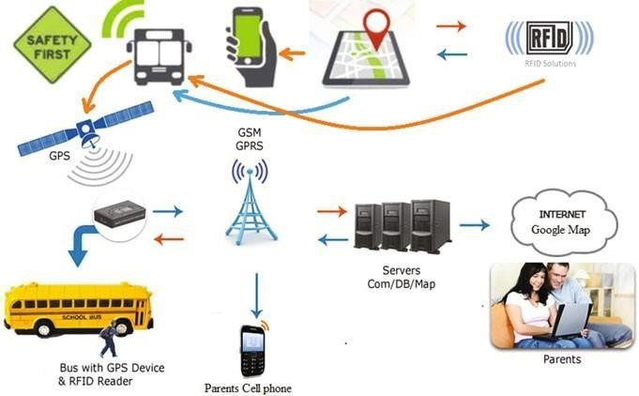

Tparticularroute.

Afuturescenarioofpublictransport

Figure 1 shows the present scenario of the public transportation system which uses RFID tags to track the public transport to have live data about the stops covered by the buses. It also uses GSM/GPRS to notify the passengers about the current status of buses. Servers are used from which data are fetched to notify the passengers. In more general, this system shows the school bus which is tracked using RFID tags and GSM/GPRS, and its status is noti*fi*ed to the parents so thattheirwaitingtimeatthestopsdecreaseswaitingunnecessarilyatstops.

AccordingtothePlanningCommission (2013) [5] survey, ithasbeenconcludedthat there is an increase in traf*fi*c of public transport as people refer it much for traveling. According to the survey, people prefer railways and roadways increasingly and it is expected to grow up to 11 percent and 7 percent per year, respectively. By this, it is expected that traf*fi*c could increase up to 16 factors by next 20years. Since it was about 7 to 8 factors in last 10 years, it is growing very fast.Hence, thisprovestheneedforpublictransportwhichshouldbescheduledaccording to the need. Figure 2 shows an increase in traf*fi*c in roadways and railwaysinbillionpassengerkilometer (bike).

Contribution

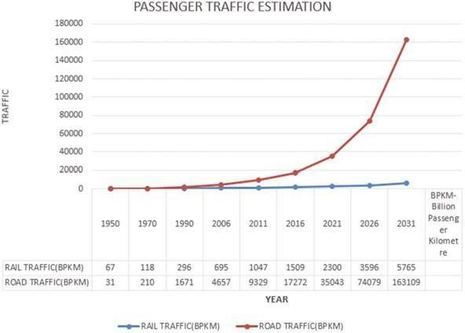

Owes:

Passengertraf*fi*cestimation

* Acompletetaxonomyofpublictransport, whichcanbefurtherclassifiedintogenerala ndselectiveapproach, isprovidedusingIoTasatool.
* Approachesusedforschedulingpublictransportareanalyzedwithrespecttoparamet ers, suchaspositioning, time.
* Finally, asystematiccomparisonofthevariouspublictransportsystemwithprosandc onsofeachisprovidedinthetext.

# Organization

Rest of the paper is organized as follows. Section 2 presents the similar work done by various researchers in this domain with tabular comparison of each approach. Section 3 provides the challenges and open research problems in this domain, and*fi*nally, Sect.4concludesthearticlewithfuturescope.

Literature Survey

This section provides the detailed description of the work done under this domain by various researchers.Wehavedividedthisdescription intotwocategories: generalized and selective. Next subsection explains each category in detail withprosandconsofeach.

# Generalized Approach

Since last few years, research has been carried out to develop the optimizationmodelswhichwillincreasetheconvenienceofpassengers, andonthebusma engagement side, bus operations are reduced. Depending on the approach for determining optimal solutions, the bus scheduling models studied so far can be class*if*ied into a number of types. These models use heuristics to calculate totaltraf*fi*ccost.

Fu et al. [6] proposed a new operating strategy in which service vehicles is followed by the lead vehicle with all stop service and also by providing the facility to skip some stops as an express service. Chen [7] measures bus service reliability, vehicle load capacity, by considering the headway adherence and average waiting time. Yan proposed a network flow problem using a mathematical model which uses Lagrangian relaxation. Kim et al. [8] constructed a schedule based on the starting point and stops by using travel time response model for critical scheduling areas.

*Selective Approach*

Vehicle Routing Problem In vehicle routing problem with time window, a numberofvehiclesareallocatedtorouteandeachwithgivencapacitywhichislocatedatas ingledepotwhichisservingpassengersdispersedgeographically.Inthisproblem, eachp assengerhasbeengiventhedemandandtheymustbeservedinspeci*fi*ctimewindow. The main objective of this problem is to minimize the total cost of traveling while serving the customers with minimum cost. Figure 3 shows the vehicle routing problem (VRP), and how a route is set up from base depot to each stop reducing the traveling cost. It reduces the path cost by setting the optimized route between stops from one station to other from depot. The main objective of VRP isasfollows:

1. Itminimizestheglobaltransportationcostbasedonglobaldistance.
2. Minimizesthenumberofresourcesneededtoserveallcustomers.
3. Variationintraveltimeandvehicleloadisleast.

OnlineDial-A-

RideProblemwithTimeWindow(DARPTW)Routingandscheduling of buses can be referred as a On-line-Dial-A-Ride problem [7]. It takescare of the available set of resources and constraints. All the services related to thetransportation is Webbased and handled by mobile phones. Here, request is gen-erated one day prior to the beginning of service. Due to a high number of

variablesinvolvedinit,thesolutionsavailablearebasedonheuristics.IntheOnlineDial- A-RideProblemwithtimewindows(ODARPTW)[9]requestsareexhibited

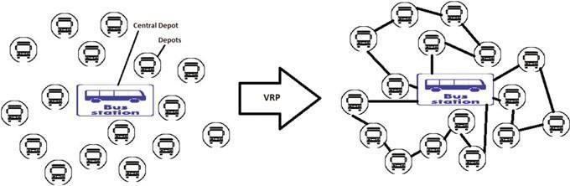 after some time, requiring the server to convey the articles from sources to destination, while the server is en-route for serving the different request. On the offchance that a demand is to be served, the server must achieve the time between thedemand’s landing and its due date. The objective here is to plan techniques for theserver to *fi*ll in whatever number of approaching requests as could reasonably beexpected by their due dates in an on-line way. The system for ODARPTW neitherhas data about the discharge time of the last demand nor has the aggregate numberofrequest.Itmustdecidetheconductoftheserverataspeci*fi*cminuteoftimeasanel ement of the considerable number of request discharged up to time *t* (and thepresenttime*t*).Interestingly,adisconnectedtechniquehasdataaboutallrequestsinthe entiresuccessionasofnowattime0.

Assignment algorithmic operation research method to optimize the cost. Itdealswiththetransportationproblemandtheassignmentofjobstotheworkersorassign mentofresourcestotheworkers.Theultimateobjectiveishowtoassign the jobs ef*fi*ciently to the workers, and which worker should be assigned which type of job. In this problem, at least 3 3 matrix is required and also the same number of × parameters. Assignment problem uses heuristics, in which theoperatingcostof the system can be maximized or minimized. If we are adding any constant in each and every element of columns and rows of the matrix, then

Itwillgenerateamatrix, whichcanminimizethetotaleffectiveness.Asituationalso exists, where we need to add a dummy column or a row when there are no exact number of resources, and jobs. The main disadvantage of this algorithm is number of jobs must be equal to the number of workers or else allocation of jobswillnotbeef*fi*cient.

The data flow diagram of assignment algorithm is discussed below in Fig. 4. This diagram shows how assignment algorithm works with its two conditions. In assignment problem, basically there are two situations: First, when the number of cutting lines is equal to the number of rows and columns, and second, when thenumberofcuttinglinesisnotequaltothenumberofrowsandcolumns.

Table 1 represents the summary of the whole survey. In the table, there are four columns. The *fi*rst column is the name of author, second is the algorithm/method they have used for implementation, third is what are the pros of paper, and thefourthoneiswhatcanbeadded/improvedorconsinpaper.

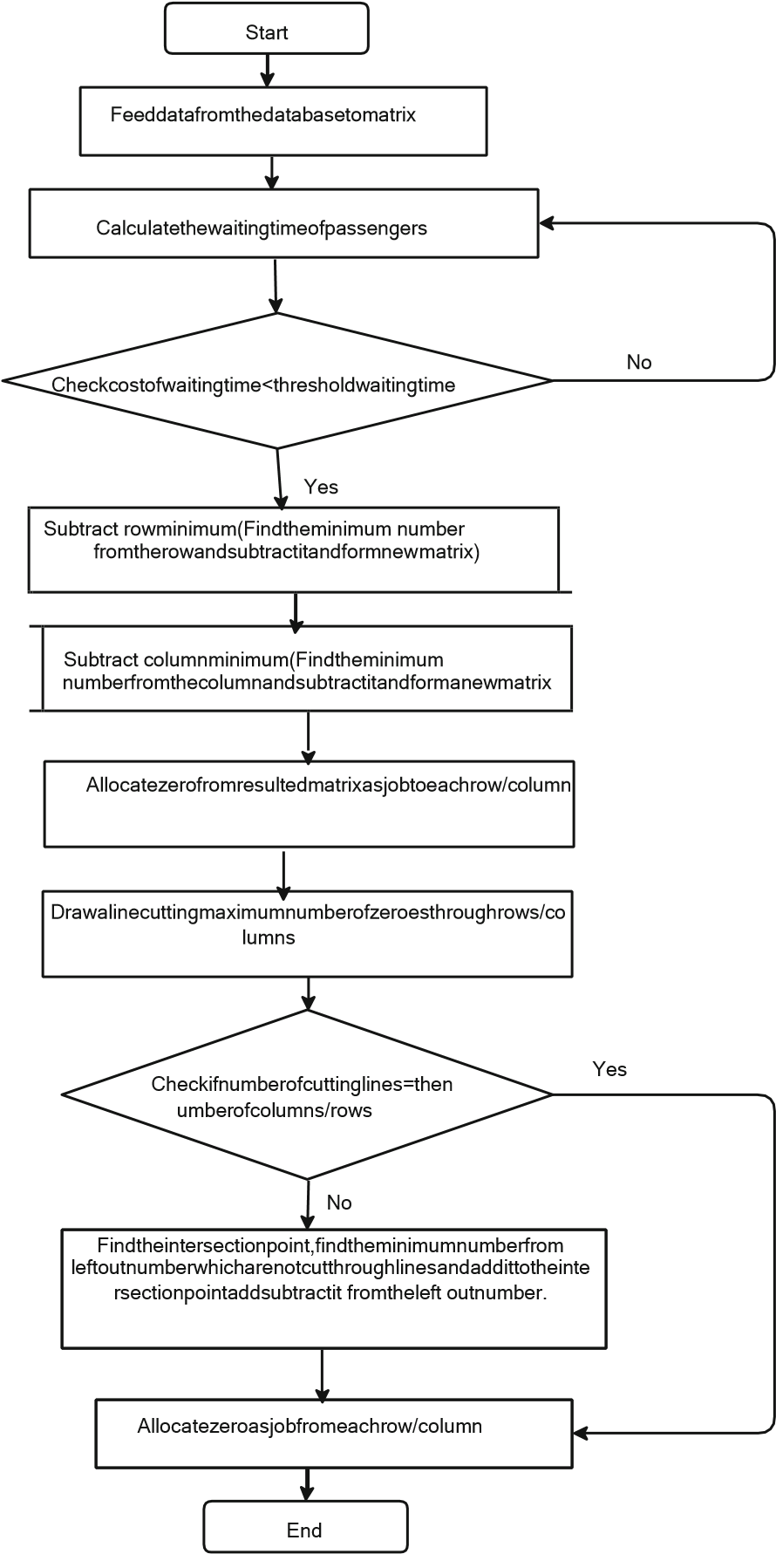Assignment algorithm

ChallengesandOpenResearchProblemsinScheduling

PublicTransport

In existing public transportation systems, passengers need to register compulsoryfortraveling.Schedulingoftransportationserviceislimitedforthelimitedre sources.Schedulingofpublictransportisnotmuchef*fi*cientasitrequiresaccuratedata on traf*fi*c. Due to this, the waiting time of passengers increases.

Passengersusedtotravelinpublictransportmostlyinpeakhours.Therefore,

inpeakhours duetononexistenceschedulingmechanism, passengersincreasebeyondthecapacityofp public transport. As capacity of public transport increases, the counting of passengers in the existing system is not ef*fi*cient. Waiting time of passenger’s increases at stops in peak hours that is in morning and evening which increases traf*fi*c infuses. Hence, there is a need to develop an ef*fi*cient and accurate system forschedulingandprovisioningofbusesdynamicallybasedoncurrentdemand.

Publictransportshouldprovidesafetraveling, cheapfare, andlesstraveltime.Inordert oachievetheseattributes, govtmustfocusonroadnetwork, optimalrouting, and minimum delay. Public transport ef*fi*ciency depends upon all other related factors, i.e. optimization of route, transfer optimization, and coordination amongfeederbusservice.