INITIAL OUTPUT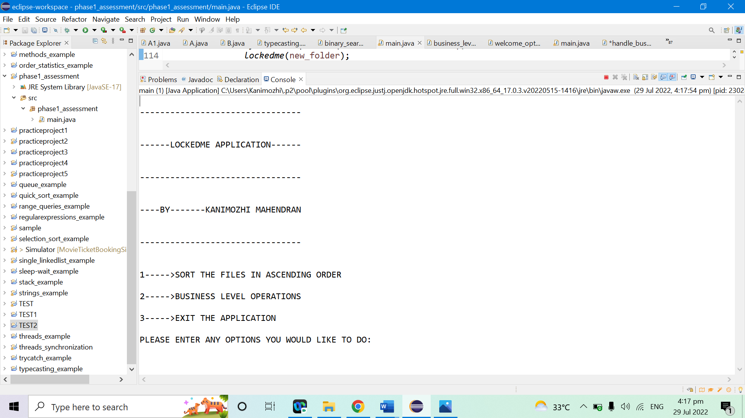

SORTING THE FILES IN ASCENDING ORDER

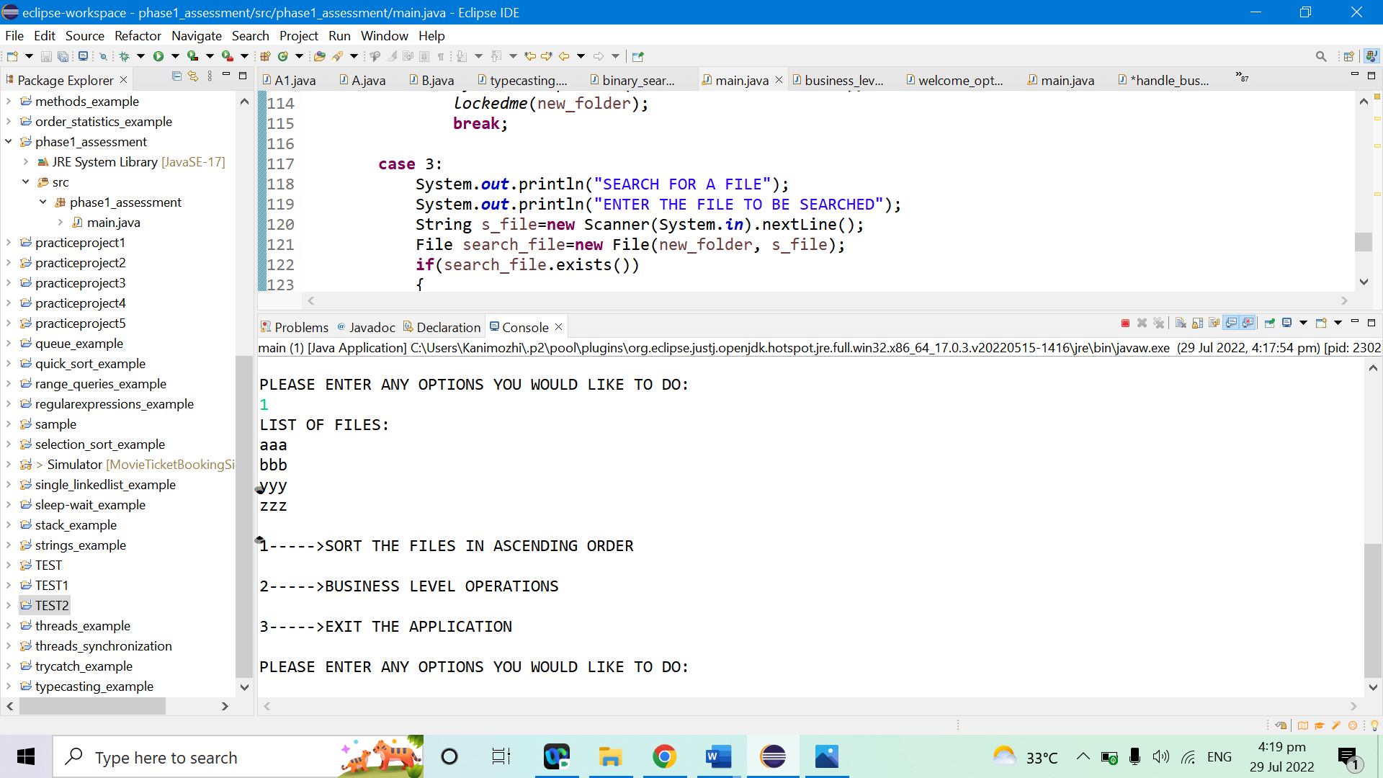

SHOWING BUSINESS LEVEL OPERATIONS MENU

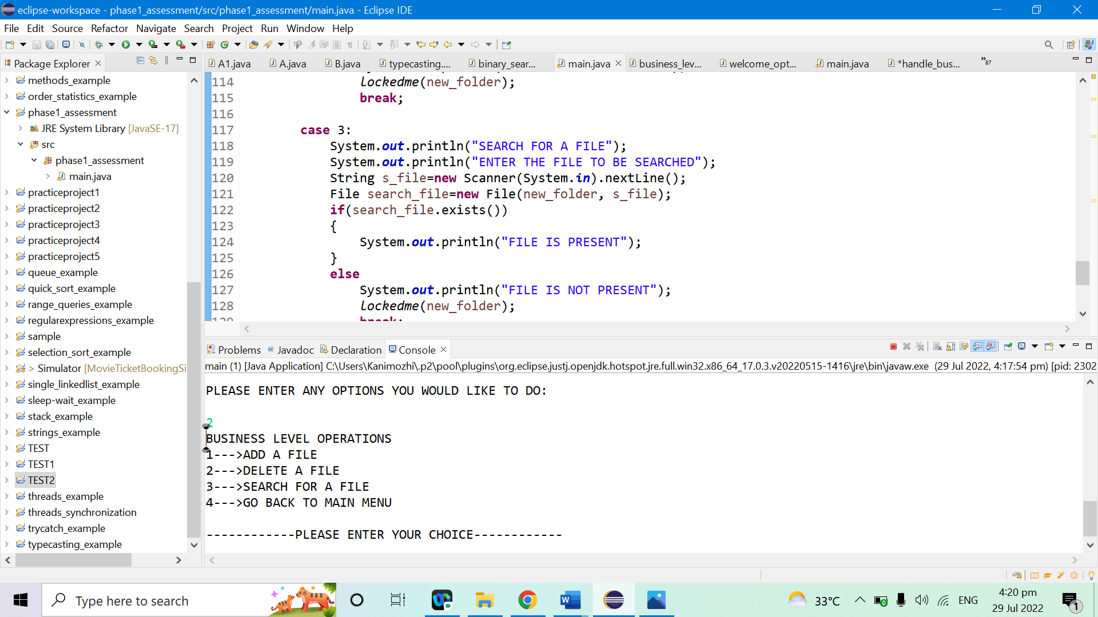

ADDING A FILE

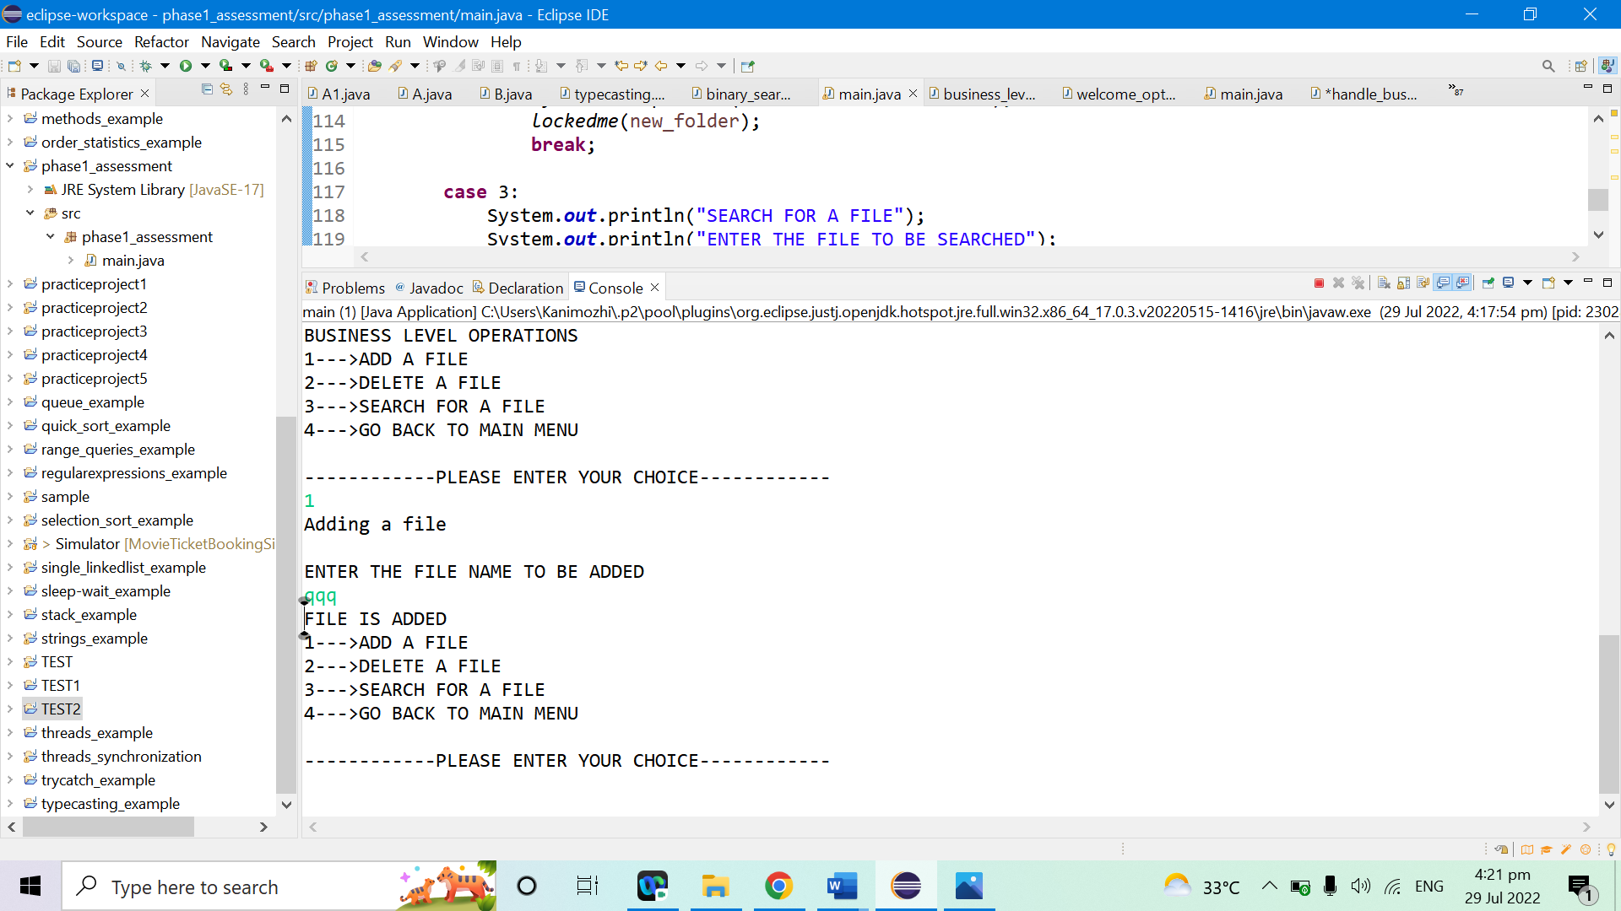

ADDING A FILE WITH FILE NAME ALREADY EXISTS IS NOT POSSIBLE

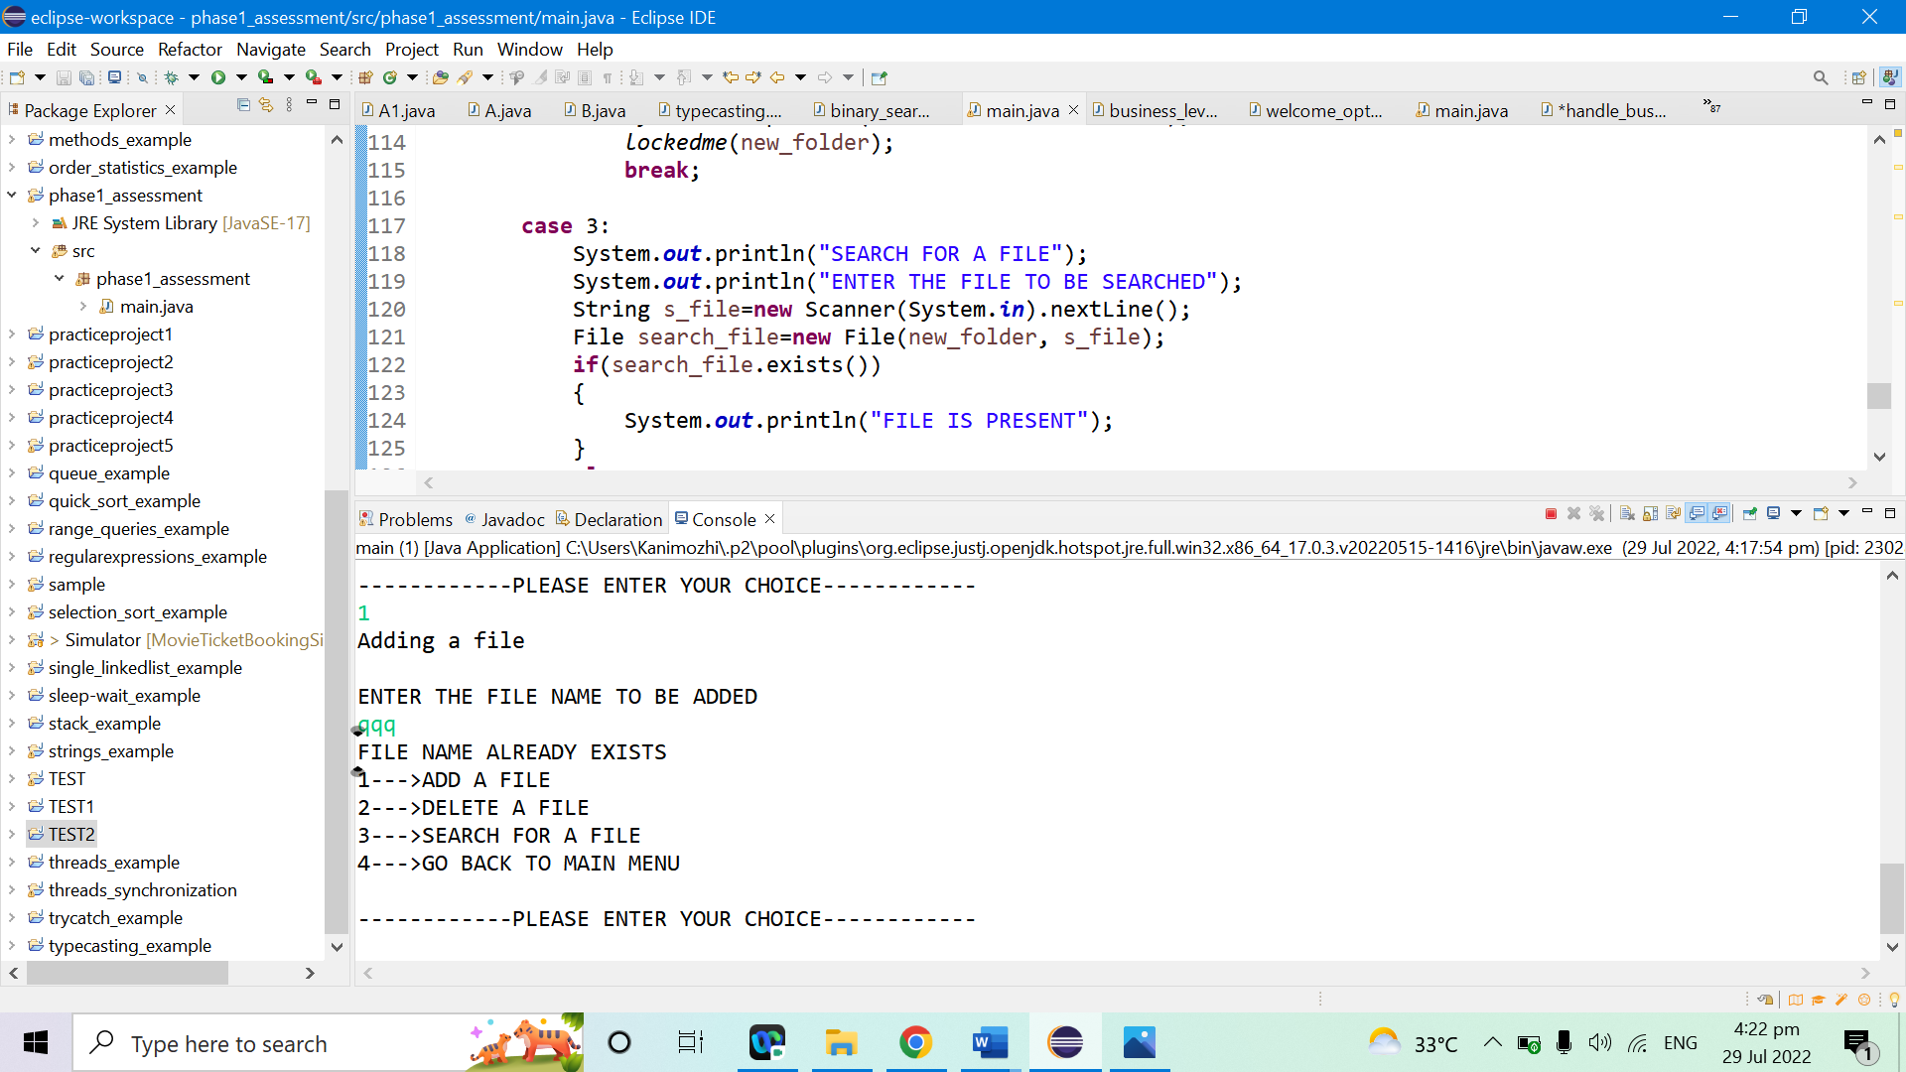

DELETING THE FILE (yyy)

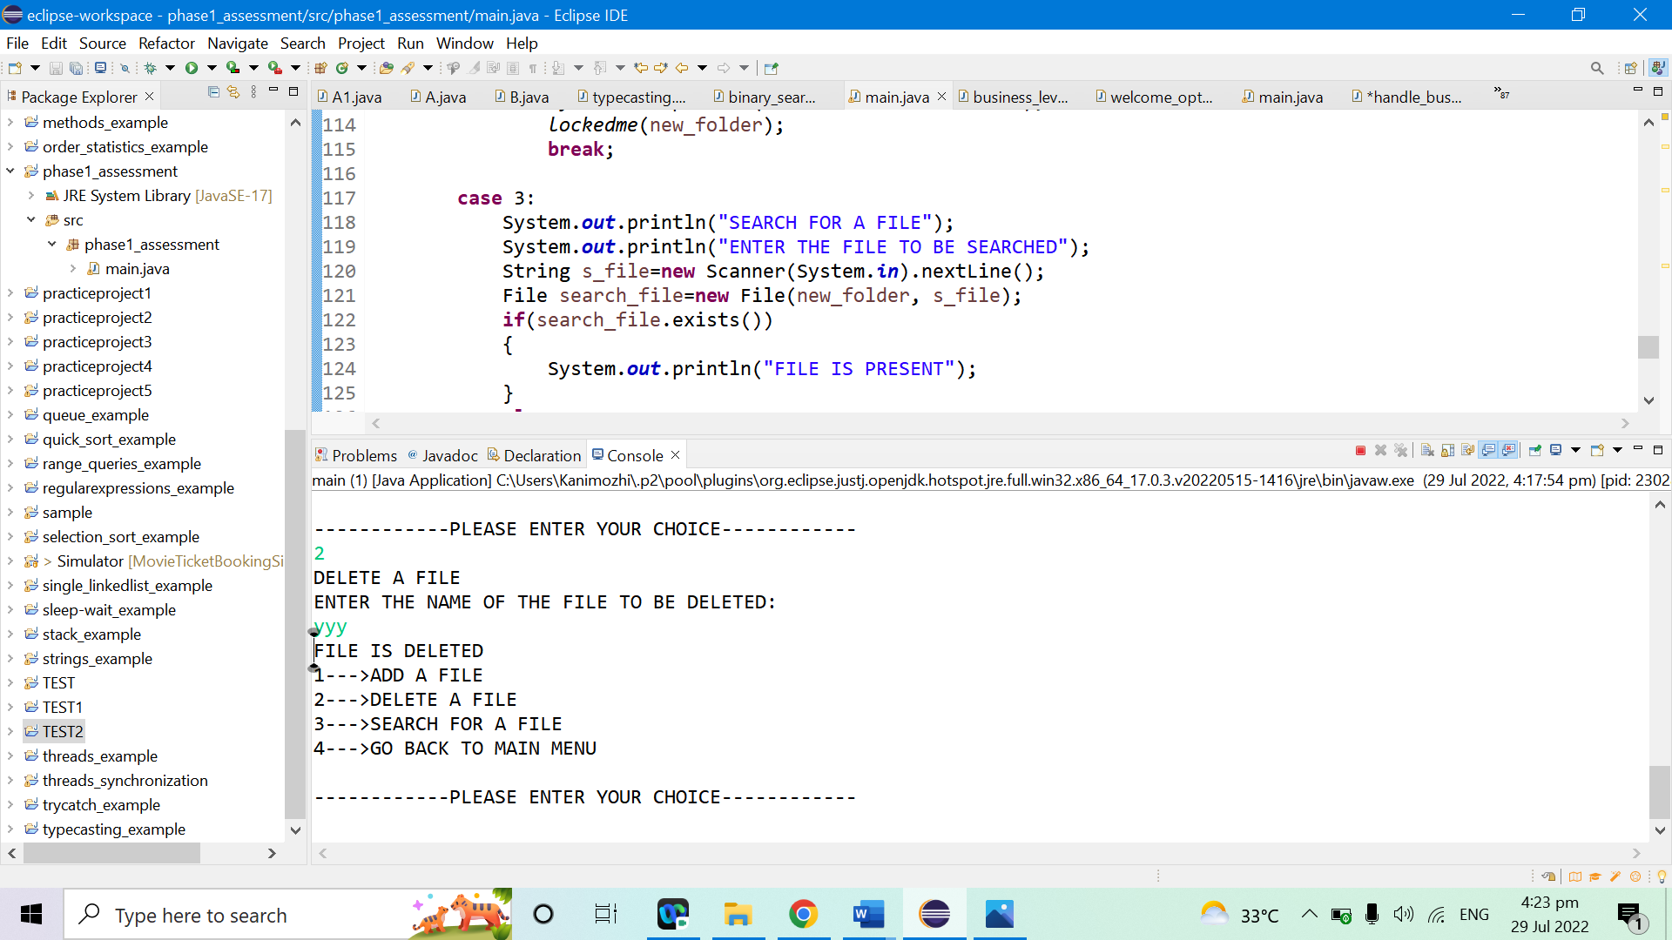

SEARCHING FOR A FILE

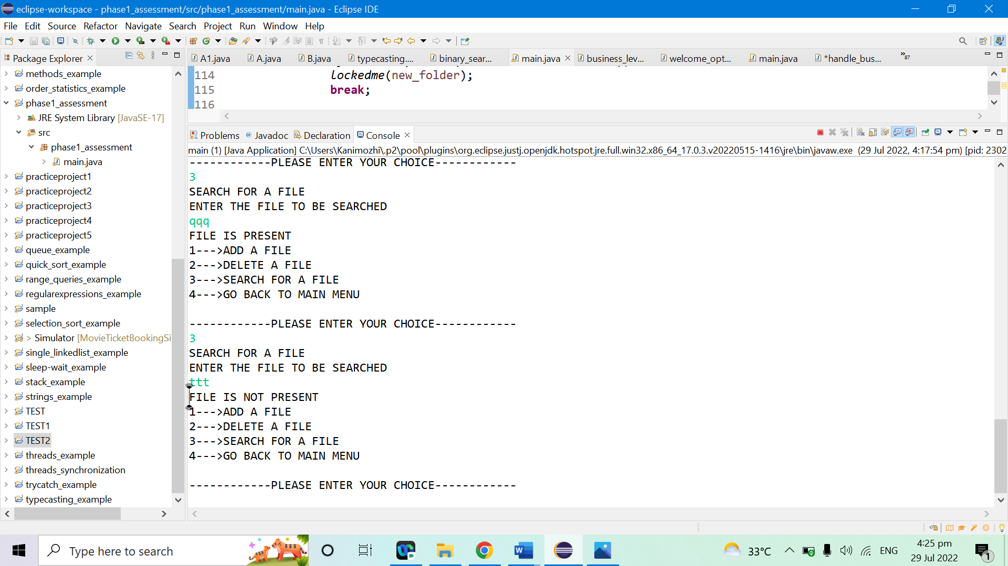

GOING BACK TO MAIN MENU

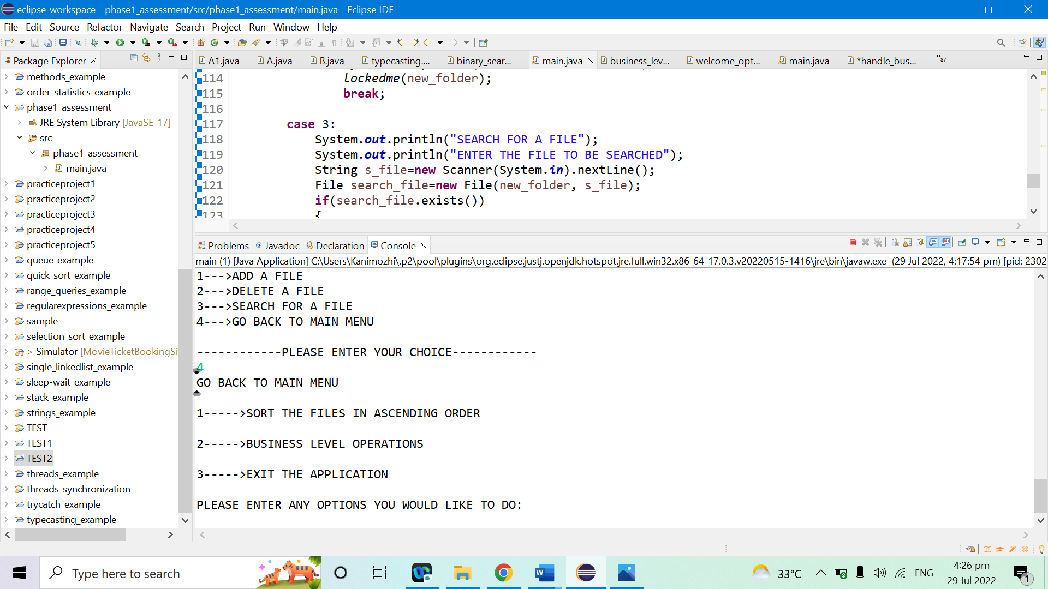

EXITTING THE APPLICATION

