Tasks Clause & Operators:
1. DISTINCT VALUES:
* A query to retrieve distinct salaries from the Employees table.
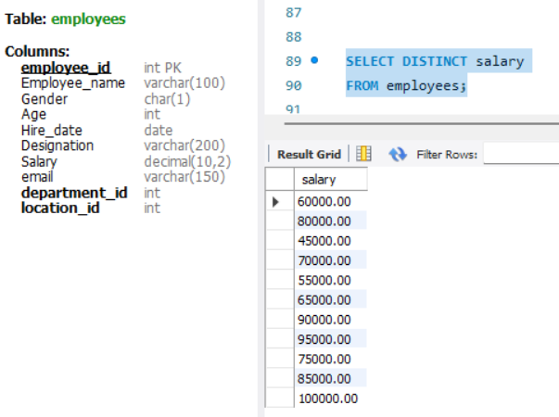
2. ALIAS (AS):
* Provide aliases for the "age" and "salary" columns as "Employee_Age" and "Employee_Salary", respectively.
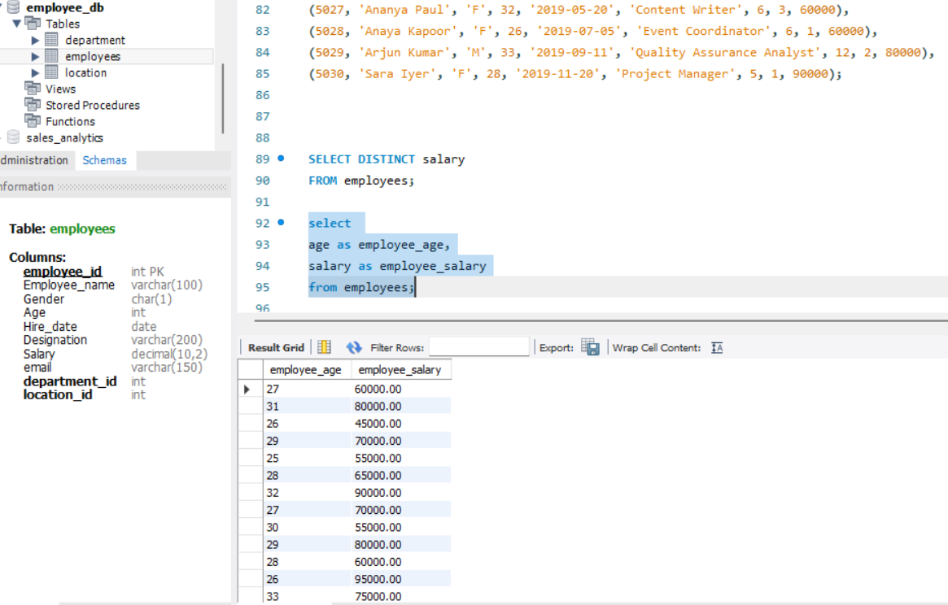
3. WHERE CLAUSE & OPERATORS:
* Retrieve employees with a salary greater than ₹50000 and hired before 2016-01-01.
* Find the employee whose designation is missing and fill it with "Data Scientist".
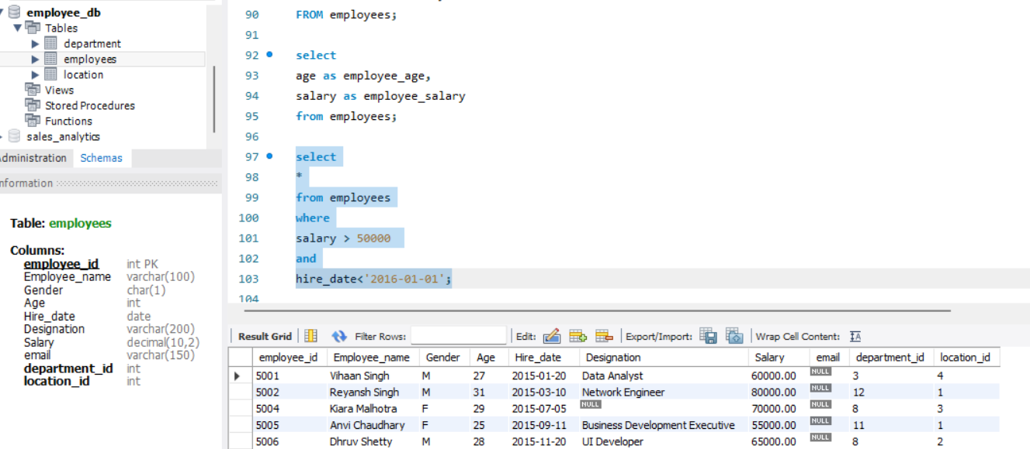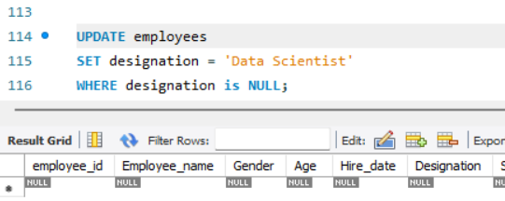
Sorting and Grouping Data:
1. ORDER BY:
Find employees sorted by department ID in ascending order and salary in descending order.
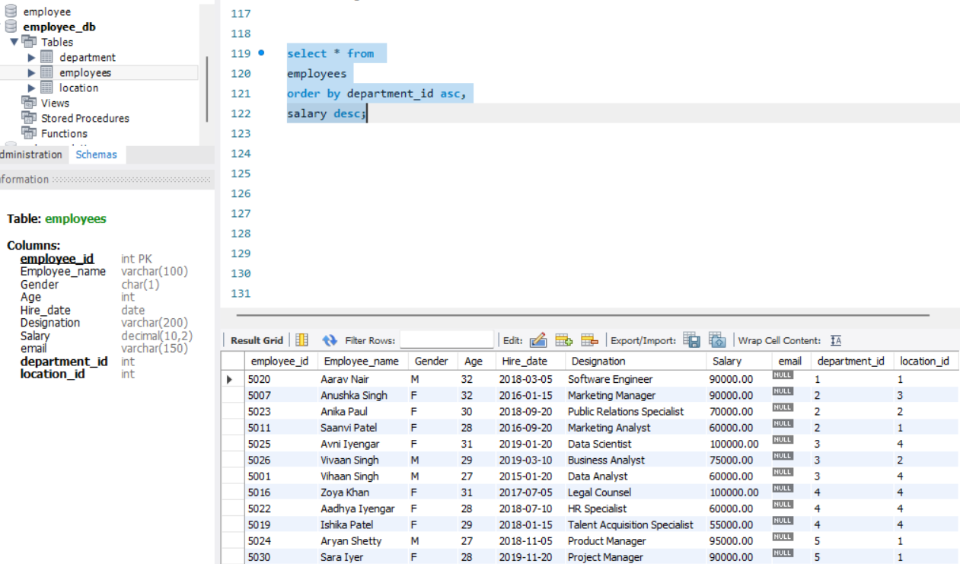
2. LIMIT:
Display the first 5 employees hired in the year 2018.
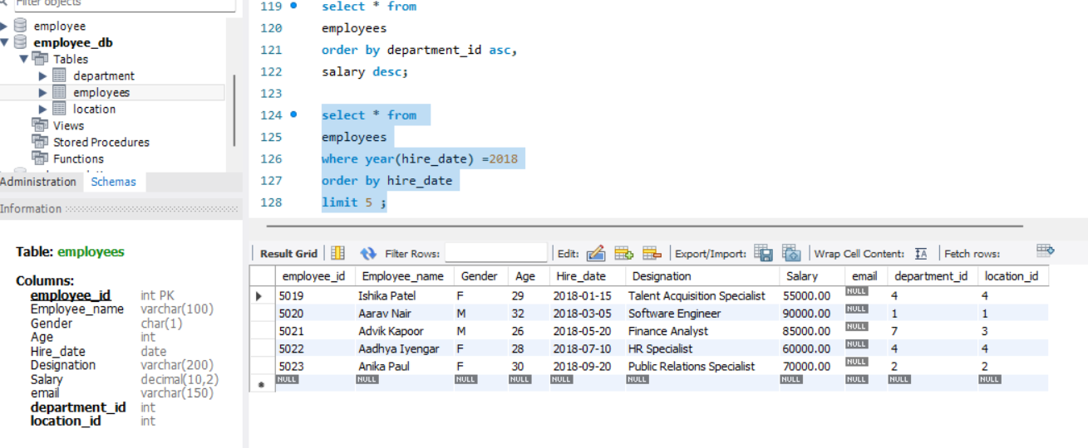
3. AGGREGATE FUNCTIONS:
● Calculate the sum of all salaries in the Finance department.
● Find the minimum age among all employees. 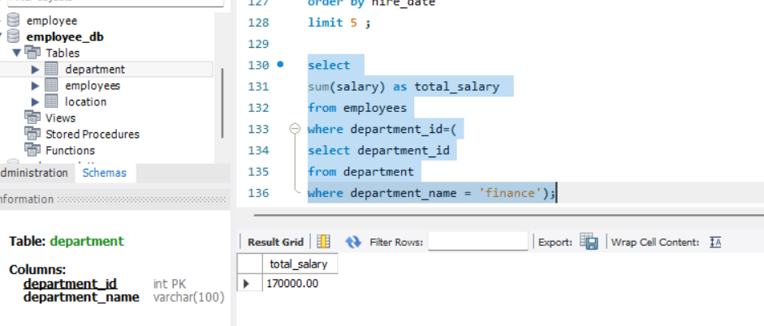
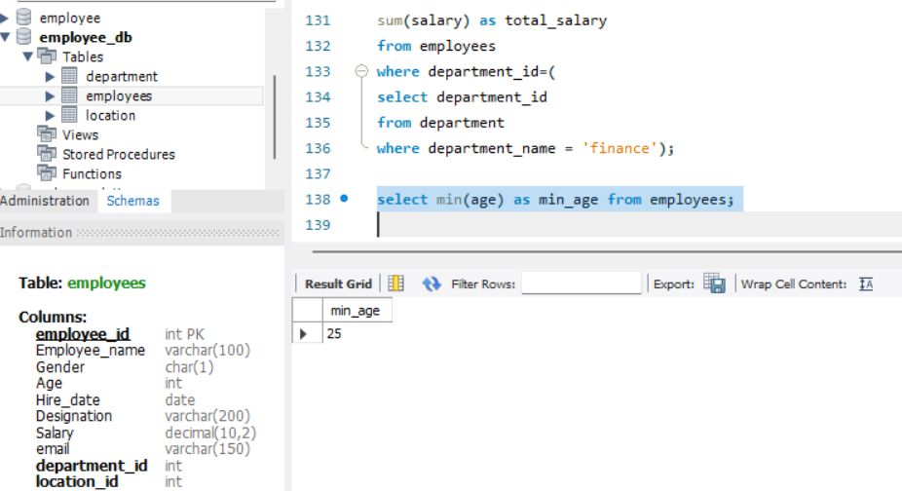
4. GROUP BY:
● List the maximum salary for each location.
● Calculate the average salary for each designation containing the word 'Analyst'.
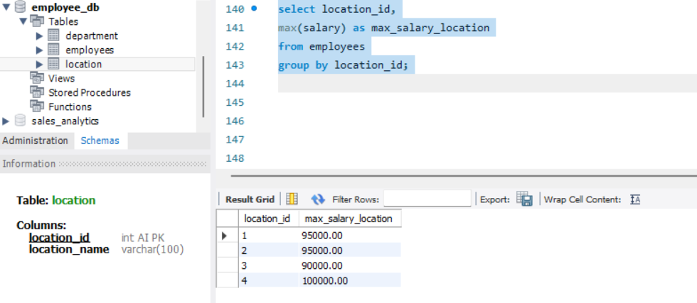
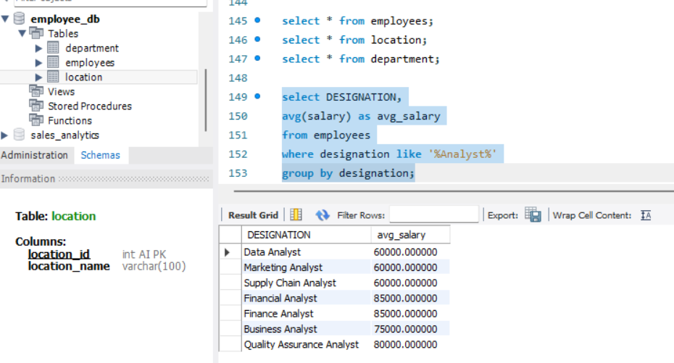
5. HAVING:
● Find departments with less than 3 employees.
● Find locations with female employees whose average age is below 30.
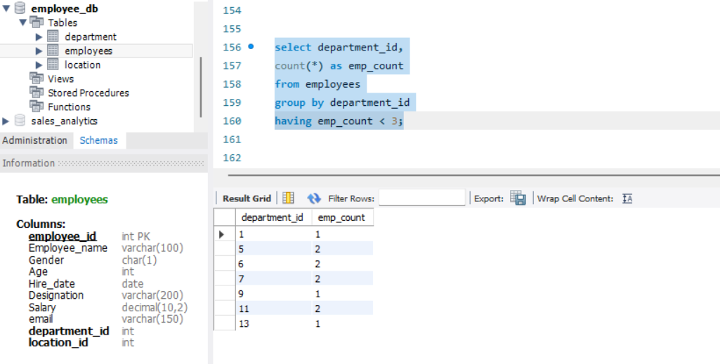
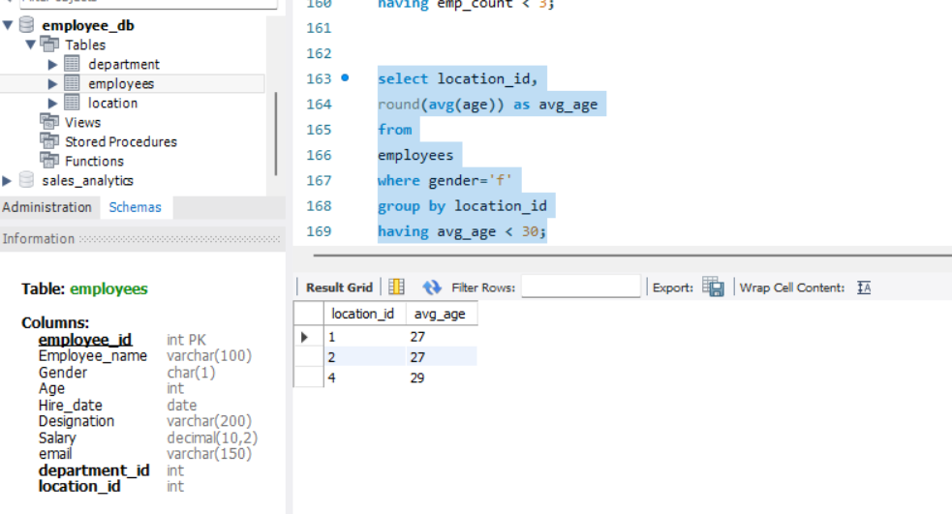
Joins:
1. INNER JOIN:
List employee names, their designations, and department names where employees are assigned to a department. 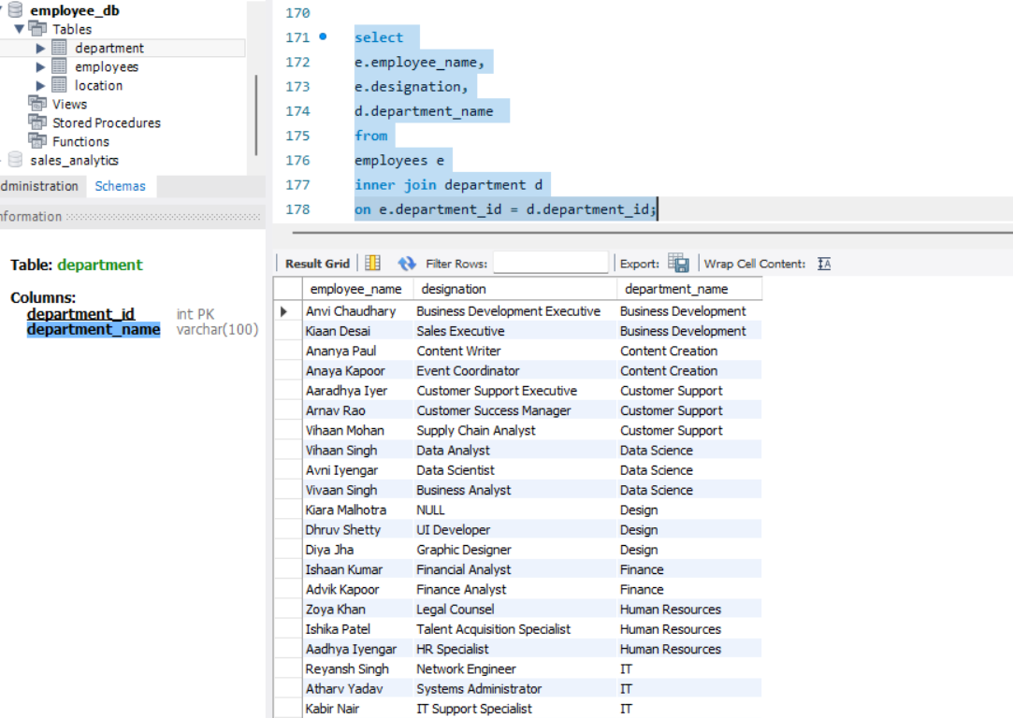
2. LEFT JOIN:
List all departments along with the total number of employees in each department, including departments with no employees.
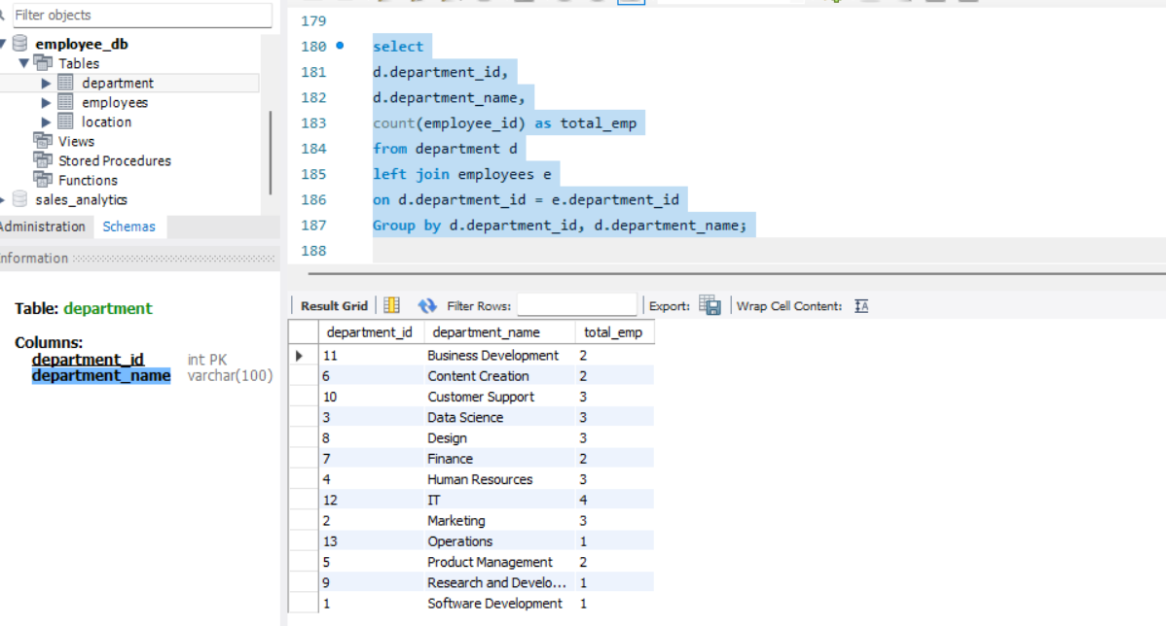
3. RIGHT JOIN:
Display all locations along with the names of employees assigned to each location. If no employees are assigned to a location, display NULL for employee name.
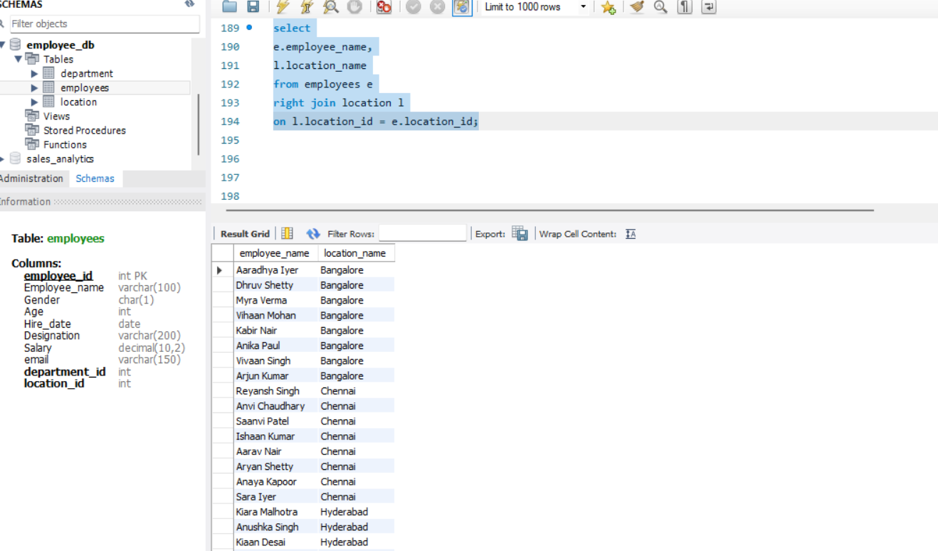
4. CROSS JOIN:
Show all possible combinations of departments and locations.
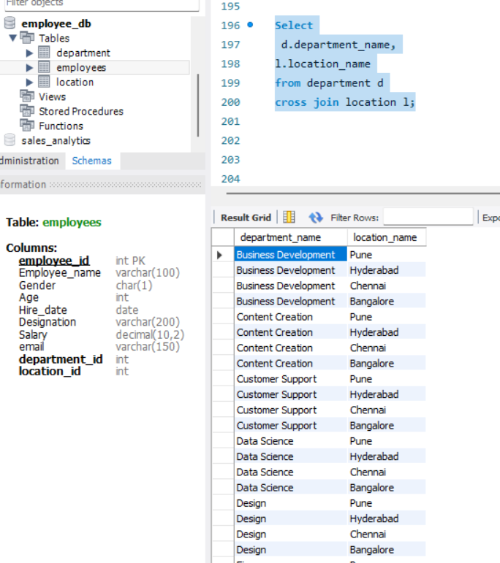
5. SELF JOIN:
Show pairs of employees working in the same department, excluding self-pairs.
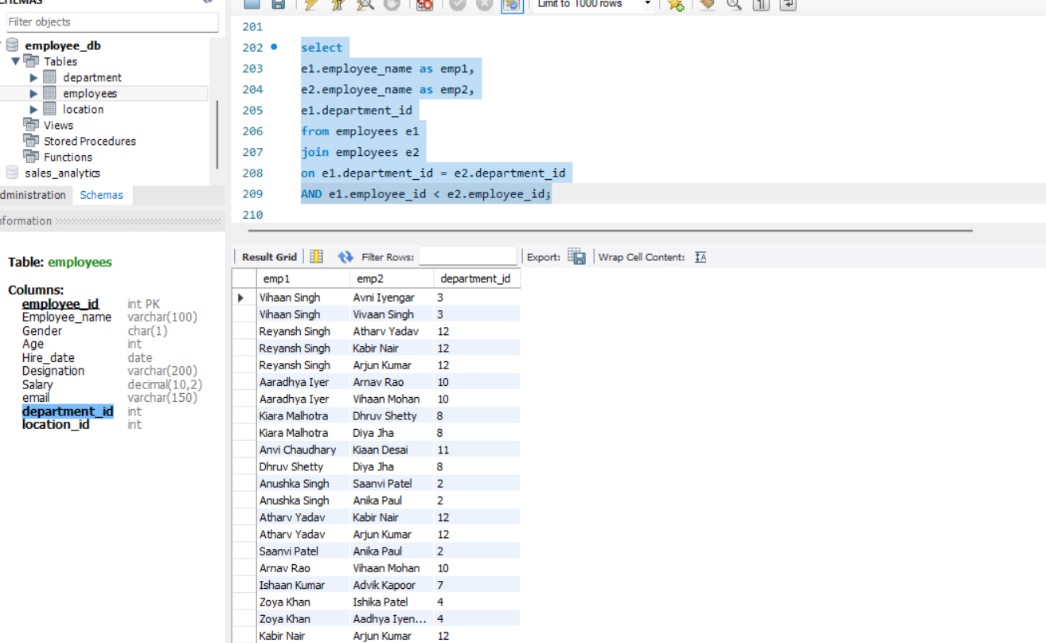
Windows function
● Write a window function query to rank employees by salary using rank().
● Write a window function query to rank employees by salary within each department using DENSE_RANK()
● Write a window function query, Running total salary by department
