Product Design
Team | Demand Forecasting of Air Conditioning for Commercial Complex, Team 12 and Akshat Goyal, Kanish Anand, Nikunj Nawal and Sridhar M

Design Overview

Architectural design
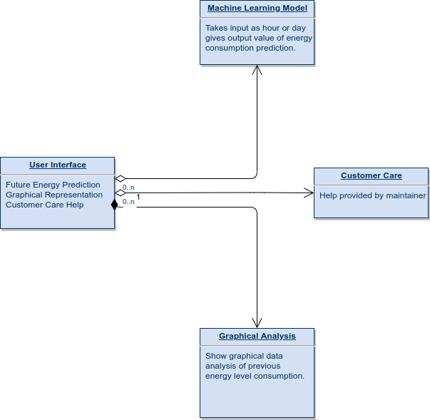

System interfaces

User Interface

1. User will be able to input any hour of the day and predict the energy consumption during that hour of the day.

2. User will be able to see various graphical representations of the data of past energy consumption so as to see the past usage of consumption of electricity in complex.

3. User will be able to get any kind of help from the maintainer using the webapp.

APIs
Not Applicable

Model
We will update the information regarding the Model and the Classes as we proceed with the code writing for the project.

Sequence Diagram(s)
UML sequence diagram for the agreed significant use cases (about 4 major use cases).
While you may reference an external file here, most instructors strongly prefer embedded images, or, failing that, external files in generic formats such as JPEG, PNG or PDF.

Design Rationale
This is a running list of issues that arise as your design process proceeds. This is an important section of the design document as it captures the thought process of the product's designers. It includes why or why not (rejected solutions) a design decision was made and supports future changes to the product. It should be updated whenever a design change occurs.

It is RARELY the case that the first design you consider is the best one that you can come up with that meets the requirements and that can be implemented, tested, and delivered on schedule. Your instructor will be looking for signs that you considered at least a few approaches, and that you had a coherent rationale for preferring the design your team eventually adopts.
This is the place to record such thoughts – what alternatives did you consider? What are the strengths (and deficiencies) of the final design compared to the other alternatives considered? Why did you select the approach you finally chose? This last question should be answered with an eye to the tradeoffs inevitably involved in creating an appropriate design.

