Product Design
Team | 23; Manas Kabre, Naman Baheti, Maheshwara Rao, Yeshwanth Baliwada

Design Overview

Architectural design
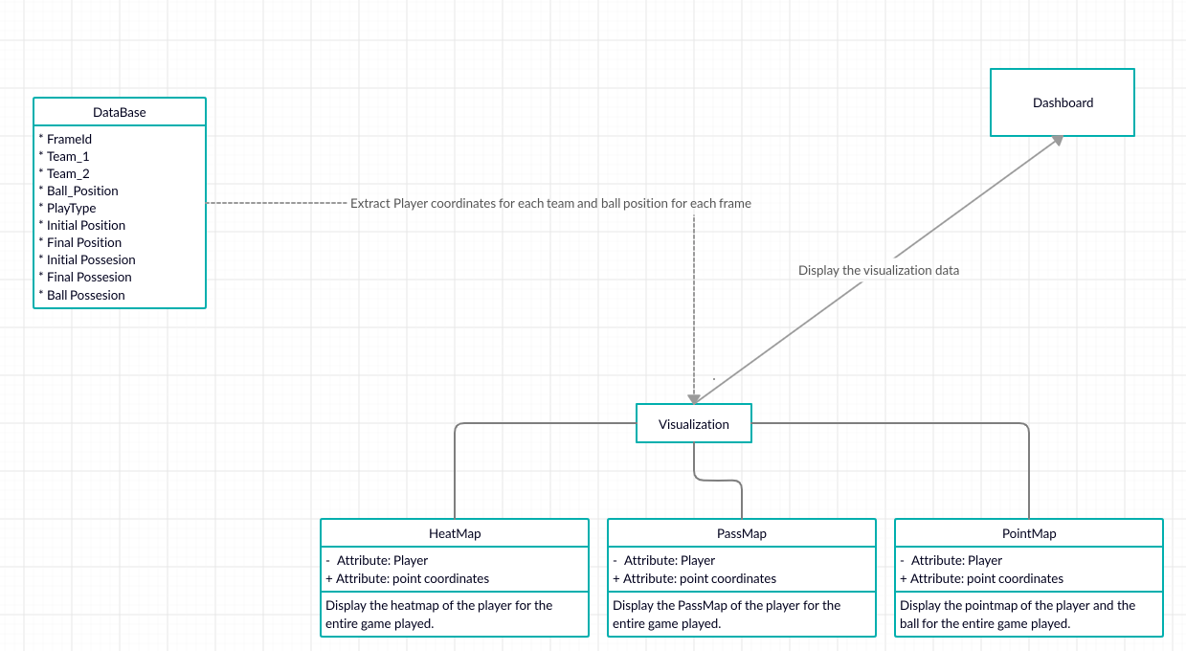

System interfaces

User Interface
User will be able to switch between different players and teams to view their statistics in their preferred forms like heatmap, pointmap, etc. User can get detailed analytics of the match like all passes, ball possessions, etc.
iuahgszfghjo’fglpfdjgviudfshgvip

Model
Class - 1 | TBD
Class - 2 | TBD
.

Sequence Diagram(s)

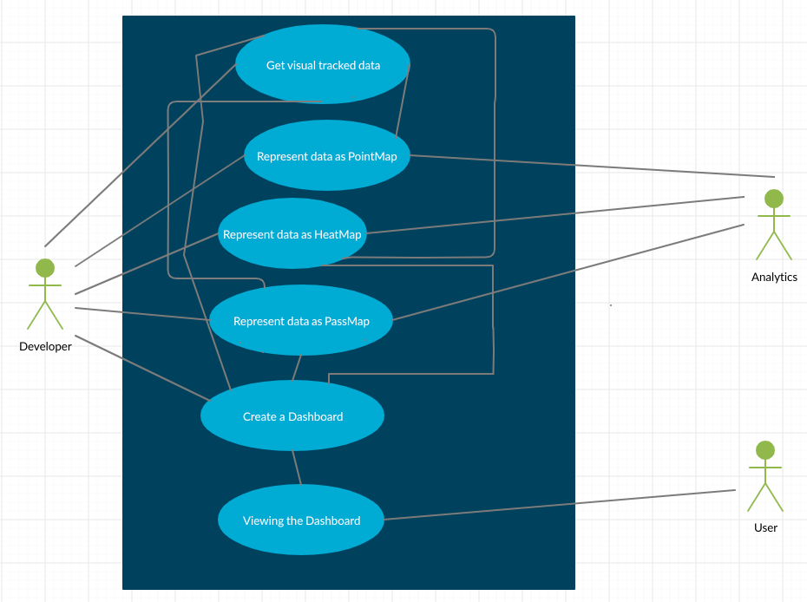

Design Rationale

