**Product Design**

|  |  |
| --- | --- |
| **Team** | Demand Forecasting of Air Conditioning for Commercial Complex, Team 12 and Akshat Goyal, Kanish Anand, Nikunj Nawal and Sridhar M |

# **Design Overview**

## **Architectural design**

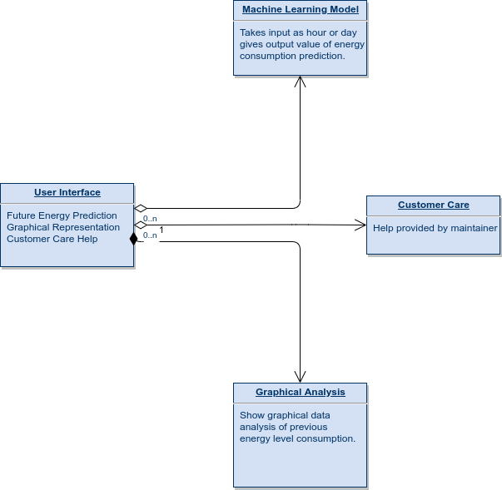

## **System interfaces**

### **User Interface**

* + 1. 1. User will be able to input any hour of the day and predict the energy consumption during that hour of the day.
    2. 2. User will be able to see various graphical representations of the data of past energy consumption so as to see the past usage of consumption of electricity in complex.
    3. 3. User will be able to get any kind of help from the maintainer using the webapp.

### **APIs**

Not Applicable

## **Model**

We will update the information regarding the Model and the Classes as we proceed with the code writing for the required project.

# Sequence Diagram(s)

# 

# **Design Rationale**

This part of the document will be updated as we proceed with writing of the code and will be updated whenever any changes will be made in the code of our project.