Product Design

|  |  |
| --- | --- |
| **Team** | 12; Akshat Goyal, Kanish Anand, Nikunj Nawal and Sridhar M |

# D Aesign Overview

## Architectural design

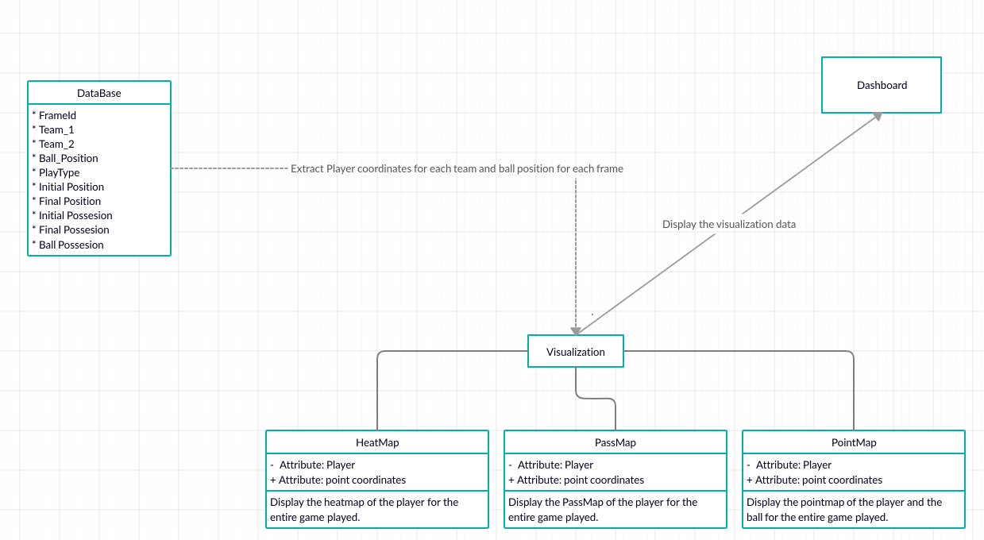

## System interfaces

### User Interface

User will be able to switch between different players and teams to view their statistics in their preferred forms like heatmap, pointmap, etc. User can get detailed analytics of the match like all passes, ball possessions, etc.

## Model

|  |  |
| --- | --- |
| Class - 1 | TBD |
| Class - 2 | TBD |
|  |  |

.

# Sequence Diagram(s)

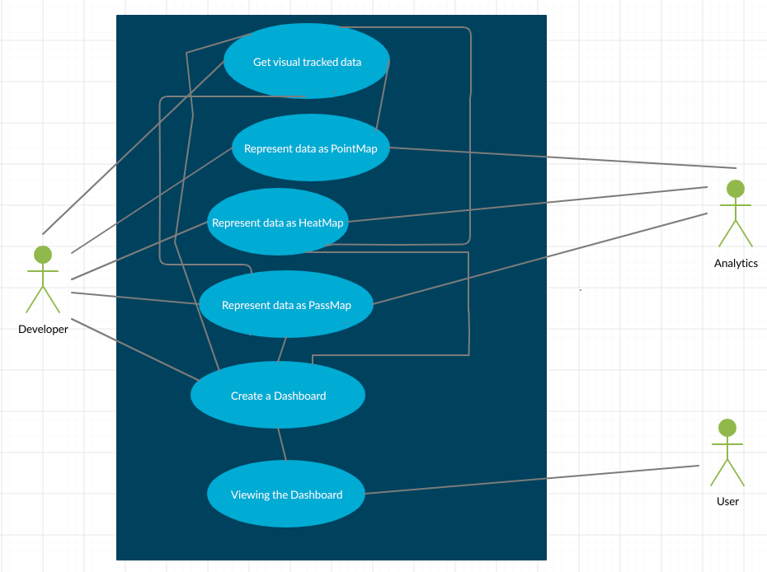

# Design Rationale