**Software Requirements Specification (SRS) Document**

|  |  |
| --- | --- |
|  | Demand Forecasting of Air Conditioning for Commercial Complex  Team 12  Akshat Goyal, Kanish Anand, Nikunj Nawal and Sridhar M |

# Brief problem statement

Given the energy consumption data of any building, we have to estimate the future energy demand of the complex on an hourly and daily basis. We are supposed to create a web application for the same problem statement.

# System requirements

# Frontend - HTML, CSS , JavaScript, React

# Backend - NodeJS

# Database - MongoDB

# Machine Learning - Python3, Mathematics and ML libraries

# Cloud Hosting - Azure or AWS (NOT NECESSARY FOR THE PROJECT)

# API - Open Weather API

# Users profile

# The different users (wrt a particular complex) who would be using the software include :

|  |  |  |
| --- | --- | --- |
| S.No. | USER | Description |
| 1 | Owner | The Owner will have full access to the product, will be familiar with using the software and can monitor the energy consumption rate, generate reports and act accordingly. |
| 2. | Finance Team | The Finance team will use future energy consumption to plan expenditure and predict the cost of electricity. |
| 3. | Maintenance/Tech Team | The Maintenance team will ensure the maintenance of the software with the changing system environment and will provide updates. |

# Feature requirements (described using use cases)

|  |  |  |  |
| --- | --- | --- | --- |
| **No.** | **Use Case Name** | **Description** | **Release** |
| 1 | Prediction of energy consumption with Notebook without UI. | Users can get the prediction of hourly and daily energy consumption by using the Jupyter Notebook. Functional Web-app not included | R1 |
| 2 | Graphical Analysis of the energy consumption | Users can get a graphical analysis of energy consumption. | R1 |
| 3 | User Interface | The users will be accessing the WebApp on a web browser. A responsive user interface will be designed to provide various functionalities. | R2 |
| 4 | Login | Different type of users can log in to access pages customized to their needs | R2 |
| 5 | Check consumption | User can check their energy consumption rate in tabular or graphical form | R1 |
| 6 | View weather | Users can view current weather status on the home screen.  Users can view the current temperature requested from API. | R2 |
| 7 | Energy Prediction | Users can select the time for which they want the predicted data. | R1 |
| 8 | Budget Prediction | Users can select the time range for which they want the energy predictions for the budget prediction. They will get total energy expected to be consumed. | R2 |
| 9 | Anomaly detection | Users can check whenever consumption statistics didn’t go as predicted. | R2 |
| 10 | Notifications option | Notifications will be sent to the user in case of high energy consumption. Users can opt for notifications via email | R2 |
| 11 | Fetching the current energy consumption | The system will fetch the current energy consumption of the building to improve the model and will keep the statistics of past energy consumption. | R2 |
| 12 | Customer Services/Queries | The user can ask the queries in case of any trouble. | R2 |
| 13 | Register | User has to register before using the system | R1 |
| 14 | View user | The owner can view all the users | R1 |
| 15 | Update profile | The user can update details of his account | R2 |
| 16 | View live update of graphical analysis | The user can see the updates live(based on fetching speed) on the graph | R2 |

**Use case diagram**

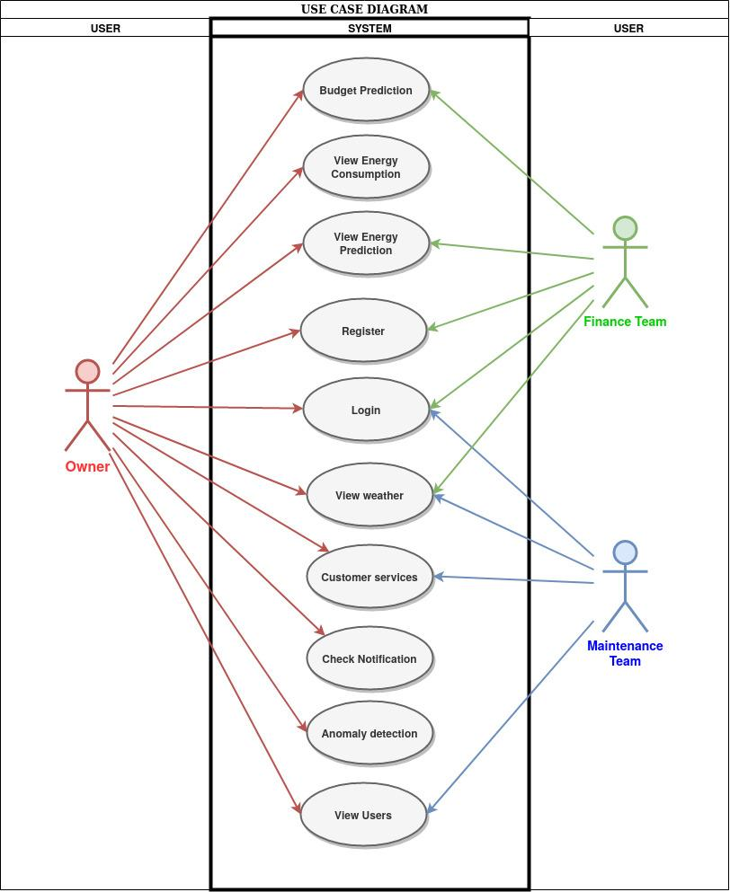

**Use case description**

|  |  |
| --- | --- |
| **Use Case :** | 1 |
| **Use Case Name:** | Real-Time Prediction of hourly or daily energy consumption with Notebook without User Interface. |
| **Overview:** | Users can get the prediction of hourly and daily energy consumption by using the Jupyter Notebook. This can be very useful for the customer to already know the future consumption and therefore can take measures to reduce consumption. |
| **Actors:** | Owner, Finance Department |
| **Precondition:** | The data of the building is required to train the model. Data cleaning and feature engineering are required before training the model. |
| **Flow:** | Users will give the date and time to get to know data consumption. |
| **Post Condition:** | Users will get a real-time prediction of energy consumption. |

|  |  |
| --- | --- |
| **Use Case :** | 2 |
| **Use Case Name:** | Graphical Analysis of the energy consumption |
| **Overview:** | Users can get a graphical analysis of energy consumption. The graph will show monthly, weekly, daily, hourly energy consumption. This will help the user to know which time has the peak energy consumption, why and so on. |
| **Actors:** | Finance Department |
| **Precondition:** | The database of past energy consumption is required. |
| **Flow:** | The user will give the time range for which graphical analysis is to be done. |
| **Post Condition:** | The graph of energy consumption will be displayed |

|  |  |
| --- | --- |
| **Use Case :** | 3 |
| **Use Case Name:** | User Interface |
| **Overview:** | The users will be accessing the WebApp on a web browser. A responsive user interface will be designed to provide various functionalities. |
| **Actors:** | Owner, Finance Department |
| **Precondition:** | Specifications of the browser and the server on which it will be hosted. |
| **Flow:** | Select the required functionality |
| **Post Condition:** | The required functionality is displayed. |

|  |  |
| --- | --- |
| **Use Case :** | 4 |
| **Use Case Name:** | Notification |
| **Overview:** | SMS notifications and emails will be sent to the user in case of high energy consumption than expected. If it continues, it may mean their device has some fault due to which it’s consuming more energy. |
| **Actors:** | Owner |
| **Precondition:** | Requires Email and mobile number |
| **Flow:** | Automatic Anomaly Detection |
| **Post Condition:** | The Email or SMS sent to the user |

|  |  |
| --- | --- |
| **Use Case :** | 5 |
| **Use Case Name:** | Fetching the current energy consumption |
| **Overview:** | The system will fetch the current energy consumption of the building to improve the model and will keep the statistics of past energy consumption. |
| **Actors:** | Owner |
| **Precondition:** | Cloud API of the current energy consumption data. |
| **Flow:** | Data will be fetched on an hourly basis automatically. |
| **Post Condition:** | Data will help the model to give more accurate predictions. |

|  |  |
| --- | --- |
| **Use Case :** | 6 |
| **Use Case Name:** | Customer Services/Queries |
| **Overview:** | The user can ask the queries in case of any trouble. |
| **Actors:** | Owner, Maintenance Team |
| **Precondition:** | The user has the query to ask the Maintenance Team. |
| **Flow:** | Users need to go to the query section, write the query and submit. |
| **Post Condition:** | The maintenance team will respond to the query through mail or SMS or call and resolve the query. |

|  |  |
| --- | --- |
| **Use Case :** | 7 |
| **Use Case Name:** | Login |
| **Overview:** | The user can log in to access functions specific to them |
| **Actors:** | Owner, Maintenance Team, Finance team |
| **Precondition:** | The owner has to authorize to use system |
| **Flow:** | Users need to go to the register section and register according to the role. |
| **Post Condition:** | The maintenance team will respond to the query through mail or SMS or call and resolve the query. |

|  |  |
| --- | --- |
| **Use Case :** | 8 |
| **Use Case Name:** | Check consumption |
| **Overview:** | The user can check the consumption of the complex. |
| **Actors:** | Owner |
| **Precondition:** | - |
| **Flow:** | Users need to go to show the consumption option on the home page, write the query and submit. Graphs and tabular data fetched will be presented |
| **Post Condition:** | - |

|  |  |
| --- | --- |
| **Use Case :** | 11 |
| **Use Case Name:** | View weather |
| **Overview:** | The user can view the present weather. |
| **Actors:** | Owner, Maintenance Team, Finance Team |
| **Precondition:** | - |
| **Flow:** | Users need to go to the home page, data fetched from weather API will be displayed there. |
| **Post Condition:** | - |

|  |  |
| --- | --- |
| **Use Case :** | 13 |
| **Use Case Name:** | Energy Prediction |
| **Overview:** | The user can see predicted energy consumptions |
| **Actors:** | Owner, finance team |
| **Precondition:** | Energy consumption data should be provided or API should be available |
| **Flow:** | select predictions option on the home page predicted data will be fetched |
| **Post Condition:** | - |

|  |  |
| --- | --- |
| **Use Case :** | 14 |
| **Use Case Name:** | Budget prediction |
| **Overview:** | The user can see predicted energy consumptions and derived budget |
| **Actors:** | Owner, finance team |
| **Precondition:** | Energy consumption data should be provided or API should be available, the rate per unit of energy should be known |
| **Flow:** | Users need to go to the budget prediction section and enter the rate per unit. |
| **Post Condition:** | The maintenance team will respond to the query through mail or SMS or call and resolve the query. |

|  |  |
| --- | --- |
| **Use Case :** | 15 |
| **Use Case Name:** | Anomaly detection |
| **Overview:** | User can check if there is an anomaly in consumption wrt to previous data |
| **Actors:** | Owner |
| **Precondition:** | previous energy data should be known |
| **Flow:** | Users need to go to check the anomaly section. view tabulated data |
| **Post Condition:** | - |