ASSIGNMENT – 3
Front End Engineering (24CSE0102)
Name: Kanish (G-14)
Roll No.: 2410991127
Date: 12.09.2024
Teacher: Dr. Preeti Sharma

Code:

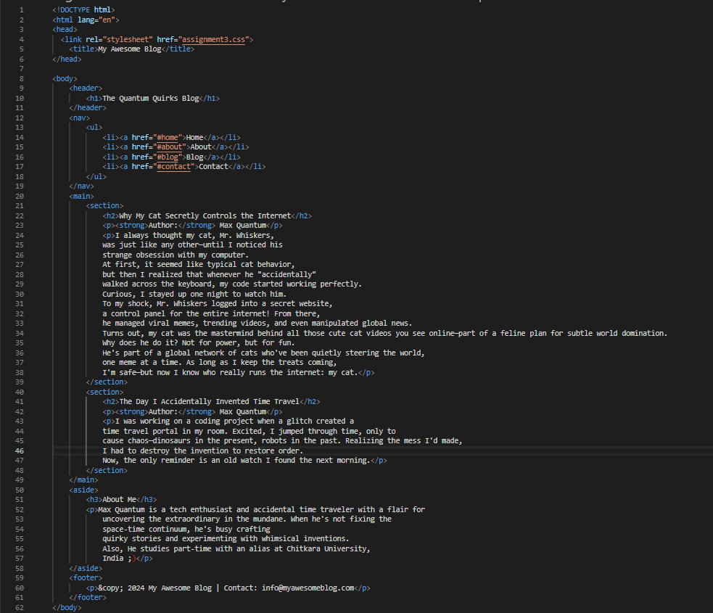
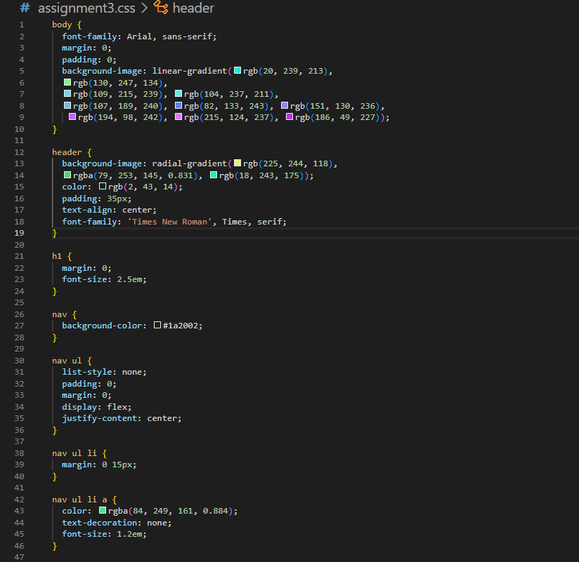
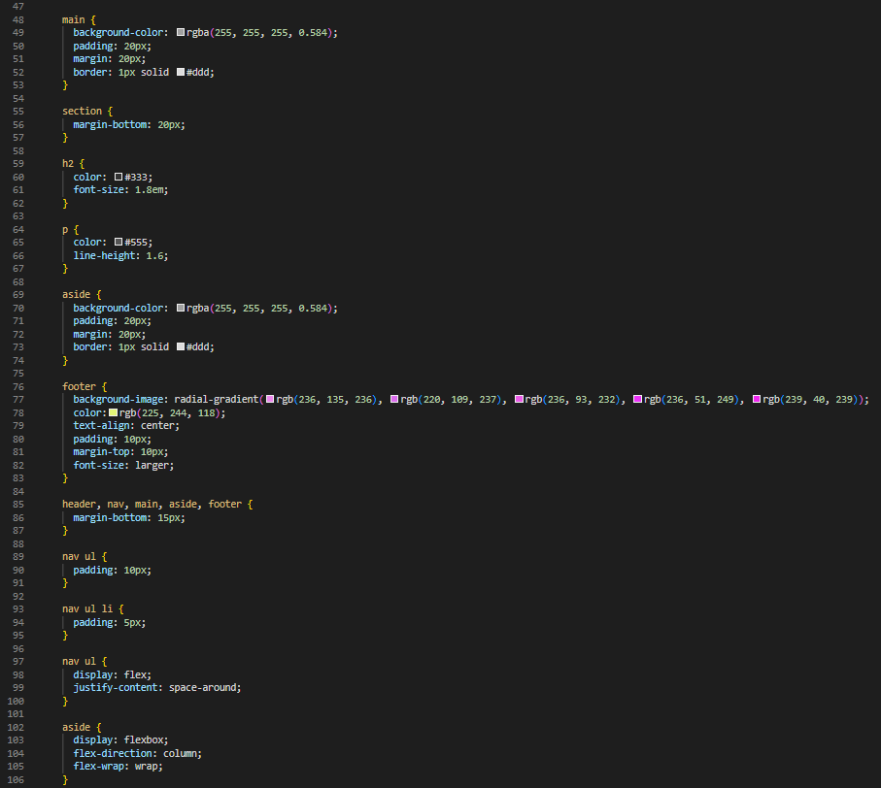
Output:
