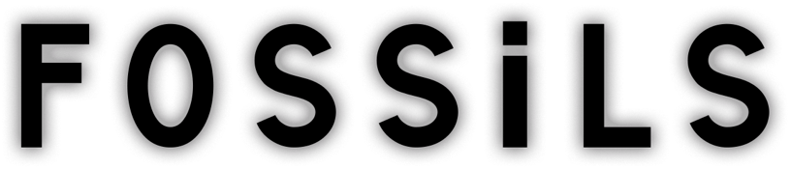

Directed and edited & AI visuals by Roxanne Ducharme aka TrashCanRoxanne

Written by Johanne Tremblay
Narrated by Kim Bubbs
Music composed & performed by Daniel Scott
Sound editing & Re-recording mixer Roger Guerin

In films and books, our species never fades away. We love to believe we’re immortal that way! Yet millennia conquer all in time’s endless chase. What if we’re but dinosaurs, awaiting our fate?
When the elements have burned all our ships, and the grandest works of nations are swept away, it is foretold that the Earth will breathe once more. And one distant day, in the deep abyss below, faint hearts will begin to beat again. But somewhere, somehow, there will remain traces of us— lingering whispers of who we were.
FOSSiLS began from a desire to create something emotionally powerful and very different from my more whimsical work. Written by my cousin Johanne Tremblay, the film holds two opposing feelings at once: the melancholy of imagining humanity’s end, and the quiet hope that something beautiful might still remain.
The film reflects on what could be left of us millions of years from now, not only ruins or monuments, but small human gestures preserved in unexpected ways. I wanted the end of the world to feel serene rather than hopeless, beautiful rather than brutal.
The narration became the emotional spine of the film. Kim Bubbs’ intimate voice, Daniel Scott’s restrained music, and Roger Guerin’s sound work shaped its quiet, reflective atmosphere.
AI was used throughout the visual process in service of the film’s tone and meaning. Midjourney was used to create most of the images, Runway for nearly all the animation, with a few scenes animated in Kling AI. ChatGPT helped with the English translation of the original French script and supported research and visual development around what traces of humanity might remain in the distant future.
The final film was edited in Adobe Premiere, where color correction, titles, and captions were also created. Topaz AI was used to upscale and enhance the film.

