IMO Strategic Engagement Platform

(IMO Shadow Committee Portal)
High-Level Design (HLD)
Prepared for: DGMA
Prepared by: Deloitte Touche Tohmatsu India LLP
Reference: FRS

Background & Objective
The International Maritime Organization (IMO) is a specialized agency of the United Nations responsible for regulating international shipping, enhancing maritime safety, preventing marine pollution, and addressing emerging challenges including greenhouse gas emissions, digitalization, and autonomous vessels. As a founding Member State, India participates at the highest levels across all IMO bodies, with its engagement managed through the International Cooperation (IC) Branch of the Directorate General of Shipping (DGS).
To strengthen this engagement, India has established Shadow Committees that mirror IMO structures, supporting the official delegation through coordinated preparation, research, and stakeholder consultation. Existing coordination mechanisms rely heavily on manual processes and dispersed communication channels, leading to inefficiencies, delays, and lack of traceability.
Objective: Develop a unified digital engagement platform the IMO Strategic Engagement Platform to streamline committee management, agenda and document preparation, stakeholder collaboration, feedback consolidation, and reporting across India's IMO engagement lifecycle.

Solution Overview
The proposed solution combines modern software engineering practices with enterprise-grade architecture principles to deliver a secure, scalable, and future-ready platform. By leveraging a microservices-based architecture, open-source technologies, cloud-native deployment, configurable security controls, and open APIs, the platform ensures flexibility, interoperability, and ease of maintenance throughout its lifecycle.
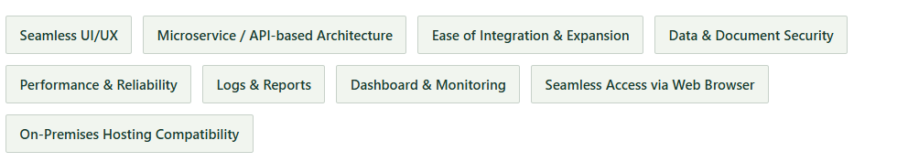
The solution will be hosted on a MeitY-empanelled cloud, with a centralized portal accessed via single sign-on. The architecture supports interoperability with existing and future Government digital platforms through secure APIs, standard data exchange mechanisms, and configurable integration services including Government identity providers (NIC SSO / ePramaan), document repositories, email gateways, notification services, and future maritime digital platforms.

High-Level Architecture
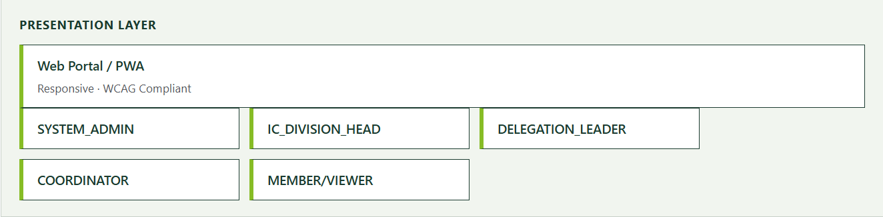
The proposed solution architecture is a layered, microservice-based design built on open standards and APIs, with a clear separation of concerns. Each layer offers defined services to the layers above and below it.

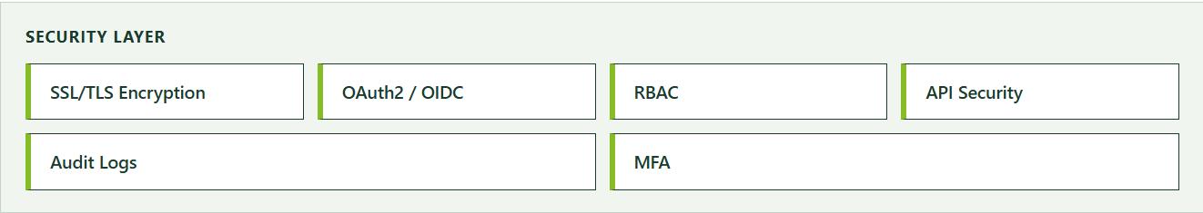

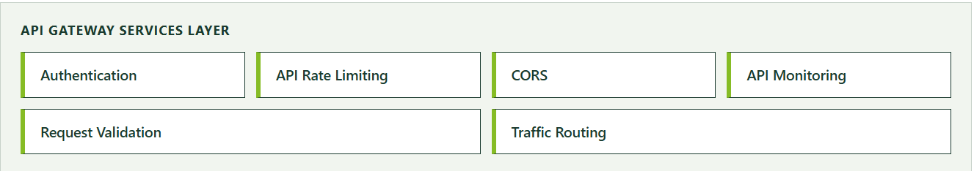
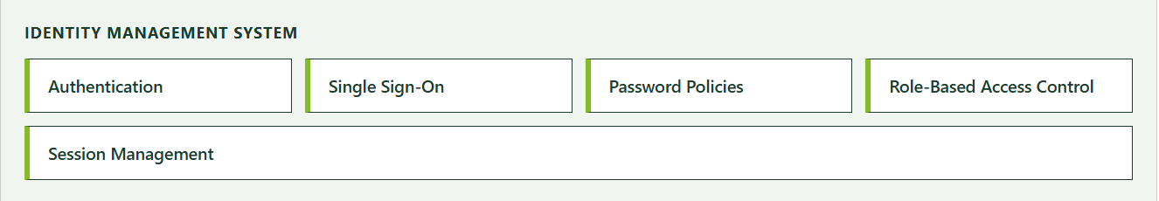

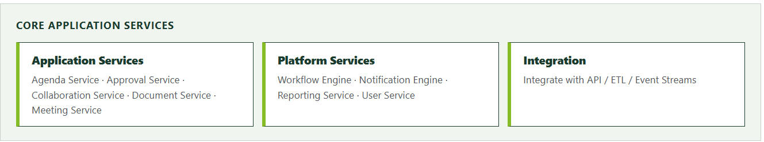

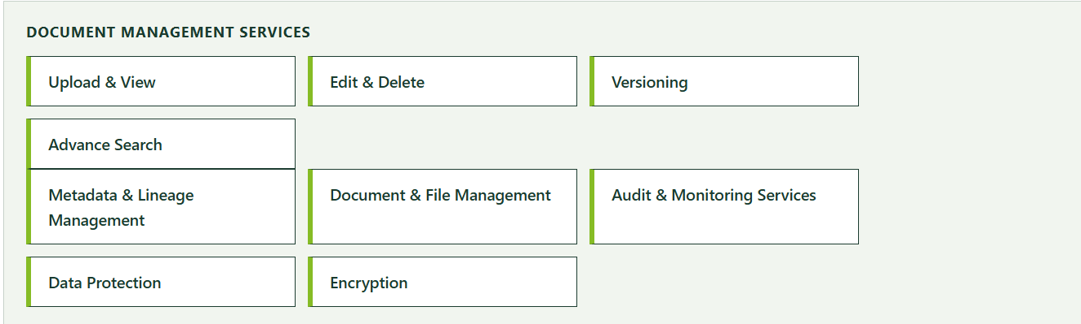

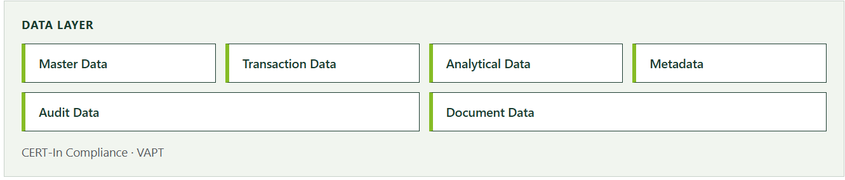

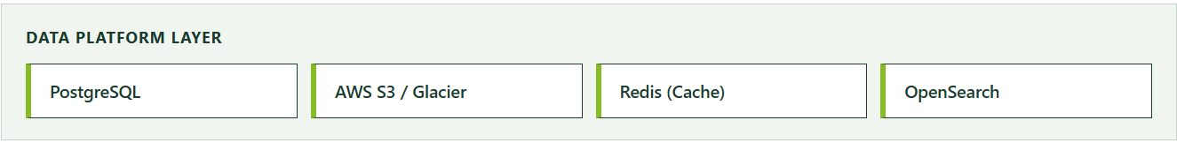

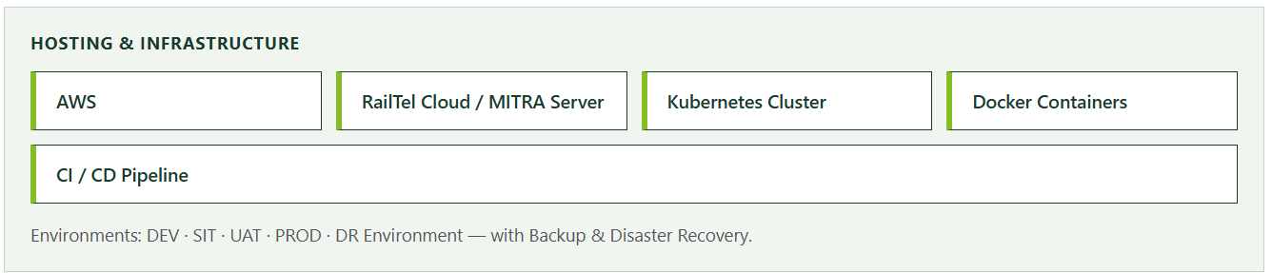

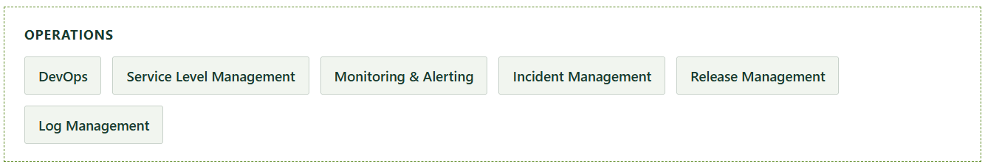

Core Functional Modules
The platform comprises ten integrated functional modules that collectively support the end-to-end management of committees, correspondence groups, agenda items, documentation, stakeholder collaboration, reporting, and system administration.
01

User Management & RBAC
Manages user identities, authentication, and authorization with configurable, role-based access permissions.
- User Authentication
- User Onboarding
- Role-Based Access Control
02

Committee, Sub-Committee & Meeting Management
Supports the complete lifecycle management of committees, sub-committees, and meetings.
- Committee Repository
- Meeting Lifecycle Management
- Meeting Dashboard
03

Agenda, Group & Correspondence Group Management
Enables management of agenda items, working groups, and correspondence groups with automated notifications.
- Agenda Management
- Group & Sub-group Management
- Automated Notifications
04

Task Management System
Enables assignment, monitoring, and tracking of activities arising from committee discussions and decisions.
- Task Creation
- Task Tracking
- Task Reports
05

Document Repository & Paper Preparation
Centralized repository for committee documents, with version control and review workflows.
- Centralized Document Repository
- Document Workflow Management
- Export Tools
06

Feedback, Review & Consolidation
Streamlines collection of comments and feedback, supporting consolidation into unified national positions.
- Feedback Submission
- Feedback Governance
- Consolidation of Comments

07

Real-Time Collaboration Tools
Promotes effective collaboration through online discussion forums and collaborative editing.
- Discussion Interface
- Collaborative Editing

08

Reporting, Monitoring & Analytics
Provides dashboards and analytical reports to support informed decision-making.
- Standard Reports
- Performance & Participation Reports
- Visual Analytics Dashboards
09

International Engagements ("Others+")
Extends the platform beyond IMO committees to other international maritime engagements and forums.
- Repository Management
- Action Item Tracking
- Reporting
10

System Administration & Non-Functional Requirements
Administrative controls and system-wide configuration ensuring performance, availability, and usability.
- Security Management
- Performance Optimization
- High Availability

Cross-Cutting Enterprise Capabilities
In addition to the functional modules, the platform provides enterprise-wide capabilities that operate across all modules to improve governance, compliance, and institutional memory.

Enterprise Search & Knowledge Discovery
Centralized search across committees, meetings, agenda items, documents, interventions, correspondence groups, national positions, reports, and archived records — supporting metadata filtering, keyword search, and OCR-based indexing.

Stakeholder Organization Registry
Centralized registry of participating Ministries, Departments, Classification Societies, Industry Associations, Research Institutions, and other approved stakeholders, including profiles and participation history.

Institutional Knowledge Repository
Preserves committee history, interventions, national positions, working papers, and decisions — enabling knowledge reuse and policy continuity for future international engagements.

User Roles & Access Management
The platform implements a Role-Based Access Control (RBAC) framework so that users are granted access only to the information and functionality required for their responsibilities. All role assignments remain fully auditable.
Role | Key Responsibilities | Access Level
Super User DGS / DDG International Cooperation | Overall governance, system configuration, monitoring of committees, users, workflows, and reports. | Full access across all modules and system configuration
Administrator | Day-to-day administration of committees, meetings, users, agendas, documents, and tasks. | Full operational management with limited system configuration rights
Delegation Leader | Reviews consolidated feedback, approves draft interventions and documents, monitors delegation readiness. | Review, approval, monitoring, and delegation-level oversight
Coordinator | Manages committees, working groups, and correspondence groups; coordinates agenda and task allocation. | Manage assigned committees, agendas, tasks, submissions, and collaboration workspaces
Convener | Functional lead for a committee / working group; validates technical positions and coordinates discussions. | Lead discussions, review submissions, manage issue registers
Member | Reviews assigned agenda items, prepares comments, participates in discussions, completes assigned tasks. | Assigned access only; no approval or administrative authority
Consultant / Support Staff | Provides research, documentation, and drafting support; uploads supporting materials. | Access limited to assigned committees, documents, and tasks
Ministry Reviewer | Reviews agenda papers, interventions, and policy documents for ministry-level examination. | Review and comment access only; no administrative privileges

Security & Compliance Framework
Powered by Keycloak (open-source) with OAuth 2.0 / OIDC. All access decisions enforced centrally via API Gateway + Spring Security. Zero-trust architecture: verify every request, least-privilege always.
- Authentication — Verifies the identity of every user before granting access to any resource, via Keycloak SSO with OAuth 2.0 / OpenID Connect and a Spring Security adapter on each service. Provides single sign-on across all microservices, eliminates custom auth code, and centrally audits login events.
- Authorization — Controls what authenticated users can see and do based on their role and context, via RBAC through Keycloak realm roles, JWT claims carrying permissions, and Spring Security @PreAuthorize. Enforces least-privilege by default with fine-grained permission enforcement without service-level duplication.
- User Roles — Defines discrete access levels aligned with the project management workflow: Admin · Project Manager · Developer · Viewer · External Stakeholder. Ensures clear separation of duties, role-based data visibility, and audit-ready compliance reviews.
- Token Management — Issues short-lived signed tokens to represent authenticated sessions: JWT access tokens (15 min TTL) plus encrypted refresh tokens (7 days), with token rotation on each refresh. Short-lived tokens minimize the breach window; refresh rotation invalidates stolen tokens immediately.
- MFA — Requires a second verification factor for privileged and external accounts, via Keycloak MFA with OTP (Google Authenticator) and FIDO2 / WebAuthn hardware keys. Protects against credential stuffing and phishing; FIDO2 is phishing-resistant by design.
- Service Auth — Secures machine-to-machine communication between microservices via the OAuth 2.0 Client Credentials flow, with each service holding its own client ID & secret in Keycloak. No shared secrets between services; per-service identity enables precise audit trails.
- API Security — Validates and enforces authorization at the API gateway before requests reach backend services; the Spring API Gateway validates JWT signature, expiry, and scopes on every inbound request. Centralized enforcement means a misconfigured service cannot bypass auth, reducing the attack surface.
- Audit & Logging — Records all authentication events, access decisions, and admin actions via Keycloak event logging, exported to a SIEM (Splunk / ELK) as an immutable audit log store. Enables forensic investigation, anomaly detection, and regulatory compliance (SOC 2, ISO 27001).
- Secret Management — Stores and rotates credentials, API keys, and certificates outside application code, using HashiCorp Vault or Kubernetes Secrets (encrypted at rest) with secrets injected at runtime via environment variables. Secrets are never in source code or config files; automatic rotation reduces credential exposure.
- Session Management — Controls user session lifetimes and supports forced logout across all services via Keycloak session timeouts, idle session expiry (30 min), and admin-initiated global logout via OIDC backchannel. Prevents session hijacking; supports compliance requirements for session termination on role change.
- Password Policy — Enforces strong credential standards for all local accounts: minimum 12 characters, complexity rules, 90-day rotation, and breach-password detection via the HaveIBeenPwned API. Reduces the risk of credential-based attacks; breach detection blocks the use of known-compromised passwords.
- Federation — Integrates enterprise identity providers so users log in with existing corporate credentials, via Keycloak LDAP / Active Directory federation, SAML 2.0 for legacy IdPs, and optional social login. Unified identity across the enterprise; eliminates duplicate user stores; onboarding/offboarding automated via AD.

Technology Stack
All components are open-source / community-supported. The 'Why' column justifies each selection for a scalable, on-prem project management platform.
Category | Software / Components | Why It's the Best Fit
Operating System | Linux | Zero licensing cost; industry-standard for server/container workloads; native Docker & Kubernetes support; hardened kernel security.
Development | Java, Spring Boot, Spring JPA, Hibernate, React JS, HTML5, CSS3 | Spring Boot eliminates boilerplate; Hibernate/JPA abstracts PostgreSQL ORM; React delivers a fast SPA UI — all with LTS support and massive talent pools.
Database | PostgreSQL | PostgreSQL offers JSONB, advanced indexing, full-text search, and ACID compliance — ideal for complex project data models at zero licensing cost.
NoSQL | Elasticsearch | Best-in-class full-text & faceted search across tasks and documents; sub-second queries across millions of records.
Dashboard | React | Connects natively to PostgreSQL; it offers a fast, user-friendly interface that lets anyone build interactive, clean data visualizations — no BI licensing fees or custom chart development.
Caching | Redis/Valkey | In-memory store for session caching, rate limiting, and pub/sub messaging; reduces DB load by up to 80%.
API Gateway | Kong | Seamless fit with Spring Boot microservices; provides routing, load balancing, rate limiting, and JWT validation out of the box.
UI Scripting Framework | React JS, JavaScript, jQuery | React's virtual DOM and component model deliver maintainable UIs; largest frontend ecosystem with rich PM-UX library support.
Document Management | AWS S3/GLACIER | Open-source ECM with versioning, audit trails, workflow integration, and REST APIs — essential for project document compliance.
Container Management | Docker | Packages every service with its dependencies into portable images; eliminates environment drift and simplifies CI/CD across all stages.
Container Orchestration | Kubernetes | Automates deployment, auto-scaling, and self-healing; supports rolling updates and zero-downtime releases at enterprise scale.
Repository | GitHub | Centralises code; enables PR-based code review; integrates with GitHub Actions for automated build, test, and deploy pipelines.
IDAM | In-house / JWT / Keycloak | Provides enterprise SSO, RBAC, OAuth 2.0, and OpenID Connect — eliminates custom auth code and enforces least-privilege access.
Performance Testing | Jmeter | Open-source load testing for REST APIs; simulates thousands of concurrent users to validate system performance before every release.
Prototype Design | Figma | Real-time collaborative UI/UX design with interactive prototypes; shortens feedback loops between designers, developers, and stakeholders.
Build Tool | Maven | Uses a standard project structure, handles dependencies automatically, and supports easy plugin management.

Deployment Model
The platform will be deployed on AWS infrastructure, orchestrated through a Kubernetes Cluster with Docker Containers and a CI/CD Pipeline. Five segregated environments — DEV, SIT, UAT, PROD, and DR Environment — support a secure and controlled application lifecycle, backed by Backup & Disaster Recovery.

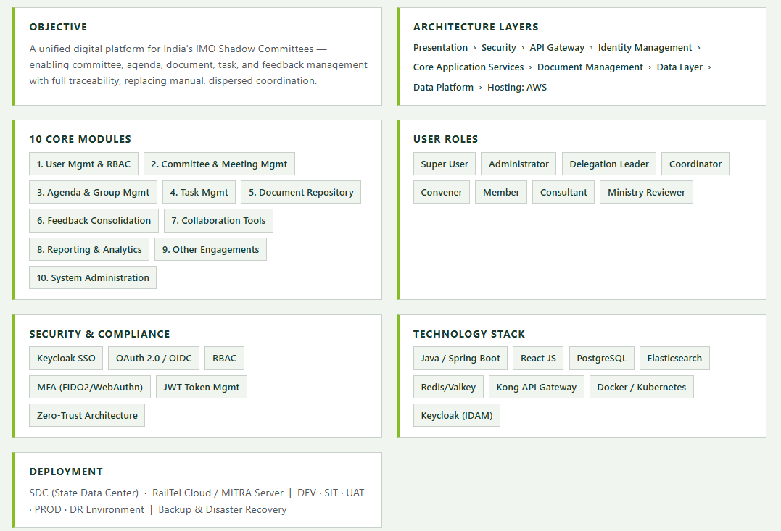
Single-Page HLD Summary

