Name: Piyush Singh
Roll No.: 24CVE1023
Topic: Problem B – Smart Attendance Reader

Recognising handwritten roll-number digits with PCA, k-means, k-NN and ANN
I2AI Assignment 2026 · NIT Goa

[DELETE THIS LINE BEFORE SUBMITTING] This is an AI-written draft. Rewrite every paragraph in your own words and keep Section 8 truthful.

1. Introduction
In most classes at NIT Goa, attendance is still taken on a paper sheet where each student writes their roll number by hand. Someone then has to read every sheet and enter the numbers into a system. This is slow, and a single misread digit marks the wrong student present. This report studies whether machine learning can read these handwritten digits automatically, and how reliable such a system would be.
The sklearn handwritten digits dataset is used as a stand-in for roll-number digits. It has 1,797 images of the digits 0 to 9. Each image is 8 × 8 pixels, so every digit is described by 64 grey-level values. The data was split once into 80% training and 20% test data, with the same proportion of each digit in both parts. The pixel values were standardised using statistics from the training set only, so the test images stay completely unseen until the final evaluation.
Four techniques are applied, two from each family of machine learning. PCA and k-means are unsupervised: they look for structure without using the labels. k-NN and an artificial neural network (ANN) are supervised: they learn from labelled examples. Comparing both families on the same data shows how much the labels actually contribute.
Table 1: Dataset and experimental setup
Item | Value
Dataset | sklearn load_digits (UCI handwritten digits)
Images | 1,797 (10 classes, digits 0–9)
Image size | 8 × 8 = 64 pixel features
Train / test split | 1,437 / 360 (80/20, stratified)
Scaling | StandardScaler, fitted on training set only
Random seed | 42 (same everywhere, results reproducible)
Tools | Python, NumPy, pandas, scikit-learn, matplotlib, seaborn

2. Task 1 – PCA (dimensionality reduction)

Method
Principal Component Analysis (PCA) finds new axes, called principal components, along which the data varies the most. The first component captures the largest share of the variation, the second the next largest, and so on. If a few components carry most of the variation, the data can be described with far fewer numbers. PCA was fitted on the standardised training images with all 64 components. The cumulative explained variance was then used to find how many components keep 90% and 95% of the information. The first two components were also used for a 2D scatter plot, and one digit was rebuilt from 2, 10, 20 and 40 components to see how much detail each level keeps.

Results
Table 2: PCA results
Measure | Value
Variance in PC1 / PC2 | 12.0% / 9.7% (21.7% together)
Variance kept with 10 / 20 / 40 components | 59.0% / 79.0% / 95.2%
Components for 90% variance | 31 of 64
Components for 95% variance | 40 of 64

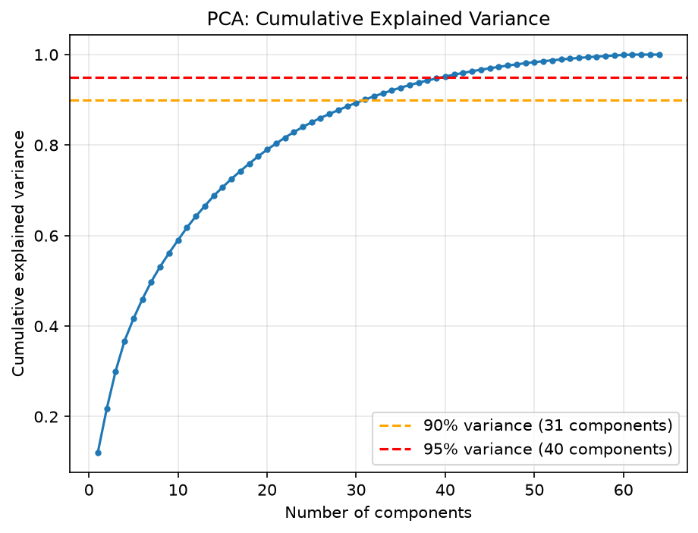
Figure 1: Cumulative explained variance vs number of principal components
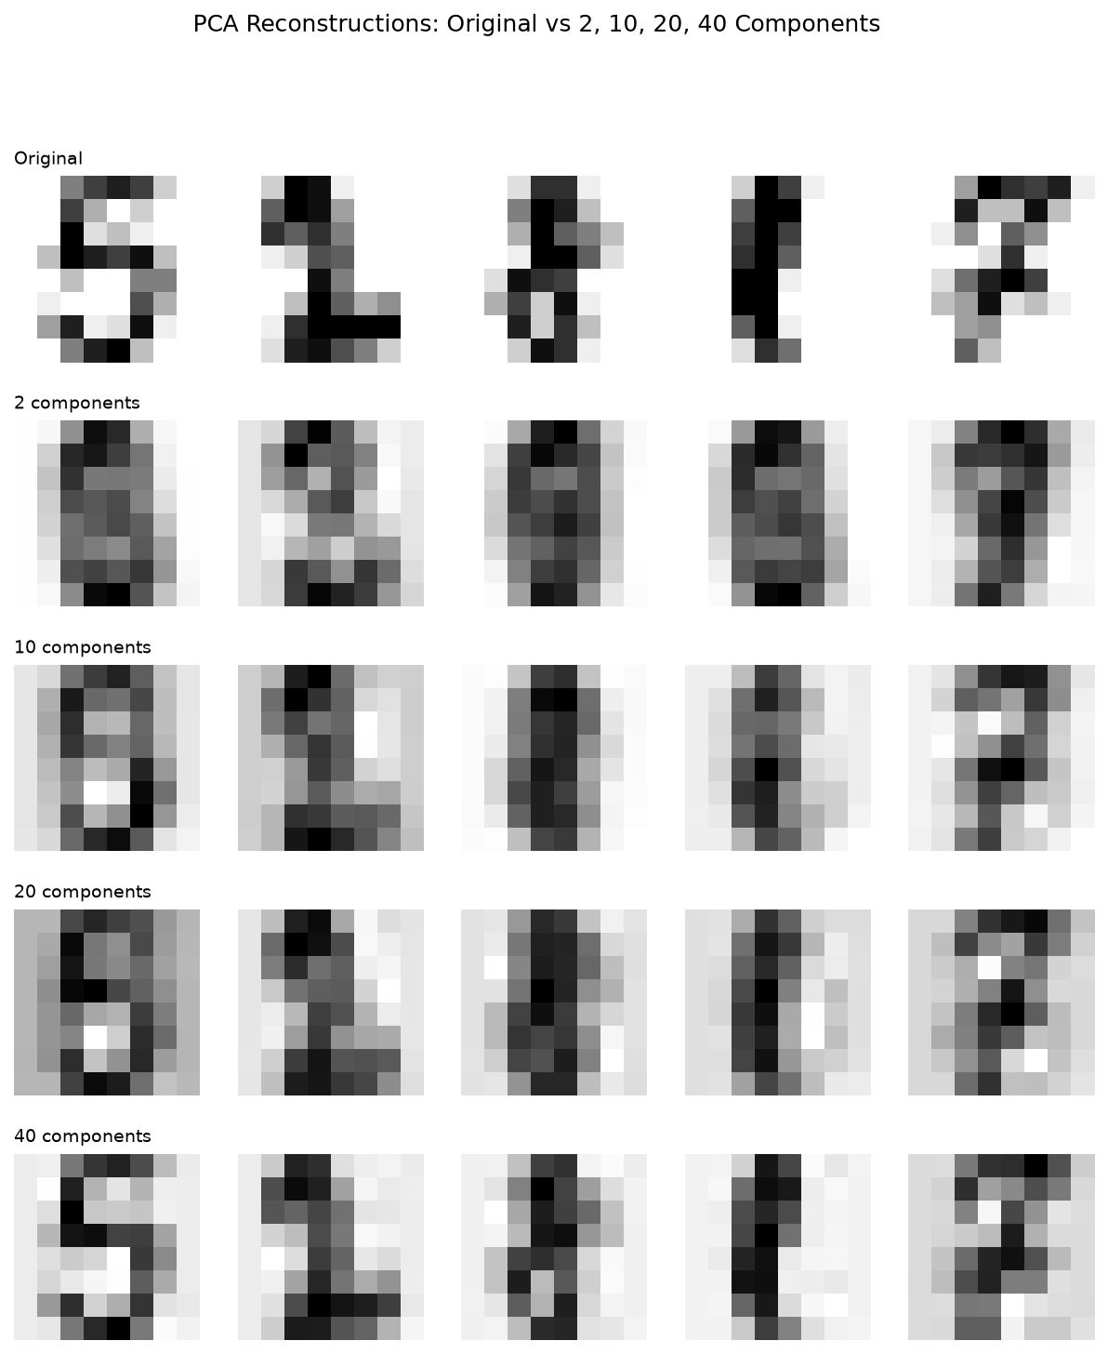
Figure 2: Digits rebuilt from 2, 10, 20 and 40 components, compared with the originals

Interpretation
Forty of the 64 components keep 95% of the variance, so each image can be stored as 40 numbers instead of 64 with very little loss. Figure 2 shows this clearly. With 2 components the digit is an unreadable blur, at 10 the rough shape appears, and at 40 it looks close to the original.
The first two components hold only 21.7% of the variance. This is why a 2D scatter plot shows the digit groups overlapping heavily: two numbers are not enough to tell ten digits apart. The 95% level needs more components than one might expect because the pixels were standardised. Standardising gives every pixel equal weight, including the almost-empty border pixels, so the variance is spread over more directions.

Limitations
PCA is a linear method, so it cannot capture curved relationships between pixels. The components also have no clear physical meaning; the first component is not simply “thickness” or “slant”. Finally, PCA keeps the directions with the most variance, which are not always the directions that best separate one digit from another, because it never looks at the labels.

3. Task 2 – k-means clustering (unsupervised)

Method
k-means is an unsupervised method that splits data into k groups. It starts with k centre points, assigns every image to its nearest centre, moves each centre to the average of the images assigned to it, and repeats until the groups stop changing. It never sees the true digit labels. Here it was run on the 40-component PCA data from Task 1. Values of k from 2 to 15 were tried using the elbow method (inertia) and the silhouette score. Then k was fixed at 10, one cluster per digit, and each cluster was given the label of the digit most common inside it. Purity is the fraction of images whose cluster label matches their true digit. The Adjusted Rand Index (ARI) and Normalised Mutual Information (NMI) were also computed, as they compare the groupings without needing that mapping.

Results
Table 3: k-means results (k = 10)
Measure | Value
Purity (train / test) | 0.669 / 0.661
Adjusted Rand Index (ARI) | 0.521
Normalised Mutual Information (NMI) | 0.667
Silhouette score at k = 10 | 0.148
Best silhouette (k = 12) | 0.170
Digits that got two clusters | 4 and 7
Digits that got no cluster of their own | 8 and 9

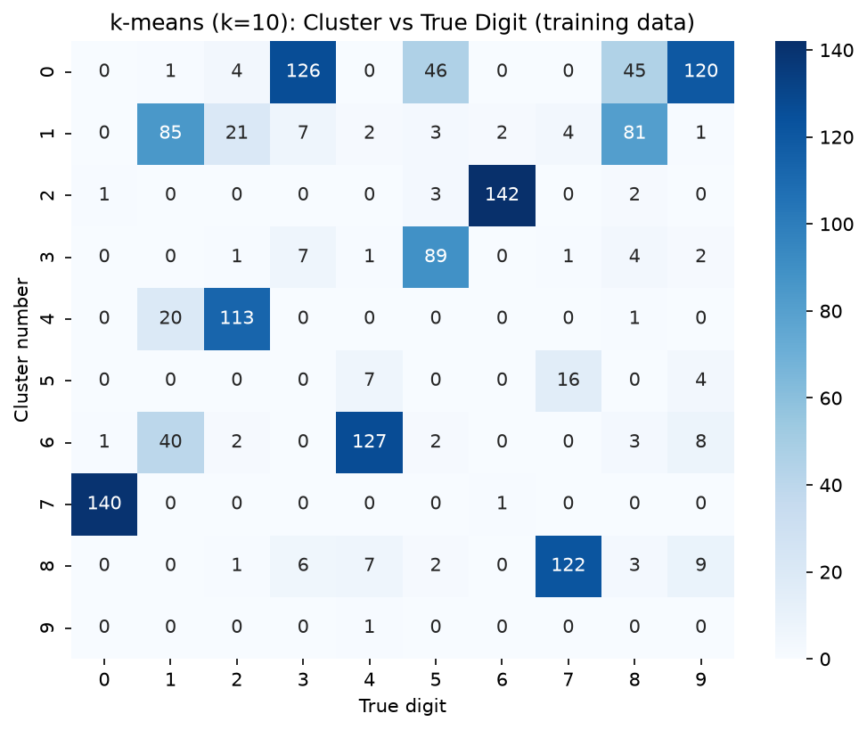
Figure 3: Number of images of each true digit in each cluster
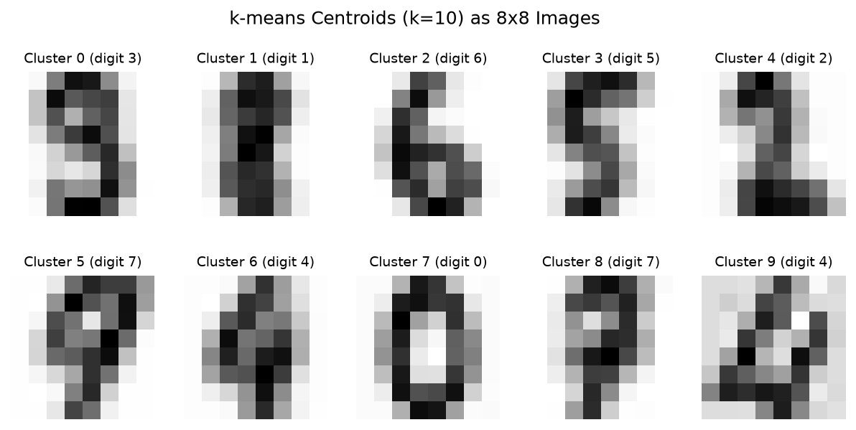
Figure 4: The 10 cluster centres shown as 8 × 8 images

Interpretation
With no labels, k-means grouped only about two thirds of the test images correctly (purity 0.661). It groups images that look alike, and visual similarity does not match digit identity well. The clearest evidence is in Figure 3. Two clusters both turned into 4s and two into 7s, while 8 and 9 got no cluster of their own. This suggests that k-means splits common digits by writing style and merges similar-looking digits such as 8 and 9 into other groups.
The cluster centres in Figure 4 support this. The centres for 0, 1 and 6 are sharp and clearly readable, while one of the two “4” centres is a faint blur that does not look like any single digit. The silhouette score at k = 10 was only 0.148, and the elbow plot had no sharp bend. Both show that handwritten digits do not form clean, well-separated natural groups.

Limitations
The number of clusters must be chosen in advance, and the best silhouette score was at k = 12, not at the 10 digits. k-means assumes round clusters of similar size, which handwriting does not form. Purity also relies on a majority-vote mapping that uses the labels after clustering, so it is not a fully unsupervised measure. The result can also change with the random starting centres.

4. Task 3 – k-Nearest Neighbours (supervised)

Method
k-Nearest Neighbours (k-NN) classifies a new image by finding the k training images closest to it, measured by distance between pixel values, and taking a vote of their labels. With distance weighting, closer neighbours get a bigger say in the vote. The value of k (1 to 15) and the weighting (uniform or distance) were chosen with 5-fold cross-validation (GridSearchCV) on the training data only. The best setting was then tested once on the 360 test images. The same model was also trained on the 40 PCA components from Task 1, to check whether the reduced data works as well as the full 64 pixels.

Results
Table 4: k-NN results
Measure | Value
Best settings (from CV) | k = 5, distance weighting
Cross-validation accuracy | 0.976
Test accuracy (raw scaled pixels) | 0.967 (348 / 360 correct, 12 wrong)
Test accuracy (40 PCA components) | 0.978
Weakest digits (recall) | 8 and 9 (0.89 each)
Most confused pair | 1 ↔ 8 (3 errors), then 4 ↔ 7 (2)

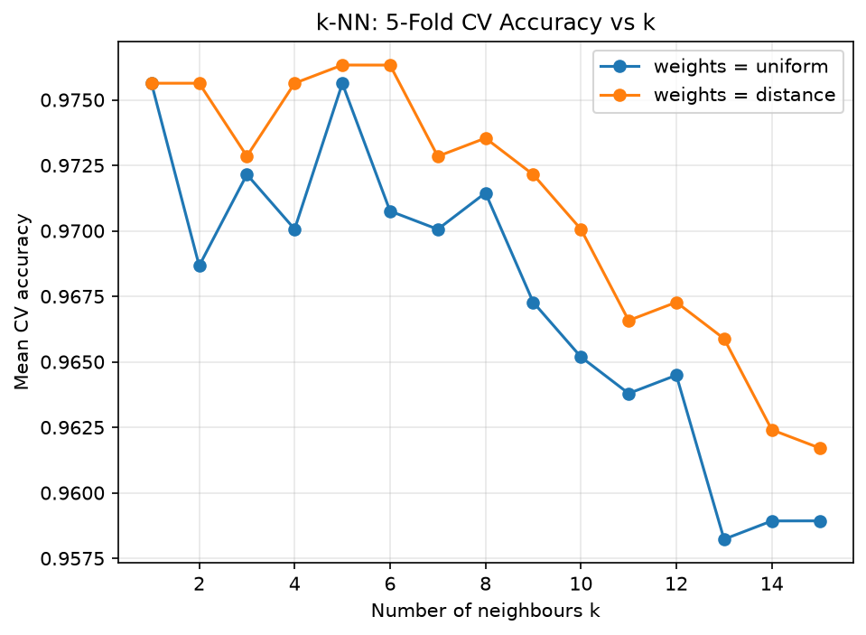
Figure 5: Cross-validation accuracy for each value of k
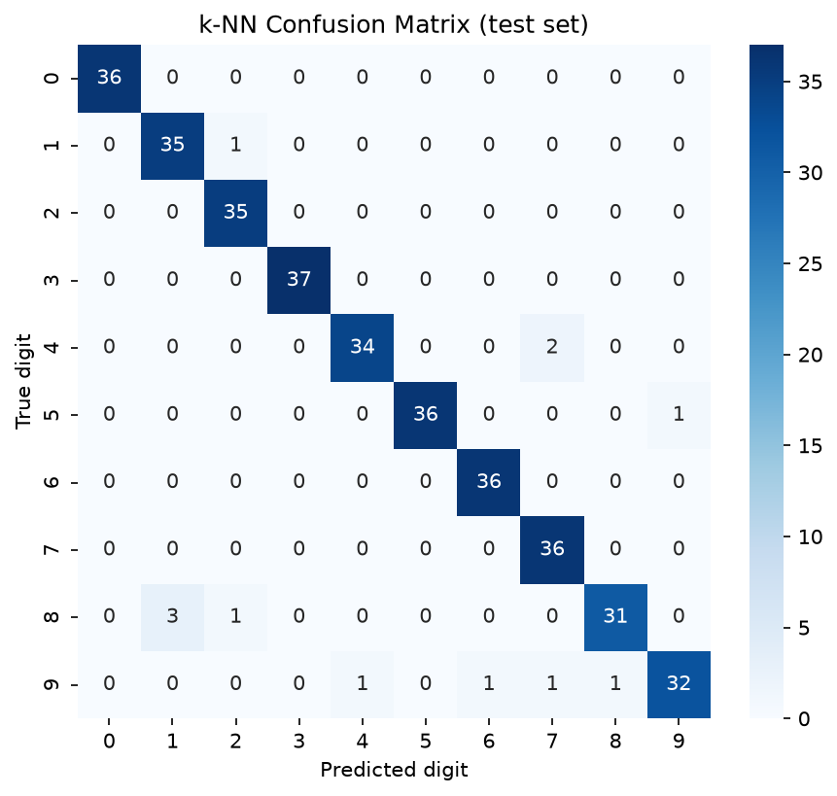
Figure 6: k-NN confusion matrix on the test set

Interpretation
k-NN classified 96.7% of the test images correctly, with only 12 errors out of 360. Cross-validation chose k = 5 with distance weighting. With k = 1, a single badly written training image can decide the answer; a vote among five neighbours smooths out such noise. Distance weighting then makes sure the closest, most similar images count the most.
The most common mistake was confusing 1 and 8, and the digits 8 and 9 had the lowest recall (0.89). These digits share strokes and loops, so in an 8 × 8 image they can look alike. On the 40 PCA components, k-NN reached 97.8%, slightly higher than on the raw pixels. This suggests the 24 dropped dimensions carried mostly noise rather than useful information, which supports the result of Task 1.

Limitations
k-NN has no real training step: it stores the whole training set and compares every new image with all of it. This is fast for 1,437 images but becomes slow and memory-hungry for a large campus with many thousands of samples. The gap between PCA and raw features is only 4 images out of 360, so it may be due to chance. The PCA model also reused the k and weighting chosen for the raw features.

5. Task 4 – Artificial Neural Network (supervised)

Method
An artificial neural network (a multi-layer perceptron) passes the 64 pixel values through one or more hidden layers of neurons. Each neuron computes a weighted sum of its inputs and applies an activation function (ReLU). The output layer gives a probability for each of the ten digits. During training, backpropagation adjusts the weights step by step to reduce the error (loss). Two architectures were compared using sklearn’s MLPClassifier: one hidden layer of 64 neurons, and two hidden layers of 128 and 64 neurons. Early stopping was used: 10% of the training data is held back as a validation set, and training stops once the validation accuracy stops improving for a set number of epochs (the “patience”). The final architecture was chosen by validation accuracy, never by test accuracy.

Results
Table 5: ANN results
Architecture | Validation acc. | Test acc. | Epochs
(64,), patience 10 (first run) | 0.965 | 0.944 | 34
(64,), patience 50 (final, chosen) | 0.986 | 0.969 | 162
(128, 64), patience 50 | 0.958 | 0.967 | 69

Final model: 11 of 360 test images wrong. Weakest digits (recall): 8 (0.91) and 1 (0.94). Most confused pair: 1 ↔ 8 (3 errors).
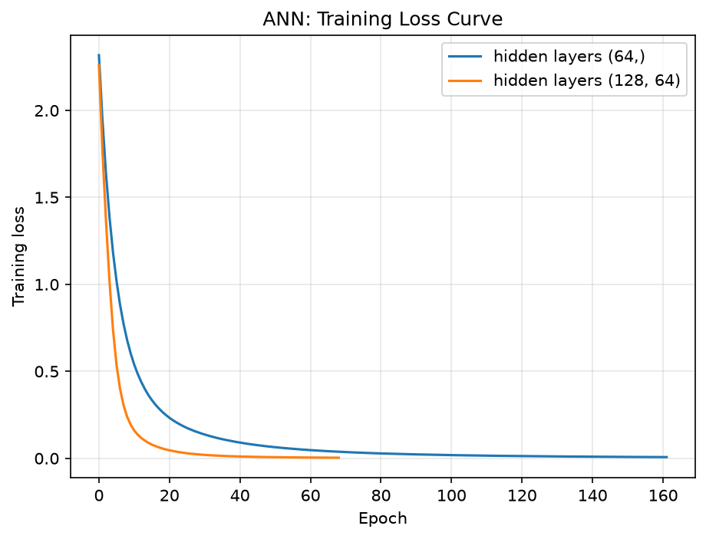
Figure 7: Training loss per epoch for both architectures
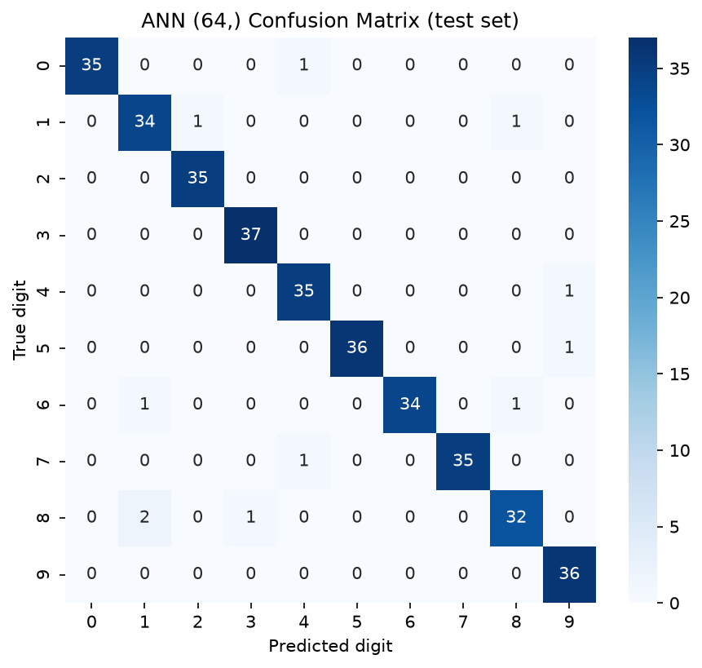
Figure 8: Confusion matrix of the final ANN on the test set

Interpretation
The first run used the default patience of 10 epochs. Training stopped at epoch 34, and the network reached only 94.4% test accuracy, below k-NN. Its predictions were also unsure: many digits were predicted with low confidence. The network had not finished learning; a short pause in validation improvement was mistaken for the end of learning. When the patience was raised to 50 epochs, training continued to epoch 162, validation accuracy rose from 96.5% to 98.6%, and test accuracy rose to 96.9%. The errors dropped from 20 to 11. This shows that default settings should not be trusted blindly.
The larger network (128, 64) did not do better: it reached 96.7% on test and a lower validation score. With only about 1,300 training images, extra layers add capacity the data cannot use. The loss curve in Figure 7 shows the expected pattern: a steep fall in the first 20 epochs, then a slow flattening as the network fine-tunes.

Limitations
The validation set has only about 144 images, so the choice between the two networks is noisy. Only one random seed was tested, and a different seed could change the ranking. The ANN is also a “black box”: it is hard to explain why it gave a particular answer. It took about 5 seconds to train, compared with almost nothing for k-NN, although this is still very small in absolute terms.

6. Comparison and campus deployment
Table 6: Model comparison
Model | Type | Test accuracy | Training time
ANN (64,) | Supervised | 0.969 | ~5.2 s
k-NN (k = 5) | Supervised | 0.967 | < 0.01 s
k-means (k = 10) | Unsupervised | 0.661 (purity) | ~0.08 s

To test the system at the level of a full roll number, 1,000 eight-digit roll numbers were simulated from test-set digit images. A roll number counts as correct only if all eight digits are right.
Table 7: Roll-number accuracy (1,000 simulated 8-digit roll numbers)
Model | Per-digit accuracy | Rolls fully correct (simulated) | Theory (accuracy⁸)
ANN | 0.969 | 76.2% | 78.0%
k-NN | 0.967 | 74.3% | 76.2%

A confidence threshold was then applied to the ANN: a roll number is auto-accepted only if its least-confident digit is above the threshold; otherwise it is sent to a human.
Table 8: Effect of the ANN confidence threshold
Threshold | Sent to a human | Accuracy of auto-accepted rolls
0.50 | 13.5% | 86.7%
0.60 | 26.4% | 92.1%
0.90 | 56.5% | 90.3%
0.95 | 74.1% | 100%

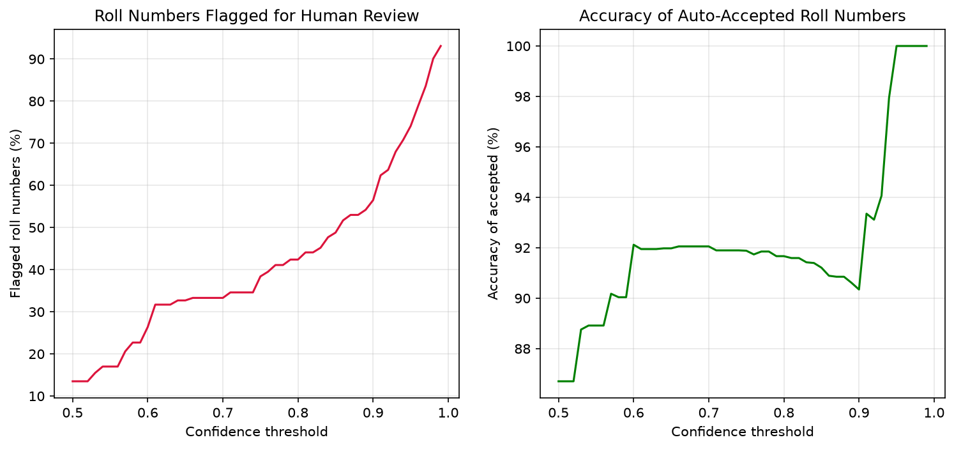
Figure 9: Share of roll numbers flagged for review and accuracy of accepted roll numbers at each threshold

Interpretation and recommendation
The supervised models clearly beat the unsupervised one: about 97% accuracy against 66% purity for k-means. The labels tell the model exactly which differences between images matter, while k-means can only group images by general visual similarity. Between the two supervised models there is no real winner. The ANN made 11 errors and k-NN 12, a difference of a single image. For deployment, the ANN is the better choice. Once trained, it predicts quickly without storing the whole training set, and it gives a confidence score for every digit, which k-NN in this form does not.
The most important result is what happens at the level of a full roll number. A roll number is correct only if all eight digits are right, so the error compounds: 0.969 to the power 8 is about 0.78. In the simulation, the ANN read only 76.2% of roll numbers fully correctly, very close to this theory. In other words, about one in four students would be recorded wrongly. A digit accuracy that sounds excellent is not good enough for attendance.
The confidence threshold helps, but it is not a complete fix. At a threshold of 0.6, about a quarter of the roll numbers go to a human, yet 8% of the accepted ones are still wrong. Only at 0.95 did the accepted roll numbers reach 100% accuracy, but then three quarters of all sheets need a human check. The recommended design is therefore to combine the model with the class list. A misread digit usually produces a roll number that does not exist in the class, so it can be caught automatically. Any number that is not on the list, or that has low confidence, is sent for manual review.

Limitations
The simulated roll numbers reuse the same 360 test images, so they are not independent samples of real handwriting. Real attendance sheets would be photographed, so the digits would also need to be located, cropped and cleaned, with problems such as lighting, ink and overlapping lines; the clean 8 × 8 images avoid all of this. The 100% accuracy at high thresholds is based on only a small number of accepted roll numbers. Finally, the timings come from a tiny dataset and vary from run to run.

7. Conclusion
This study applied four machine learning techniques to handwritten digits as a model for reading roll numbers on attendance sheets. PCA reduced each image from 64 to 40 features while keeping 95% of the variance. k-means, without labels, reached only 66% purity, showing that handwriting styles do not split cleanly into digits. k-NN and the ANN both reached about 97% accuracy, and the ANN only got there after its early-stopping patience was increased.
The key finding is that per-digit accuracy is not enough. At 97% per digit, about one roll number in four is still read wrongly, so a practical system must check each prediction against the class list and send uncertain cases to a person. The next step would be to test the system on real photographed attendance sheets and to try a convolutional neural network, which is designed for images.

8. AI usage declaration
[Edit this section so it is true for what you actually did, then delete this line.]
I used AI assistants (Claude and Claude Code) in this assignment as follows:
- Claude helped me choose the problem and plan the four tasks.
- Claude Code generated the Python code. I ran it, checked the outputs, and studied the code so that I can explain every line.
- Claude reviewed the results and pointed out that early stopping ended the ANN’s training too soon. I tested the change and reported both runs.
- Claude produced a draft of this report. I rewrote the text in my own words and checked every number against my results files.
All results come from my own runs of the code, with random seed 42.

