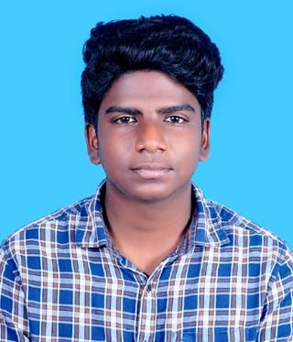

|  |  |
| --- | --- |
| Kanishk K U  33, Selvapuram Nagar,  Pollachi, Coimbatore-642001  **(+91) 7358410340**  **kanishkkanagaraj.u@gmail.com** |  |

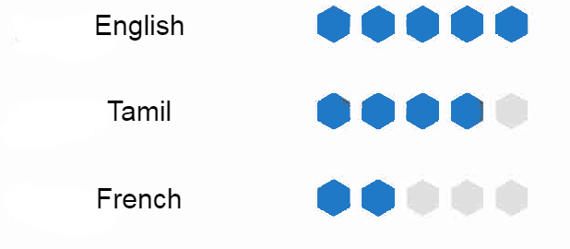

|  |  |
| --- | --- |
| EDUCATION[SRM Institute of Science and Technology](https://www.srmist.edu.in/), Chennai — *Bachelor’s Degree*JULY 2020 - JUNE 2024 B.Tech Electronics and Communication Engineering PKD Matriculation Hr Sec School, Pollachi, Coimbatore — *High School*JUNE 2016 - MARCH 2020 Senior and Higher Secondary EXPERIENCE[Uniplus C](https://uniplus-computers.business.site/)omputers, Coimbatore — *Trainee*APRIL 2020 - PRESENT Hardware Engineer. [Hello Daily](https://hellodaily.in/), Bengaluru — *Internship*DECEMBER 2019 - MARCH 2020 Visual Designer and Software Engineer. SPECIALISMDesign  * User Interface Architecture, * User Experience Designing .  Photography & Videography Adobe Photoshop, Adobe After Effects,  Adobe Lightroom, Adobe Premiere,  2D Animation(Apple certified). Software Development Python,C,Flutter(Basics) | SKILLS Computer skills, Leadership,Hardware & Networking, Management skills, Problem solving, Creativity, Teamwork. LANGUAGESSPORTS AND HOBBIES  * Football * Esports Athlete * Cricket * Swimming * Photography * Planting and Farming * Cooking * Drawing * Bike Riding  *“Science of today is Technology of tomorrow”*SOCIAL MEDIA [Instagram](https://www.instagram.com/kanimage_factory/) [Linkedin](https://www.linkedin.com/in/kanishk-k-u-2003/) F[aceb](https://www.facebook.com/kanishkkanagaraj)ook |