% Experiment 1: To plot the spectrum of a pulse of width 10.

% Kanishk

% 2021UCA1810

% pulse clc; clear all; close all; syms t w x=1;

expw=exp(-1\*1i\*w\*t); z=int(x\*expw,t,-5,5); xlabel('t') ylabel('x(t)') figure(1); fplot('1',[-5 5]) figure(2);

fplot(z)

*Warning: fplot will not accept character vector or string inputs in a future release. Use fplot(@(t)1\*ones(size(t))) instead.*

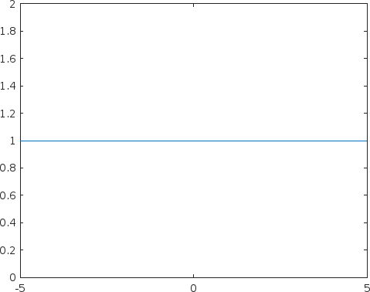

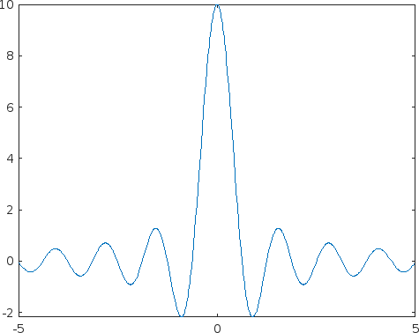

*Published with MATLAB® R2022b*