% Experiment 2: To Verify the Following Properties of Fourier Transform:

% (i) Time Shifting

% (ii) Frequency Shifting

% (iii) Convolution

% KANISHK

% 2021UCA1810

clc; clear all; close all;

% 1. Convolution Property N = 128;

x1 = ones(1, 4);

x2 = ones(1, 6); n1 = length(x1); n2 = length(x2);

x1 = [x1, zeros(1, N - n1)];

x2 = [x2, zeros(1, N - n2)]; n = 0 : N - 1;

k = 0 : N - 1;

w = 2 \* pi \* k / N; X1 = fft(x1);

X2 = fft(x2); figure(1); subplot(211);

stem(w, abs(X1), 'filled'); xlim([0 2 \* pi]);

xlabel('w'); ylabel('Magnitude'); title('128 - point DFT of x1'); subplot(212);

stem(w, abs(X2), 'filled'); xlim([0 2 \* pi]);

xlabel('w'); ylabel('Magnitude'); title('128 - point DFT of x2'); X3 = 1 / N \* cconv(X1, X2, N); x4 = x1 .\* x2;

X4 = fft(x4); figure(2); subplot(211);

stem(w, abs(X3), 'filled'); xlim([0 2 \* pi]);

xlabel('w'); ylabel('Magnitude');

title('Circular Convolution of DFTs of x1 and x2'); subplot(212);

stem(w, abs(X4), 'filled'); xlim([0 2 \* pi]);

xlabel('w'); 1

ylabel('Magnitude');

title('DFT of multiplication of x1 and x2');

% 2. Time Shifting n0 = 2;

y = [zeros(1, n0), x1(1 : N - n0)]; Y = fft(y);

Y1 = X1 .\* exp(-j \* w \* n0); figure(3);

subplot(311);

plot(-10 : N, [zeros(1, 11), x1], 'LineWidth', 1); hold on;

plot(-10 : N, [zeros(1, 11), y], 'LineWidth', 1); xlim([-10 18]);

ylim([-0.2 1.2]);

xlabel('n'); ylabel('Magnitude'); title('x1(n) & x1(n - n0)'); subplot(312);

plot(w, abs(Y), '--', 'LineWidth', 1); xlim([0 2 \* pi]);

xlabel('w'); ylabel('Magnitude'); title('DFT [x1(n - n0)]'); subplot(313);

stem(w, abs(Y1), 'filled'); xlim([0 2 \* pi]);

xlabel('w'); ylabel('Magnitude');

title('DFT [x1 \* exp(-j\*w\*n0)]');

%3. Frequency Shifting

f0 = 8;

Y = [zeros(1, f0), X1(1 : N - f0)];

y1 = x1 .\* exp(j \* 2 \* pi \* f0 \* n); Y1 = fft(y1);

figure(4); subplot(211);

plot(w, abs(X1), 'LineWidth', 1); hold on;

plot(w, abs(Y), 'LineWidth', 1); xlim([0 2 \* pi]);

xlabel('w'); ylabel('Magnitude');

title('X1 (DFT [x1]) & X1(f - f0)'); subplot(212);

stem(w, abs(Y1), 'filled'); xlim([0 2 \* pi]);

xlabel('w'); 2

ylabel('Magnitude');

title('DFT [x1 \* exp(j\*2\*pi\*f0\*n)]');

*ans =*

*1*

*ans =*

*2*

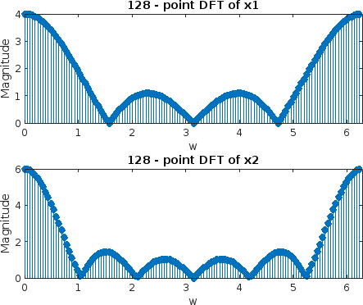

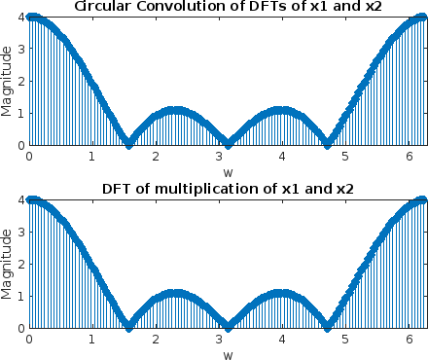

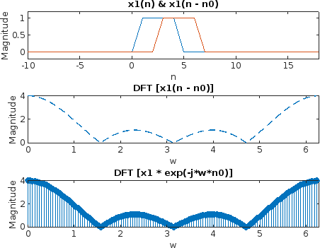

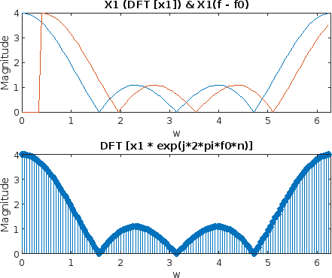

*Published with MATLAB® R2022b*