% Experiment 4: To Generate Gaussian Distributed Random Number and Plot the

% Density Function.Find the Mean and Variance.

% KANISHK

% 2021UCA1810

clc; clear all; close all;

N=1000000;

step=0.1;

x=randn(1,N); mux=mean(x); sigmax2=var(x); range=-3:step:3

f=1/sqrt(2*pi*sigmax2).*exp(-(range-mux).^2./(2.*sigmax2)); figure

plot(range,f,'b-*'); hold on h=histc(x,range); sinf=h/(step*sum(h)); plot(range,sinf,'m-'); xlabel('Range') ylabel('PDF')

title ('PDF of Gaussian Random Variable'); legend('Theoretical','Simulated');

*range =*

|  |  |  |  |  |  |  |
| --- | --- | --- | --- | --- | --- | --- |
| *Columns 1* | *through 7* | |  | | | |
| *-3.0000* | *-2.9000* | *-2.8000* | *-2.7000* | *-2.6000* | *-2.5000* | *-2.4000* |
| *Columns 8* | *through 14* | |  |  |  |  |
| *-2.3000* | *-2.2000* | *-2.1000* | *-2.0000* | *-1.9000* | *-1.8000* | *-1.7000* |
| *Columns 15* | *through* | *21* |  |  |  |  |
| *-1.6000* | *-1.5000* | *-1.4000* | *-1.3000* | *-1.2000* | *-1.1000* | *-1.0000* |
| *Columns 22* | *through* | *28* |  |  |  |  |
| *-0.9000* | *-0.8000* | *-0.7000* | *-0.6000* | *-0.5000* | *-0.4000* | *-0.3000* |
| *Columns 29* | *through* | *35* |  |  |  |  |
| *-0.2000* | *-0.1000* | *0* | *0.1000* | *0.2000* | *0.3000* | *0.4000* |
| *Columns 36* | *through* | *42* |  |  |  |  |
| *0.5000* | *0.6000* | *0.7000* | *0.8000* | *0.9000* | *1.0000* | *1.1000* |
| *Columns 43* | *through* | *49* |  |  |  |  |
| *1.2000* | *1.3000* | *1.4000* | *1.5000* | *1.6000* | *1.7000* | *1.8000* |

|  |  |  |  |  |  |  |  |
| --- | --- | --- | --- | --- | --- | --- | --- |
| *Columns 50* | *through* | *56* |  | | | | |
| *1.9000* | *2.0000* |  | *2.1000* | *2.2000* | *2.3000* | *2.4000* | *2.5000* |
| *Columns 57* | *through* | *61* |  |  |  |  |  |
| *2.6000* | *2.7000* |  | *2.8000* | *2.9000* | *3.0000* |  |  |

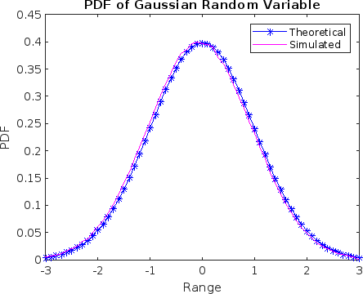

*Published with MATLAB® R2022b*