% Experiment 5: Compute the Signal to quantization Noise ratio of Uniform

% Quantization. Plot SNQR versus Quantization levels.

% KANISHK

% 2021UCA1810

clc;

clear all;

close all;

n=100; x=rand(1, n);

vmin=min(x);

vmax=max(x);

xpow=sum (x.^2)/n;

for i=1:1:14

L(i) =2^i;

d= (vmax-vmin)/L (i); for j=1:length(x)

start =min(x) ; while (start<x(j))

start=start+d;

end xq(j)=start-d;

if (start==x(j)) xq(j)=start;

end

end

end

err=x-xq; noisepow(i)=sum(err.^2)/n;

sqnr=xpow./noisepow; sqnrdb=10. \*log10(sqnr); plot (L,sqnrdb)

xlabel ('number of quantization levels'); ylabel ('SqNR');

title ('Uniform quantization')

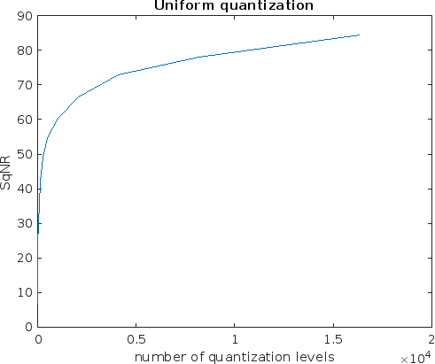

*Published with MATLAB® R2022b*