% Experiment 6: Compute the Signal to quantization Noise ratio of Non-Uniform

% Quantization.Plot SNQR versus Quantization levels.

% KANISHK

% 2021UCA1810

clc;

clear all;

close all;

n=100;

x=rand (1,n);

u=255;

xcomp= ((log(1+(abs (x)./max(x)).\*u))./log (1+u) ) ; %compressed sample vmin=min (xcomp); vmax=max (xcomp) ; xpow=sum (xcomp.^2)/n;

for i=1:1:14

L(i)=2^i;

d= (vmax-vmin)/L(i) ; for j=1:length (xcomp)

start =min (xcomp); while (start<xcomp (j) )

start=start+d;

end xq(j)=start-d; if(start==x(j))

xq(j) =start;

end

end

end

err=xcomp-xq;

noisepow (i)=sum (err.^2) /n;

sqnr=xpow./noisepow; sqnrdb=10.\*log10 (sqnr) ; plot (L, sqnrdb)

xlabel ('number of quantization levels'); ylabel ('SqNR');

title ('Non Uniform quantization')

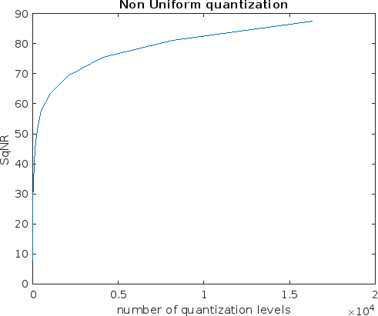

*Published with MATLAB® R2022b*