% Experiment 7 : Study of passband digital

% communication technique BPSK.Calculate the BER of BPSK modulated signal.

% KANISHK

% 2021UCA1810

N = 10^6; % number of bits or symbols

% Transmitter

a = rand(1,N)>0.5; % generating 0 and 1

s = 2*a-1; % BPSK modulation 0 -> -1; 1 -> 1 snr_dB = 1:1:10; % multiple Eb/N0 values snr_ratio = 10.^snr_dB/10;

n = 1/sqrt(2).*(randn(1,N)+1i*randn(1,N)); % mean=0; variance=1; for i = 1:length(snr_dB)

y = 10^(snr_dB(i)/20).*s + n;

a_dec = real(y)>0; % receiver - decision decoding nErr(i) = size(find(a- a_dec),2); % counting the errors end

simBer = nErr/N; % simulated ber

theoryBer = 0.5*erfc(sqrt(10.^(snr_dB/10))); % theoretical ber figure

semilogy(snr_dB,theoryBer,'b-','Linewidth',1.5); hold on semilogy(snr_dB,simBer,'x','MarkerSize',8);

%axis([-3 20 10^-6 0.5])

grid on

legend('theory', 'simulation'); xlabel('snr dB');

ylabel('Bit Error Rate');

title('Bit error probability - BPSK modulation');



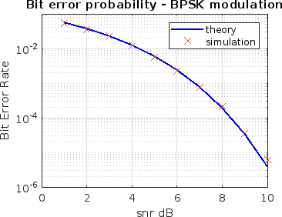

*Published with MATLAB® R2023a*