%Expt9.To generate a M/M/1 Queue having infinite buffer space with parameters (lambda,mu) and plot the average delay per packet vs lambda/mu.

%KANISHK

%2021UCA1810

clear all; close all clc; n=100000;

%Generating Lambda(Interarrival Time) And Mu(Service Time)

%Both Are Exponentially Distributed x=rand(1,n);

ex=(log(1-x)); count=hist(ex,20); lamda=count/(5*n); x=rand(1,n); ex=(log(1-x)); count=hist(ex,20); mu=count/(n); ltrue=max(lamda); mutrue=max(mu);

%True Rho Value rhotrue=ltrue/mutrue;

%Assigning X-Axis xaxis=linspace(0,rhotrue,length(lamda));

%Arrival Time Plot

plot(xaxis,lamda,'-d','Linewidth',1.2);hold on;

%Service Time Plot

plot(xaxis,mu,'-d','Linewidth',1.2);

%Calculating Waiting Time Wt(1) = lamda(1) + mu(1); for i=2:length(lamda)

if Wt(i-1) > lamda(i)

%extra_waiting_time ewt=Wt(i-1) - lamda(i);

Wt(i) = ewt + mu(i);

else if Wt(i-1) <= lamda(i) Wt(i) = mu(i);

end end end

%Waiting Time Plot

plot(xaxis,Wt,'-h','Linewidth',1.2) grid on; hold off;

legend('\lambda','\mu','Waiting time','location','NW'); title('\lambda \mu & Waiting Time','fontsize',14) xlabel('\rho=\lambda/\mu -->>','Fontsize',12,'fontweight','b')

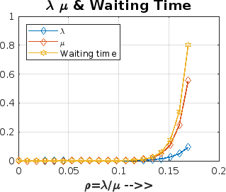

*Published with MATLAB® R2023a*