Documentation – 1

Playwright Installation
Cmd : npm init playwright@latest
- TypeScript or JavaScript (default: TypeScript)
- Tests folder name (default: tests, or e2e if tests already exists)
- Add a GitHub Actions workflow (recommended for CI)
- Install Playwright browsers (default: yes)
- npx playwright test
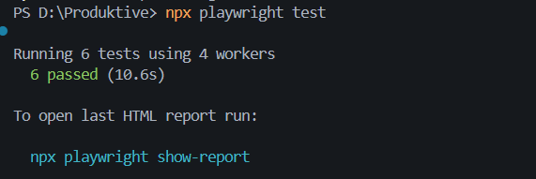
- npx playwright show-report 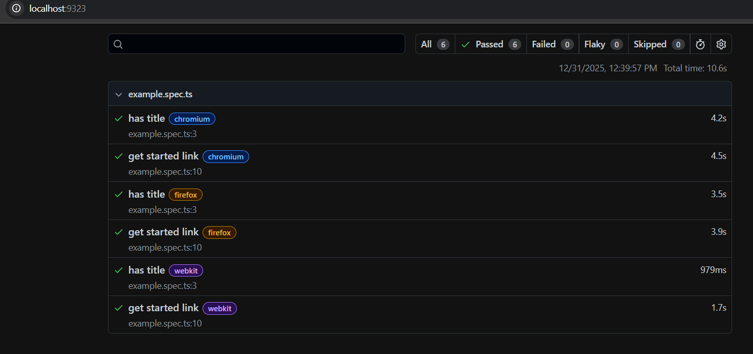

Writing tests and Assertions

