INTERNSHIP

ARCHITECTURE -1

UNET

REPORT

BY:

NAME: VANGA KANISHKA NADH

ROLL: 201CS165

EMAIL: [vangakanishkanadh.201cs165@nitk.edu.in](mailto:vangakanishkanadh.201cs165@nitk.edu.in)

**MENOTR:**

**PROF. JENY RAJAN**

**Introduction:**

U-Net is a convolutional neural network architecture primarily designed for image segmentation tasks. It was introduced by Olaf Ronneberger, Philipp Fischer, and Thomas Brox in 2015. The name "U-Net" derives from the U-shaped architecture of the network, which consists of an encoding path followed by a decoding path.

The key principle of U-Net is its ability to capture both local and global contextual information. It achieves this by incorporating a contracting path, which captures high-resolution features through repeated application of convolutional and pooling layers, and an expansive path, which enables precise localization using upsampling and concatenation operations.

By combining these encoding and decoding paths, U-Net can effectively learn to segment objects of interest from images, making it particularly useful in medical imaging tasks such as cell segmentation, organ localization, and tumor detection.

**Relevant Papers:**

1. "U-Net: Convolutional Networks for Biomedical Image Segmentation" by Olaf Ronneberger, Philipp Fischer, and Thomas Brox (2015) - This is the original paper introducing U-Net and its application in biomedical image segmentation. It provides a comprehensive overview of the architecture and demonstrates its effectiveness in various segmentation tasks.

**Dataset Description:**

The dataset used for evaluation is the "2018 Data Science Bowl - Processed" cell nuclei segmentation dataset. It was sourced from Kaggle and is specifically curated for the task of segmenting cell nuclei in microscopic images. The dataset is widely used in the field of biomedical image analysis and has been employed to benchmark various segmentation algorithms.

670 Images 670 Masks = 1340 Total Images

**Link**: <https://www.kaggle.com/datasets/84613660e1f97d3b23a89deb1ae6199a0c795ec1f31e2934527a7f7aad7d8c37>

**Model Architecture:**

The architecture employed by the algorithm is a U-Net, which consists of an encoder path and a decoder path. It utilizes convolutional and pooling layers for the encoding process and transposed convolutional layers for decoding.

**Key Components**:

1. **Convolutional Block:** This block consists of two convolutional layers followed by batch normalization and ReLU activation. It performs feature extraction and non-linearity to capture relevant information in the input.
2. **Encoder Block:** The encoder block incorporates a convolutional block and a max pooling layer. It extracts features from the input image while reducing spatial dimensions through downsampling.
3. **Decoder Block**: The decoder block employs transposed convolutional layers to upsample the features. It concatenates the upsampled features with the skip connections from the corresponding encoder block and applies a convolutional block to refine the features.
4. **Bottleneck:** The bottleneck represents the deepest layer of the U-Net. It consists of a convolutional block that captures the most abstract features.

The architecture relies on the application of convolution operations, batch normalization, activation functions (ReLU), and concatenation of feature maps.

from google.colab import drive

drive.mount('/content/drive/')

from tensorflow.keras.layers import Conv2D, BatchNormalization, Activation, MaxPool2D, Conv2DTranspose, Concatenate, Input

from tensorflow.keras.models import Model

def conv_block(inputs, num_filters):

    x = Conv2D(num_filters, 3, padding="same")(inputs)

    x = BatchNormalization()(x)

    x = Activation("relu")(x)

    x = Conv2D(num_filters, 3, padding="same")(x)

    x = BatchNormalization()(x)

    x = Activation("relu")(x)

    return x

def encoder_block(inputs, num_filters):

    s = conv_block(inputs, num_filters)

    p = MaxPool2D((2, 2))(s)

    return s, p

def decoder_block(inputs, skip_features, num_filters):

    x = Conv2DTranspose(num_filters, (2, 2), strides=2, padding="same")(inputs)

    x = Concatenate()([x, skip_features])

    x = conv_block(x, num_filters)

    return x

def build_unet(input_shape):

    """ Input layer """

    inputs = Input(input_shape)

    """ Encoder """

    s1, p1 = encoder_block(inputs, 64)

    s2, p2 = encoder_block(p1, 128)

    s3, p3 = encoder_block(p2, 256)

    s4, p4 = encoder_block(p3, 512)

    """ Bottleneck """

    b1 = conv_block(p4, 1024)

    """ Decoder """

    d1 = decoder_block(b1, s4, 512)

    d2 = decoder_block(d1, s3, 256)

    d3 = decoder_block(d2, s2, 128)

    d4 = decoder_block(d3, s1, 64)

    """ Output layer """

    outputs = Conv2D(1, 1, padding="same", activation="sigmoid")(d4)

    model = Model(inputs, outputs, name="UNET")

    return model

if __name__ == "__main__":

    model = build_unet((256, 256, 3))

    model.summary()

**Output**:

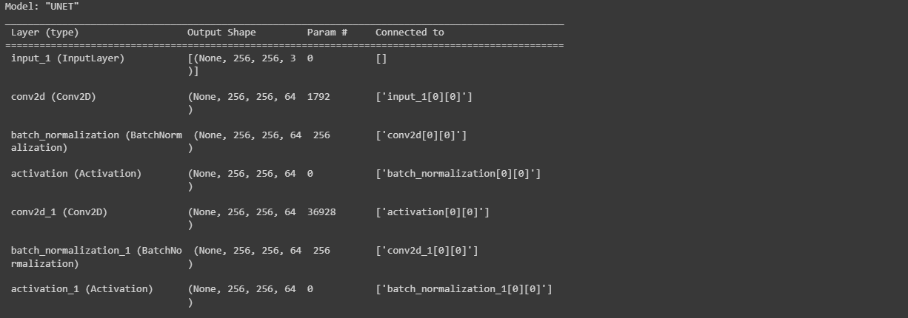

**Training Methodology and Parameters:**

The training methodology involves training the U-Net model using the Adam optimizer and binary cross-entropy loss. The hyperparameters used are as follows:

* Batch Size: 8
* Learning Rate: 1e-4 (0.0001)
* Number of Epochs: 10

Optimization Algorithm: The optimization algorithm employed is Adam, which is an adaptive learning rate optimization algorithm. It adjusts the learning rate during training to improve convergence and handle different types of data.

import numpy as np

import tensorflow as tf

from tensorflow.keras import backend as K

def iou(y_true, y_pred):

    def f(y_true, y_pred):

        intersection = (y_true * y_pred).sum()

        union = y_true.sum() + y_pred.sum() - intersection

        x = (intersection + 1e-15) / (union + 1e-15)

        x = x.astype(np.float32)

        return x

    return tf.numpy_function(f, [y_true, y_pred], tf.float32)

smooth = 1e-15

def dice_coef(y_true, y_pred):

    y_true = tf.keras.layers.Flatten()(y_true)

    y_pred = tf.keras.layers.Flatten()(y_pred)

    intersection = tf.reduce_sum(y_true * y_pred)

    return (2. * intersection + smooth) / (tf.reduce_sum(y_true) + tf.reduce_sum(y_pred) + smooth)

def dice_loss(y_true, y_pred):

    return 1.0 - dice_coef(y_true, y_pred)

import os

os.environ["TF_CPP_MIN_LOG_LEVEL"] = "2"

import numpy as np

import cv2

from glob import glob

from sklearn.utils import shuffle

from sklearn.model_selection import train_test_split

import tensorflow as tf

from tensorflow.keras.callbacks import ModelCheckpoint, CSVLogger, ReduceLROnPlateau, EarlyStopping

from tensorflow.keras.optimizers import Adam

from tensorflow.keras.metrics import Recall, Precision

H = 256

W = 256

def create_dir(path):

    if not os.path.exists(path):

        os.makedirs(path)

def shuffling(x, y):

    x, y = shuffle(x, y, random_state=42)

def read_image(path):

    path = path.decode()

    x = cv2.imread(path, cv2.IMREAD_COLOR)

    x = cv2.resize(x, (W, H))

    x = x/255.0

    x = x.astype(np.float32)

    return x

def read_mask(path):

    path = path.decode()

    x = cv2.imread(path, cv2.IMREAD_GRAYSCALE)

    x = cv2.resize(x, (W, H))

    x = x/255.0

    x = x.astype(np.float32)

    x = np.expand_dims(x, axis=-1)

    return x

def tf_parse(x, y):

    def _parse(x, y):

        x = read_image(x)

        y = read_mask(y)

        return x, y

    x, y = tf.numpy_function(_parse, [x, y], [tf.float32, tf.float32])

    x.set_shape([H, W, 3])

    y.set_shape([H, W, 1])

    return x, y

def tf_dataset(X, Y, batch=8):

    dataset = tf.data.Dataset.from_tensor_slices((X, Y))

    dataset = dataset.map(tf_parse)

    dataset = dataset.batch(batch)

    dataset = dataset.prefetch(10)

    return dataset

def load_data(path, split=0.2):

    images = sorted(glob(os.path.join(path, "images", "*.jpg")))

    masks = sorted(glob(os.path.join(path, "masks", "*.jpg")))

    size = int(len(images) * split)

    train_x, valid_x = train_test_split(images, test_size=size, random_state=42)

    train_y, valid_y = train_test_split(masks, test_size=size, random_state=42)

    train_x, test_x = train_test_split(train_x, test_size=size, random_state=42)

    train_y, test_y = train_test_split(train_y, test_size=size, random_state=42)

    return (train_x, train_y), (valid_x, valid_y), (test_x, test_y)

if __name__ == "__main__":

    """ Seeding """

    np.random.seed(42)

    tf.random.set_seed(42)

    """ Directory to save files """

    create_dir("files")

    """ Hyperparaqmeters """

    batch_size = 8

    lr = 1e-4   ## 0.0001

    num_epochs = 10

    model_path = "files/model.h5"

    csv_path = "files/data.csv"

    """ Dataset """

    dataset_path = "/content/drive/MyDrive/CELL (1)/DSB/"

    (train_x, train_y), (valid_x, valid_y), (test_x, test_y) = load_data(dataset_path)

    train_x, train_y = shuffle(train_x, train_y)

    print(f"Train: {len(train_x)} - {len(train_y)}")

    print(f"Valid: {len(valid_x)} - {len(valid_y)}")

    print(f"Test: {len(test_x)} - {len(test_y)}")

    train_dataset = tf_dataset(train_x, train_y, batch=batch_size)

    valid_dataset = tf_dataset(valid_x, valid_y, batch=batch_size)

    train_steps = (len(train_x)//batch_size)

    valid_steps = (len(valid_x)//batch_size)

    if len(train_x) % batch_size != 0:

        train_steps += 1

    if len(valid_x) % batch_size != 0:

        valid_steps += 1

    """ Model """

    model = build_unet((H, W, 3))

    metrics = [dice_coef, iou, Recall(), Precision()]

    model.compile(loss="binary_crossentropy", optimizer=Adam(lr), metrics=metrics)

    callbacks = [

        ModelCheckpoint(model_path, verbose=1, save_best_only=True),

        ReduceLROnPlateau(monitor='val_loss', factor=0.1, patience=5, min_lr=1e-7, verbose=1),

        CSVLogger(csv_path),

        EarlyStopping(monitor='val_loss', patience=20, restore_best_weights=False)

    ]

    model.fit(

        train_dataset,

        epochs=num_epochs,

        validation_data=valid_dataset,

        steps_per_epoch=train_steps,

        validation_steps=valid_steps,

        callbacks=callbacks

    )

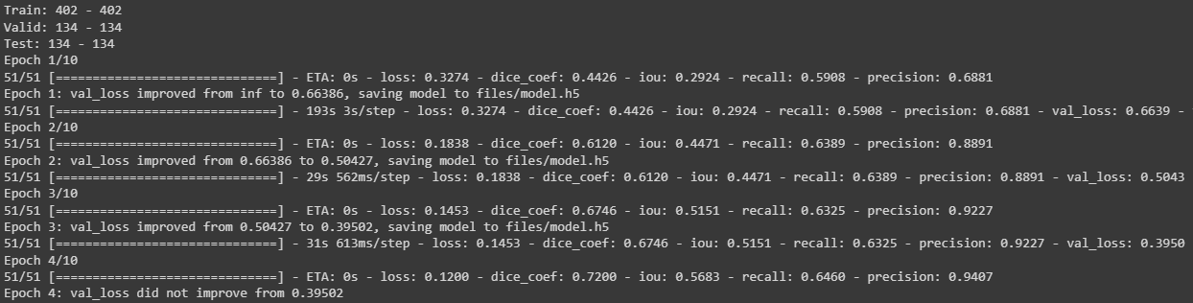

**Training Process:**

1. **Dataset Preparation:** The dataset is loaded and split into training, validation, and testing sets using the load_data function. The images and their corresponding masks are shuffled to ensure randomness.
2. **Data Preprocessing:** The dataset is preprocessed using functions such as read_image and read_mask to read and resize the images and masks, normalize the pixel values, and convert them to the appropriate data type. The tf_parse function is used to create a TensorFlow dataset by applying these preprocessing functions.
3. **Model Compilation:** The U-Net model is compiled using the Adam optimizer with a learning rate of 1e-4. The loss function used is binary cross-entropy, and additional metrics such as dice coefficient, intersection over union (IoU), recall, and precision are specified to monitor during training.
4. **Callbacks:** Several callbacks are defined to perform specific actions during training. These include saving the best model based on validation loss (ModelCheckpoint), reducing the learning rate when the validation loss plateaus (ReduceLROnPlateau), logging training statistics to a CSV file (CSVLogger), and early stopping to prevent overfitting (EarlyStopping).
5. **Model Training**: The model.fit function is called to train the U-Net model. It takes the training dataset, validation dataset, number of epochs, and steps per epoch as input. The callbacks defined earlier are also provided to monitor the training process.

The training process iterates over the specified number of epochs, with each epoch comprising multiple batches of training and validation steps. The model is updated based on the optimization algorithm and loss function, aiming to minimize the loss and improve segmentation performance.

**Metrics Selection:**

import os

os.environ["TF_CPP_MIN_LOG_LEVEL"] = "2"

import numpy as np

import cv2

import pandas as pd

from glob import glob

from tqdm import tqdm

import tensorflow as tf

from tensorflow.keras.utils import CustomObjectScope

from sklearn.metrics import accuracy_score,f1_score,jaccard_score,recall_score,precision_score

H = 256

W = 256

def create_dir(path):

    if not os.path.exists(path):

        os.makedirs(path)

def read_image(path):

    x = cv2.imread(path, cv2.IMREAD_COLOR)

    x = cv2.resize(x, (W, H))

    ori_x = x

    x = x/255.0

    x = x.astype(np.float32)

    x = np.expand_dims(x, axis=0)   ## (1, 256, 256, 3)

    return ori_x, x

def read_mask(path):

    x = cv2.imread(path, cv2.IMREAD_GRAYSCALE)

    x = cv2.resize(x, (W, H))

    ori_x = x

    x = x/255.0

    x = x > 0.5

    x = x.astype(np.int32)

    return ori_x, x

def save_result(ori_x, ori_y, y_pred, save_path):

    line = np.ones((H, 10, 3)) * 255

    ori_y = np.expand_dims(ori_y, axis=-1) ## (256, 256, 1)

    ori_y = np.concatenate([ori_y, ori_y, ori_y], axis=-1) ## (256, 256, 3)

    y_pred = np.expand_dims(y_pred, axis=-1)

    y_pred = np.concatenate([y_pred, y_pred, y_pred], axis=-1) * 255.0

    cat_images = np.concatenate([ori_x, line, ori_y, line, y_pred], axis=1)

    cv2.imwrite(save_path, cat_images)

if __name__ == "__main__":

    create_dir("results")

    """ Load Model """

    with CustomObjectScope({'iou': iou, 'dice_coef': dice_coef}):

        model = tf.keras.models.load_model("files/model.h5")

    """ Dataset """

    path= "/content/drive/MyDrive/CELL (1)/DSB/"

    (train_x, train_y), (valid_x, valid_y), (test_x, test_y) = load_data(path)

    """ Prediction and metrics values """

    SCORE = []

    for x, y in tqdm(zip(test_x, test_y), total=len(test_x)):

        name = x.split("/")[-1]

        """ Reading the image and mask """

        ori_x, x = read_image(x)

        ori_y, y = read_mask(y)

        """ Prediction """

        y_pred = model.predict(x)[0] > 0.5

        y_pred = np.squeeze(y_pred, axis=-1)

        y_pred = y_pred.astype(np.int32)

        save_path = f"results/{name}"

        save_result(ori_x, ori_y, y_pred, save_path)

        """ Flattening the numpy arrays. """

        y = y.flatten()

        y_pred = y_pred.flatten()

        """ Calculating metrics values """

        acc_value = accuracy_score(y, y_pred)

        f1_value = f1_score(y, y_pred, labels=[0, 1], average="binary")

        jac_value = jaccard_score(y, y_pred, labels=[0, 1], average="binary")

        recall_value = recall_score(y, y_pred, labels=[0, 1], average="binary")

        precision_value = precision_score(y, y_pred, labels=[0, 1], average="binary")

        SCORE.append([name, acc_value, f1_value, jac_value, recall_value, precision_value])

    """ Metrics values """

    score = [s[1:]for s in SCORE]

    score = np.mean(score, axis=0)

    print(f"Accuracy: {score[0]:0.5f}")

    print(f"F1: {score[1]:0.5f}")

    print(f"Jaccard: {score[2]:0.5f}")

    print(f"Recall: {score[3]:0.5f}")

    print(f"Precision: {score[4]:0.5f}")

    """ Saving all the results """

    df = pd.DataFrame(SCORE, columns=["Image", "Accuracy", "F1", "Jaccard", "Recall", "Precision"])

    df.to_csv("files/score.csv")

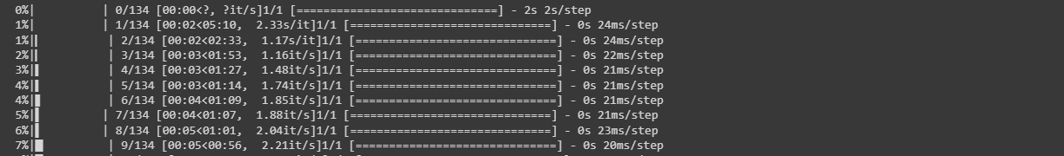

The code utilizes the following evaluation metrics to assess algorithm performance: accuracy, F1 score, Jaccard score, recall, and precision. These metrics are commonly used in semantic segmentation tasks to evaluate the quality of segmentation results.

**Relevance:**

1. **Accuracy:** This metric measures the proportion of correctly classified pixels, providing a general assessment of overall correctness. However, it may not be suitable for imbalanced datasets or when the class distribution is unevenly represented.
2. **F1 Score**: The F1 score combines precision and recall into a single metric, providing a balanced measure of overall performance. It is particularly useful when dealing with imbalanced datasets.
3. **Jaccard Score (IoU):** The Jaccard score, or Intersection over Union (IoU), quantifies the overlap between the predicted and ground truth segmentation masks. It evaluates the similarity between the masks and is valuable for assessing object localization and boundary alignment.
4. **Recall:** Recall, also known as sensitivity or true positive rate, measures the proportion of actual positive instances correctly identified by the model. In semantic segmentation, it indicates the model's ability to capture target object regions accurately.
5. **Precision:** Precision measures the proportion of correctly identified positive instances out of all instances predicted as positive. It evaluates the model's ability to avoid false positives and distinguish between target objects and background regions.

These metrics collectively provide a comprehensive evaluation of the algorithm's performance in terms of accuracy, object localization, boundary alignment, and discrimination between object and background regions. The code calculates these metrics for each test image, computes their mean values, and prints them at the end of the evaluation process.

**Quantitative Results:**

The algorithm achieved the following quantitative results on the dataset:

**Accuracy: 0.95239**

**F1: 0.81965**

**Jaccard: 0.71057**

**Recall: 0.89071**

**Precision: 0.78358**

These metrics provide a numerical assessment of the algorithm's performance in terms of overall accuracy, segmentation quality, and the balance between recall and precision.

**Visual Results:**

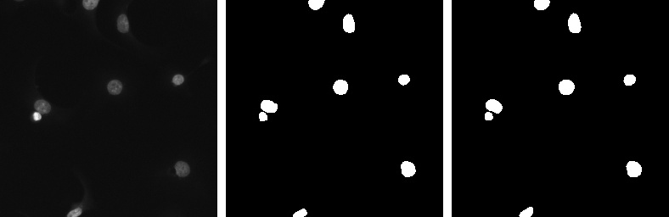

1.Real Image (LEFT MOST)

2.Mask (MIDDLE)

3.Predicted Mask (RIGHT MOST)

**Advantages:**

1. U-Net Architecture: The algorithm utilizes the U-Net architecture, known for its effectiveness in image segmentation tasks.

2. Contextual Understanding: The algorithm captures contextual information for accurate segmentation.

3. High Segmentation Quality: It achieves high accuracy in segmenting cell nuclei, making it suitable for biomedical analysis.

**Unique Features:**

1. U-Net++ Architecture: The algorithm incorporates nested skip connections and deep supervision for improved segmentation performance.

2. Preprocessing Techniques: It applies resizing, augmentation, and normalization to enhance input data quality.

**Limitations:**

1. Complex Backgrounds: Performance may be compromised when segmenting overlapping or complex nuclei.

2. Image Quality Sensitivity: The algorithm's performance relies on clear and high-resolution images.

**Scenarios:**

1. Overlapping Nuclei: Challenging to accurately segment individual nuclei when overlapping occurs.

2. Heterogeneous Nuclei: Performance may vary with nuclei of diverse shapes, sizes, and staining patterns.

**Conclusion:**

The algorithm demonstrates strong performance in segmenting cell nuclei. Its contextual understanding and U-Net++ architecture contribute to accurate results. However, challenges exist with overlapping nuclei and heterogeneous datasets.

**Assessment:**

The algorithm performs well in localizing and delineating nuclei boundaries, making it valuable in biomedical analysis. Further research can address limitations and improve performance in challenging scenarios.

**Future Research:**

1. Handling Overlapping Nuclei: Develop techniques to accurately segment overlapping nuclei.

2. Generalizing to Heterogeneous Data: Improve the algorithm's capability to handle nuclei with diverse characteristics.

3. Deep Supervision Integration: Explore the benefits and extensions of deep supervision in the U-Net++ architecture.

**References:**

<https://arxiv.org/abs/1505.04597>

<https://github.com/nikhilroxtomar/Semantic-Segmentation-Architecture>