Assessment 4
HTML, CSS, DESIGN, AND JS

Name: Kanishk Nanda
Student ID: 11842396
Subject code: ITC-293
Date of submission: /04/2026

Kanishk Gaming Portfolio Website Report

TABLE OF CONTENTS:

1) Introduction
2) Concept Map
3) CSS Design
4) Navigation Map
5) Structure Chart
6) Storyboards
7) Testing Plan
8) Validation Section
9) Requirement Checklist
10) Test Section
11) Improvements from A3 to A4
12) Personal Reflection
13) References

INTRODUCTION
This report explains the development and improvement of my portfolio website based on a fictional company called “Kanishk Gaming” in the online gaming sector. The purpose of this website is to showcase both technical and professional skills through the use of HTML, CSS, and JavaScript while creating a consistent and user-friendly experience.
In this assessment, I expanded my previous website from Assignment 3 by introducing additional pages to highlight different skills, including problem-solving, communication, teamwork, and digital technology knowledge. A newsletter signup page was also developed using HTML forms and JavaScript validation to improve website functionality and interactivity.
The website maintains a consistent design across all pages through the use of external CSS and organised folder structures. This report includes updated design documentation, testing outcomes, validation results, and reflections to demonstrate that the website meets the required standards and assignment objectives.

CONCEPT MAP

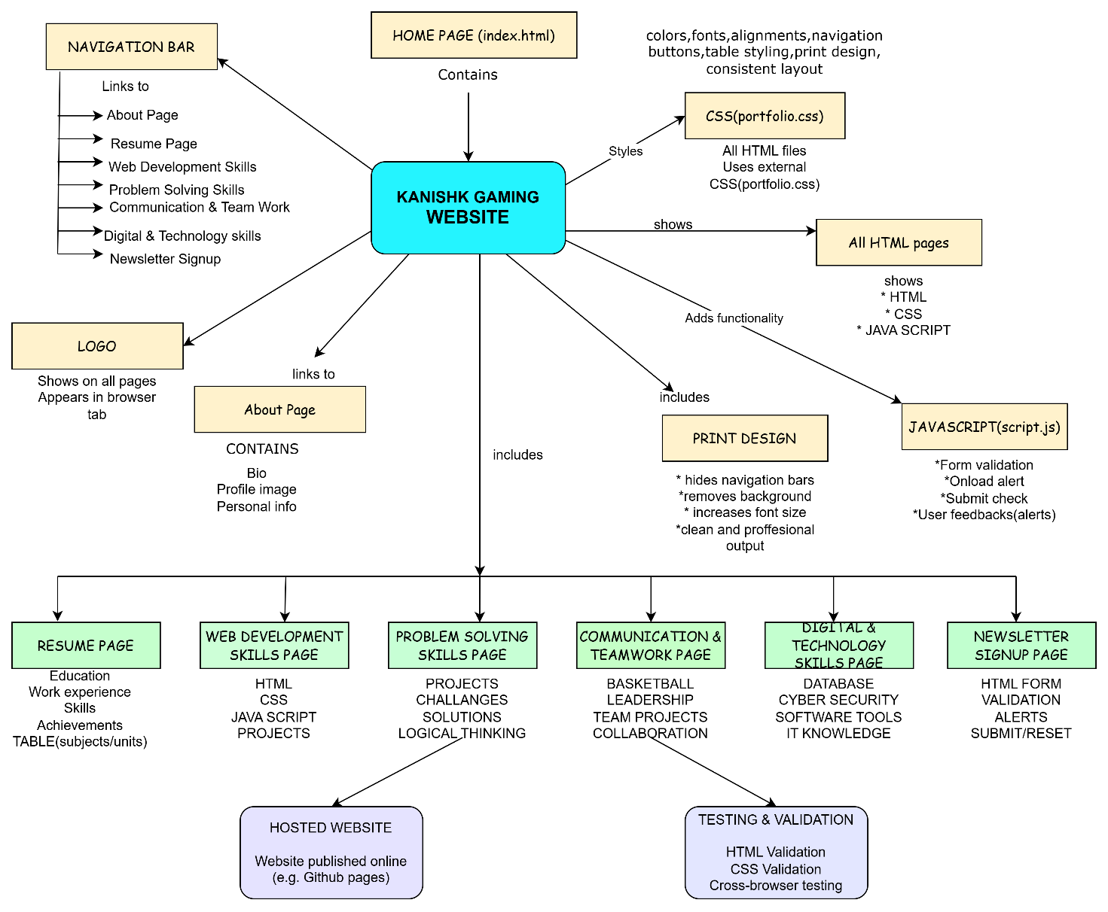

The concept map shows the updated structure of the Kanishk Gaming website and how the different pages and features are connected. Compared to the previous assignment, additional pages were introduced to showcase technical and professional skills, including Problem Solving, Communication and Teamwork, Digital and Technology Skills, and a Newsletter Signup page.

The updated concept map also includes the use of external CSS for consistent styling and JavaScript to support interactive features such as form validation and alert messages. These additions improved website functionality, organisation, and overall user experience while maintaining a consistent design across all pages.

CSS DESIGN

The website uses an external CSS file (portfolio.css) to maintain a consistent appearance across all pages. A dark theme was continued to match the Kanishk Gaming concept while improving readability through spacing, colours, and content organisation.

CSS was used to style navigation buttons, content sections, tables, images, and the footer. Different selectors, including universal, element, class, and ID selectors, were applied to create a structured and reusable design.

Compared to the previous assignment, additional styling was applied to support the new pages and improve consistency across the expanded website structure. Styling was also added to the Newsletter Signup page to improve form readability and user interaction.

Print-friendly CSS remains included using media queries to remove unnecessary elements and improve readability when printed.

Visual demonstration of CSS elements of the proposed website-

- NAVIGATION BAR

The navigation bar is styled using CSS buttons with background colours, spacing and hover effect to improve user interaction.

- HOME PAGE LAYOUT

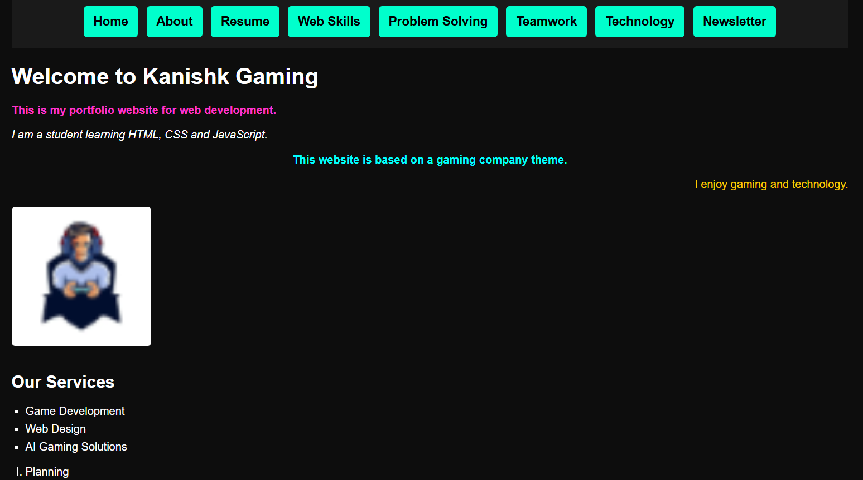

Home page layout showing the dark theme design, text alignment, colours, spacing and overall structure styled using CSS.

- RESUME TABLE

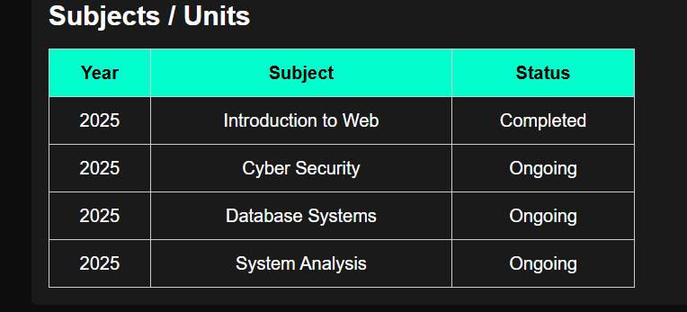

Resume page table showing year, subject, status, using CSS with borders, alignment and background colours for a clear presentation of data.

- FOOTER



Footer section displaying contact details and copyright information styled using CSS.

- PRINT VIEW

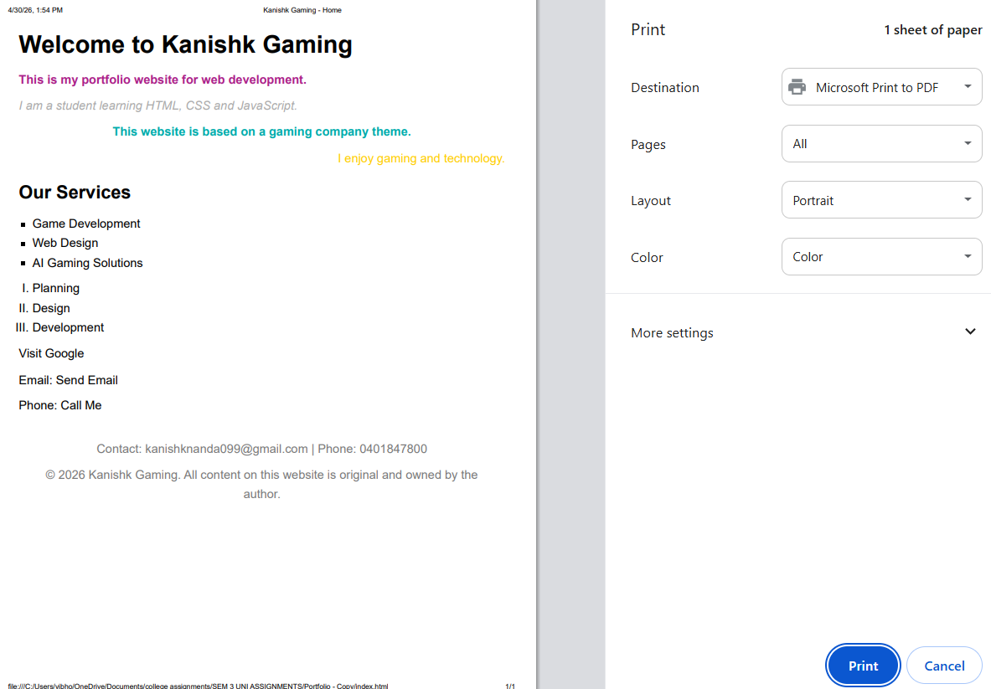
Print view of the website showing removal of navigation bar, white background and increased readability using CSS media query.

- NEWSLETTER FORM

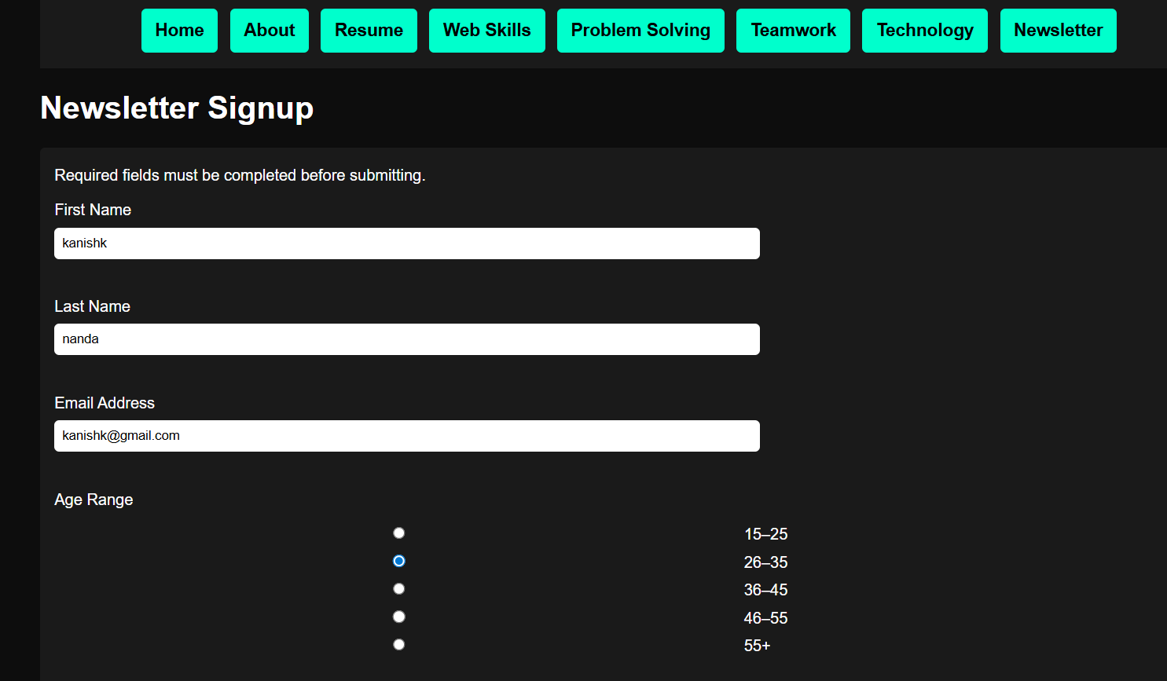

Newsletter form layout showing text inputs and user information fields.

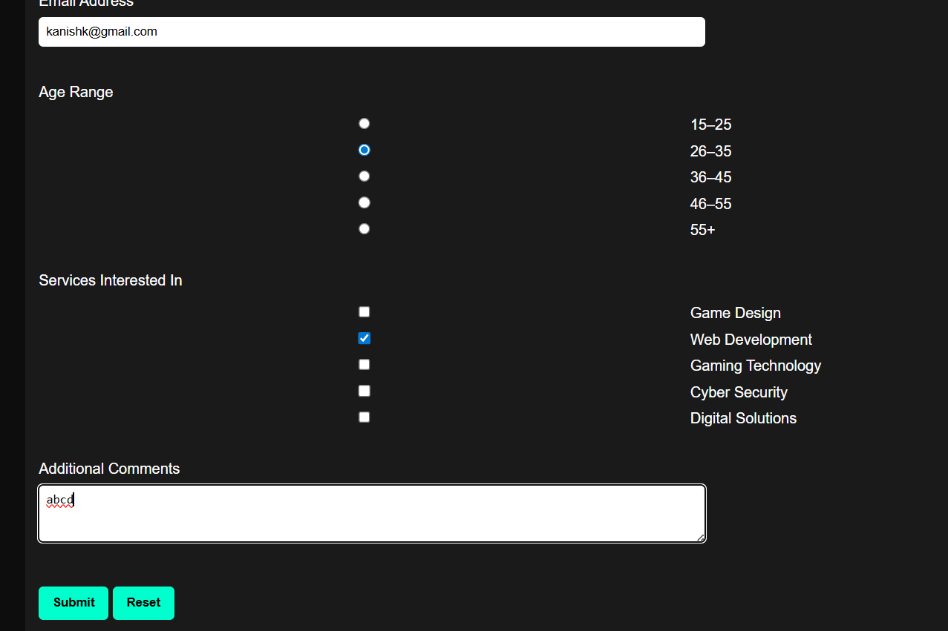Newsletter form controls showing checkbox selection, comments area and submission buttons with JavaScript validation support.
NAVIGATION MAP

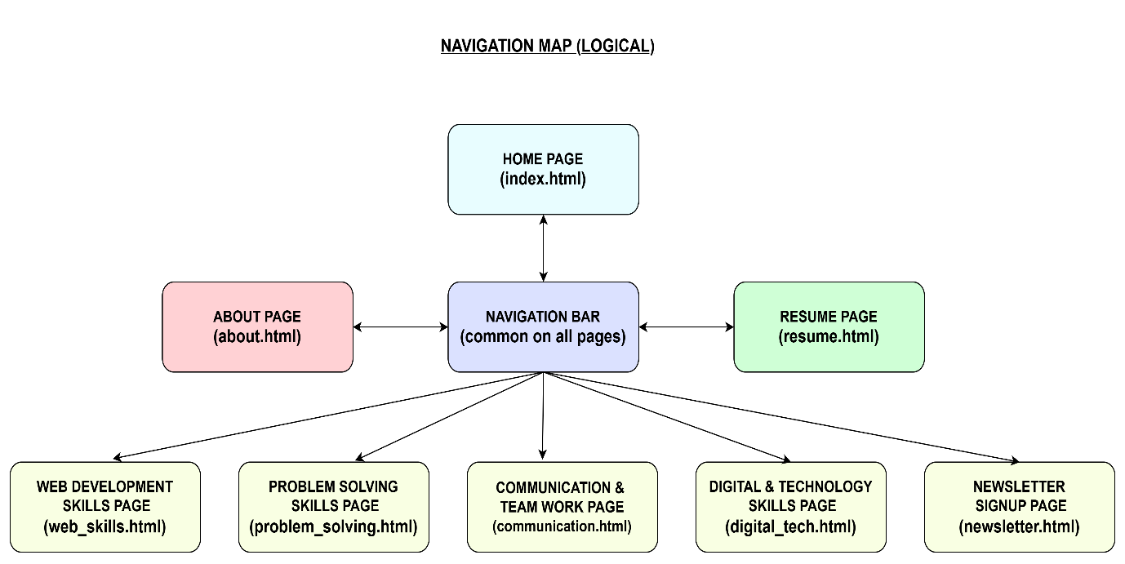

This navigation map shows the updated structure of the Kanishk Gaming website and how users move between pages. Compared to the previous assignment, additional pages were added to improve website content and functionality, including Problem Solving, Communication and Teamwork, Digital and Technology Skills, and the Newsletter Signup page.

The navigation bar is available across all pages and provides consistent access throughout the website. This structure improves usability, creates a smoother user experience, and allows users to move easily between different sections of the portfolio website.

STRUCTURE CHART

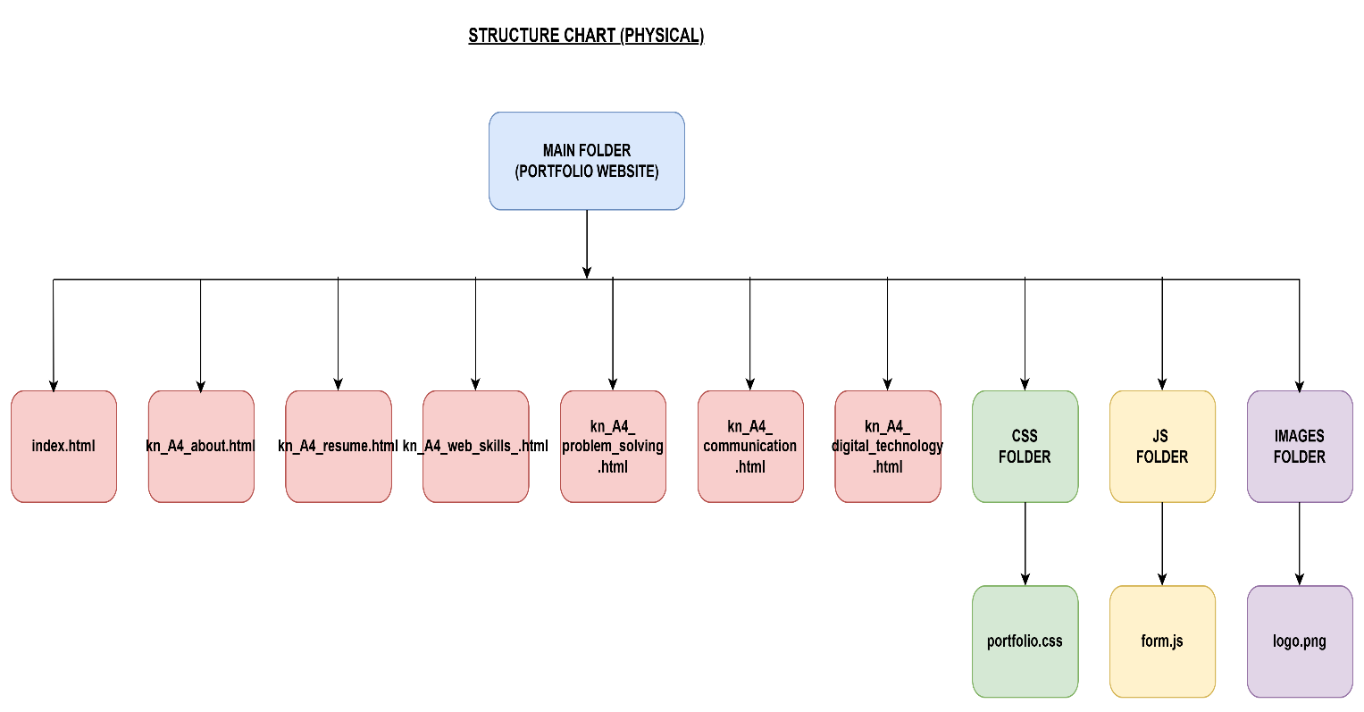

This structure chart shows how the website files are organised into folders to improve organisation and maintenance. Compared to the previous assignment, additional HTML pages and a JavaScript folder were added to support new website features and interactive functionality.

The CSS folder stores the external stylesheet used across the website, while the images folder contains visual assets such as the logo. The JavaScript folder contains the form validation script used by the Newsletter Signup page.

STORYBOARDS

HOME PAGE

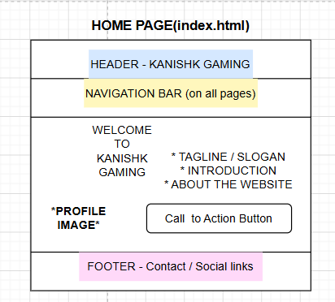

This storyboard shows the updated layout of the Home page, including the navigation bar, introduction content, image section, and services area. The page is designed to create a strong first impression while providing clear access to all sections of the website.

ABOUT PAGE

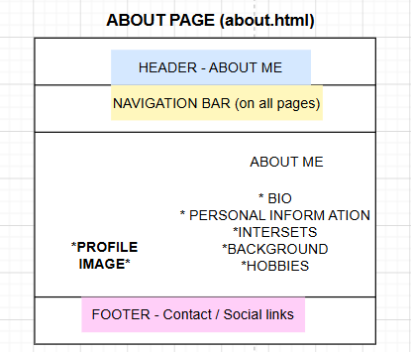

This storyboard represents the layout of the About page, which introduces background information and personal details. The page maintains consistent navigation and styling to support a clear and organised user experience.

RESUME PAGE

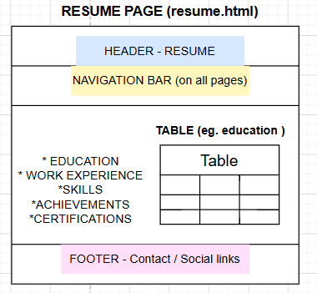

This storyboard shows the Resume page layout, including education, experience, skills, and structured information presentation. Tables and organised content improve readability and maintain consistency across the website.

WEB SKILLS PAGE

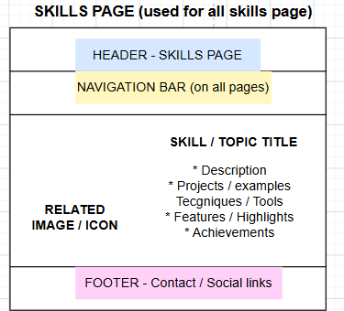

This storyboard represents the layout used across the skills-related pages including Web Skills, Problem Solving, Communication and Teamwork, and Digital Technology. A consistent structure was maintained to improve usability and create a unified website appearance.

NEWSLETTER PAGE

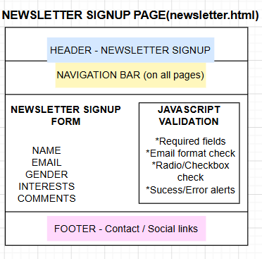
This storyboard shows the layout of the Newsletter Signup page, including input fields, selection controls, validation behaviour, and action buttons. The page was designed to improve user interaction through HTML forms and JavaScript functionality.

TESTING PLAN

The website was tested to ensure that all pages, navigation functions, styling, and interactive elements operate correctly and provide a consistent user experience.

All HTML pages were opened and checked in a web browser to confirm that content, colours, layout, and navigation displayed correctly. The navigation bar was tested across all pages to ensure users could move between sections without errors.

Additional testing was completed for the Newsletter Signup page. JavaScript functionality was tested to confirm that the welcome alert appears correctly, required fields are validated, successful submission messages display, and the reset button clears form data as expected.

The print-friendly feature was tested using print preview to confirm that unnecessary visual elements are removed and readability is improved. HTML and CSS validation were also completed to ensure correct syntax and compatibility across different browsers.

VALIDATION SECTION

Index.html validation screenshot

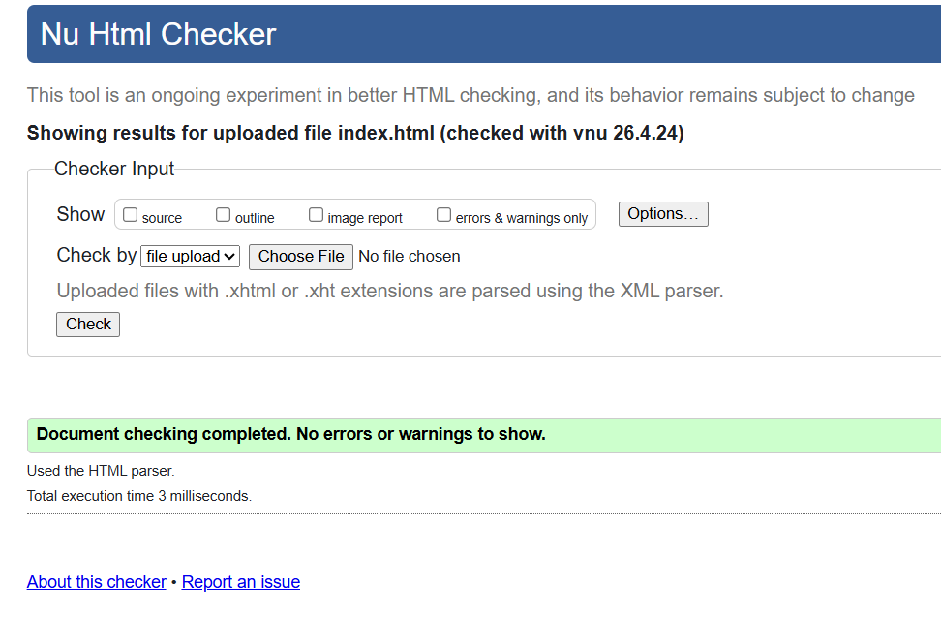

VALIDATION APPROVED

kn_A4_about.html validation screenshot

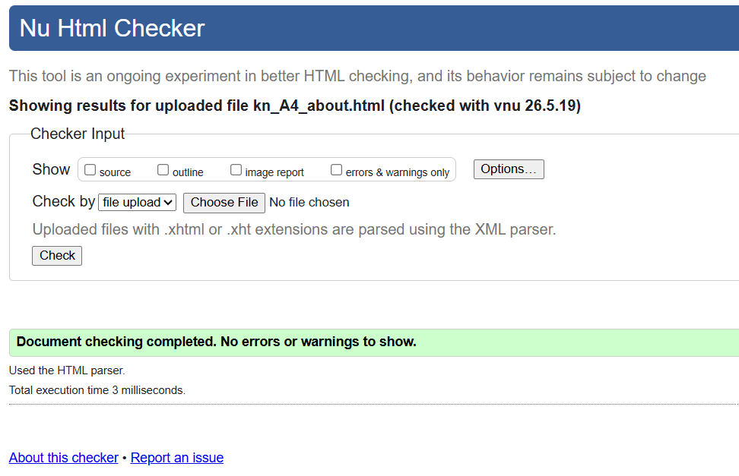

VALIDATION APPROVED

kn_A4_resume.html validation screenshot

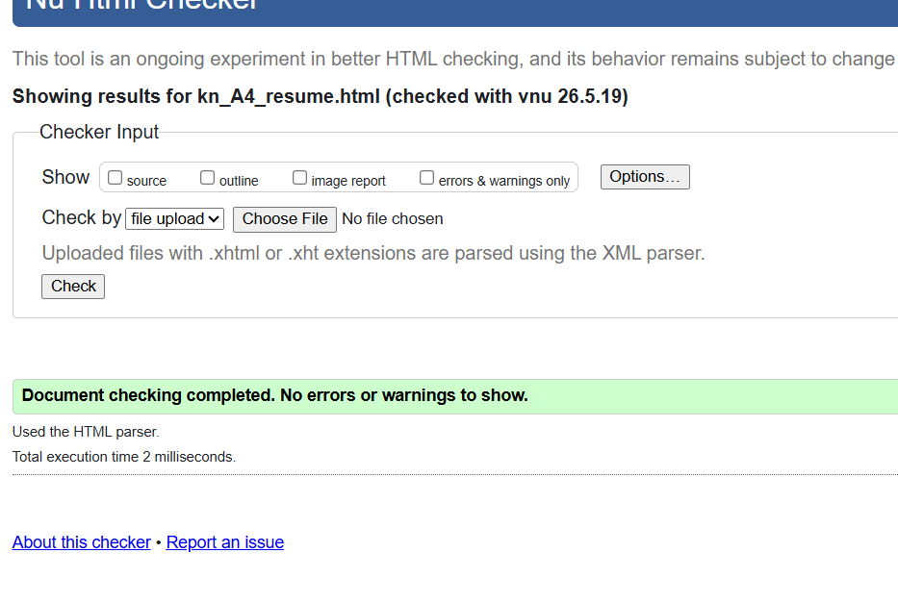

VALIDATION APPROVED

kn_A4_web_skills.html validation screenshot

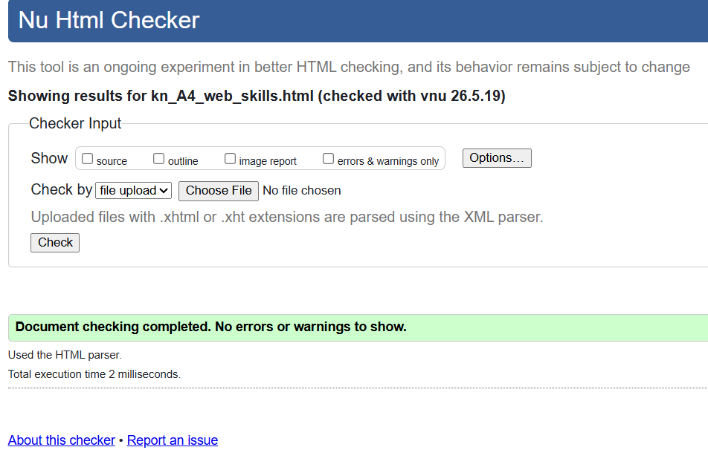

VALIDATION APPROVED

kn_A4_problem_solving.html validation screenshot

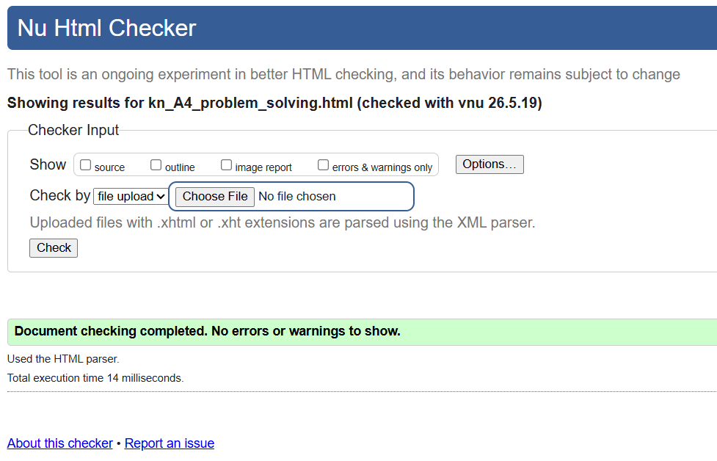

VALIDATION APPROVED

kn_A4_communication.html validation screenshot

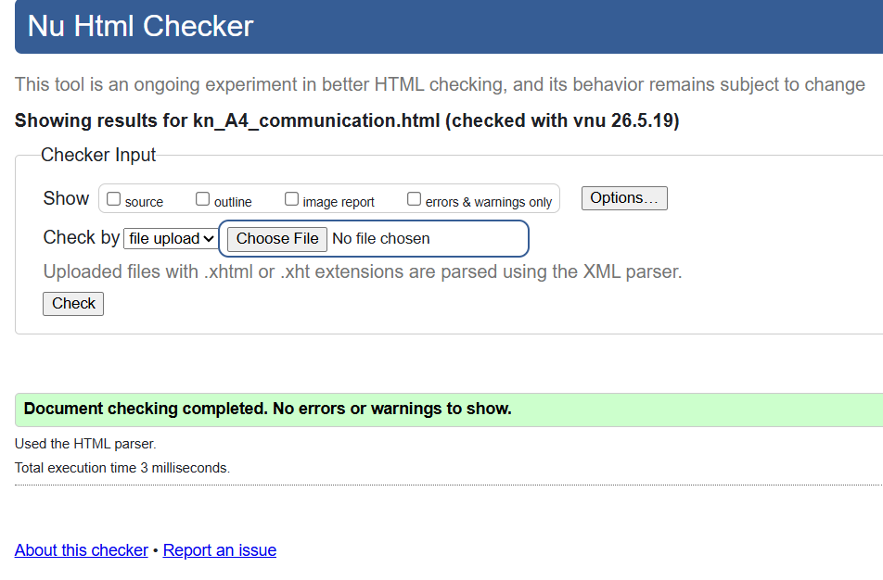

VALIDATION APPROVED

kn_A4_digital_technology.html

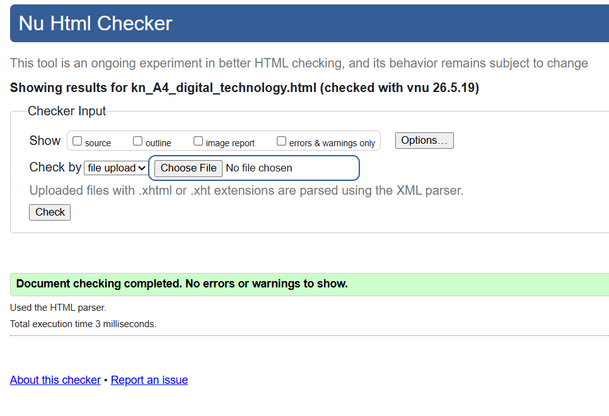

VALIDATION APPROVED

kn_A4_newsletter.html validation screenshot

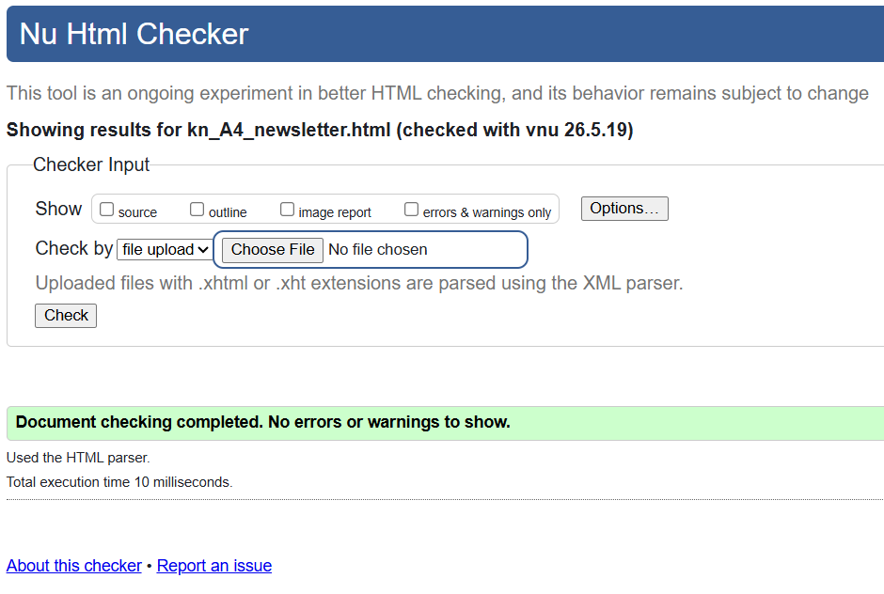

VALIDATION APPROVED

portfolio.css validation screenshot

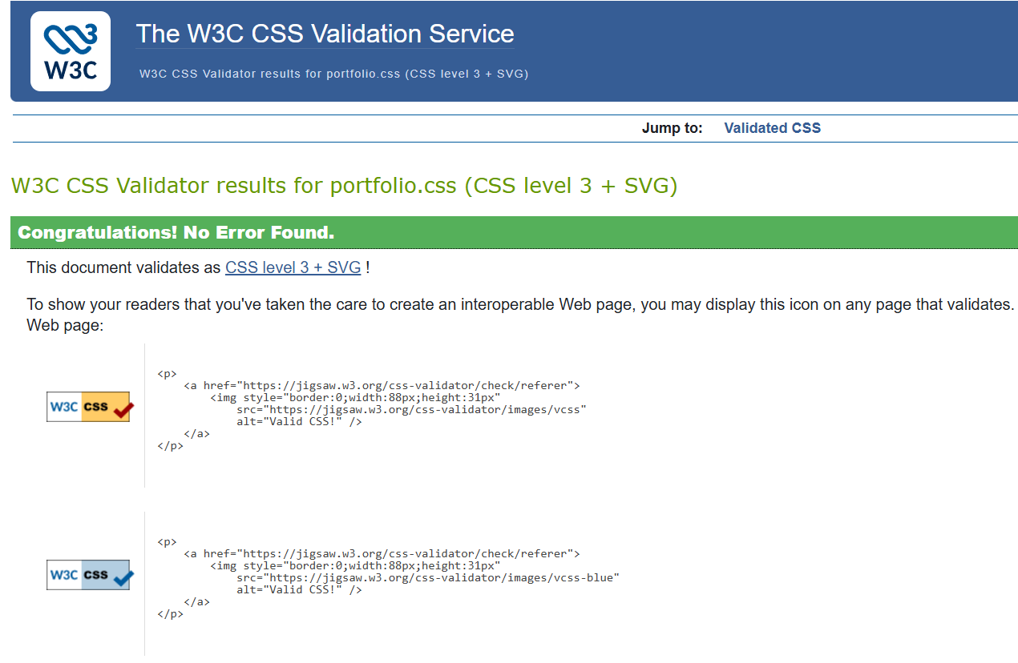

VALIDATION APPROVED
All HTML pages and the external CSS file were validated using online validation tools to confirm correct syntax and website compatibility.
The W3C Markup Validation Service was used to validate all HTML files, while the W3C CSS Validator was used to validate the external stylesheet (portfolio.css). Validation confirmed that the website contains no major errors and follows standard web development practices.
Compared to the previous assignment, additional validation was completed for the new HTML pages and the newsletter functionality to ensure reliable website performance and consistency.

REQUIREMENT CHECKLIST

Requirement | Status | Explanation
External CSS used | Yes | All pages linked to portfolio.css
Consistent navigation bar | Yes | Navigation available on all pages
Minimum website pages completed | Yes | Additional pages created for A4
JavaScript implemented | Yes | Newsletter validation and alert added
HTML form included | Yes | Newsletter signup page created
Validation completed | Yes | HTML and CSS validated using W3C
Updated navigation map | Yes | Reflects additional website pages
Concept map updated | Yes | Updated to match new website structure
Updated storyboards | Yes | Includes newsletter and expanded layout
Testing completed | Yes | Functional and validation testing completed
Folder structure organised | Yes | HTML, CSS, JS and images separated
Print-friendly design | Yes | Media query maintained

TEST SECTION

Test Case | Action | Expected result | Actual result
Open Home Page | Open index.html | Home page loads | Working as expected
Navigation | Click all navigation links | Correct pages open | Working as expected
Newsletter Alert | Open newsletter page | Welcome alert appears | Working as expected
Form Validation | Submit empty form | Error message shown | Working as expected
Form Submission | Enter details and submit | Success message shown | Working as expected
CSS styling | Open website | Styles display correctly | Working as expected
Print view | Press ctrl + P | Navigation hidden, clean layout | Working as expected
Reset Button | Click reset | Form clears | Working as expected
HTML Validation | Validate HTML | No errors | Working as expected
CSS Validation | Validate CSS | No errors | Working as expected

Improvements from A3 to A4

Compared to Assignment 3, several improvements were made to expand both the functionality and overall quality of the Kanishk Gaming website.
One of the main improvements was the addition of multiple new pages to better showcase technical and professional skills. New sections were created for Problem Solving, Communication and Teamwork, Digital and Technology Skills, and a dedicated Newsletter Signup page.
Another major improvement was the implementation of JavaScript functionality. Unlike the previous assignment which focused mainly on HTML and CSS, this version introduced interactive behaviour through form validation, automatic welcome messages, and user input checking. This improved both usability and user interaction.
The website structure was also expanded by organising files into HTML, CSS, JavaScript, and image folders to improve maintenance and readability. Navigation was updated to support the additional pages while maintaining a consistent design across the website.
Additional testing and validation were completed to ensure that all pages and interactive features function correctly. Overall, these improvements resulted in a more complete, interactive, and professional website compared to Assignment 3.

Personal Reflection

During this assignment, I improved my understanding of creating a multi-page website using HTML, CSS, and JavaScript while maintaining a consistent design and structure across all pages. Compared to the previous assignment, I became more confident in extending an existing website rather than creating a completely new one.
One of the main things I learned was how JavaScript can improve user interaction through form validation and alert messages. Creating the Newsletter Signup page helped me understand how HTML forms and JavaScript work together to make websites more interactive and functional.
I also improved my ability to organise website files using separate folders and maintain a consistent design using external CSS. Updating the navigation structure and adding additional pages helped me understand the importance of usability and website planning.
Testing and validation were valuable parts of the process because they helped identify errors and improve overall website quality. Overall, this assignment strengthened my practical web development skills and increased my confidence in designing and improving structured websites.

REFRENCES

W3C. (2024). Markup Validation Service. https://validator.w3.org

W3C. (2024). CSS Validation Service. https://jigsaw.w3.org/css-validator

