5G Technology Explorer
Project Documentation

Author | Kanishk Bhatt
Project Type | Interactive Educational Web Application
Domain | 5G / Telecommunications
Technology | HTML5 · CSS3 · Vanilla JavaScript · JSON
Deployment | GitHub Pages — Static Web Hosting
URL | https://kanishkbhatt-lucifer.github.io/5G-Tech-Explorer/
Version | 2.0 (Data-separated architecture)
Status | Active — ongoing feature development

1. Abstract
5G Technology Explorer is a fully client-side, zero-dependency educational web application that makes 5G telecommunications accessible to learners, engineers, and enthusiasts of all backgrounds. The platform presents complex 5G concepts through layered interactivity: users click into topics, explore popups with rich content, and engage with animated simulations — all within a single-page architecture that requires no backend, no authentication, and no installation.

The application spans six interconnected modules: a main discovery interface, a 5G architecture visualiser, a protocol intelligence panel, a network simulator with ten animated procedures, interactive quizzes with over two hundred questions, and a historical timeline of cellular evolution. All data is externalized into seven JSON files, keeping the engine logic clean and making content updates trivially easy.

Built entirely with native web technologies, the project demonstrates that production-quality interactive learning tools can be delivered without frameworks, build tools, or server infrastructure — a single folder deployed to GitHub Pages reaches a global audience instantly.

2. Project Overview

2.1 Goals and Motivation
5G is the backbone of modern telecommunications, yet most learning resources are either too academic (dense 3GPP specifications) or too shallow (marketing material). This project bridges that gap by presenting 5G architecture, protocols, and procedures in a visual, interactive, and self-paced format that rewards curiosity.

The primary goals are:
- Make 5G concepts approachable for students without a telecom background.
- Give working engineers a quick visual reference for NF roles, interfaces, and call flows.
- Demonstrate interactive learning UX achievable with zero external dependencies.
- Serve as a portfolio project showcasing data-driven frontend architecture.

2.2 Scope
The application covers the following 5G knowledge domains:
- 5G NR (New Radio) and the NG-RAN access network
- 5G Core (5GC) network functions: AMF, SMF, UPF, AUSF, UDM, PCF, NSSF, NRF
- Service-Based Architecture (SBA) and reference-point interfaces
- Protocol stack: NAS, NGAP, RRC, PFCP, GTP-U, SIP, RTP, and 18 others
- Key procedures: Registration, PDU Session, VoNR, Xn Handover, EPS Fallback, MT Paging, and more
- Historical evolution: 1G through 5G with speed, latency, and technology milestones
- Use cases: eMBB, URLLC, mMTC with real-world applications

3. Features

3.1 Main Discovery Interface
The landing page presents a responsive card grid of six content areas. Each card opens a popup with contextual information, child cards, animations, or interactive tools. The popup system uses a blurred glass backdrop and smooth scale transitions.
- Radial gradient dark-blue background for immersive focus
- Popup close on backdrop click or Escape key
- Navigation buttons to the simulator, history timeline, and 5G deep-dive page

3.2 5G Architecture Visualiser
An interactive diagram of the 5G system showing all NFs (Network Functions) with their SBA interfaces, N-reference points, and CP/UP separation. Components are rendered from architecture.json and responsibilities.json.
- Clickable NF nodes open detailed popups: name, full name, description, interfaces, and responsibilities
- Control-plane and user-plane paths visually separated
- SBA bus rendered as a horizontal connector across CP functions

3.3 Protocol Intelligence Panel
A three-column layout for exploring all 24 protocols used in 5G networks:
- Left column: OSI Model with per-layer color coding; active layers highlight when a protocol is selected
- Center column: 24 color-coded protocol cards grouped by category (5G-specific, transport, security, voice, infra). Each card opens a details panel with technical content.
- Right column: Protocol dependency graph showing the full stack from Application to 5G Tunnel with animated active state
- Bottom section: Animated Procedure Flow with UE → gNB → 5G Core → IMS/DN pipeline, triggerable for Registration, PDU Session, and IMS/VoNR flows

3.4 Network Simulator
A standalone simulator page with ten animated 5G network procedures. Each simulation is fully described in simulator-data.json.

Simulation | Nodes Involved | Key Concepts
5G Registration | UE, gNB, AMF, AUSF, UDM | SUCI, 5G-AKA, KAMF, NAS security
PDU Session | UE, gNB, AMF, SMF, UPF, DN | PFCP, N3 tunnel, CP/UP separation
VoNR Call Setup | UE-A/B, gNB-A/B, UPF, IMS | SIP INVITE, GBR 5QI=1, RTP
Xn Handover | UE, Src/Tgt gNB, AMF, UPF | XnAP, Path Switch, PFCP modify
Deregistration | UE, gNB, AMF, SMF, UDM | NAS teardown, PFCP delete, UDM UECM
Service Request | UE, gNB, AMF, SMF, UPF | CM-IDLE→CONNECTED, DRB restore
Slice Selection | UE, AMF, NSSF, NRF, SMF | S-NSSAI, Allowed NSSAI, NRF discovery
Session Release | UE, gNB, AMF, SMF, UPF | PFCP delete, IP release, CDR
EPS Fallback | UE, gNB, AMF, MME, eNB | N26 inter-system HO, key mapping
MT Paging | DN, UPF, SMF, AMF, gNB, UE | DL data notification, PCCH, RACH

Controls: Auto Play (480 ms step delay), Step Forward (manual), and Reset (instant, generation-counter cancellation of in-flight animations). Each step shows a colored animated packet, highlights the source node in yellow, pulses the destination in green, updates the description panel, and advances the step-dot progress indicator.

3.5 Quiz System
Two separate quiz modules with a shared architecture (dual-question-bank design, localStorage analytics):

5G NR Quiz
- 195 questions total across two banks
- Bank A: 90 difficulty-stratified questions (30 Easy, 30 Medium, 30 Hard)
- Bank B: 105 category-stratified questions (15 per category × 7 categories: NR, Stack, Core, Slicing, Mobility, VoNR, Security)
- Purple/violet color scheme to distinguish from the 4G quiz (blue)
- Results screen links to the Case Study Quiz

5G Case Study Quiz
- 15 real-world 5G troubleshooting scenarios
- Scenarios cover: AMF/NGAP failures, PFCP/PDR mismatches, beam failure, NSSF slice rejection, VoNR audio faults, Xn HO failures, SUCI decryption, NRF re-registration, URLLC SLA breach, and more

3.6 5G Architecture Puzzle
A drag-and-drop puzzle where the learner places 8 5G NF nodes (5G UE, gNB, AMF, SMF, PCF, AUSF, UDM, UPF) into their correct groups (NG-RAN, Control Plane, User Plane). Features include:
- Visual SBA bus and CP/UP separation labels
- Interface labels: Uu, N1/N2, N3, N4, N6, N7, N8/N10, N11, N12
- On completion, links to the 5G NR Quiz
- Data-driven from puzzle-data.json — same JS engine as the 4G puzzle

3.7 History Timeline
An interactive 1G → 5G evolution timeline rendered on a glowing bus layout. Each generation node shows key metrics (peak speed, latency, frequency bands) and expands with historical context. Data sourced from evolution.json.

3.8 About 5G Deep-Dive Page
A dedicated information page covering:
- Why 5G — with feature cards, stat badges, application grid, and 4G vs 5G comparison table
- Technologies — OFDM, Massive MIMO, Beamforming, Network Slicing, MEC, mmWave, Sub-6 GHz with images and detail popups
- Use Cases — eMBB, URLLC, mMTC with real-world industry examples
- Protocols — 24-protocol panel reused from the main app, adapted for standalone page

4. Use Cases

4.1 Student Learning
A telecommunications or networking student unfamiliar with 5G can open the site, click through the main interface cards, explore 5G architecture, read about protocols via the color-coded cards, and simulate registration and PDU session flows — all without reading a single 3GPP document.
- Self-paced — no account, no timer, no gatekeeping
- Layered depth — surface overview to detailed technical content on demand
- Quiz reinforcement after learning to test retention

4.2 Engineer Quick Reference
A working telecom or cloud engineer can use the site as a visual cheat sheet:
- AMF/SMF/UPF responsibilities at a glance from the architecture panel
- Protocol card details (PFCP, GTP-U, NGAP, SCTP) without searching documentation
- Xn Handover or EPS Fallback procedure flow refreshed in 90 seconds via Auto Play

4.3 Educator / Trainer Reference
A trainer running a 5G workshop can share the live GitHub Pages URL as a visual companion:
- Simulator projected during a session to animate each procedure step-by-step
- Puzzle used as a class activity to reinforce NF placement
- Quiz used as a post-session knowledge check

4.4 Interview Preparation
A candidate preparing for a 5G/telecom role can use the quizzes and simulators to:
- Test knowledge on 195 graded NR questions
- Work through 15 real troubleshooting scenarios in the Case Study Quiz
- Visualize call flows to articulate them in interviews

4.5 Portfolio Demonstration
As a portfolio piece, the project demonstrates frontend engineering skills:
- Data-driven architecture with JSON separation
- SVG-based animation engine built from scratch
- Complex interactive UI built without frameworks
- GitHub Pages deployment with zero build pipeline

5. About the Build

5.1 Technology Stack
Languages | HTML5, CSS3, Vanilla JavaScript (ES2020+), JSON
Rendering | Native browser DOM · SVG (animations) · CSS animations
External CDN | Font Awesome 6.4 (icons only)
Fonts | Segoe UI (system font, no download)
Data format | JSON (7 data files, 1 simulator data file, 1 puzzle data file)
Hosting | GitHub Pages (static, zero backend)
Build tools | None — plain HTML/CSS/JS, no bundler, no transpiler
Dependencies | Zero npm packages in production
Version control | Git / GitHub

5.2 Architecture
The application follows a data-driven, module-separated architecture. All content is stored in external JSON files; the JavaScript engine reads the data and renders HTML dynamically into a shared popup overlay.

Data Layer (JSON files in /data/)
- evolution.json — 1G–5G timeline entries with metrics and descriptions
- architecture.json — 5GC/RAN NF definitions, colors, interfaces
- technology.json — radio and network technology cards with images
- usecase.json — eMBB, URLLC, mMTC use case data
- why5g.json — feature cards, stat badges, application grid, comparison table
- protocols.json — 24 protocol definitions: title, content, OSI layers, dependency stack
- responsibilities.json — 15 NF responsibility detail blocks (HTML fragments)

Engine Layer (app.js → 946 lines post-separation)
- Fetches all 7 JSON files in parallel via Promise.all() on DOMContentLoaded
- Renders main menu cards dynamically from a config object
- showX() functions render each section into the shared #popup overlay
- Protocol panel, OSI highlighting, and dependency graph are event-driven, stateless renders
- Packet animation via setTimeout chains + CSS class toggling

Simulator Engine (simulator.js → standalone)
- Fetches simulator-data.json on load; resolves color key strings to CSS color objects
- animatePacket() uses SVG getPointAtLength() for smooth line-following motion
- Generation counter (animGen) provides instant cancellation of in-flight requestAnimationFrame loops
- stepForward() → animatePacket() → onDone callback chain drives both Auto Play and manual stepping

Quiz Engine (quiz.js / case-quiz.js → shared architecture)
- Dual-bank question selection: difficulty-stratified + category-stratified
- Session state: shuffled question arrays, answer tracking, score accumulation
- localStorage key: '5gQuizAnalytics' — stores per-session results for potential analytics extension

5.3 File Structure

Path | Purpose
index.html | Main app entry point; popup overlay; nav buttons
app.js | Core engine: data load, section renders, popup logic, animations
style.css | All app styles (~2700 lines); protocol, architecture, quiz, popup
data/evolution.json | 1G–5G evolution timeline content
data/architecture.json | NF definitions: 5GC control/user plane, RAN, DN
data/technology.json | Radio tech and network feature cards
data/usecase.json | eMBB, URLLC, mMTC use case content
data/why5g.json | Why-5G section: features, stats, comparison table
data/protocols.json | 24 protocol definitions with OSI layers and stack
data/responsibilities.json | 15 NF responsibility HTML blocks
about-5g/index.html | Deep-dive page: why 5G, technologies, use cases
history-before-5G/index.html | History page: cellular generation timeline
5g-quiz/index.html+quiz.js | 195-question 5G NR quiz
5g-case-quiz/index.html | 15-scenario 5G troubleshooting quiz
5g-puzzle/index.html | Drag-and-drop 5G architecture puzzle
network-simulator/index.html | 10-procedure animated network simulator
network-simulator/simulator-data.json | All 10 simulation definitions (40 steps)
4g-quiz/ | 195-question 4G LTE quiz (blue scheme)
4g-case-quiz/ | 15-scenario 4G troubleshooting quiz
lte-puzzle.html | Drag-and-drop LTE architecture puzzle

5.4 Performance Characteristics
Because the application is entirely static:
- First Contentful Paint: < 1 second on a standard connection (no JS bundle, no API call)
- Data load (7 JSON files): parallel fetch, completes in ~150 ms on a local network
- No cookies, no tracking, no analytics by default
- Works offline once cached (all assets static)
- GitHub Pages CDN provides global edge delivery at zero cost

5.5 Build Journey — Key Decisions

Decision 1 — No Framework
The project deliberately avoids React, Vue, Angular, and any state management library. Every render is a simple innerHTML assignment or DOM createElement call. This keeps the codebase readable by anyone who knows basic JavaScript, eliminates build tooling, and makes the deployment path trivially simple.

Decision 2 — Data Separation
Originally all content was inline in app.js (3,058 lines). All data was extracted into 7 JSON files, reducing app.js to 946 lines. This separation means content editors can update protocol descriptions or add a 6th use case without ever touching JavaScript. It also enables future internationalization without code changes.

Decision 3 — Shared Popup Overlay
All six main content areas render into a single #popup div. This avoids duplicating CSS for panel chrome, keeps z-index management simple, and ensures consistent open/close animations across every section. Each showX() function simply sets popup.innerHTML and calls openPopup().

Decision 4 — SVG Animation Without Libraries
The simulator uses SVG line elements and getPointAtLength() to move packets along connector lines. This is 30 lines of vanilla code that perfectly follows curved or angled paths with no dependency on GSAP, Anime.js, or Three.js. The generation counter (animGen) provides instant cancellation without complex state management.

Decision 5 — Color-Keyed JSON
In the simulator's JSON data, node colors are stored as short string keys ("ue", "ran", "core") rather than hex values. The JavaScript engine resolves these to full color objects after loading. This keeps the JSON clean and human-readable, lets the color palette be changed in one place, and prevents JSON from containing JS-dependent references.

6. Known Issues & Future Roadmap

6.1 Known Issues
- Image path case-sensitivity: some images defined in data files may not load on Linux-based servers (case-sensitive FS). Paths need auditing.
- Protocol details panel: uses a non-standard <p1> tag in app.js. Should be converted to <p> or <div> with a CSS class.
- Responsive layout: the popup overlay is not fully optimized for screens below 768px width.
- No 404 page: missing routes on GitHub Pages fall through to the default GitHub 404.

6.2 Planned Improvements
- Add favicon and Open Graph meta tags to all pages for better SEO and social sharing
- Create a custom 404.html for GitHub Pages
- Audit and fix image path case sensitivity
- Add 6 more network simulator procedures (10 → 16 total)
- Implement a search bar across all protocol and NF content
- Add dark/light theme toggle
- Make the architecture diagram fully zoomable and pannable
- Progressive Web App (PWA) manifest for offline use and installability

7. Deployment

7.1 GitHub Pages Setup
The project is deployed as a static site on GitHub Pages:
- Repository: github.com/kanishkbhatt-lucifer/5G-Technology-Explorer
- Live URL: https://kanishkbhatt-lucifer.github.io/5G-Technology-Explorer/
- Branch: main (GitHub Pages serves from root of main branch)
- Deployment: push to main → live within 60 seconds, zero configuration

7.2 Local Development
Because the app fetches JSON files via fetch(), it requires a local HTTP server (browsers block file:// XHR by default):
- VS Code: use the Live Server extension (right-click index.html → Open with Live Server)
- Python: run python -m http.server 8080 in the project root
- Node.js: run npx serve in the project root

8. Glossary
AMF | Access and Mobility Management Function — handles UE registration, authentication routing, and paging
SMF | Session Management Function — manages PDU sessions, UPF selection, IP allocation
UPF | User Plane Function — routes user-plane data between RAN and DN; enforces QoS
AUSF | Authentication Server Function — orchestrates 5G-AKA and EAP-AKA'
UDM | Unified Data Management — stores subscriber data (SUPI, keys, subscription)
NSSF | Network Slice Selection Function — determines Allowed NSSAI per UE and TA
NRF | Network Repository Function — NF registration and discovery registry
PCF | Policy Control Function — provides QoS and charging policies
gNB | Next-Generation NodeB — the 5G NR base station (NG-RAN)
PFCP | Packet Forwarding Control Protocol — control protocol between SMF and UPF (N4)
GTP-U | GPRS Tunnelling Protocol (User plane) — encapsulates user data on N3 (gNB↔UPF)
NGAP | NG Application Protocol — control protocol between gNB and AMF (N2)
NAS | Non-Access Stratum — UE↔AMF signalling layer (registration, session management)
SUCI | Subscription Concealed Identifier — ECIES-encrypted form of SUPI sent over the air
5QI | 5G QoS Identifier — standardized QoS characteristic (e.g. 5QI=1 for VoNR GBR)
S-NSSAI | Single Network Slice Selection Assistance Information — identifies one network slice
DRB | Data Radio Bearer — radio bearer mapping a QoS flow to the NR air interface
TEID | Tunnel Endpoint Identifier — identifies a GTP-U tunnel at one endpoint
SBA | Service-Based Architecture — 5GC NFs expose REST-like HTTP/2 services to each other
eMBB | Enhanced Mobile Broadband — 5G slice for high-bandwidth services
URLLC | Ultra-Reliable Low-Latency Communication — 5G slice for industrial and safety systems
mMTC | Massive Machine-Type Communication — 5G slice for IoT and sensor networks

ACTUAL WEBSITE IMAGES
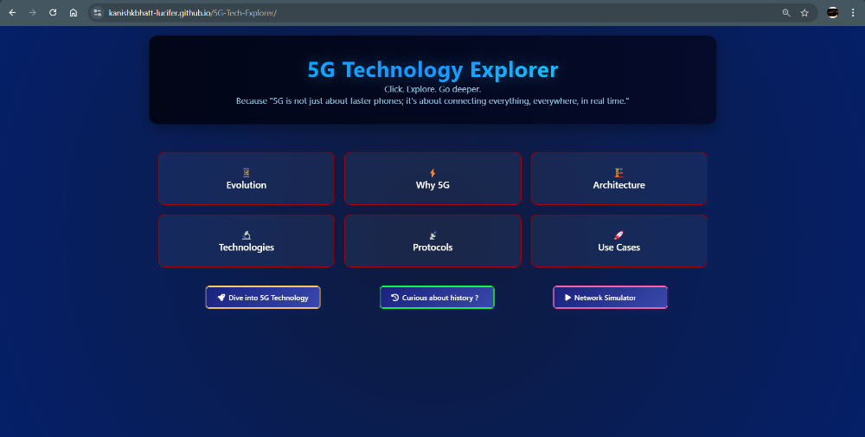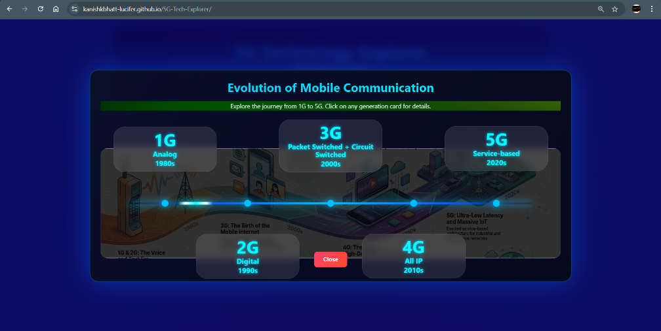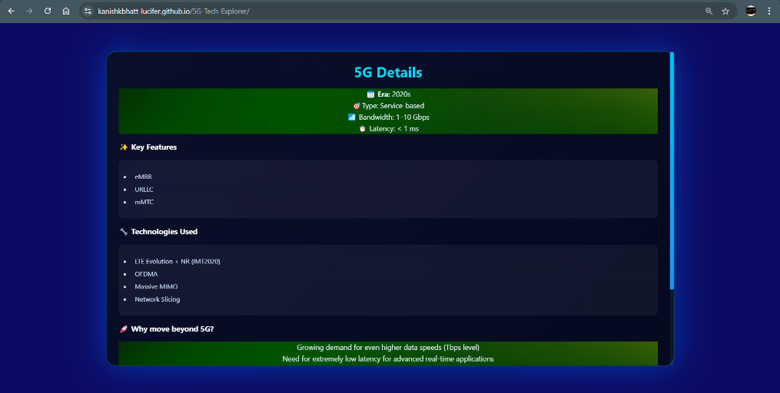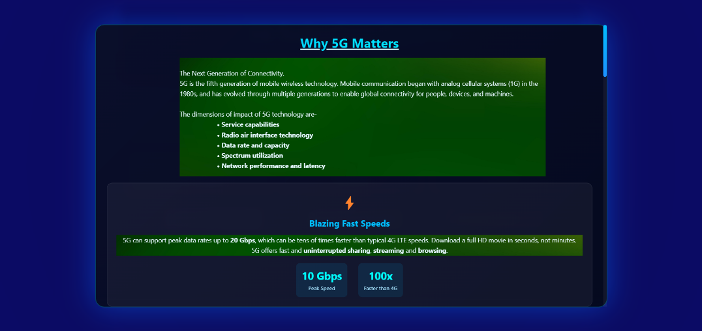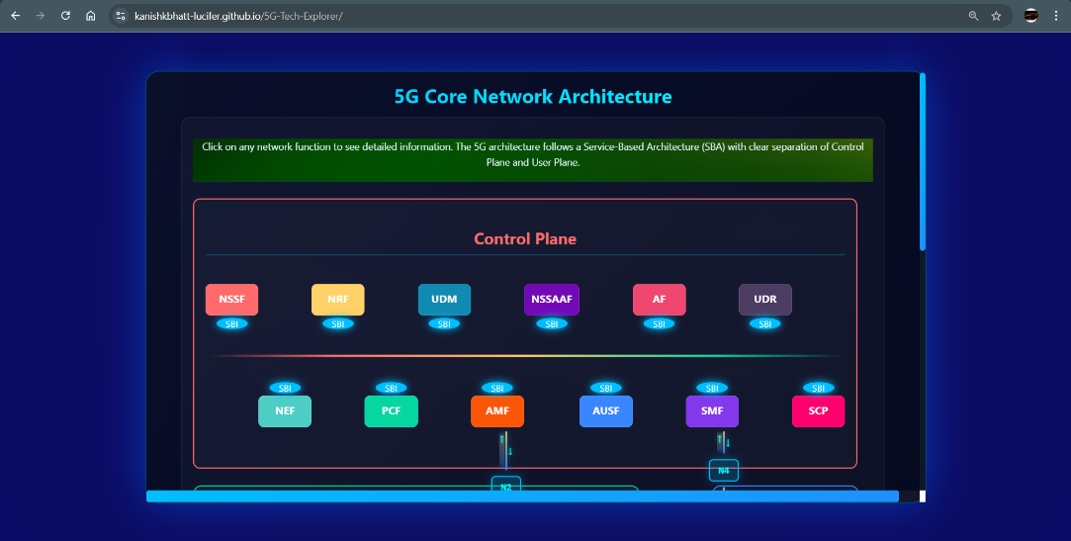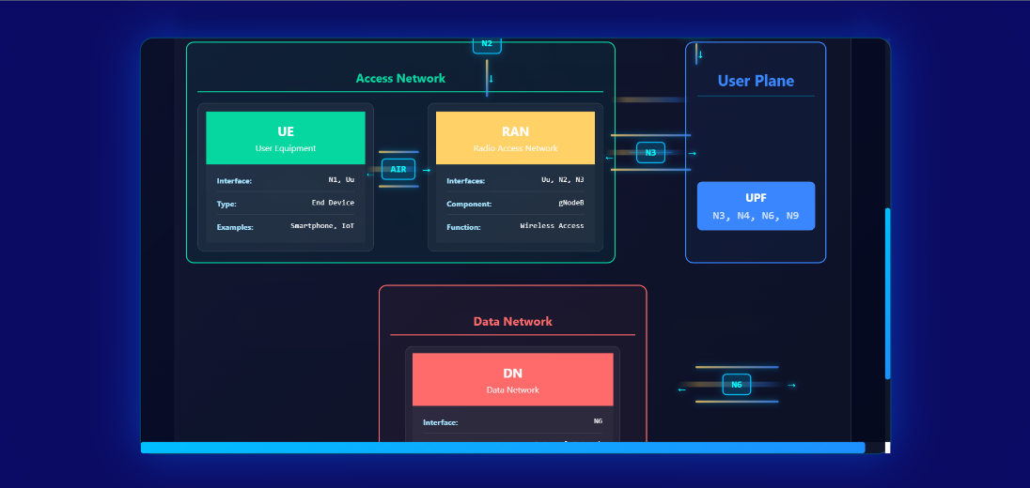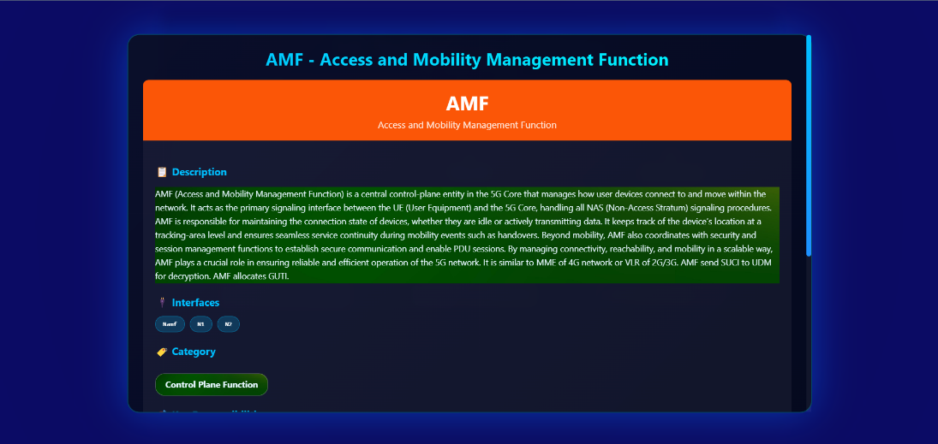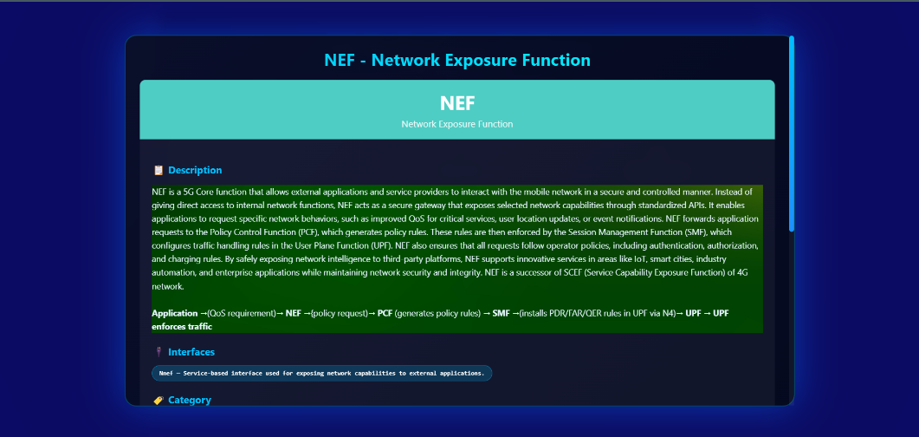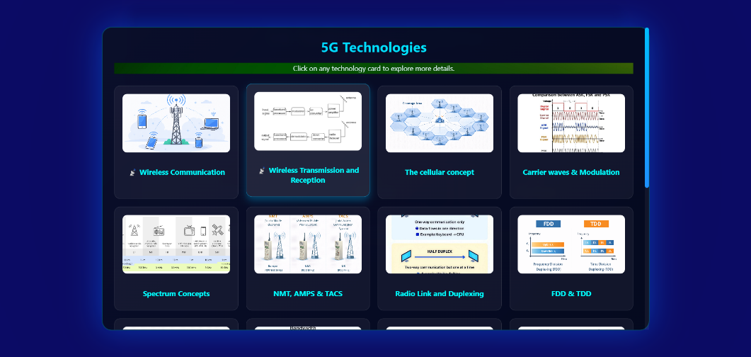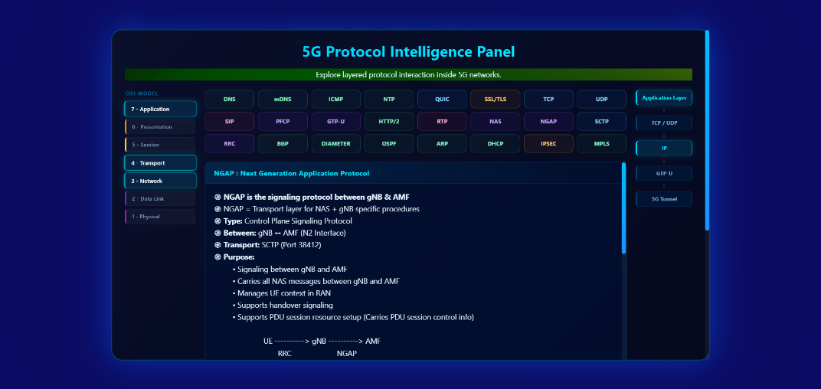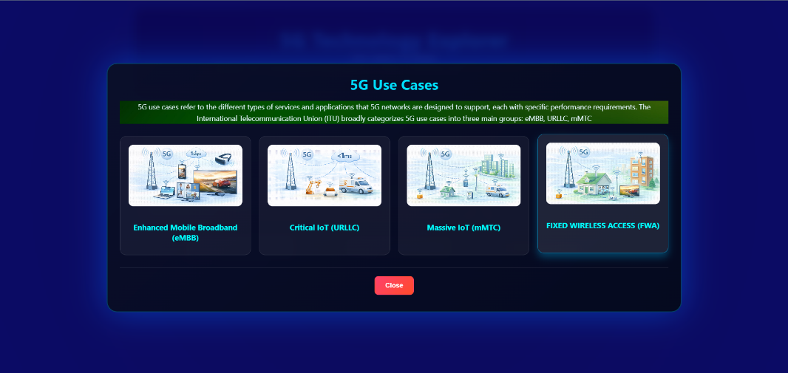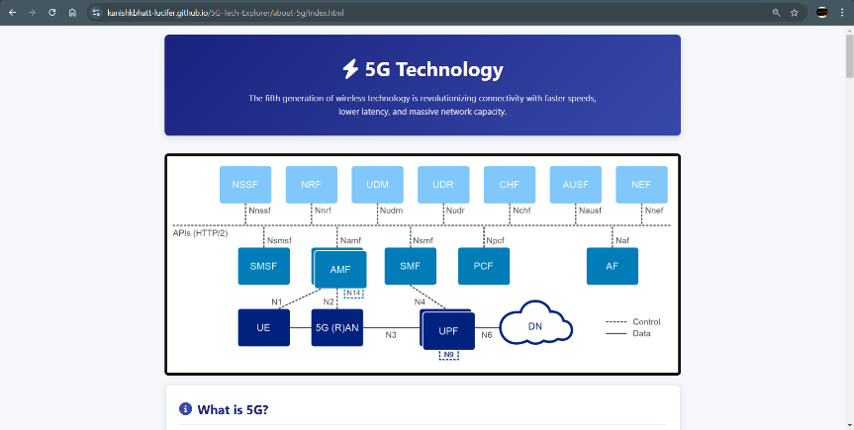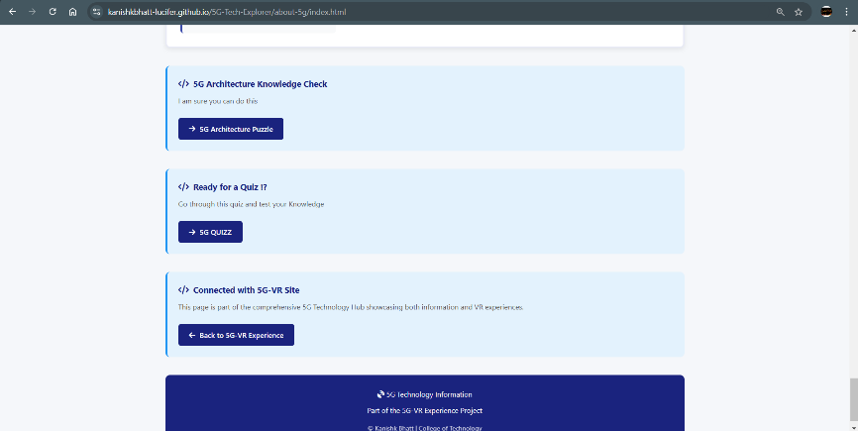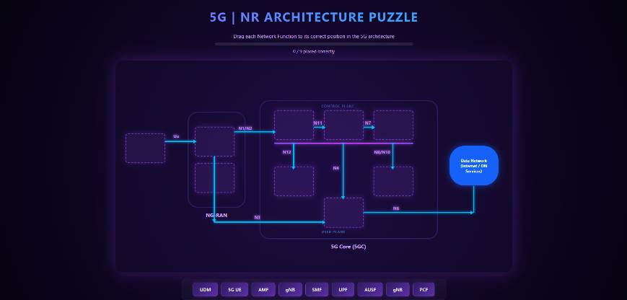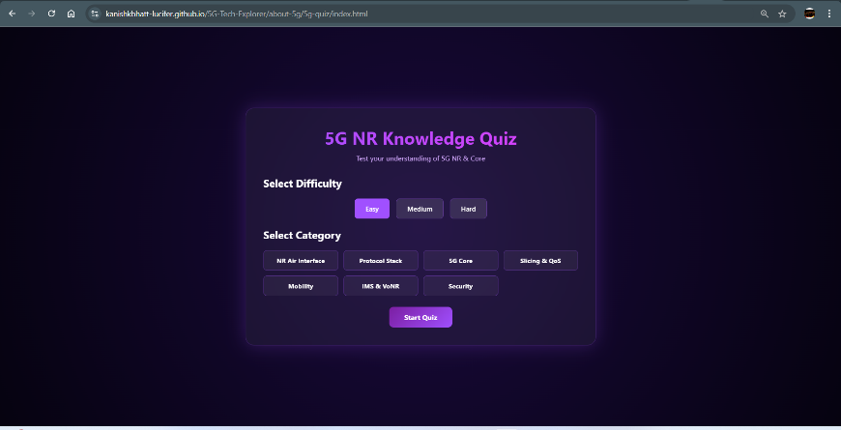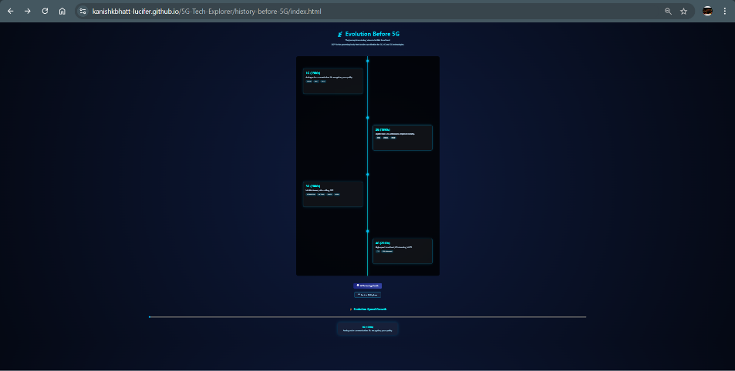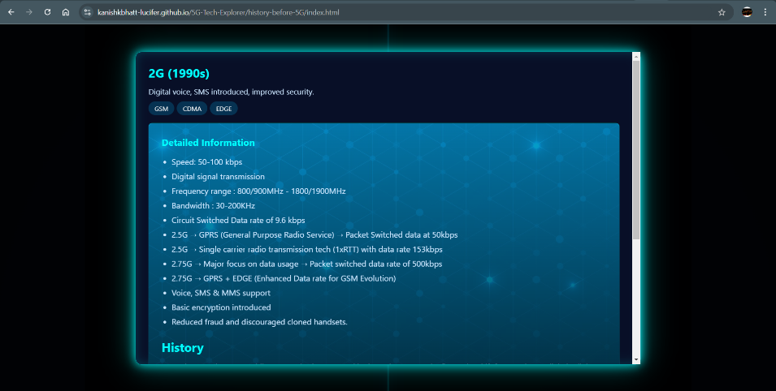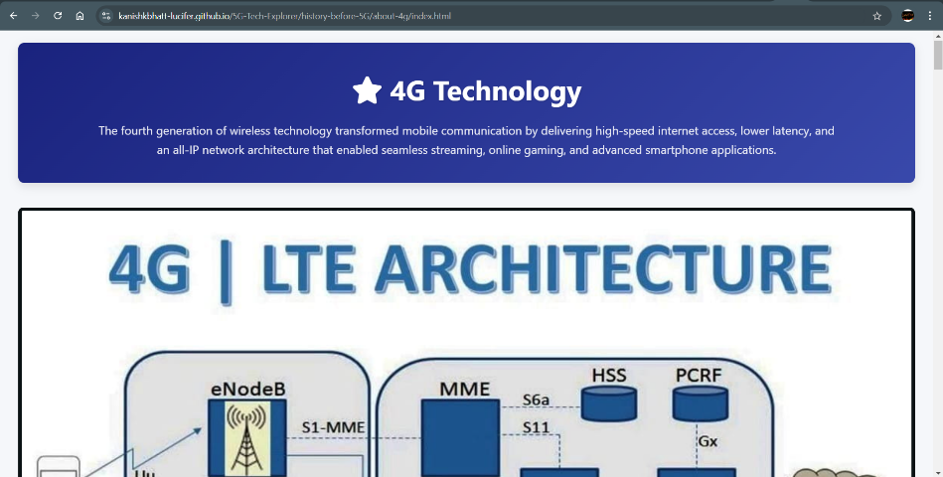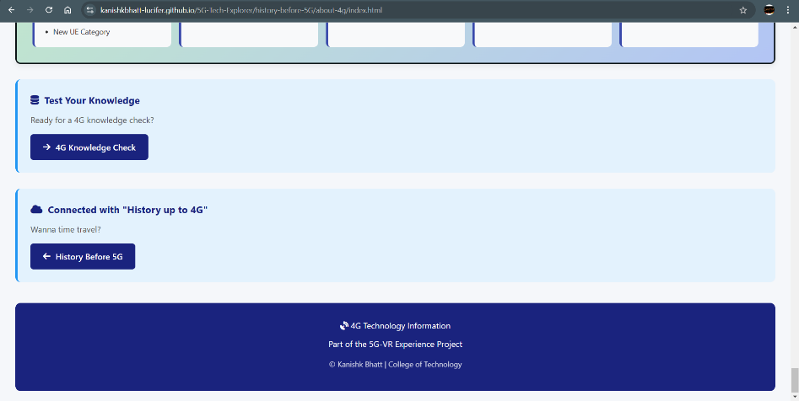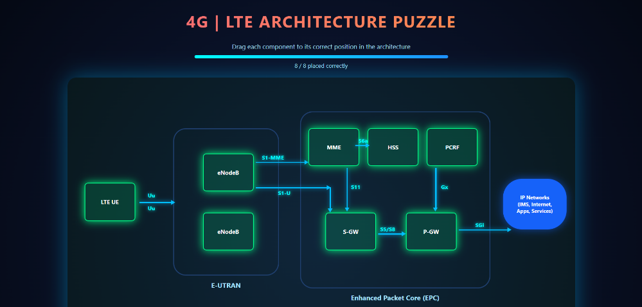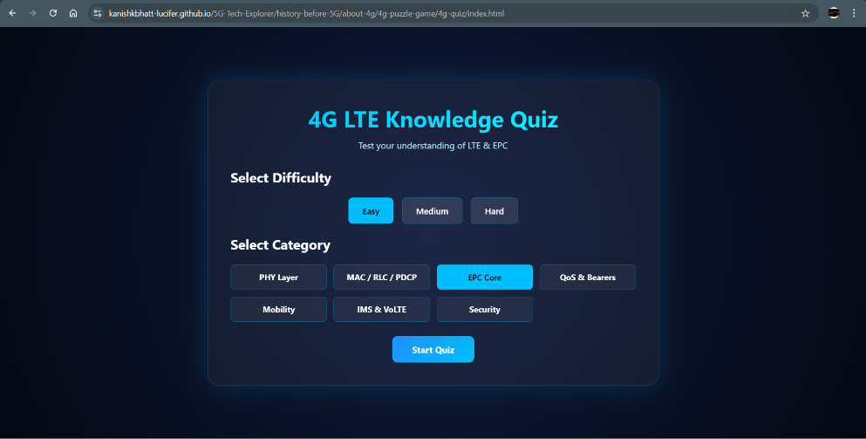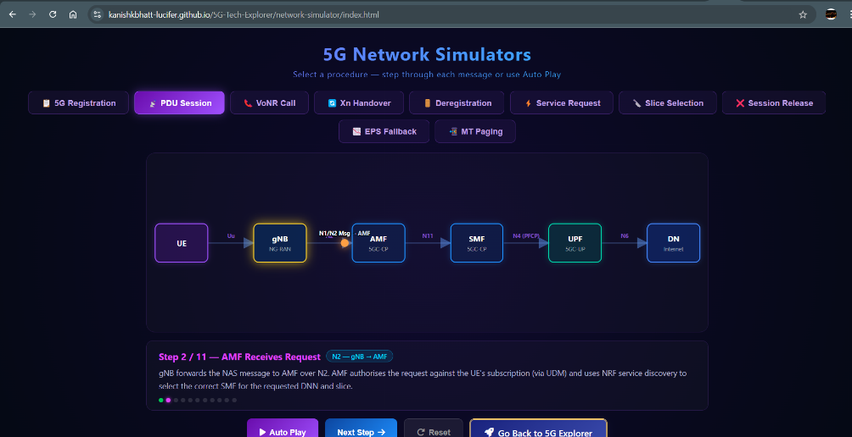
End of Document

