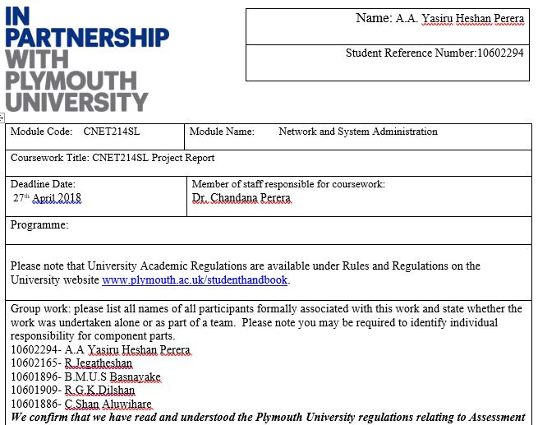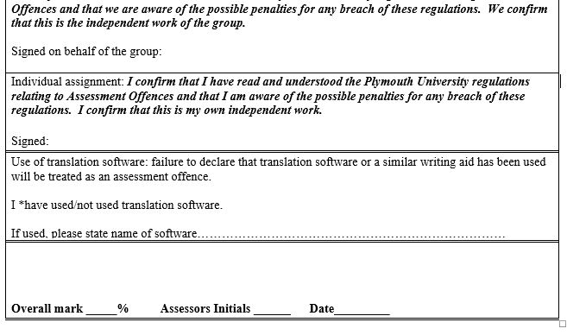

Contents

Introduction 3

Existing system Problems 3

Server System And LAN Solution 4

Active Directory 5

Remote Cluster 6

Automatic Backup in Cloud Repository 7

Operating System For Workstation And Server 8

Hardware Solution & Accessories 9

Securing the network 10

Refferences 11

Turniting 11

# Introduction

According to the scenario given in the coursework we’re proposed a network & server solution. As per the task we are expected to implement a WAN (Wide Area Network) where the workers can be connected to the same network.

Company which has 200 workers and there are consultants who connects through their own devices and network from different places. Remote users who are from different location should get connected server throughout a public server as remote users there are developer from different locations whom also wanted to get connected to the server through their laptop and mobile phones. Stake holders who are located in UK and US & they can only login through the cloud and get updated about the company.

The company stores its data to the main server and then sends a backup to the cloud which is located in a different location such in a foreign country. This is what the scenario says and according to the problem we’ve implemented solution for this.

# Existing system Problems

* Unable to defend the server from harmful threats. Authenticationpolicy is unavailable
* Network is unable to protect backup, control and manage.
* No centralized OS and a directory control database
* No proper Networking plan
* Many multiple client OS versions can run in remote PCs.

# Server System And LAN Solution

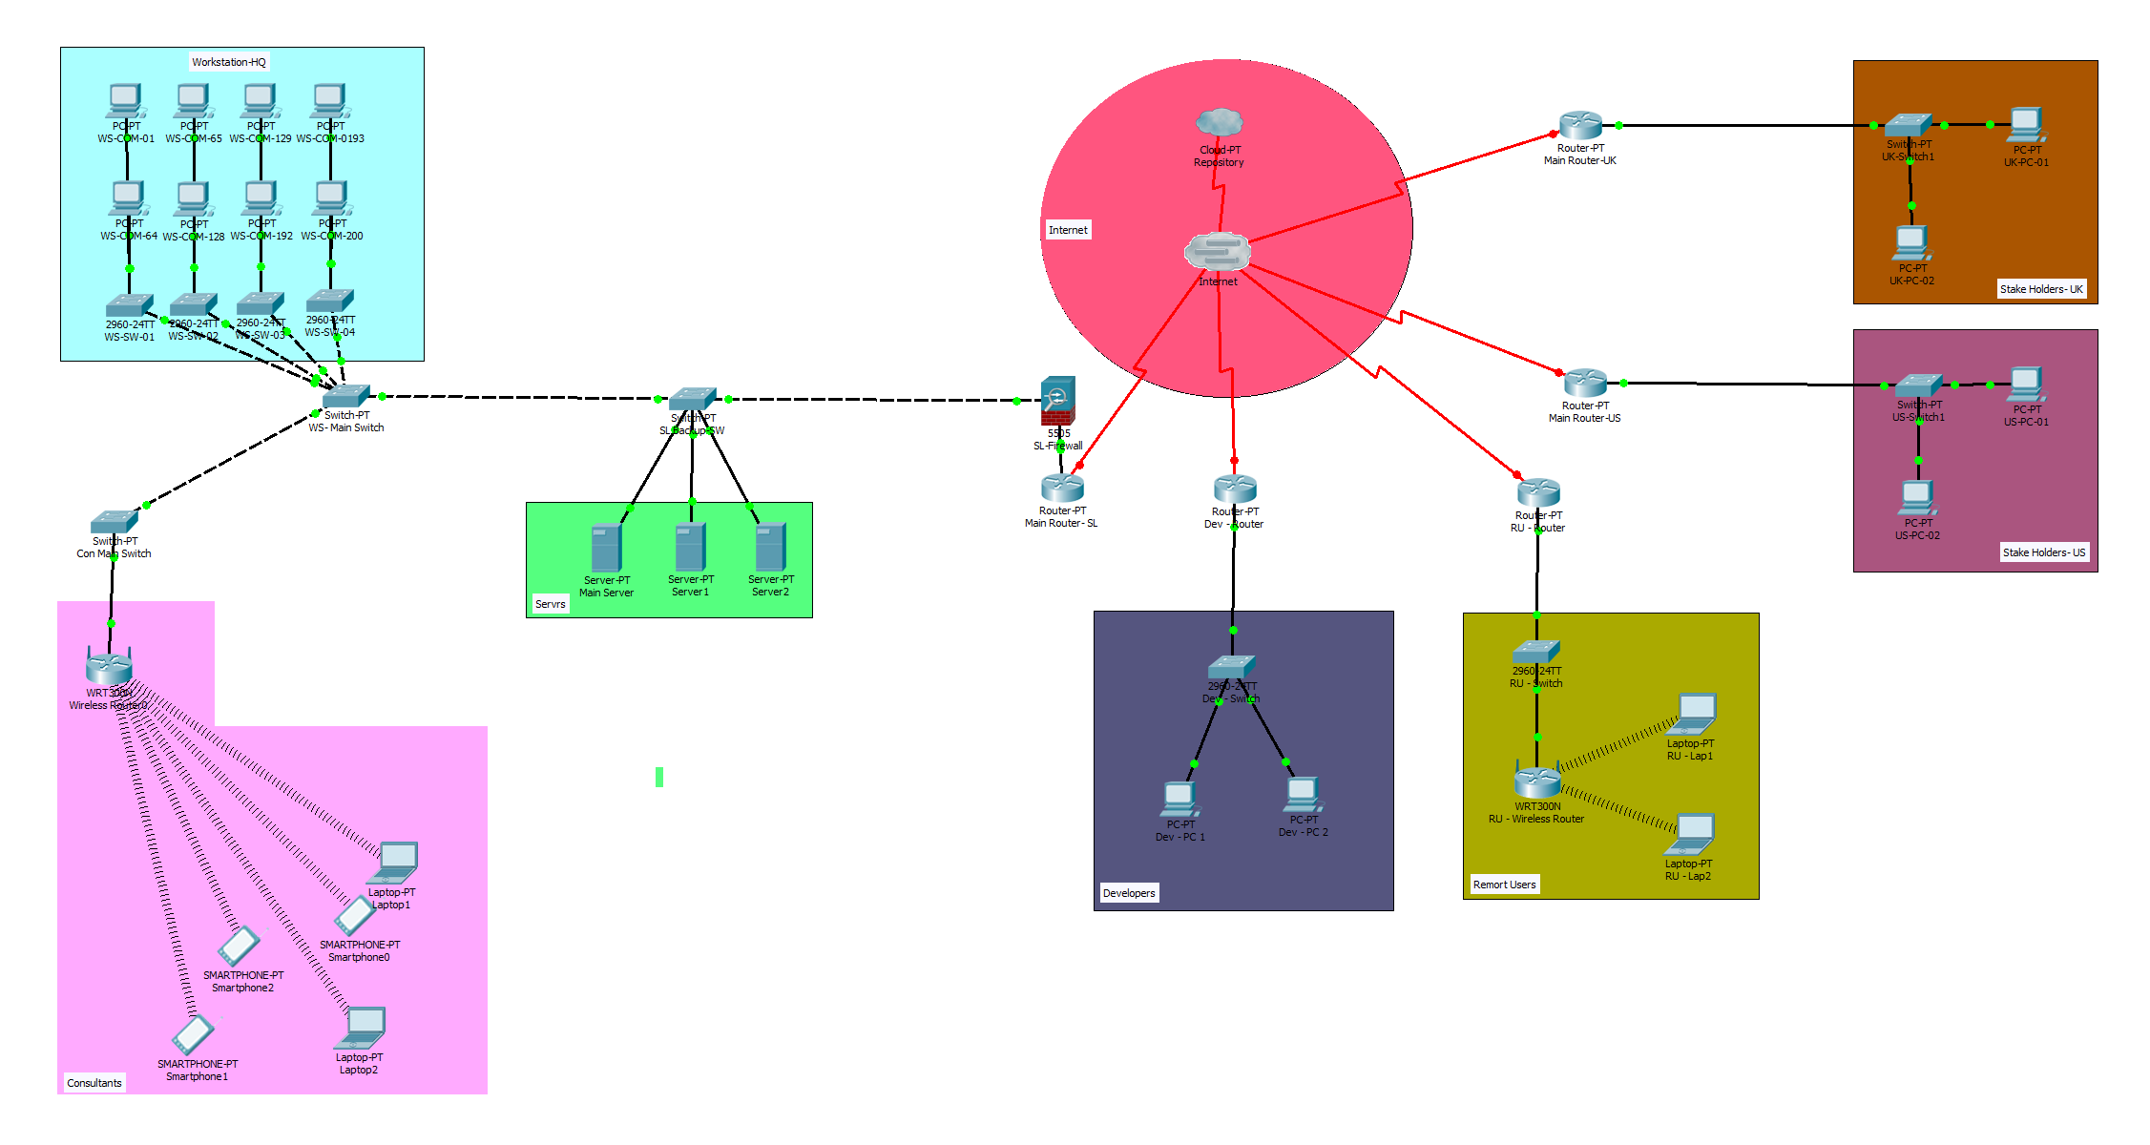

Proposed Network Diagram

Every workstations and the devices of this company are directly connected to the main server using physical wires and switches. 200 workstations of the company are connected to the 64 port , 4 access switches. These 4 access switches are connected to the main switch and the consultants are getting connected to the main switch through a wireless router. The three servers are connected access switch and then the access switch is also getting connected to the main router of company through a hardware firewall .The company s’ main router is a ISP. So this LAN ( Local Area Network ) will get connected to the internet through the ISP.

Developers and remote users are also getting connected to the internet through the ISP. The stake holders who are located in US and UK will also get connected the internet through ISP and also to the cloud.

**Assumption**

* Stake holders of USA and UK are represented by two PCs.
* We have used 64 port , 4 access switches.
* We have taken only 10 PC’s to represent 200 workstations.
* Stake holders of USA and UK are represented by two PCs.

# Active Directory

* Active directory is kept up spcially for disseminated networking situations where it is an incorporated institutionalized system which robotize network administration of clients’ information , shared assets, security and empowers interoperation with other registries.
* Security is kept through log on validation and access control to objects in the directory. Indeed even the most complex networks can be overseen by using policy based administrations. The new changes of the active directory dmain service benefit secures the active directory environment.
* 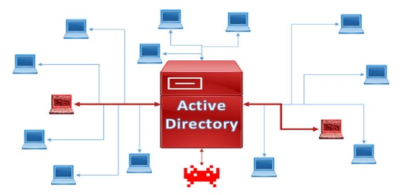For instance if the overseer of the company needs to install a specific software to the companys workstation PCs he can install it through the activity directory at once to all the computers instead of installing to each and every PC separately. This helps in centralized management and save the recourses and time.

**New improvements of the active directory domain service**

• Microsoft password enabling for work in organizations.

• Stretching out cloud capacities to windows 10 devices through Azure Active Directory.

• Privileged access management

• Interfacing domain-joined devices to Azure AD for windows 10 encounters.

• Devaluation of document replication service (FRS) and windows server 2003 functional levels.

• IT managers of the organization are allowed to connect remote devices to the organizations’ active directory and they can utilize this association as consistent second factor authentification

• Representatives in the organizations' workstations will be allowed to utilize single sign-on from the devices which are connected with the organization systems' active directory

• Since we have conveyed this element this will associate the applications and administrations from anyplace utilizing web application proxy.

• Multi-factor Access control and Multi factor verification highlight will oversee danger of clients working from anyplace and will offer access to shielded information from their gadgets.

# Remote Cluster

* A cluster is a group of physical machines or digital machines that paintings together to offer services. every person gadget is called a node, and each node in the cluster is connected to, and responsible for monitoring the opposite nodes.
* If one of the nodes turns into unavailable, or in any other case fails, the closing nodes will without delay word and anticipate the duties formerly assigned to the failed node. this method of assuming obligations is known as a failover. so as for the home windows cluster to be appropriate for a square server failover clustering, they want to be configured with a shared storage area called clustered shared quantity or csv. this will be a network drive that every one the machines in the cluster can access. sq. server will use this area to keep statistics and log documents so if the primary node fails, the backup node will immediately start using the identical database documents and not using a lack of information.
* There are some conditions to do not forget when creating a windows cluster. the first is that each gadget is to be going for walks the equal version of home windows server. 2nd, each gadget needs that allows you to get right of entry to the cluster shared extent. and third, all of the machines need to be at the equal active directory area. to installation a windows cluster, you'll want to first allow the failover clustering feature on every machine. this is performed thru the server manager dashboard, upload roles and functions wizard. once that step has been finished on all machines on the way to get added to the cluster, you may use the failover cluster supervisor device at the number one server.

# Automatic Backup in Cloud Repository

* **Provides immediate recovery of last data**
* **Easily accessible**
* **Affordable solution**
* **Scheduled backups reduces impact on bandwidth**
* **What is Cloud Backup ?**
* **Cloud backup involves the backing up of ones records into a provider company’s information center , over a wide location network , using standard internet protocols.**
* **The principle foundation of cloud backup is that the hardware infrastructure is shared ,thereby increasing efficiencies and decreasing charges.**
* **Cloud backup as having an unlimited quantity of garage that’s exceedingly available , relaxed and inexpensive.**
* **What is Cloud Repository ?**
* 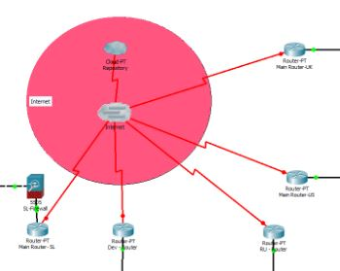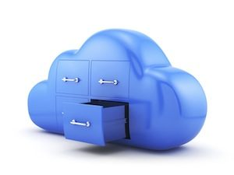**Cloud repository is a storage location on the cloud where clients can store their VM data. Users can apply the cloud repository as a target for the backup, that backup copy can restore data from the cloud repository.**

# Operating System For Workstation And Server

* We proposed to implement Windows 10 for all of the PCs in the Workstation and Windows Server 16 as the operating system (Server 16 is the latest server operating system released by Microsoft.)

**Benefits Of Windows Server 16 ,**

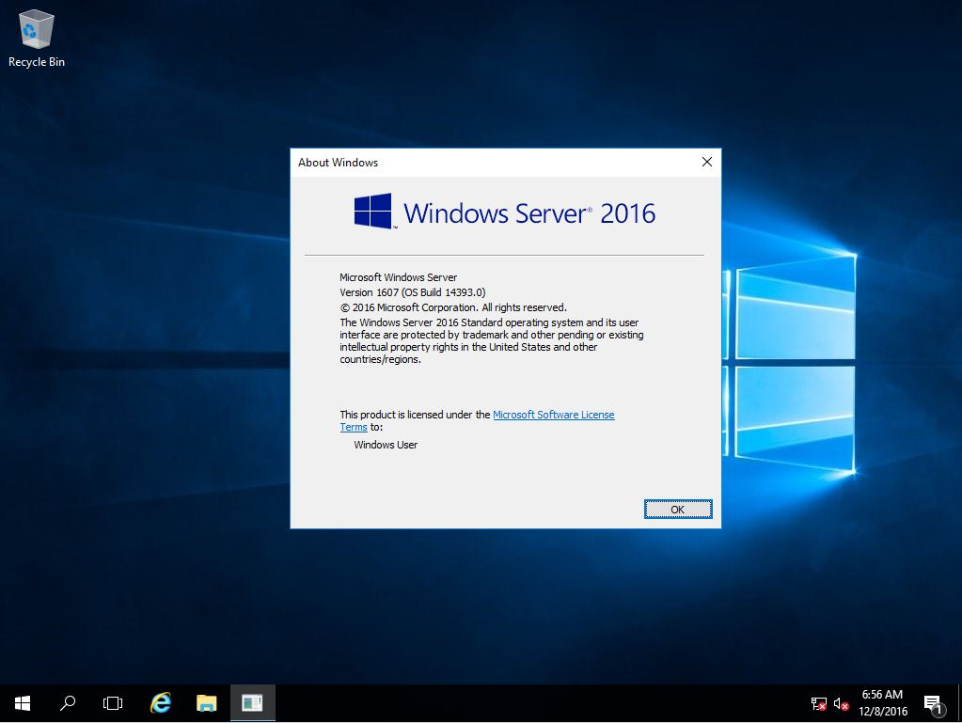

* **Virtual machines' protection**
* **Operating system protection**
* **Improved attack detection capability**
* **Application's isolation**

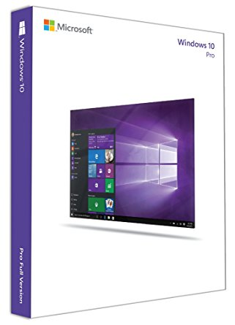

**Benefits Of Windows 10 ,**

* **Windows 10 security features allow businesses to keep their data, devices and users protected 24x7.**
* **Enable Secure Productivity**
* **Scalability and Affordability**

# Hardware Solution & Accessories

* **Subsequent to outlining the server system and LAN we inquired about to give the better information security better correspondence coordinated effort and threat assurance in the system so we proposed following devices operating systems application software's and network devices in the arrangement**
* **Devices**
* Intel® Celeron® G3900, Optional Operating System, 4GB Memory, 500GB / Server x200
* ACER EXTENSA EM2710 – core i5-6700- 3th generation ( Windows 10 Enterprise Edition ) x75
* **Operating Systems**
* Windows Server 2016 Datacenter Edition (x1)
* Windows 10 Pro Edition (x200)

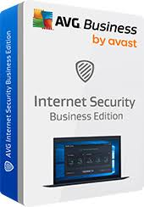

* **Application Software’s**
* AVG Internet Security Business Edition (x280)
* **Network Devices**
* SGE2010 64-port Gigabit switch (x7 )
* SGE2010 48-Port Gigabit switch (x4 )
* 2901 integrated Services Router (x1)
* PT Router (x2)
* WRT300N Router (x1)
* ASA 5505 Adaptive Security Appliance (x1)

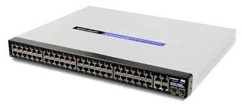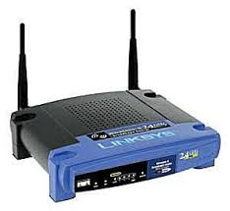

# Securing the network

**Firewall & Analysis**

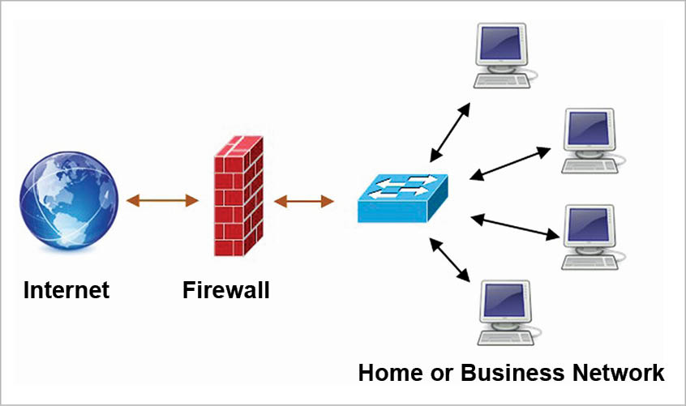

A firewall is a system security framework intended to keep unapproved access to or from a private system. Firewalls can be executed as both equipment and programming, or a blend of both. System firewalls are as often as possible used to keep unapproved Internet clients from getting to private systems associated with the Internet, particularly intranets. All messages entering or leaving the intranet go through the firewall, which looks at each message and hinders those that don't meet the predetermined security criteria.

* **Explain Firewall ?**

A firewall is a framework intended to keep unapproved access to or from a private PC network.Firewalls are as often as possible used to keep unapproved Internet clients from getting to private systems associated with the Internet

* **Uses of Firewall ?**

A firewall is a system intended to keep unapproved access to or from a private system. You can execute a firewall in either hardware or software structure, or a blend of both. Firewalls keep unapproved Internet clients from getting to private systems associated with the Internet, particularly intranets.

# Refferences

<https://www.cisco.com/c/en/us/index.html>

<https://smbitsolutions.wordpress.com/>

<https://www.sap.com/index.html>

<https://ies.ed.gov/>

<https://searchcloudcomputing.techtarget.com/>

# Turniting

