DEFECT REPORT
Tichi Web Application — Login Module
1. Defect Summary:
Field | Details
Defect ID | DEF-001
Title | The application allows registration with an invalid Indian mobile number
Application | Tichi Web App
Module | Sign Up / User Registration
Environment | Staging
URL | https://tichi-app-webapp-stage.web.app/
Browser Used | Google Chrome (Latest Version)
Device | Desktop / Laptop
Operating System | Windows 11
Build Version | Not displayed in the application. Ask the development team to confirm.
Reported By | Kanishka R
Date Reported | 03-Jul-2026
Assigned To | Development Team
Severity | Medium
Priority | High
Status | Open
Defect Type | Validation Error

2. Defect Description:
The Sign-Up page accepts an invalid Indian mobile number (2456783901) and allows the user to register successfully. Indian mobile numbers should contain exactly 10 digits and start with 6, 7, 8, or 9. The application should reject invalid mobile numbers and display an appropriate validation message.

3. Preconditions:
- The user is on the Sign-Up page.
- The Sign-Up page is accessible.
- The user has not already registered with the email address being used.
4. Steps to Reproduce:
Step 1: Navigate to the Tichi Sign Up page.
Step 2: Enter a valid First Name.
Step 3: Enter a valid Last Name.
Step 4: Enter 2456783901 in the Mobile Number field.
Step 5: Enter a valid Email Address.
Step 6: Enter a valid Password and Confirm Password.
Step 7: Accept the Terms & Conditions.
Step 8: Click Sign Up.
5. Test Data Used:
The wrong Mobile Number format which I gave while testing,
- 2456783901
- 2234557865
6. Expected Result:
The application should reject the invalid mobile number and display an appropriate validation error indicating that Indian mobile numbers must start with 6, 7, 8, or 9.
7. Actual Result:
The application accepts the invalid mobile number and successfully redirects the user to the Verify Your Account page.
8. Severity:
Medium – The application accepts invalid mobile numbers, affecting data accuracy and validation, but it does not prevent users from using the application.
9. Priority:
High – The issue should be fixed soon because it allows invalid user data to be stored in the system and impacts the registration process.
10. Attachments / Evidence:
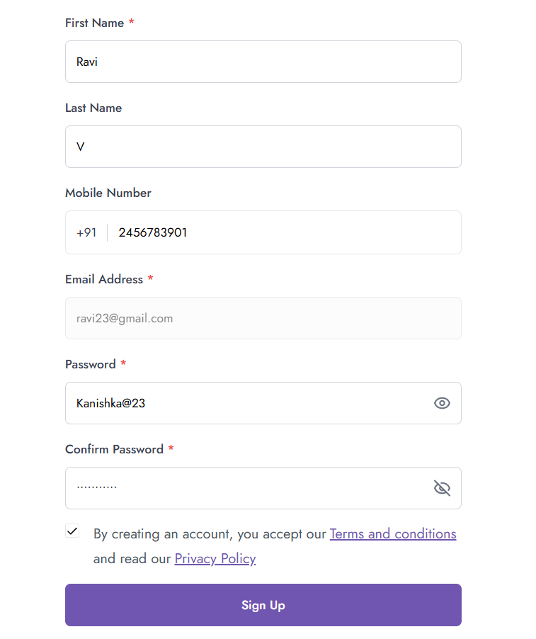
Screenshot 1: Sign Up page showing the invalid mobile number (2456783901) entered before registration.

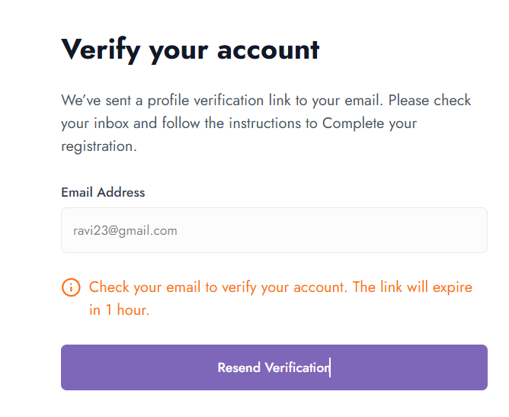
Screenshot 2: Verify Your Account page showing that registration was successful with the invalid mobile number.

