Figure 1. UML Use Case Diagram for the DriverPass System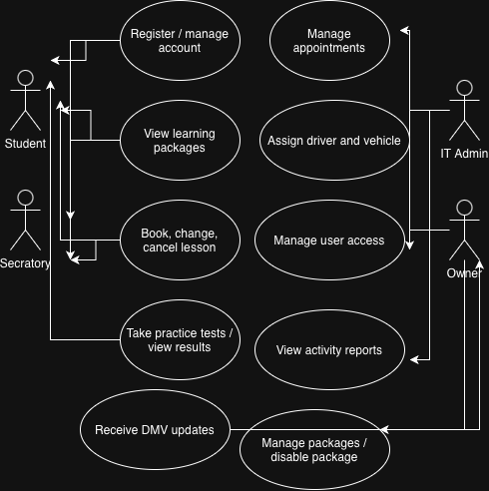
Figure 1. Use Case Diagram
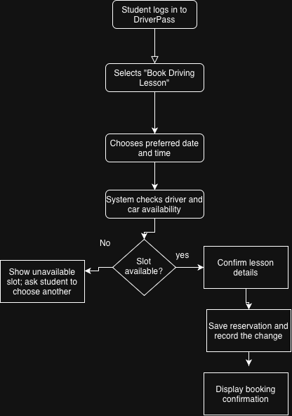
Figure 2. Activity Diagram — Booking a Driving Lesson

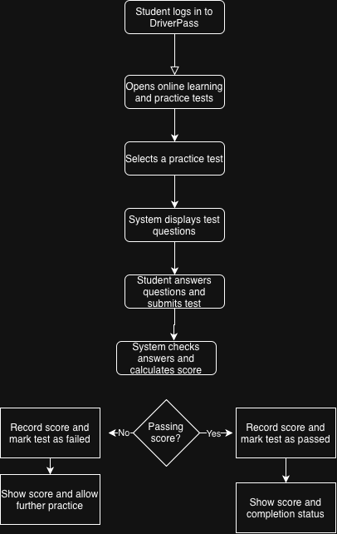
Figure 3. Activity Diagram. Taking an Online Practice Test

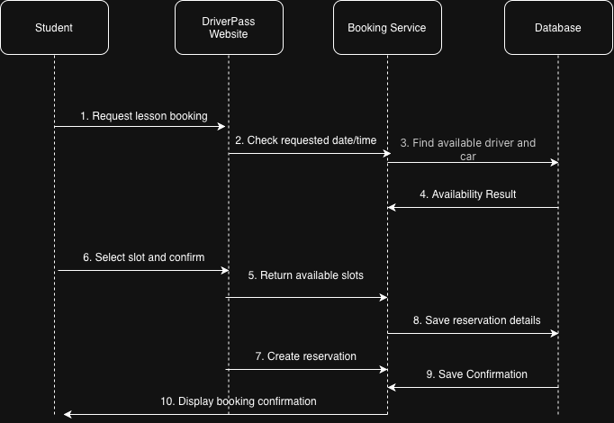
Figure 4. Sequence Diagram. Booking a Driving Lesson

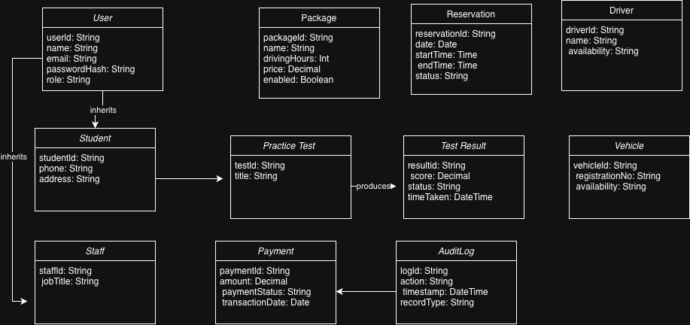
Figure 5. UML Class Diagram for the DriverPass System

