TEAM NAME- METASTABE MINDS
MEMBERS NAME- Jyoti Gupta, Kanishka Bhardwaj

Project Title: Design of a 16-bit ALU with Basic Testbench and Flag Support

INTRODUCTION:
The Arithmetic Logic Unit (ALU) is one of the most fundamental components of any digital system, especially processors. It is responsible for performing arithmetic operations such as addition and subtraction, as well as logical operations like AND, OR, and XOR. In this project, We designed and implemented a 16-bit ALU in Verilog, capable of handling arithmetic, logical, and shift/rotate operations along with status flag generation.
This project gave us hands-on experience in designing combinational logic, understanding how different operations are selected using control signals (opcode), and implementing real-world concepts like carry and overflow detection. It also helped us explore how low-level hardware operations form the backbone of higher-level computing systems.

GITHUB Link: https://github.com/Kanishka345/16_bit_ALU
THE COMPLETE DATAPATH:
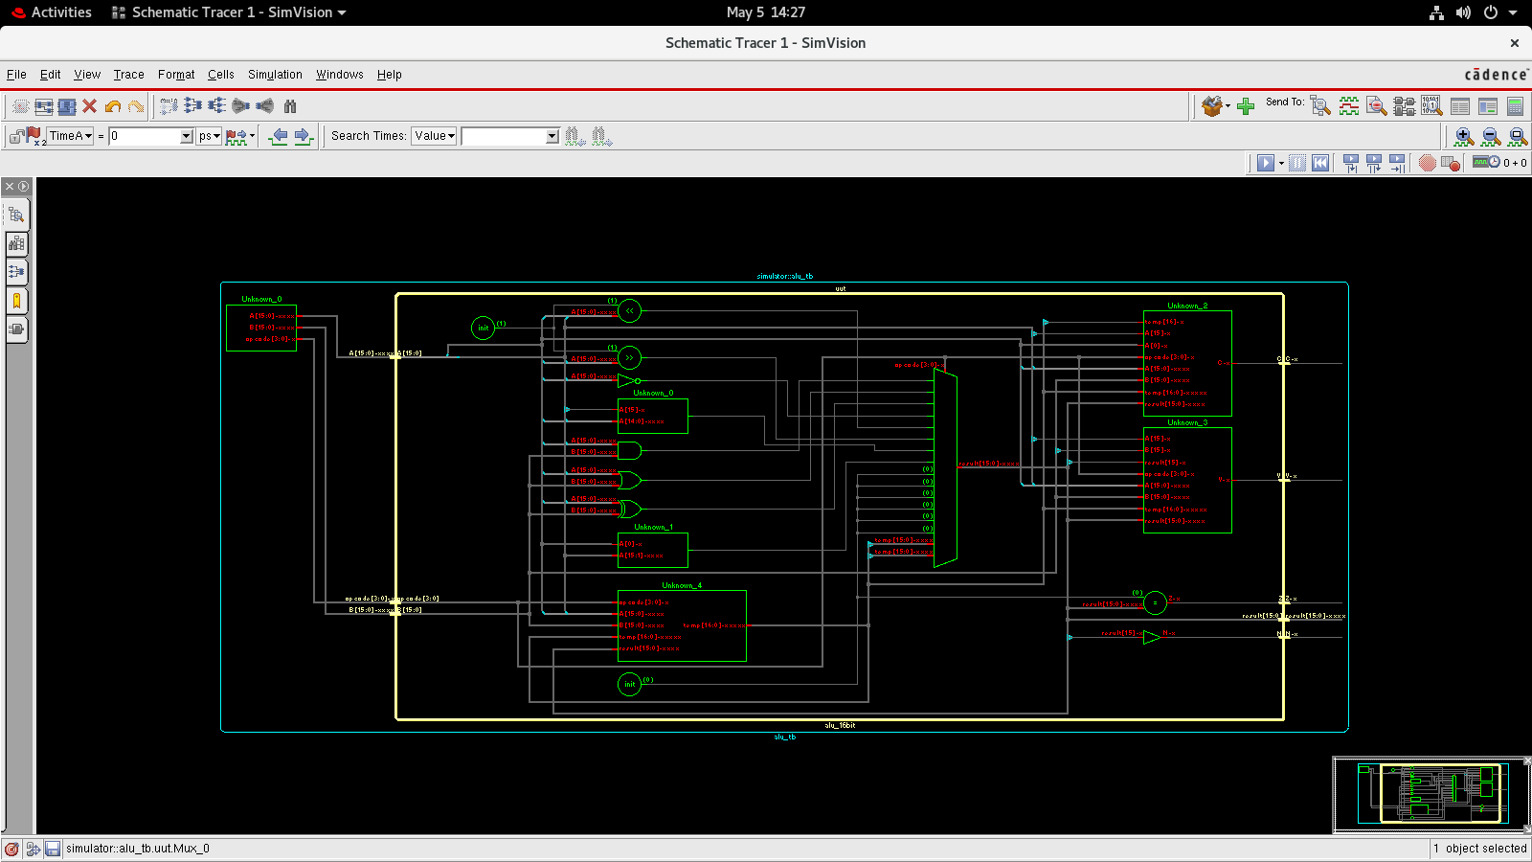

APPROACH / LOGIC USED:
- The ALU is designed as a combinational circuit.
- Operations are selected using a 4-bit opcode.
- A case statement is used to perform different operations.
- A 17-bit temporary register is used to handle carry.
- Flags are generated based on result conditions.

FEATURES OF 16-BIT ALU:
- Supports multiple operations using a 4-bit opcode selection mechanism.
- Performs arithmetic operations like addition, subtraction, increment, and decrement
- Includes logical operations such as AND, OR, XOR, and NOT.
- Provides shift operations (logical left shift and logical right shift) for fast bit manipulation.
- Implements rotate operations (rotate left and rotate right) to preserve data bits.
- Supports arithmetic right shift, which maintains the sign bit for signed numbers.
- Generates important status flags:
  - Zero (Z) → result is zero
  - Negative (N) → indicates sign of result
  - Carry (C) → indicates carry/borrow
  - Overflow (V) → indicates signed overflow

ALU ARCHITECTURE:
ALU is a combinational circuit (no clock needed)
- It takes two inputs A and B (16-bit) and an opcode.
- Opcode decides which operation to perform.
- Performs:
  - Arithmetic operations
  - Logical operations
  - Shift/rotate operations
- Produces a 16-bit result.
- Also generates flags:
  - Zero (Z)
  - Negative (N)
  - Carry (C)
  - Overflow (V)
- Uses internal logic to ensure correct and fast computation.

Module-Wise Design:
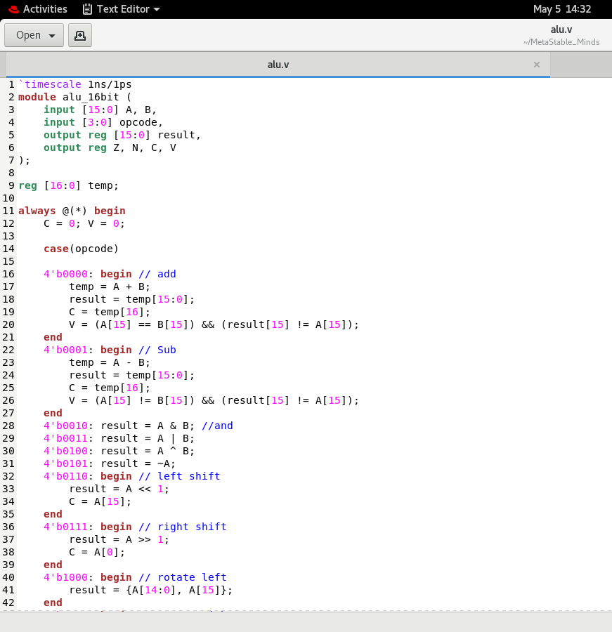
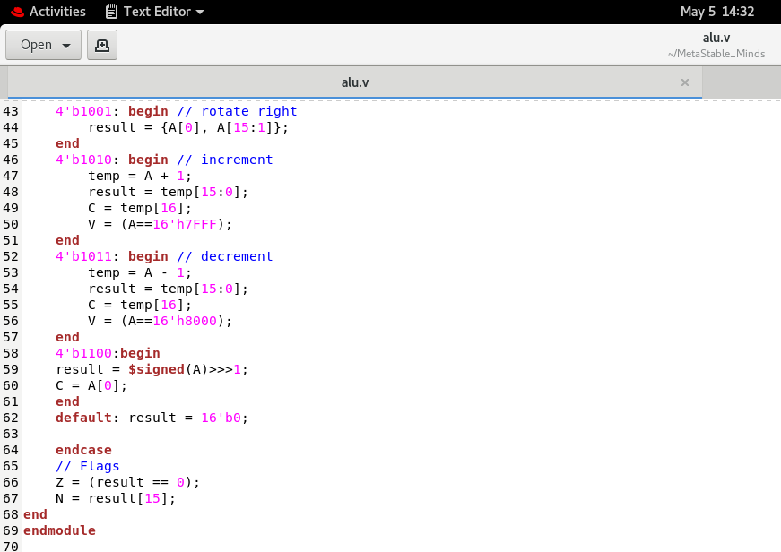

TESTBENCH:
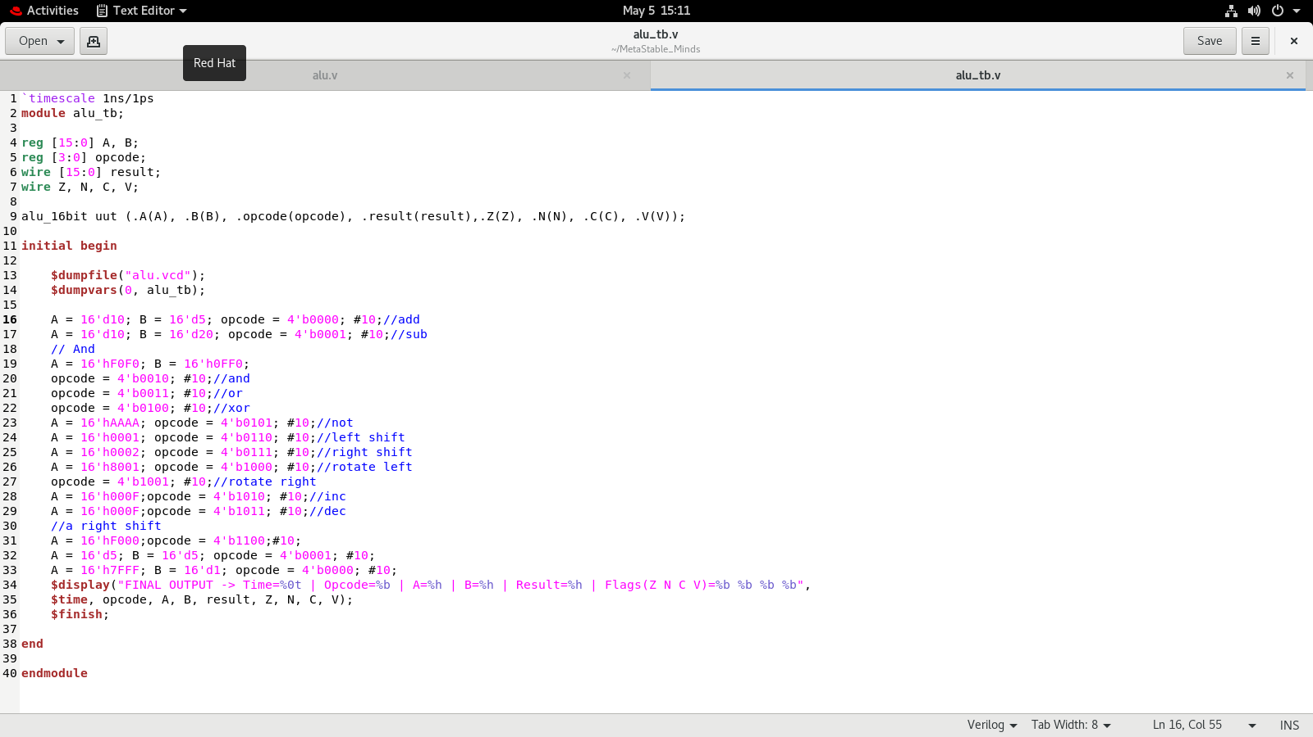

WAVEFORM ANALYSIS:
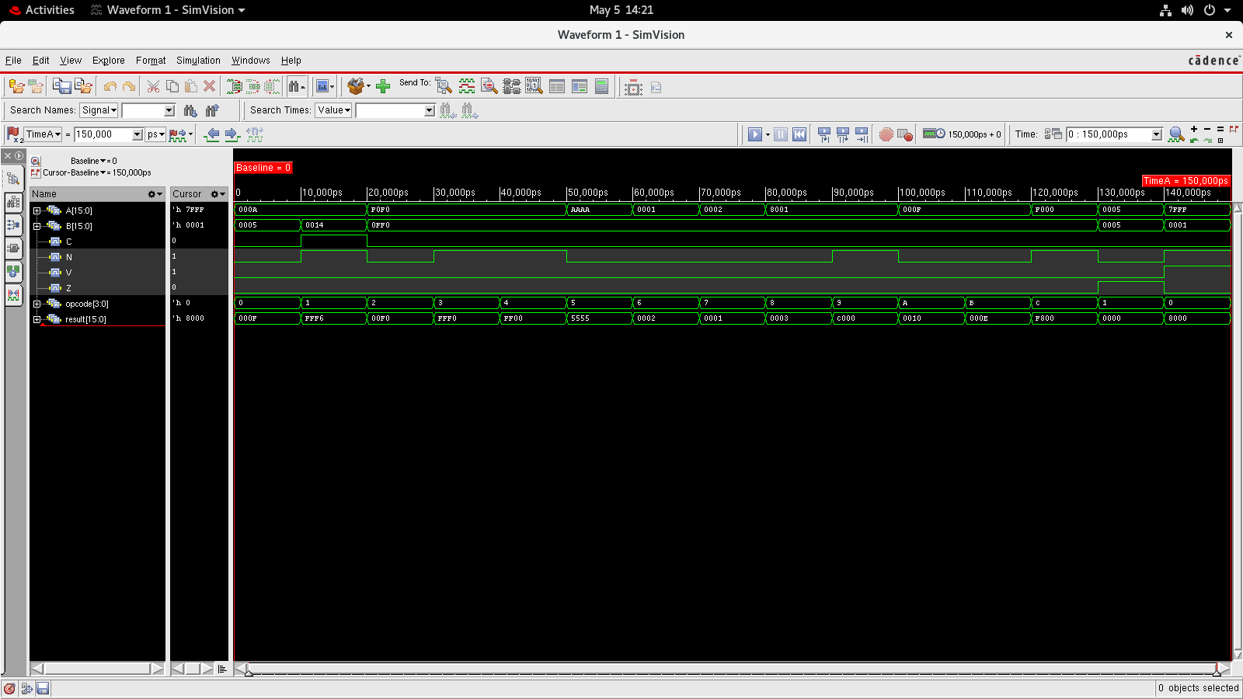

OBSERVATIONS:
- Z flag becomes 1 when result is 0.
- N flag becomes 1 when MSB is 1 (negative number).
- C flag is set during addition overflow.
- V flag is set when signed overflow occurs.
For example:
When adding FFFF + 0001, result becomes 0000
Z = 1
C = 1
Waveform clearly shows transitions between operations and helps confirm correctness.

CHALLENGES FACED:

Some issues I faced during this project:

- Understanding overflow vs carry (they are not the same).
- Getting signed arithmetic right.
- Debugging incorrect flag values initially.
- Remembering correct syntax for shift operations in Verilog.
- Making sure all cases are covered in testbench.

CONCLUSION:

This project helped me understand how an ALU works internally and how different operations are implemented in hardware using Verilog. It also improved my understanding of flags and testing digital designs.

THANK YOU

