01.**INTRODUCTION / BACKGROUND**

Now a day the web has greatly improved and has become a very big factor in our modern society. Internet and web applications are now being used in every steps of modern technology where the modern society largely depends on computer technologies. So, I have chosen an important project on ‘’ Ornamental Fish Online Ordering System for Ekanayaka Aquarium “ that situated in Polonnaruwa, Aralaganwila.

This proposal focuses on initialization of the project. This system will be started with the exploration on ordering the various types of ornamental fishes and providing all fishes related information system. This chapter will concentrate on the introduction, motivation towards the proposed system and a description about the existing process/ functions, problem identification and its drawbacks as well as the objectives of the proposed system with measurable outcomes, key processes/ functions of the proposed system and system development methods and methodology and brief description of the software, hardware specification to develop the proposed system will be discussed, organization/ time schedule of the system development, breakdown of tasks and durations, Gantt chart with work schedule, timeline and work calendar and finally the conclusion of the chapter will be described.

System development methods and methodology is expected of why chosen system development method and methodology selected for proposed farm and generation on developed time-period. The hardware, software and graphic design technology, which is going to use is mentioned in the brief description of the software, hardware specification to develop the proposed system topic.

Ornamental fish culture is the culture of attractive, colorful fishes of various characteristics. Aquarium keeping is amongst the most popular of hobbies with millions of enthusiasts worldwide. Ornamental fish culture provides an excellent business opportunity in Sri Lanka since there is a strong demand from both domestic and export markets. The aquarium fish industry in Sri Lanka has become a valuable foreign exchange earner during recent years.

The Ekanayaka Aquarium is a well known farm that is ordering and providing all fish related information. But they use manual system to maintain these activities. using this system they have to face a lot of problems or difficulties. And also customers are unable to know about all the fish details. After analyzing the Ekanayaka Aquarium, I have identified, they are using a slower system for day to day activities. Because of that I decided to introduce a ornamental fish ordering and providing all fish related information system to Ekanayaka Aquarium.

We expect to provide ornamental fishes to local market and global market through This new system. Here this Aquarium owner expect delivering to the Customers such as, mainly exporter, buyer, supplier, and some institutes. In this Aquarium has various kind of fishes such as “ Guppy, Gold fish, Carp, Angel, Gourami, Calico, Red Mosaic, Platy, molly, Zebrafish “ and they deliver various sizes of fishes. This Aquarium’s owner breed various fishes for delivering and to buy fish orders from suppliers for providing fish order to customers, buyers or exporters. This is main purpose of this system. And also they expected to provide most information related fishes such as ‘kinds of fish, sizes of fish , diseases of fish and what are the suitable diseases treatment , suitable foods for variance sizes fish , prices to our customers through the online. It is important and easy for customers to know details about fish. After our customers or exporters are ordering the ornamental fishes, Ekanayaka Aquarium is provided transport service to customers or exporters.

By using this system, the Aquarium can earn economically profit than existing system or manual system and can provide better service for their customers, suppliers and exporters.

* 1. **Problem Statement**

Ekanayaka Aquarium has a manual system. therefore, owner have to face a lot of problems because of it’s existing system. It is very difficult to satisfy the requirements of the owners and customers or exporters. Followings are some problems to face owners and customers;

* Mistake are made when taking the orders of the customers and suppliers.
* Difficult to use
* Documents can be lost easily.
* Time wasting
* Customers are unable to get information easily through this manual system.
* Owner can’t maintain bill card easily and quickly.
* The record keeping system is poor.
* By using the manual system owner can’t earn a lot of money. Because There are many customers don’t know about details of the this Aquarium. So, it is not famous for community.

These are the major problems facing the existing system and would be corrected with the help of the proposed system.

* 1. **. Objectives**

Because a new system is a significant investment for the Aquarium, the successful implementation will need to meet or exceed a number of goals. These goals will be used in conjunction with critical success factors to guide project decision-making process.

* Provide the better service for customers or suppliers and exporters.
* Customers and suppliers can make order ornamental fish through online.
* Customers can get information (prices, types of fish) about fish through online.
* Customers can pay through online using credit or debit cards.
* Admin can handle all of the details correctly and easily.
* To reduce the paper costs and eliminate the unnecessary spaces.
* To minimize the human errors.
* To improve the customer satisfaction and employee efficiency.
  1. **. Project Scope**

By the project scope we can identify the description of full online ordering system. First of all after analyzing existing system we decide to design an online ordering system for the Ekanayaka Aquarium instead manual system. This manual system is very difficult task for owner, customers or suppliers. Ekanayaka Aquarium sell various types of ornamental fishes (Guppy, Gold fish, Carp, Angel, Gourami, Calico, Red Mosaic, Platy, molly, Zebrafish). We are breeding these all types of fishes and most probably we get orders from our suppliers and provide order to customer or exporters. This is Ekanayaka Aquarium own business. They earn some amount of profit by using manual system., but it is not enough. Today, technology is very advanced. many people are fulfilling their needs thought the internet. So in today world all transactions are conducting over the internet. According to purpose system , we can easily conduct fish ordering details. It gives information’s of ornamental fishes, it’s name, price, categories, details etc.

Their Aquarium are doing manually, So it is failure because owner and customer face many difficulties. We proposed to design a new online ordering system for their Aquarium to reduce these difficulties and fulfilling owner’s and customer’s expectations effectively. Customers can get more information and give some order by online. Further customer can pay for credit cards. Here ,customers have to login in the website and then choose the require fish or details and finally they can order easily based on internet by using new online ordering system.

* 1. **. Motivation of the Project**

The current Ekanayaka Aquarium system is a system which is done by using manual documents. There are number of customers or exporters in Local market and they use manual system for ordering ornamental fish. Due to manual information maintaining, The Aquarium has faced many difficulties. So the main idea the Project is to convert that manual processing system in to new system by first developing new unique software for the Ekanayaka Aquarium. The owner of the Ekanayaka Acquarium has asked to develop the software with their requirements. So the Project needs to be developed fulfilling all those requirements. Some of those requirements are as follows.

* Fully functional database.
* Application is developed on a based user interface.
* Use different user logins for the manager, different levels of staff, customers or suppliers, and exporters.
* Use different user accessibilities for the different levels of staff.
* Keep customers records such as,
* customer ordering and payment
* Keep stock Records such as,
* Customer details
* Supplier details
* Stock balance

By using creative methodologies to everything which can possible, the farm can go to a standard position. Because the farm can provide better service to our customers and exporters. So this fish ordering system will be a good solution for all these problems.

The current system of the Ekanayaka Acquarium has lots of disadvantages. So, the project idea is to develop the new system preventing those disadvantages and also with a user friendly interface and functions which makes it easy for the customers to use the new.

**02.BACKGROUND ANALYSIS**

This is described the background analysis of proposed system. It includes the detailed of review relevant theory, background analysis for the proposed system, advantages and disadvantages of existing system. It also comprises the functions of the proposed system through the background analysis and provides the solution to overcome the problems in the manual system.

The system that is going to be developed is ornamental fish online ordering for Ekanayaka Aquarium in Aralaganwila. This system is used by the owner to facilitate their customers and exporters to ordering ornamental fishes using online and getting more details about the fishes. In addition to that the owners can upload about new breeding fishes and their details. The customers can see most suitable details or get the clear idea and can order fish accordingly customer’s requirements.

Basically, this system has some features and services. According to the proposed system provides a better solution for the ornamental fish online ordering process of the Ekanayaka Aquarium.

**03.PROJECT METHODOLOGY**

In this section, the life cycle analysis of the project will be discussed. By completing this section, we can easily understand the comprehensive mechanism of the project.

The main methodology involves in this research are collecting data and online ordering system development. Collecting data method is to gather data needed to develop the system. The system will be developed using a relational database which is Microsoft SQL server. The proposed system will develop based on the waterfall model. In a life cycle analysis, waterfall model can be identified.

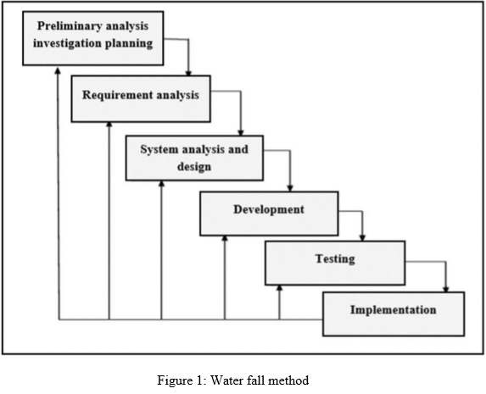

I. Preliminary Analysis Investigation Planning:

The First phase of the waterfall model is preliminary analysis investigation planning. Its main objective is identifying the problems. In this phase first of all discuss an appointment date with the owner of the Ekanayaka Aquarium for an interview and visited the place for an exploration. And also online research on the background of the Ekanayaka Aquarium system and especially about database controlling.

1. Requirement Analysis:

Requirement analysis will show the operation of the current system and more vitally and gather business process information about current structure and manager approval to study within the documents and reports.

Organization mission and vision are discussed. And observation, document about ordering process and providing information. Identifying the actual needs of the users in functional and non-functional viewpoint is covered in this phase. In this phase, complete investigation of the client organization and identifying the project objectives, goals, and deliverables are focused to initialize the project.

1. System Analysis and Design:

System analysis and design has consisted identifying requirement and summarizing. Thus, it will prepare the structure and interface design. So, and provide make modelling the existing system using a context data flow diagram. The concept makes modelling the new system using the context and draw modelling an Entity relationship (ER) diagram. The proposed solution will be architected with UML diagrams and with this foundation, the proposed system must be generated to deploy in the client organization.

1. Development:

The concept of development has based on the design; the system can design using SQL server, JAVA and other programming language in its developing an environment.

1. Testing

It is an obvious fact that every system needs to be tested before it goes for the initial working environment. Each unit is developed and test for its functionality. This is called as unit testing. Then, these units are integrated into complete system and test to check if all units coordinate between each other. This is called integrated testing and system testing will be done. Finally, the system will be handover to the customer to user testing. Each component or unit of the system will be tested to remove the errors and incompatibilities of the generated system. Unit and integration testing will be taken first and then the installation testing done.

1. Implementation:

The implementation step is performed in this phase. Any problem with the system will be sorted once the testing has been completed. And working out with the real environment. Continuous evaluation of the processes of the system is an unending activity of the developers and users. Future modifications and alterations will take place continually in the span of life of the system

**Reasons for Choosing the Waterfall Model:-**

* Easy to explain to the user.
* Stages and activities are well defined.
* Helps to plan and schedule the project.
* Verification at each stage ensures early detection of errors / misunderstanding.
* It allows compartmentalizing the life cycle into various phases, which allows planning the resources and effort required through the development process.
* It allows setting expectations for deliverables after each phase.

**3.1. Requirement Analysis**

The requirements analysis describes the business needs for what owner require from the system. The proposed system is the Online Ordering System for Ekanayaka Aquarium. This Aquarium’s current system is a manual system. After analyzing the this existing system, could identify it has some difficulties to customers or exporters and owner to maintain and conduct require activities. These days online is very famous and most customers use online service doing day to day activities for doing easily. And also today customers may be a busy person, so they need to serve their time. The process that are using manual system (Collecting information process, growing process, maintaining process and ordering process is manually) for all activities are not suitable.

According to owner requirements, we decided to create online system for Ekanayaka Aquarium. It is easy and comfortable for owner and customers, suppliers or exporters. The proposed system intend to provide ordering facility and providing more details facility than manual system. Ordering is the basic requirement in our business. According to customer’s order we provide transport service and providing most suitable details about various ornamental fish for customer requirements. after analyzing the all requirements and advantages, we decided to create ornamental fish online ordering system for Ekanayaka Aquarium. This new system is effectively and efficiently.

**3.2. Feasibility of the project**

This include feasibility study and requirement analysis for the proposed system. Feasibility study means understanding the problems and determines whether it's possible to create the software without any difficulties. Feasibility studies are undertaken under many circumstances to find out whether a company or client have enough money for a project, to find out whether the software being created will suit, or to see if there are enough human resources for the project

This feasibility study involves the analysis of the problem and collection of all information what are relating to the ornamental fish online ordering system. Different data items are used to the system. Each and every phase of the development cycle should be tested for its feasibility and initial feasibility is deal with the budget and the temporal factors. This feasibility study is mainly focused on the current system and current system and also about new proposed system. As Ekanayaka Aquarium have no computerized system, they are using manual system. Feasibility study is very important for development purpose. The main objective of the feasibility study is to test the technical, operational, economical and behavioral feasibility for adding new features. To determine this possibility it can be focused on four interrelated feasibility types those are,

* Technical Feasibility
* Operation Feasibility
* Economic Feasibility
* Behavioral Feasibility

**3.3. Design, Testing and Development**

I would like to deal with the life cycle analysis of the project and clear understanding on this section. In a life cycle analysis , waterfall model can be identified. Various life cycle can be applied in computerized information system developments and we will follow a widely accepted model called waterfall life cycle model. The logic behind the name waterfall model difficulty is swimming up a waterfall.

This view point has been viewed as a drawback to inconsistent projects in terms of its requirements and other processes. But in context to this projects the requirements are going to be well-defined and the complete evaluation throughout the project will in case to remove the errors and incompatibilities.

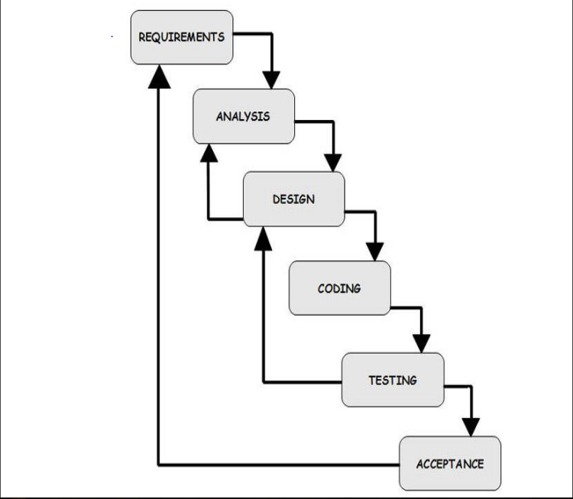

Figure 2: system development method life cycle

**Design :-** The proposed solution will be architected with UML diagrams and with this foundation the proposed system must be generated to deploy in the client organization. Precise diagrams and models will be granted as the blueprint to the system.

**Testing :-**  Each component or unit of the system will be tested to remove the errors and incompatibilities of the generated system. Unit and integration testing will be taken first and then the installation testing done. After all testing processes the software will be ready to deploy in the client organization.

**Development :-** The concept of the development has based on the design, the system can design using SQL Server, Java and other programming language in its developing an environment.

**04. HARDWARE AND SOFTWARE TOOLS FOR THE DEVELOPMENT AND DEPLOYMENT**

In order to develop a better system, it is very important to choose the correct hardware, software and technology. Here are some explanations of the hardware, software and technology chosen as development tools for the Ekanayaka Aquarium.

* **Software Technology Consideration :-**
* Front end technologies :-
* - HTML
* - CSS
* - JavaScript
* - jQuery(libraries)
* - Bootstrap (frameworks)
* Back end technologies:-
* - PHP
* - MySQL (Database language)
* Local server :- Xampp Sever
* Text editor :- Sublime text editor
* **Hardware Technology Consideration :-**
* Core i3 or higher
* 2.40 GHz or higher
* 4 GB RAM
* 1 TB
* Printer
* Keyboard and Mouse
* Fast USB port.
* Proper internet connection

**05. PROPOSED BUDGETERY REQUIREMENTS**

|  |  |
| --- | --- |
| **Description** | **Amount** |
| Planning | Rs. 15,000.00 |
| Development | Rs. 40,000.00 |
| Testing | Rs. 10,000.00 |
| Implementation ( Hardware and software purchase) | Rs. 200,000.00 |
| Training | Rs. 20,000.00 |
| Total | Rs. 285,000.00 |

Table 1: Budgetary requirements for the proposed system

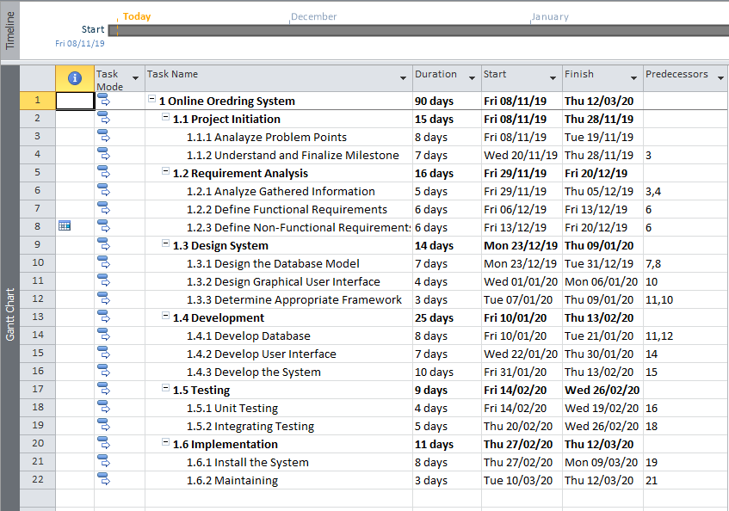**06. PROJECT SCHEDULE**

Figure 3: Work Break Down Structure

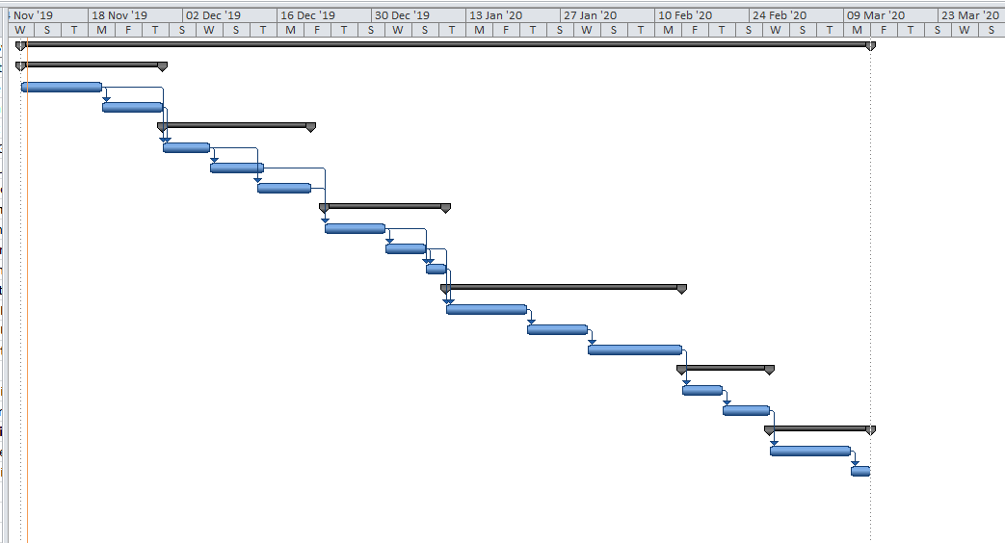

Figure 4: Gantt Chart

**07. CHAPTER ORGANIZATION OF THE PROJECT REPORT**

Chapter 01: Introduction

Chapter 02: Background Analysis / Literature Review

Chapter 03: Feasibility Study and Requirement Analysis

Chapter 04: System Analysis & Logical Design

Chapter 05: Physical Design and System Development

Chapter 06: Testing and System Debugging

Chapter 07: Implementation, Maintenance, and User Manual with Screen Shot

Chapter 08: Future Improvements and Conclusion

**08. REFERENCES**

* Rambadagalla Ornamental Fish Breeding Training Center in Kurunegala.
* OASIS Fish Farm in Kalukele.
* Kuruppu M.M (1998) Developing the ornamental fish industry
* Adballah, M.(2000). Current status of ornamental fish trade.
* Home Aquarium and Ornamental Fish Culture by C.S. Tharradevi and N. Arumugam.