# **Analysis of Nykaa's Best Skin Care Products**



*A*

*Project Report Submitted By*

***Kanishka Gairola***

*For The Degree Of*

***PGDM [BDA-04]2023-2025 Batch***

Submitted to

Professor Amarnath Mitra

Student

Kanishka Gairola (045025)

**1.Introduction**

This project gives a brief overview of the project entitled Analysis of Nykaa’s Best Skincare Products using Python. It discusses the coding analysis, general description of data, the statistical as well as mathematical methods used to analyze and interpret the data. This analysis and manipulation of data using Python allows us to understand and compute predictions and decisions based on patterns and charts. The project analysis was done on the Google Collab Platform using the Python language. For this project, I have used scraped data from Nykaa’s website to conduct an analysis about the best-selling skincare products on Nykaa. This report will incorporate computation and study of various graphs and charts along with descriptive statistical study.

**2.Project Objectives**

* **Learning and Efficiency:**

The main objective of this project is to learn and become more efficient with the usage of Python as a language. It also gives a fair understanding of how to interpret and analyze the given data using Python. Some of the other highlighted objectives are:

* **Chart Design Using Python:**

Visualization plays a critical role in data interpretation. Therefore, the next objective is to represent our findings visually. Using Python's libraries, such as Matplotlib and Seaborn, we aim to design charts and depict data. The purpose of our work is to ensure clarity and precision while using bar charts, histograms, or heat maps.

* **Derivation of Managerial Insights:**

In addition to statistical findings, I seek to bridge the gap between data analysis and managerial decision-making. By correlating our analytical findings with real-world scenarios, market dynamics, and industry benchmarks, we will derive actionable insights. These insights will be framed in a manner that caters to decision-makers, offering them a clear roadmap on leveraging the data for tangible benefits

* **Understand the brand better:**

The objective of this project is to analyse the best-selling skincare products of Nykaa. Founded by Falguni Nayar in the year 2012, Nykaa is an Indian e-commerce multi-brand company headquartered in Mumbai. It sells beauty, wellness and fashion products across websites, mobile apps and 100+ offline stores.

**3. General Description of Data**

The data presented in the project was picked up from Nykaa’s official website. For my dataset, I chose a dataset that includes Nykaa’s top selling skincare products, an ecommerce website that deals in skincare, beauty and wellbeing multi-brand products.

This dataset contains columns pertaining to product name, reviews, offer price, discount, original price and free gifts. These columns represent the following data:

* 1. **Product name:** This column includes the name of all the skincare brands.
  2. **Reviews:** This column talks about the number of reviews about all the brands.
  3. **Offer Price:** The price at which the product is being offered to the customer post the discounts and offers.
  4. **Original Price:** This mentions the MRP of the product before discounts.
  5. **Discount:** This mentions the discount percentages that are offered on the different products and brands. 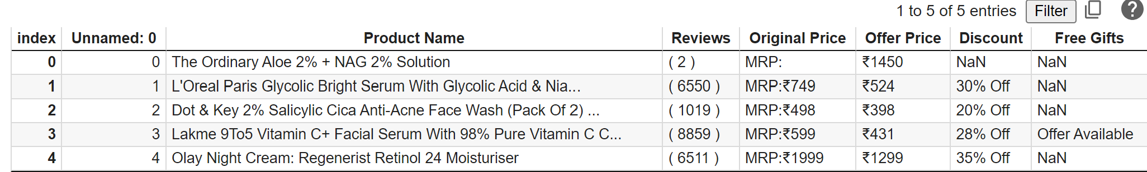**This data is then uploaded to Google Collab in the form of data frame for further analysis and work on the data.**

**4. Basic Descriptive & Mathematical or Statistical Analysis**

##### In order to make the comparability factor easier, the data has been presented in tabular form to analyse the discounts, original prices, offer prices, reviews and free gifts with respect to the best-selling skincare products belonging to different brands. Discount percentage has also been calculated using mathematical operations. Statistical methods like correlation analysis have also been used to understand the correlation between prices, discounts and reviews. For better visual representation of data, bar graphs have also been used to identify the price difference, to analyse the discount amount provided for each product and to identify the top 10 products with the highest price difference.

**5. Findings & Inferences**

The above-mentioned analysis helps in having a fairer picture of the market value of their products with respect to their competitors, the overall outreach of their products with respect to the feedback, comparing the price of similar products and also understand the kind of discounts and schemes that have been widely used by brands for better sales. In the project I have made tabular representation of data to determine the original price of the product with the help of the offer price and have also determined the discount percentages with the help of the original price and offer price of the products.

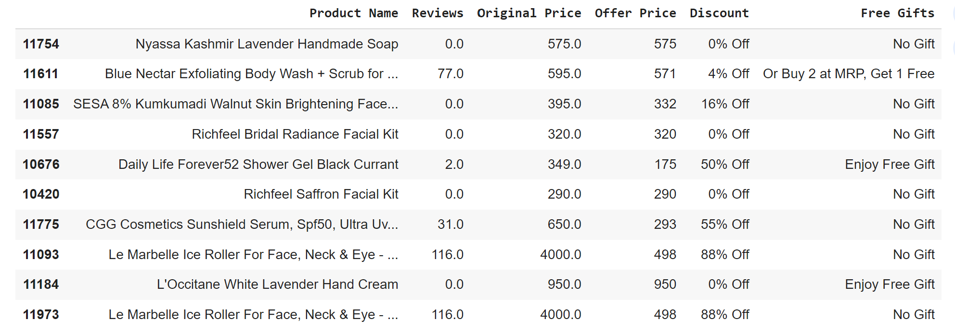

**Inference of Graphs:** In the project I have 2 bar plots, the first is used to display the top 10 products with the highest price differences. The 'Price Difference' is shown on the x-axis, and the product names are shown on the y-axis. The second bar plot in continuation to the data obtained represents the top 10 products with the highest price differences, making it easy to identify which products have the largest price variations in the dataset.

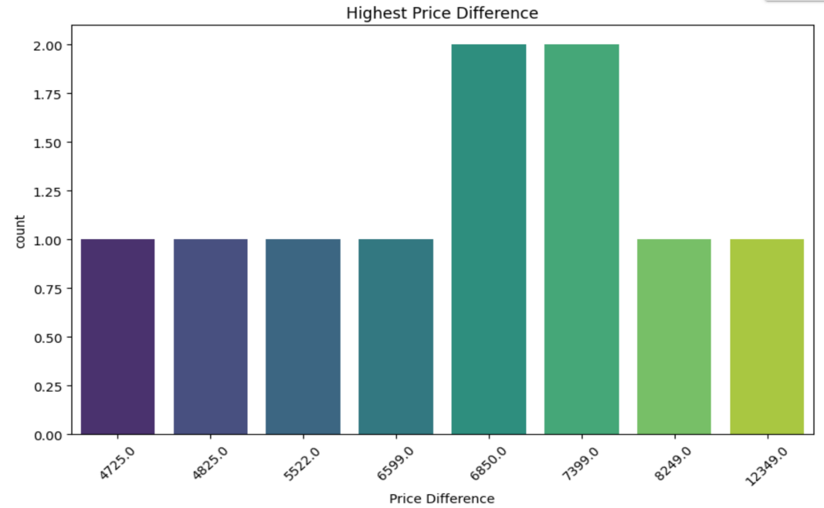

**Bar plot 1.**

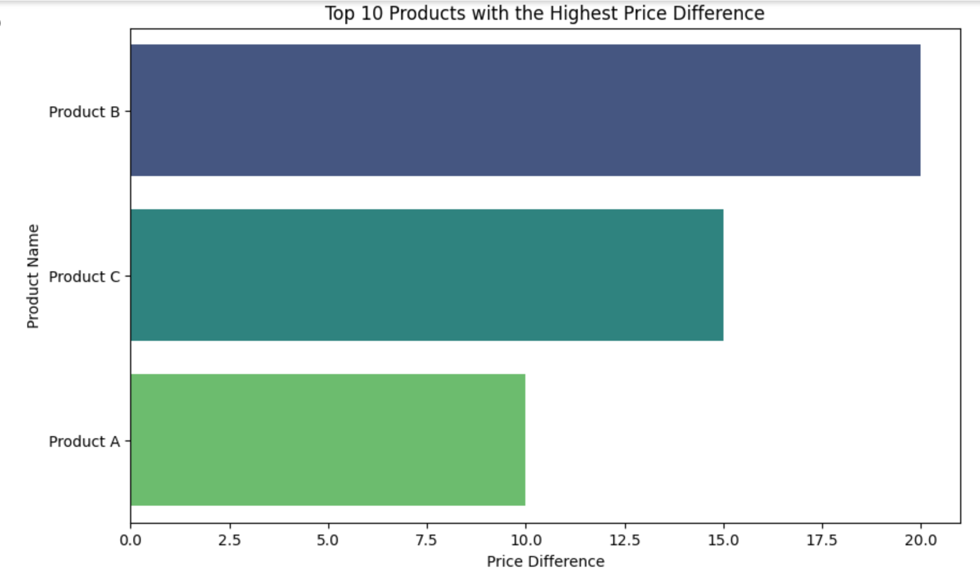

**Bar plot 2.**

**Inference of the Heat Maps:** Correlation heatmaps present correlations between multiple variables as color-coded matrixes. Correlation heatmaps show the correlation between variables based on their rows and columns. As per the heat map, reviews and original price share a positive relation, with reviews being the hottest, discounts the coldest, and offer price being cold.

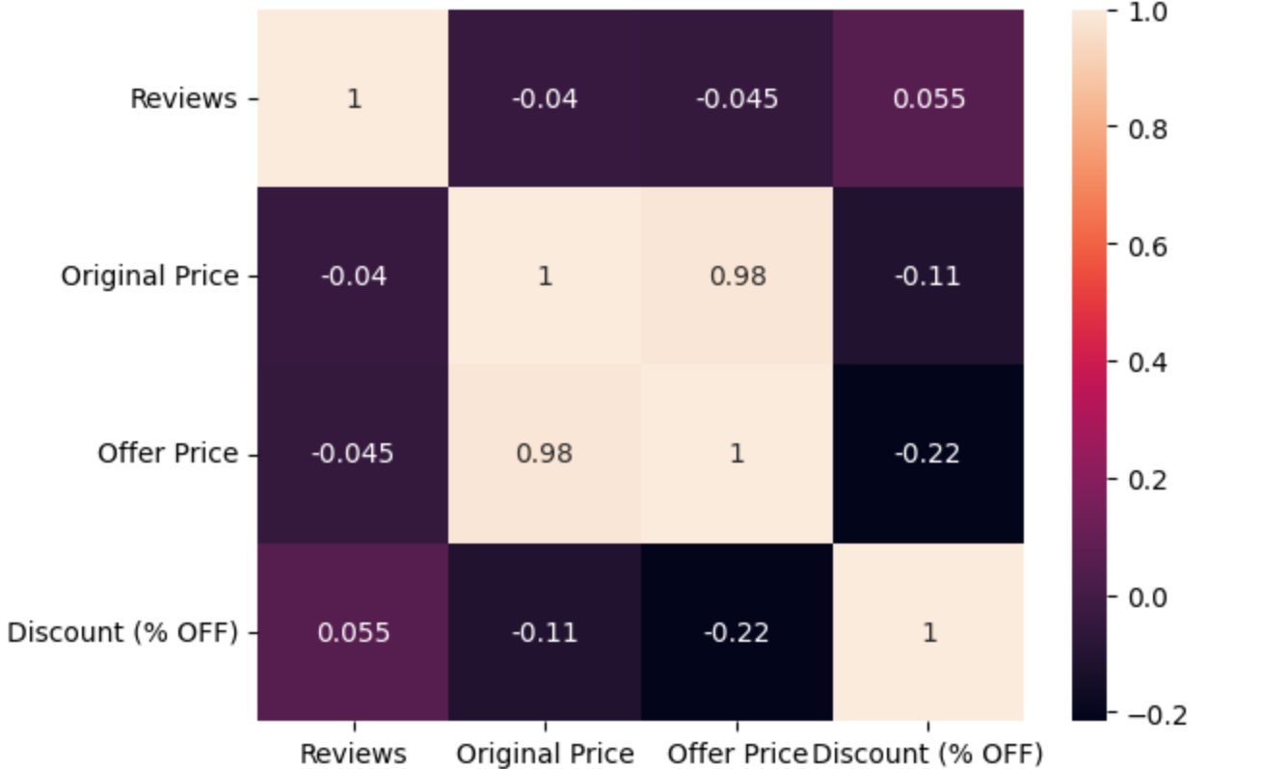

**6. Managerial Insights | Implications**

Based on the comprehensive analysis conducted on Nykaa, which encompassed a detailed examination of factors that affect the overall sales of a product, taking into consideration factors like original prices, offer prices, discounts, reviews, free gifts of various brands to determine the best-selling skincare products on Nykaa. This information can help Nykaa sustain and potentially enhance the success of its best-selling skincare products, meet customer needs effectively, and remain a trusted source for skincare solutions.

This data can further be used to decide which brands needs maximum campaigning and which are the ones don’t generate a larger section of the sales.

Bettered feedback loops with suppliers and manufacturers to address any supply chain issues promptly. Managers can ensure a consistent and reliable supply of best-selling products.

With the help of these insights managers can make data-driven decisions by implementing robust sales reporting and analysis tools to track the performance of best-selling skincare products.