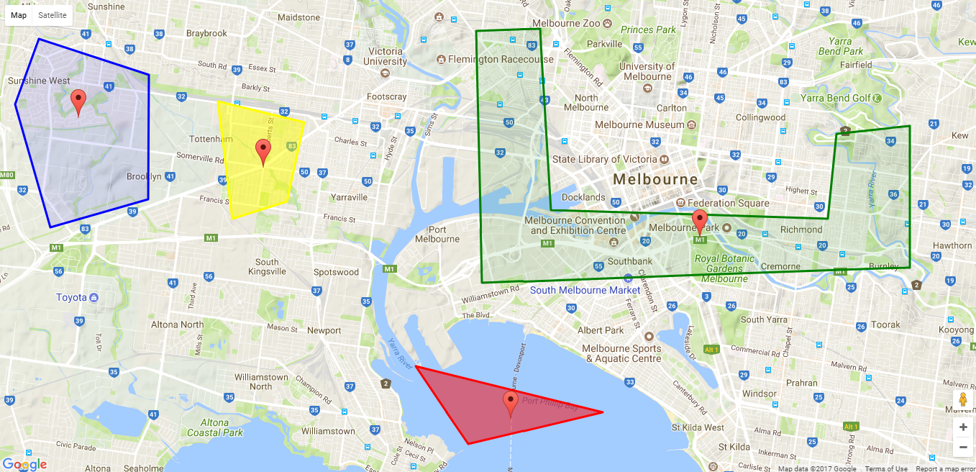

This program is designed with Object Oriented concept in JavaScript language. When analysing the problem I found out that when creating polygons most of the codes were repeating. Therefore I created a class to reuse and avoid the repeating of the design. This class takes coordinates and display properties of the polygon and then place them on the map.

class Polygon{

//constructor takes the map object from the initialisation

constructor(map){

this.map = map;

}

setCoordinates(coordinates){

this.cord = [];

//loop through the latitude and longitude coordinates. Polygons can have different number of corners

for(var i=0;i<=coordinates.length-1;i++){

this.cord.push( new google.maps.LatLng(coordinates[i][0],coordinates[i][1]));

}

this.cord;

}

//set the display properties for the polygon

setDisplayProperties(props){

var bermudaTriangle = new google.maps.Polygon({

paths: this.cord,

strokeColor: props.color,

strokeWeight: 3,

fillColor: props.color,

fillOpacity: props.opacity

});

bermudaTriangle.setMap(this.map);

}

//set the marker for the polygon

setMarker(marker){

var marker = new google.maps.Marker({

position: marker,

map: this.map

});

}

}

Then pass the parameters by creating objects for each polygon

// Define the LatLng coordinates for the polygon.

var first_polygon_cords = [[-37.787131751153915,144.8159408569336],[-37.79391457604158,144.84220504760742],[-37.81737834565081,144.84203338623047],[-37.82266683618851,144.81868743896484],[-37.79947602782783,144.81027603149414]];

//creates first object

var first_polygon = new Polygon(map);

//set the cordinate for the first polygon

first_polygon.setCoordinates(first_polygon_cords);

//set the display properties for the first polygon

first_polygon.setDisplayProperties({color:'blue',opacity:0.1});

//set the marker for the first polygon

first_polygon.setMarker({lat: -37.80205314400207, lng: 144.82538223266602});

Change the opacity using drop down menu.

**Assumption**

1. The developer is giving the coordinates for the polygons, not the user
2. The shapes cannot be edit or drag on the map
3. User should have internet connection to view the map

**Run the program**

Simply extract the zip file then open map.html file. If you get any problem using this method then try it on WAMP server or similar localhost server.