NETWORKWALKS
Penetration Testing Report
Mediroza General Hospital

Project Type | Penetration Testing & Vulnerability Assessment
Client | Mediroza General Hospital
Target | https://medirozahospital.com
Target IP Address | 199.188.201.16
Engagement Type | Black-box Web Application Penetration Test
Testing Window | 5 days (Week 4, Batch B083)
Authorisation | Written authorisation granted by the client for security testing of the in-scope web infrastructure
Report Date | 4 October 2026
Prepared By | Networkwalks Trainee Penetration Tester — Batch B083
Classification | CONFIDENTIAL — Authorised Personnel Only
This report documents an authorised black-box penetration test conducted in a controlled training environment. All testing was performed under written permission from the client within the agreed scope and rules of engagement. This report and its contents are confidential and intended solely for the client and authorised Networkwalks personnel.

01. Executive Summary
Networkwalks conducted an authorised black-box penetration test against Mediroza General Hospital's public-facing web application at https://medirozahospital.com over a five-day engagement. The objective was to identify exploitable vulnerabilities, demonstrate their real-world impact, and provide the client with a prioritised remediation roadmap.
Testing uncovered a chain of vulnerabilities that, combined, resulted in a critical and complete compromise of confidential data. Weak input validation on the Patient Portal login allowed unauthorised access to three confidential patient pathology reports. These PDF reports were protected with weak, dictionary-crackable passwords, all three of which were recovered in under a second of attack time. Metadata embedded in one of the decrypted files contained an internal staff note referencing a database backup left in a legacy directory. That directory was found to have directory listing enabled, exposing a full SQL database backup containing the complete staff table (names, roles, contact details, national ID numbers, and salaries) and the hospital's shareholder register.
In addition to this primary attack chain, the application was found to be vulnerable to clickjacking due to missing anti-framing headers, and its robots.txt file unintentionally revealed the existence of sensitive, non-public directories, which aided reconnaissance.
Overall Risk Rating: CRITICAL
The combination of broken authentication, weak file encryption, information disclosure, and an exposed production database backup represents a severe risk to patient confidentiality, staff privacy, and the hospital's regulatory compliance obligations (e.g. POPIA). Immediate remediation is recommended, prioritised in Section 05.

Summary of Findings
ID | Finding | Risk
F1 | Clickjacking — Missing X-Frame-Options / CSP frame-ancestors | MEDIUM
F2 | Information Disclosure via robots.txt | LOW
F3 | Broken Authentication — Patient Portal (SQL-injection-style bypass attempt succeeded in gaining session access) | HIGH
F4 | Weak / Dictionary-Crackable PDF Encryption on Confidential Patient Reports | HIGH
F5 | Sensitive Information Disclosure via PDF Metadata | MEDIUM
F6 | Directory Listing Enabled on /old/ | HIGH
F7 | Critical Data Exposure — Full Database Backup (staff PII, salaries, shareholder register) | CRITICAL

02. Scope and Methodology

Scope
The engagement was limited to the following target, as agreed with the client prior to testing:
- Target: https://medirozahospital.com (IP: 199.188.201.16)
- Type: Full black-box penetration test — no credentials or internal knowledge provided
- Objective: Identify vulnerabilities, exploit them to demonstrate real impact, and document findings

Rules of Engagement
- Testing limited strictly to the target domain
- No social engineering permitted
- No denial-of-service testing permitted
- No testing outside the agreed scope
Written authorisation for this engagement was provided by Mediroza General Hospital prior to the commencement of any testing activity.

Methodology
Testing followed a standard black-box methodology: reconnaissance, enumeration, vulnerability analysis, exploitation, post-exploitation analysis, and reporting.
- Reconnaissance: HTTP header and technology fingerprinting (Wappalyzer), robots.txt / sitemap enumeration (curl)
- Configuration review: automated clickjacking assessment against response headers
- Authentication testing: manual input-validation testing of the Patient Portal login form
- File analysis: encryption/password review of retrieved PDF documents, metadata extraction (ExifTool)
- Password auditing: dictionary attack against PDF password hashes
- Post-exploitation analysis: directory enumeration and review of exposed backup data

Tools Used
- Kali Linux
- curl — HTTP enumeration
- Wappalyzer — technology fingerprinting
- Clickjacker (clickjacker.io) — framing / X-Frame-Options assessment
- qpdf — PDF decryption
- ExifTool — document metadata extraction
- Networkwalks Hash Calculator & Password Cracker — PDF password hash dictionary attack

03. Findings and Proof of Exploitation
Findings are presented in the order they were discovered and chained together during the engagement, since several lower-severity issues directly enabled the critical data exposure described in F7.
F1 — Clickjacking: Missing X-Frame-Options / CSP frame-ancestors
MEDIUM Risk Rating: Medium
The application does not send an X-Frame-Options header or a Content-Security-Policy with a frame-ancestors directive. This was confirmed using an automated clickjacking test, which flagged the site as vulnerable and captured the raw response headers, which contain no framing protection of any kind. This allows the site to be embedded in a malicious iframe on an attacker-controlled page, enabling UI-redress (clickjacking) attacks against patients and staff (e.g. tricking a logged-in user into unknowingly submitting actions).
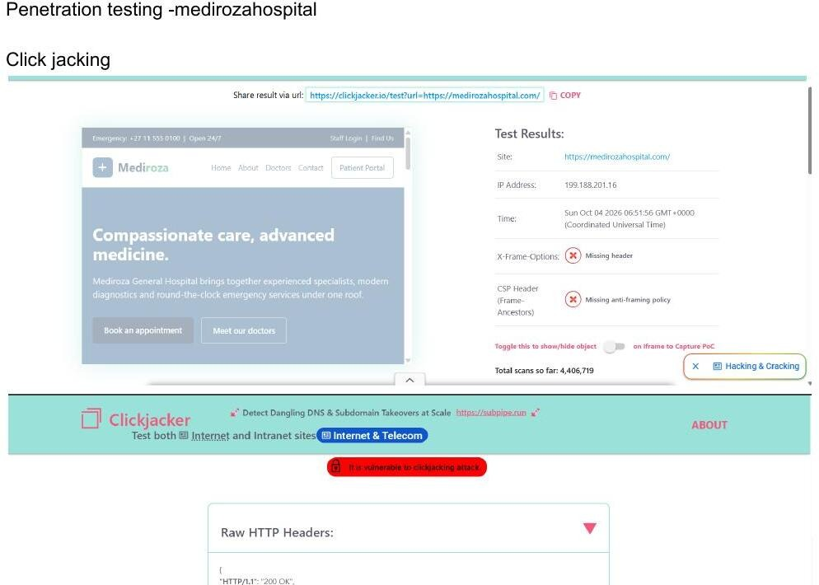
Figure 1: Clickjacking scan confirming missing X-Frame-Options and CSP frame-ancestors headers.
F2 — Information Disclosure via robots.txt
Risk Rating: Low
The site's technology stack was fingerprinted (LiteSpeed web server) and its robots.txt file was retrieved via curl. While robots.txt is intended to guide search-engine crawlers, this one explicitly disallowed /patient/, /staff/, and /old/ — effectively publishing a map of sensitive, non-public directories to anyone who requests the file. This directly informed later stages of the test, including the discovery of the exposed /old/ directory in F6.
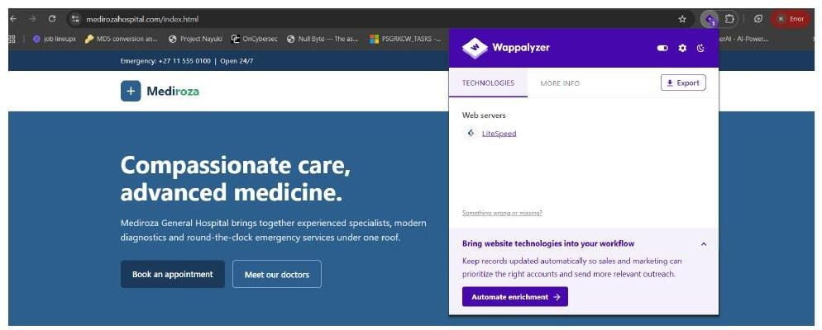
Figure 2: Wappalyzer fingerprinting identifying the LiteSpeed web server.
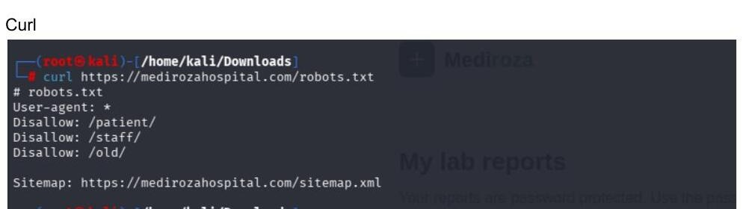
Figure 3: robots.txt disclosing sensitive directory paths (/patient/, /staff/, /old/).
F3 — Broken Authentication on the Patient Portal
Risk Rating: High
The Patient Portal login form (/patient/login.php) was tested for input validation weaknesses. A classic SQL-injection-style authentication-bypass payload (username admin'--, password '1=1') was submitted against the login form, a strong indicator that user input is not being properly sanitised or parameterised before being used in a backend query. Following this testing, unauthorised access to an authenticated patient session was obtained, exposing the "My lab reports" area and three confidential, patient-identifiable pathology reports (S. Dlamini, P. Reddy, E. Thompson) that should not have been accessible without valid patient credentials.
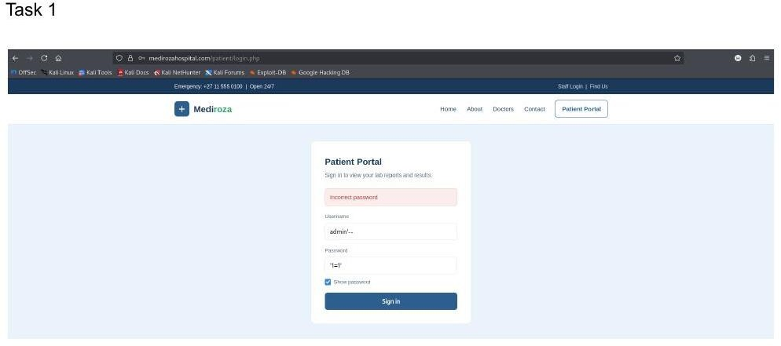
Figure 4: Authentication-bypass-style payload submitted against the Patient Portal login form.
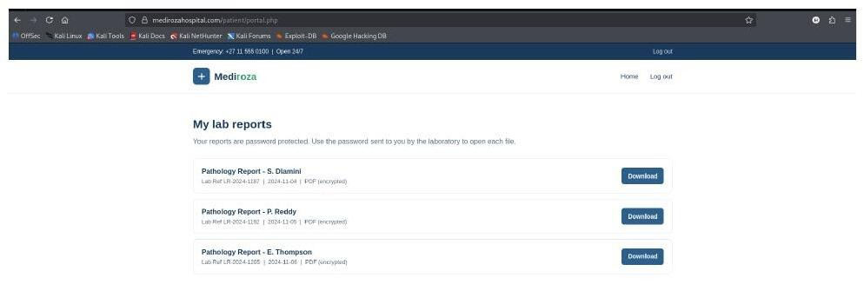
Figure 5: Unauthorised access obtained to the authenticated patient reports area, exposing three confidential PDF reports.
F4 — Weak / Dictionary-Crackable PDF Encryption
Risk Rating: High
All three confidential pathology PDF reports retrieved in F3 are password-protected, but each password was trivially weak. Each file's $pdf$ password hash was extracted and run through a dictionary attack. All three passwords were recovered almost instantly: 123456, password, and !@#$%^&. Weak password policy on confidential patient documents provides effectively no real protection against an attacker who has already obtained the files.
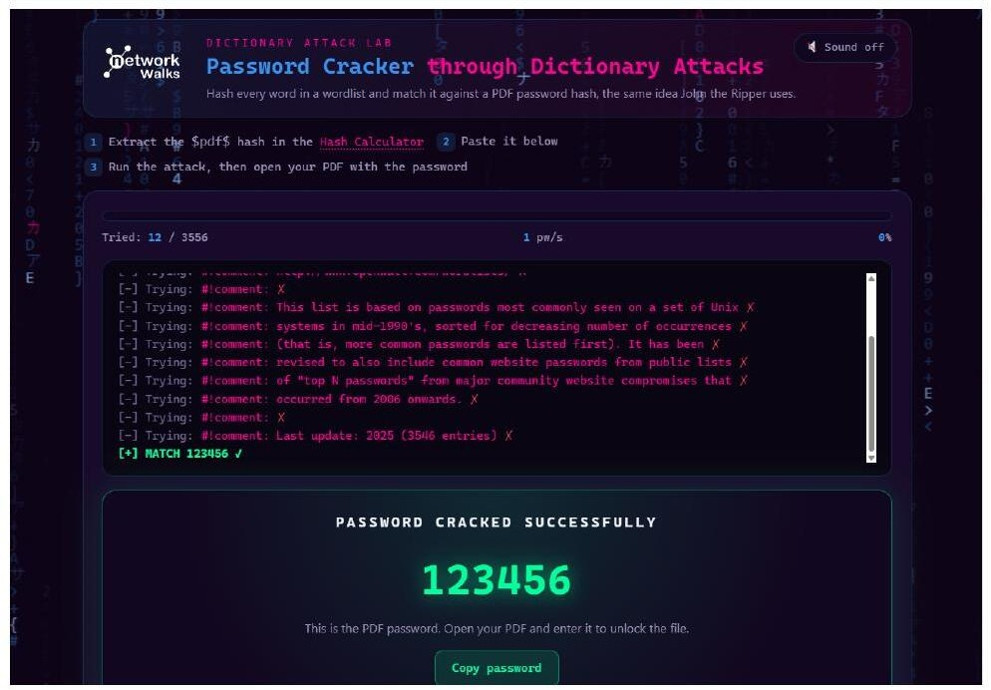
Figure 6: Dictionary attack recovering the password "123456" for the first report (12 attempts).
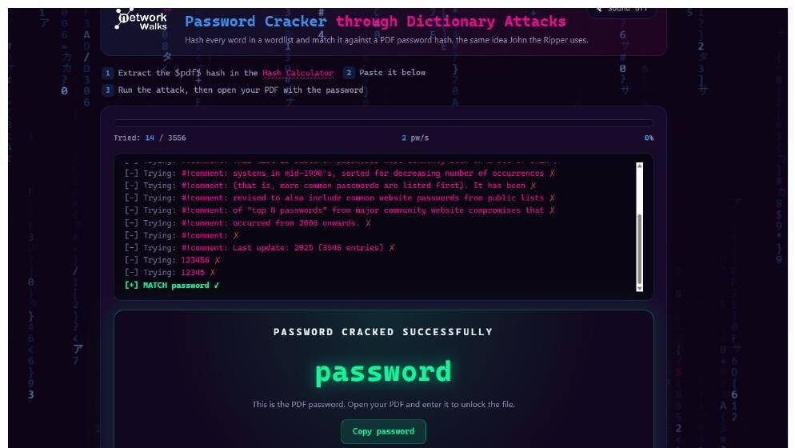
Figure 7: Dictionary attack recovering the password "password" for the second report (14 attempts).
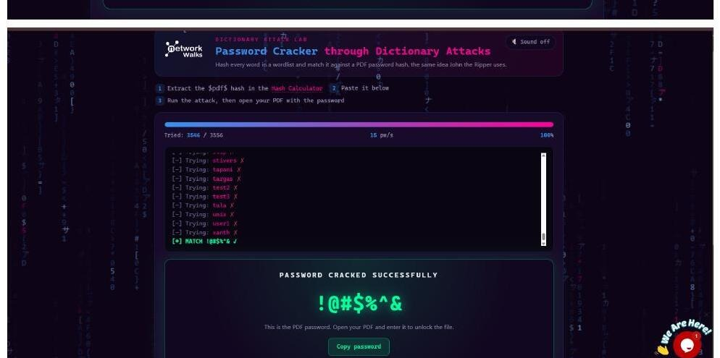
Figure 8: Dictionary attack recovering the password "!@#$%^&" for the third report (3,546 attempts).

F5 — Sensitive Information Disclosure via PDF Metadata
Risk Rating: Medium
After decrypting the third report with qpdf, its metadata was reviewed with ExifTool. The Author field revealed an internal staff username (j.malik), the Creator field revealed the exact CMS version in use (Mediroza CMS 1.4.2), and — most critically — the Comments field contained an internal operational note never intended for external readers: "DB backup moved to /old before site migration, do not delete." This single line of leaked metadata directly pointed to the location of a production database backup, which was pursued in the next finding.
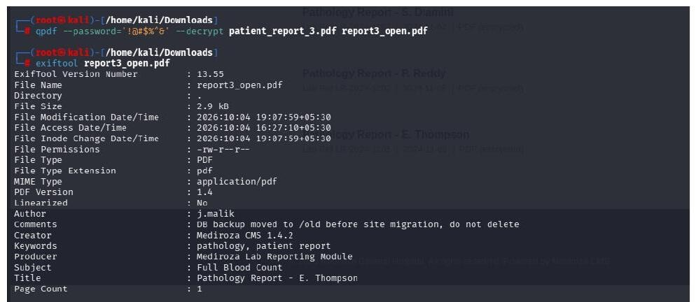
Figure 9: ExifTool output on the decrypted PDF, revealing an internal note about a database backup location.
F6 — Directory Listing Enabled on /old/
Risk Rating: High
Acting on the lead from F5 (and the /old/ path disclosed in robots.txt in F2), the /old/ directory was requested directly. Directory listing (indexing) was enabled on this path, exposing a single file: mediroza_db_backup_2019.sql (7 KB), freely downloadable with no authentication of any kind.
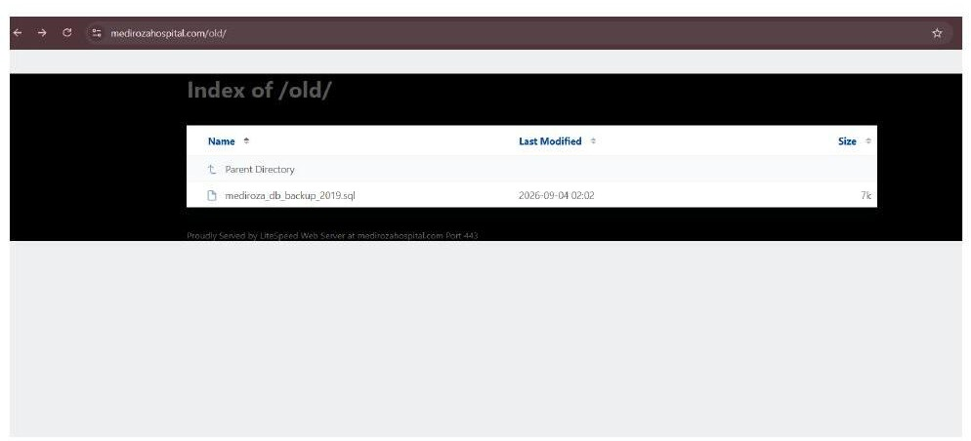
Figure 10: Directory listing enabled on /old/, exposing a downloadable SQL database backup.
F7 — Critical Data Exposure: Full Database Backup
Risk Rating: Critical
The exposed mediroza_db_backup_2019.sql file was downloaded and reviewed. It contains complete, unredacted SQL INSERT statements for two highly sensitive tables:
- staff — 30 full records including full name, job title, department, email address, phone number, national ID number, monthly salary (ZAR), and date joined, covering roles from Chief Pathologist and CFO down to ward clerks and nursing staff.
- shareholders — 10 full records including shareholder name, shareholding percentage, number of shares held, and share class, detailing the hospital's ownership/cap table.
This single file represents a complete breach of staff personally identifiable information (PII), payroll data, and confidential corporate ownership records. Exposure of national ID numbers and salary data for 30 employees, combined with the hospital's shareholder structure, constitutes a severe privacy and regulatory compliance failure (e.g. under South Africa's POPIA) and would almost certainly require mandatory breach disclosure if found in a production environment.
Representative excerpt (full dataset retained as separate confidential evidence, not reproduced in full in this report body):
- Staff table: 30 rows — e.g. Dr. Rajesh Naidoo, Chief Pathologist, Diagnostics Lab, salary ZAR 138,000/month; Sarah Botha, Chief Financial Officer, Finance, salary ZAR 152,000/month (additional 28 records held as evidence).
- Shareholders table: 10 rows — e.g. Dr. Rajesh Naidoo, 18.0% (180,000 ordinary shares); Cedar Health Holdings (Pty) Ltd, 15.0% (150,000 ordinary shares) (additional 8 records held as evidence).

Attack Chain Summary
No single finding above is, on its own, catastrophic — but chained together they produced a complete breach of patient, staff, and corporate data:
- 1. robots.txt (F2) revealed sensitive directory paths, including /old/
- 2. Weak input validation on the Patient Portal (F3) allowed unauthorised access to confidential patient reports
- 3. Weak PDF passwords (F4) meant that access to the files equalled access to their content
- 4. Metadata leakage (F5) revealed the precise location of a forgotten database backup
- 5. Directory listing (F6) made that backup freely downloadable
- 6. The backup itself (F7) contained the "crown jewels": full staff PII, salaries, and the shareholder register

04. Risk Rating
Each finding was rated using likelihood and business impact, consistent with a standard qualitative risk matrix (Critical / High / Medium / Low).
ID | Finding | Risk
F1 | Clickjacking — Missing X-Frame-Options / CSP frame-ancestors | MEDIUM
F2 | Information Disclosure via robots.txt | LOW
F3 | Broken Authentication — Patient Portal (SQL-injection-style bypass attempt succeeded in gaining session access) | HIGH
F4 | Weak / Dictionary-Crackable PDF Encryption on Confidential Patient Reports | HIGH
F5 | Sensitive Information Disclosure via PDF Metadata | MEDIUM
F6 | Directory Listing Enabled on /old/ | HIGH
F7 | Critical Data Exposure — Full Database Backup (staff PII, salaries, shareholder register) | CRITICAL

Rating Justification
- Critical (F7): Unauthenticated, complete exposure of staff PII, national ID numbers, salaries, and the shareholder register — direct, severe, and immediately actionable by any anonymous visitor.
- High (F3, F4, F6): Each directly enables unauthorised access to confidential data or materially lowers the effort required to obtain it.
- Medium (F1, F5): Enables further attacks or leaks sensitive internal information, but requires additional steps or user interaction to cause direct harm.
- Low (F2): Does not expose data directly, but materially aids an attacker's reconnaissance and was a key enabler of the overall attack chain.

05. Recommendations and Remediation
Immediate (within 24–48 hours)
- Remove mediroza_db_backup_2019.sql and the entire /old/ directory from the public web root immediately; store backups outside the web-accessible file system.
- Disable directory listing (indexing) on the web server for all directories (LiteSpeed: Options -Indexes, or equivalent virtual-host configuration).
- Rotate all credentials and consider all data in the exposed backup compromised: notify affected staff and begin incident-response / breach-notification procedures as required under applicable data-protection law.
High Priority (within 1–2 weeks)
- Remediate the Patient Portal authentication logic: use parameterised queries / prepared statements for all database calls, and apply strict server-side input validation and output encoding.
- Enforce a strong password policy for all PDF-protected confidential documents (minimum length/complexity, no dictionary words, unique per document); consider replacing password-protected PDFs with an authenticated, access-controlled document delivery system instead.
- Implement account lockout / rate limiting on the login endpoint to slow brute-force and automated bypass attempts.
Medium Priority (within 30 days)
- Add X-Frame-Options: DENY (or SAMEORIGIN) and a Content-Security-Policy with a frame-ancestors directive to all responses.
- Strip or sanitise metadata (author, comments, software/CMS version, internal notes) from all documents before they are published or made downloadable.
- Review and restrict the contents of robots.txt so it does not enumerate the existence of sensitive, non-public paths; rely on proper access control rather than obscurity for those paths regardless.
General Hardening
- Conduct a full review of all legacy/backup files left in the web root across the entire application, not only /old/.
- Establish a secure backup process with retention, encryption at rest, and storage outside of any public-facing system.
- Schedule regular, recurring penetration tests and vulnerability scans rather than one-off assessments.
End of Report — Confidential — Authorised Personnel Only

