

**AWS INSTANCE SUMMERY**

**ESBPII**

IT 13 0673 66

CKB Wickramasinghe

Weekend

Github link :- <https://github.com/KanishkaPicaros/ESBII_Lab>

**Lab1**

Introduction

Web services, these are provided by use of cloud services. These cloud services provides various types of services through the internet. We can access these services and use them without installing them in to our personal computers. The web services can provide network, software services.

These services are all available to use even operating systems are available to use according to our requests.

Multiple users can access web services at the same time to get services. All authorized users get them through a cloud. Which has various security standards to ensure the secureness of the data that you use in the services.

**Creating a web service**

First you must have working web access to receive services.

Create a valid account and register in the Amazon web services.(Will take 24 hours to enable the account for use)

After completing the above steps use EC2 category to create instance then launch instance

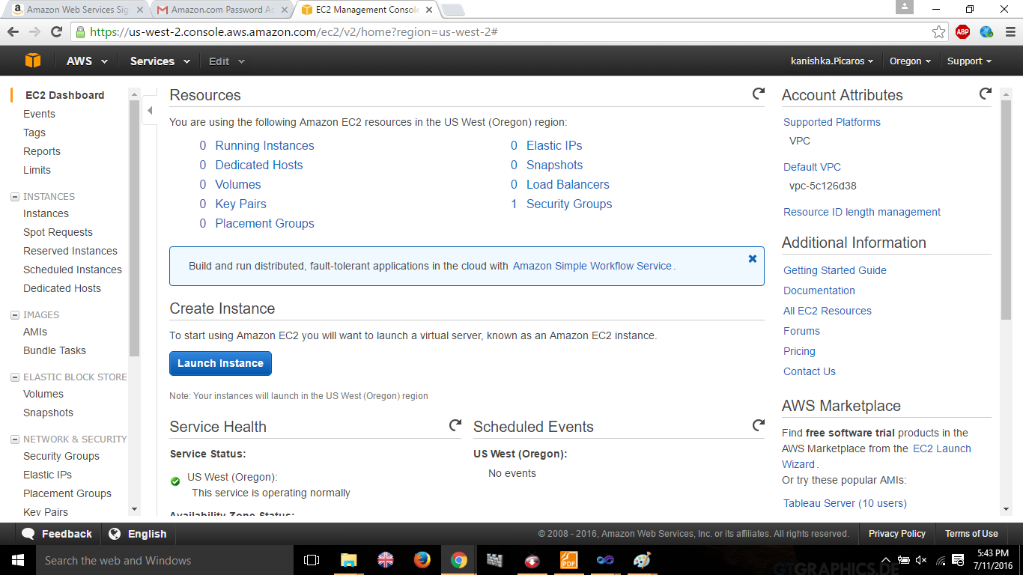

Select required service to create instance.

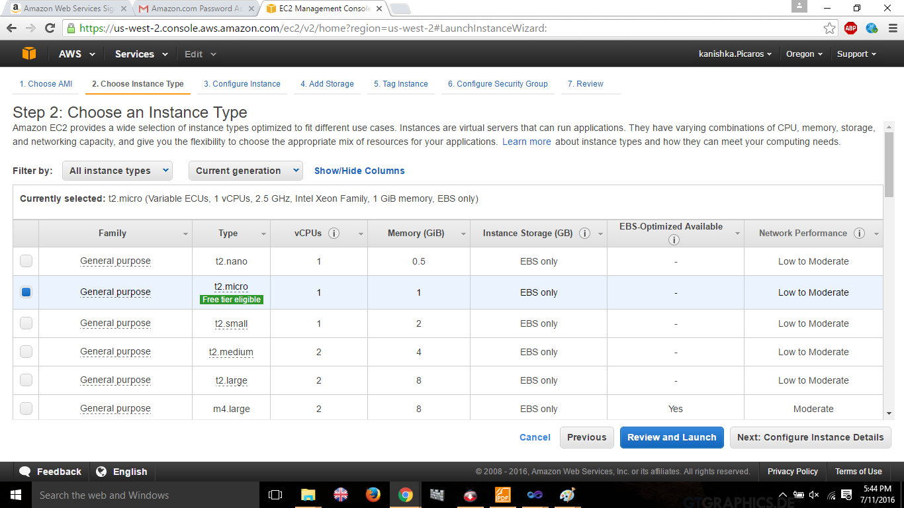

Complete the following requirements

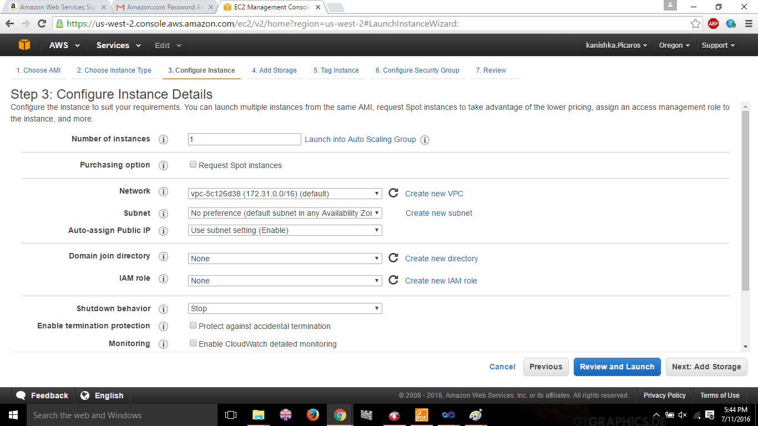

Add the storage details

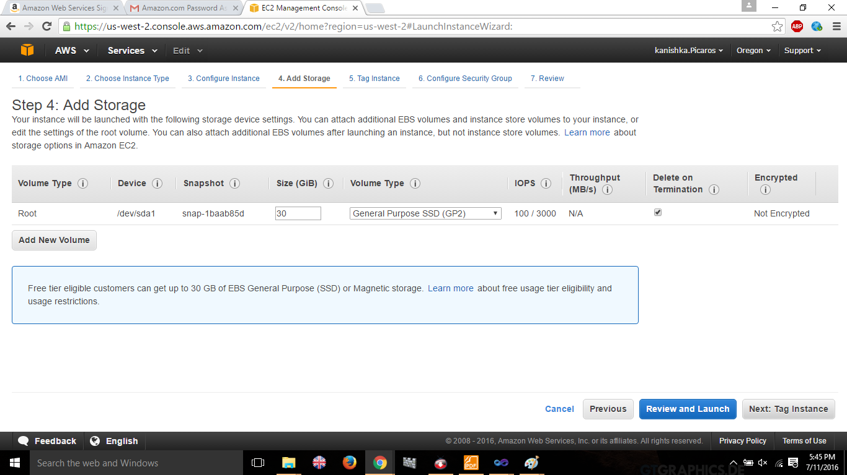

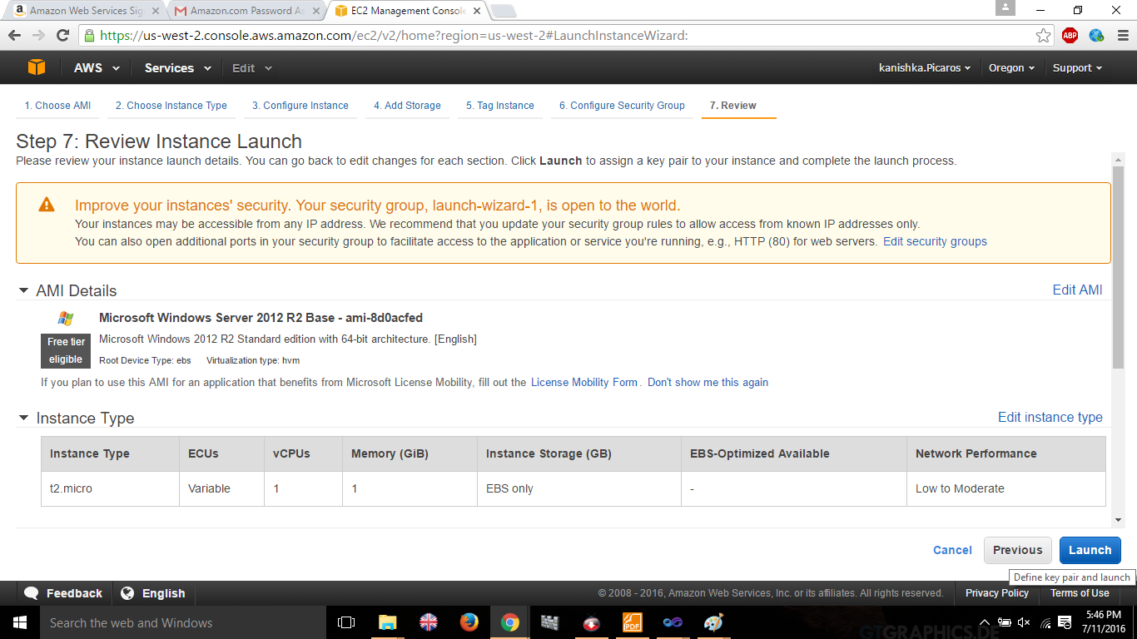

Download key in order to decrypt data that we use

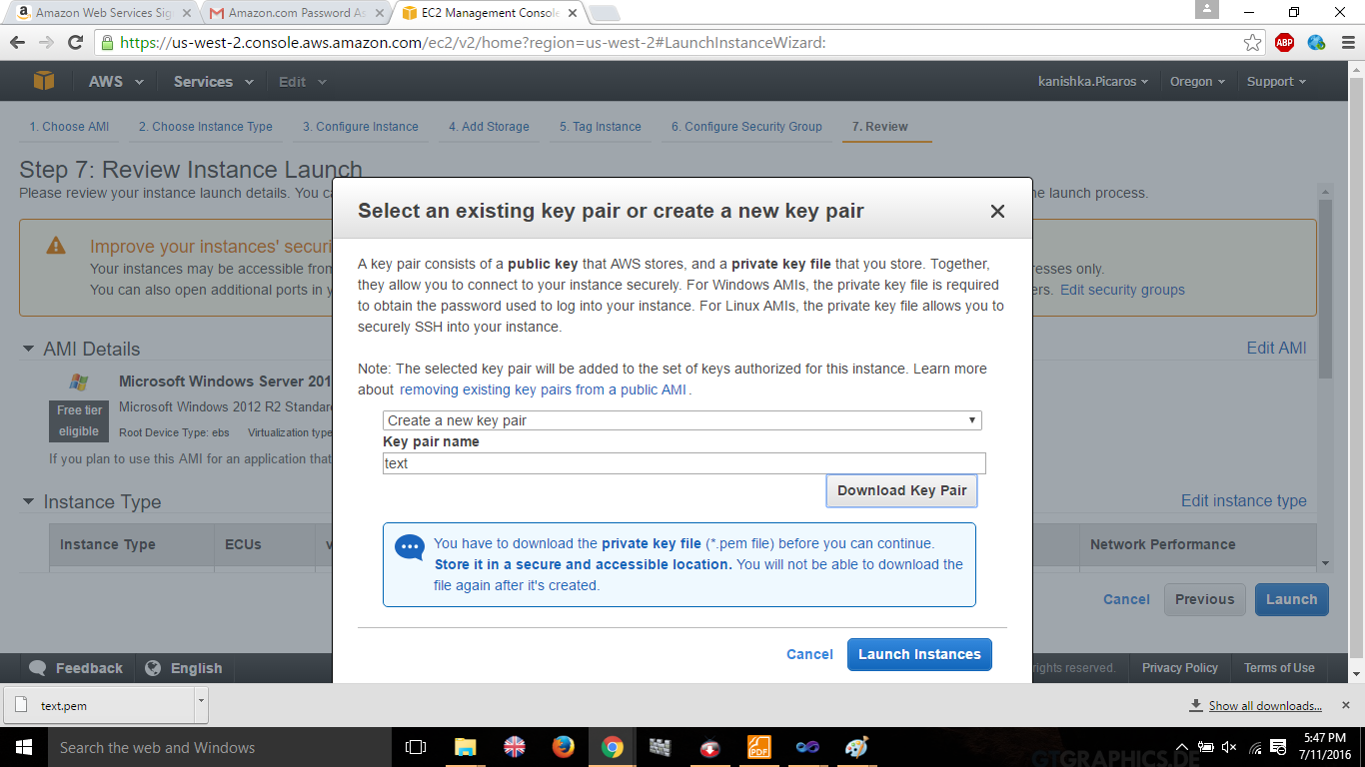

Launch instance

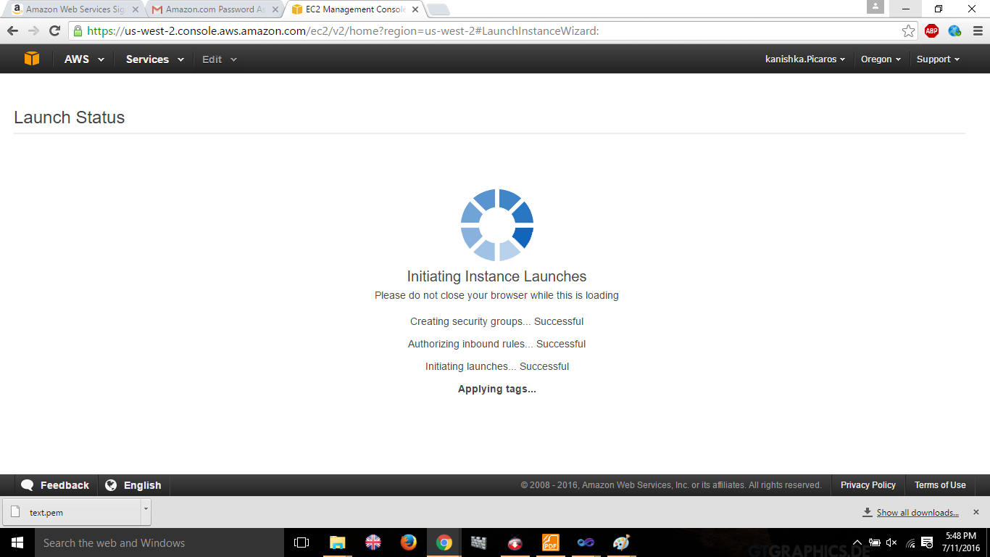

Choose the key in order to decrypt the data

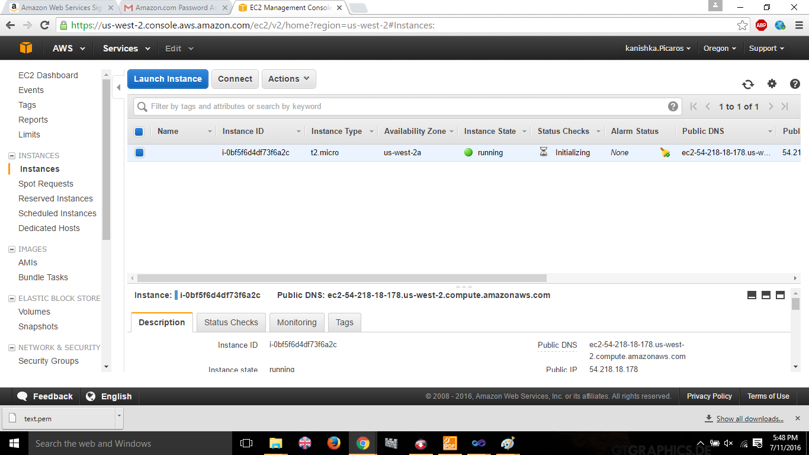

Decrypt the data using the key

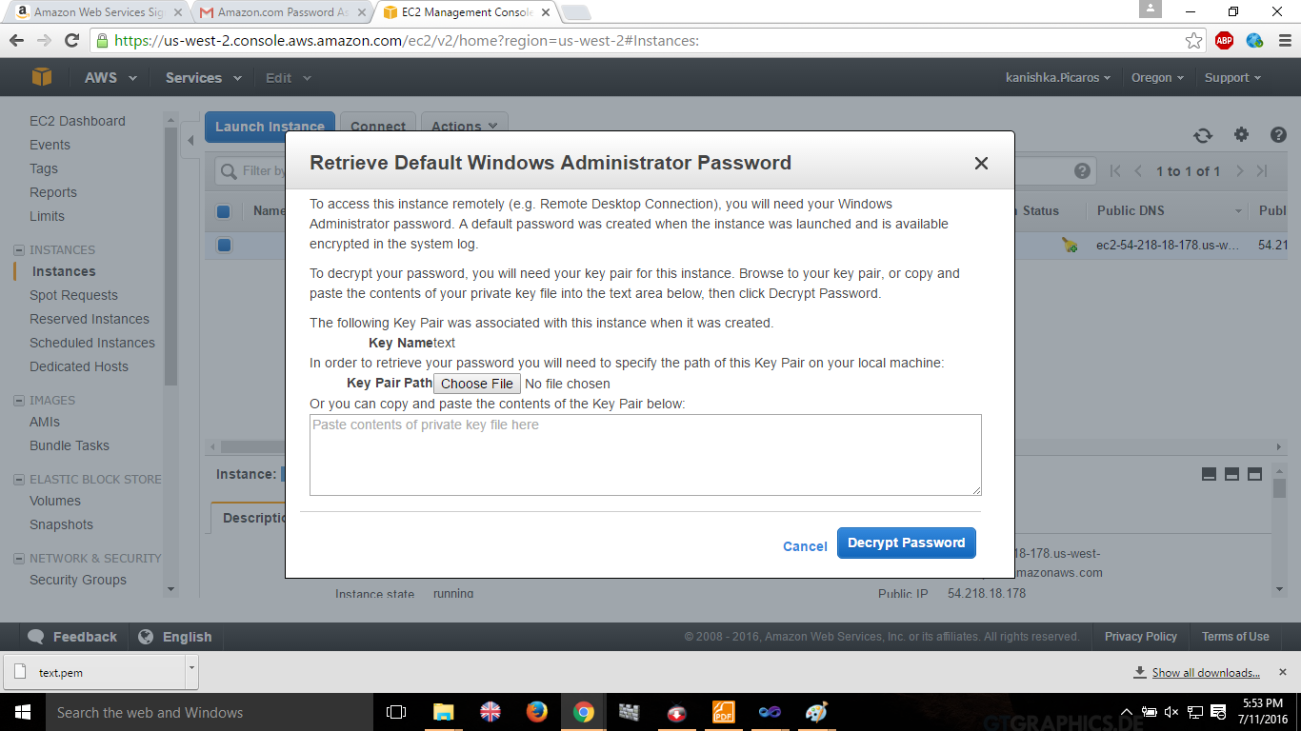

Launch the instance after entering the key

.

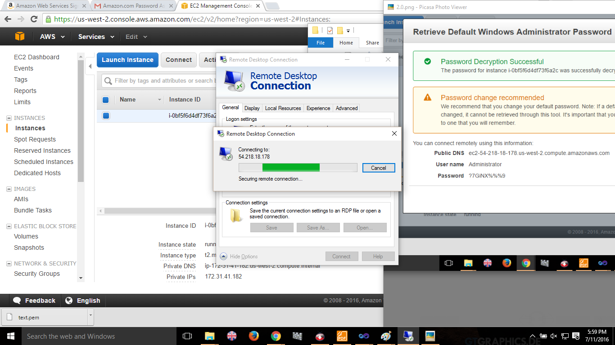

**Lab2**

**Creating a Linux based AMI Service**

Choose the linux free tire service.

Click launch instance

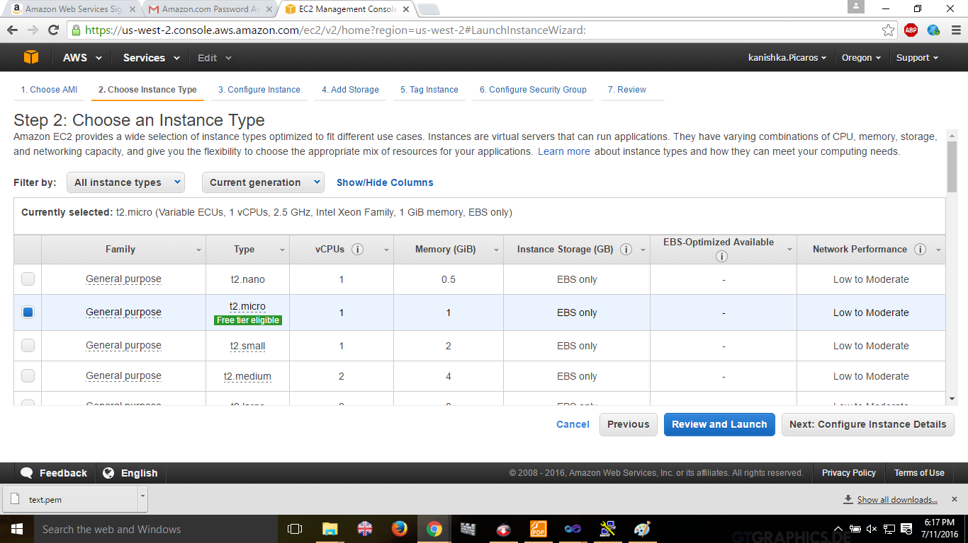

Use the default settings of linux instance to launch , and click on launch

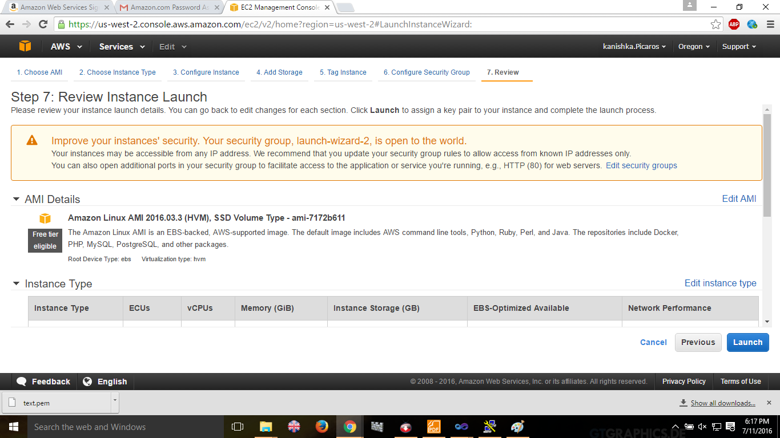

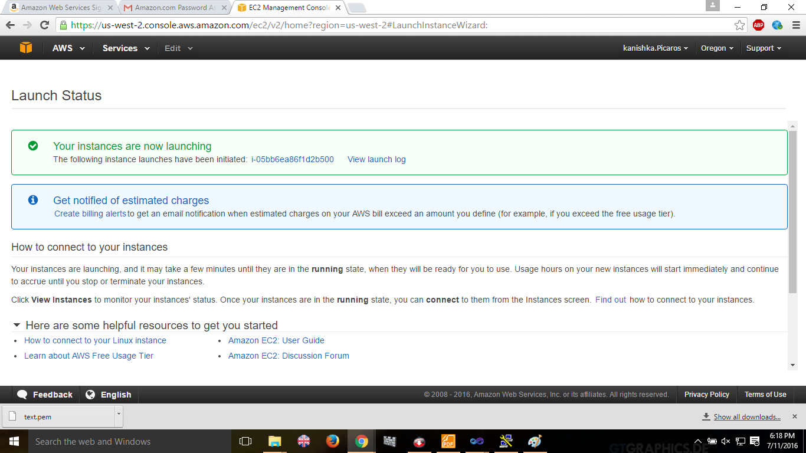

The instance is ready to use

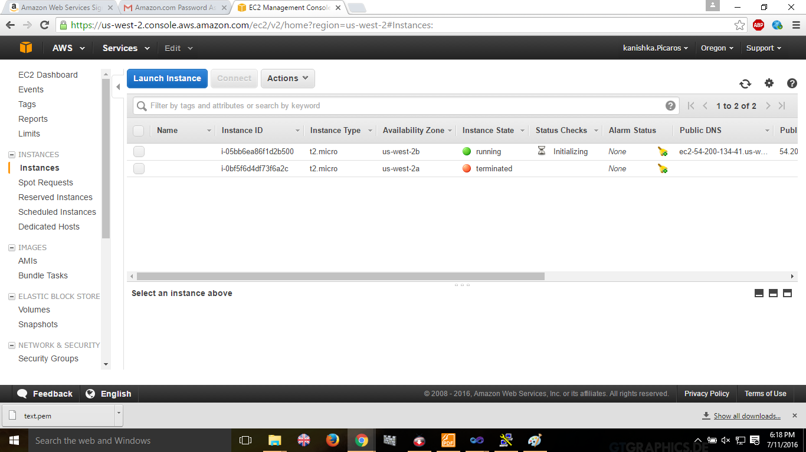

Launch putty gen to create a private key by importing the previously created key wen creating the Linux Instance.

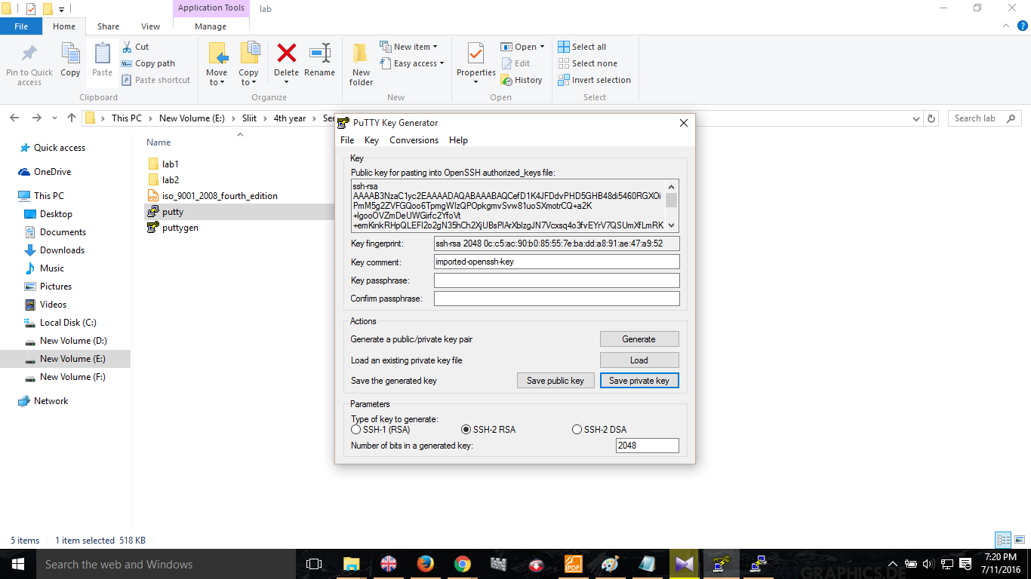

Use the private key when launching service.. And launch service successfully.

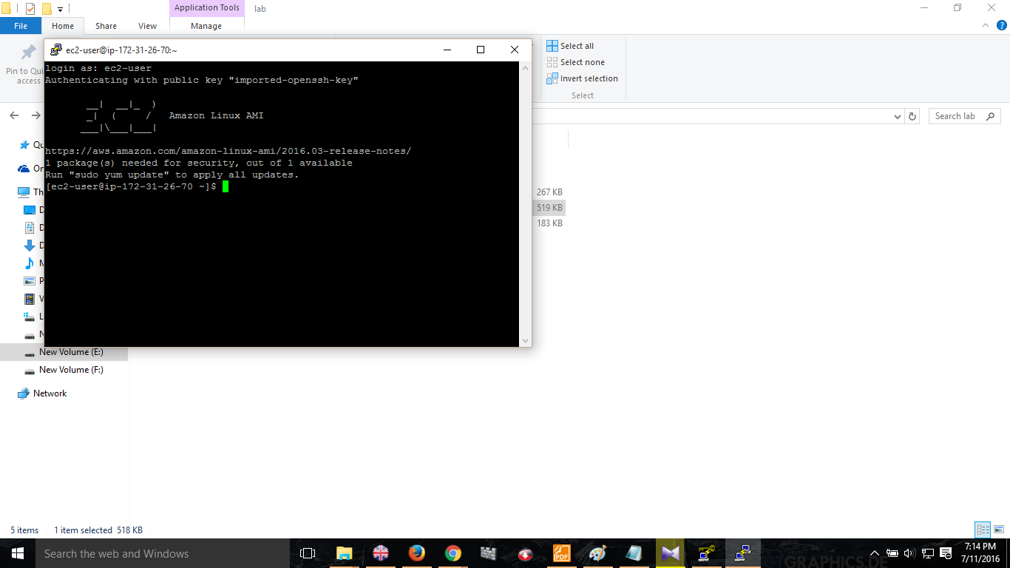

**Lab 3-**

**Creating and launching an Amazon Rational Database Service**

Select database service and click on get started now.

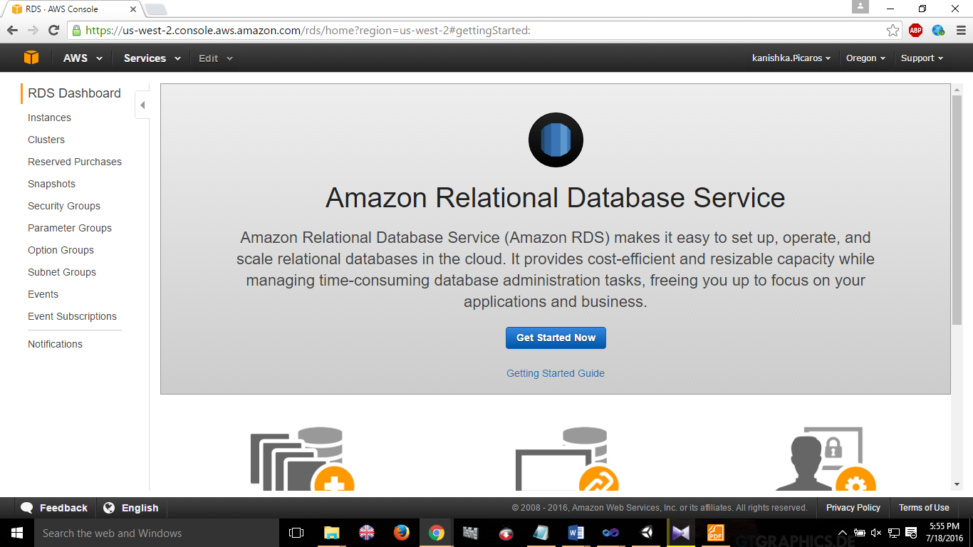

Select a database service type-(I used MySQL)

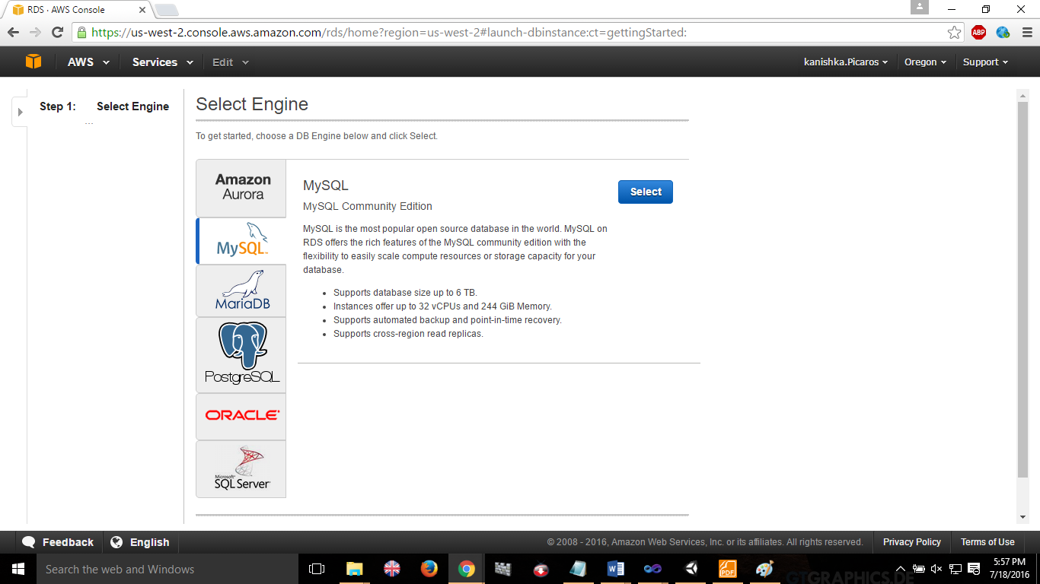

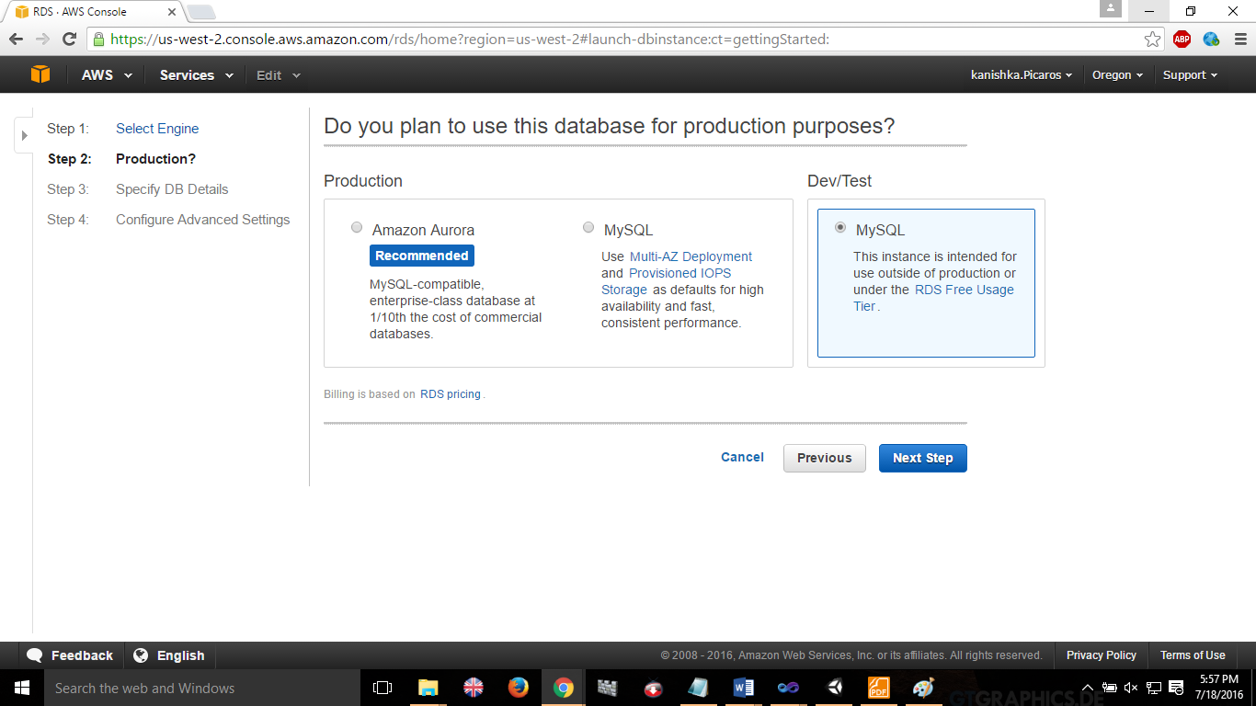

Fill in Database data.

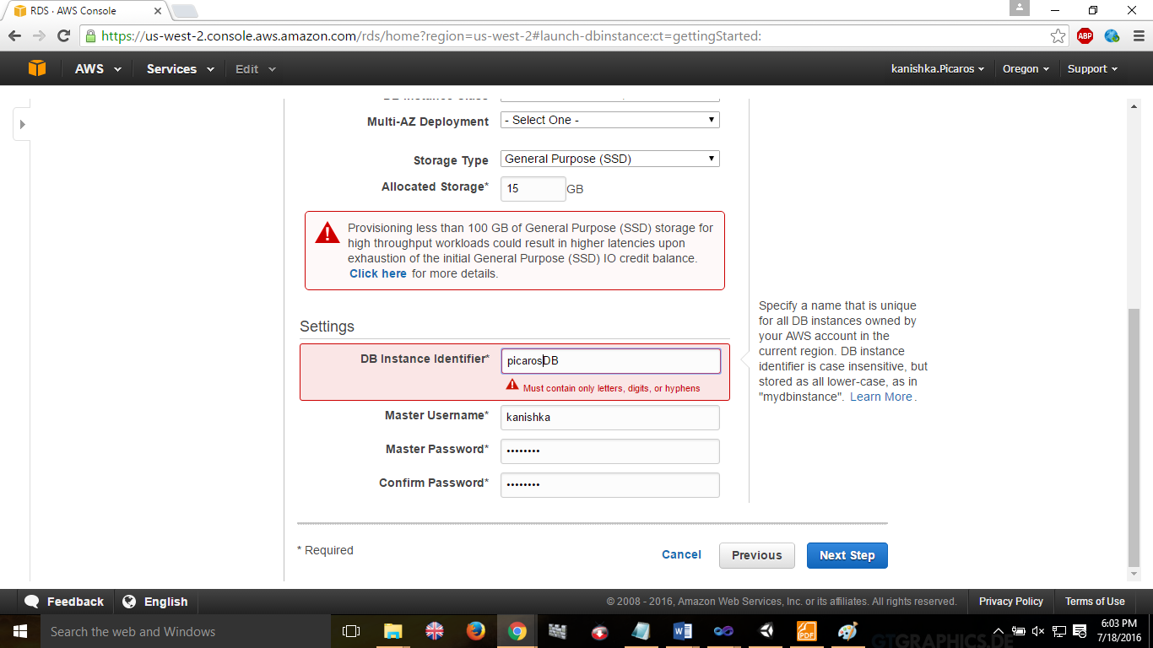

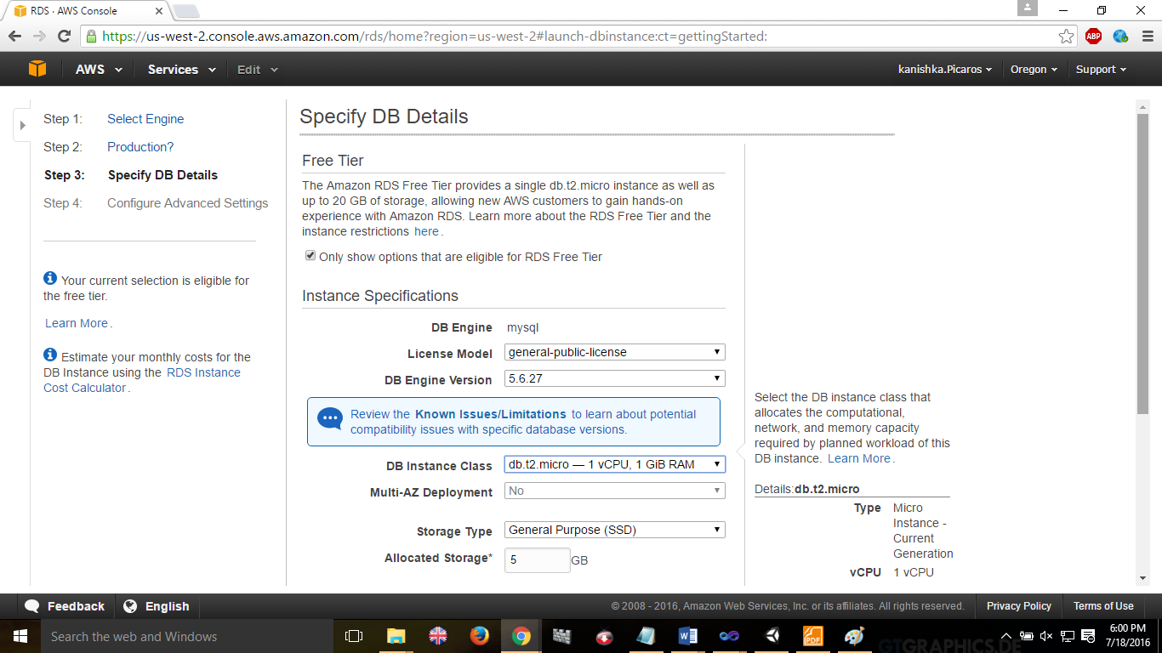

Fill in advance settings of configuration.

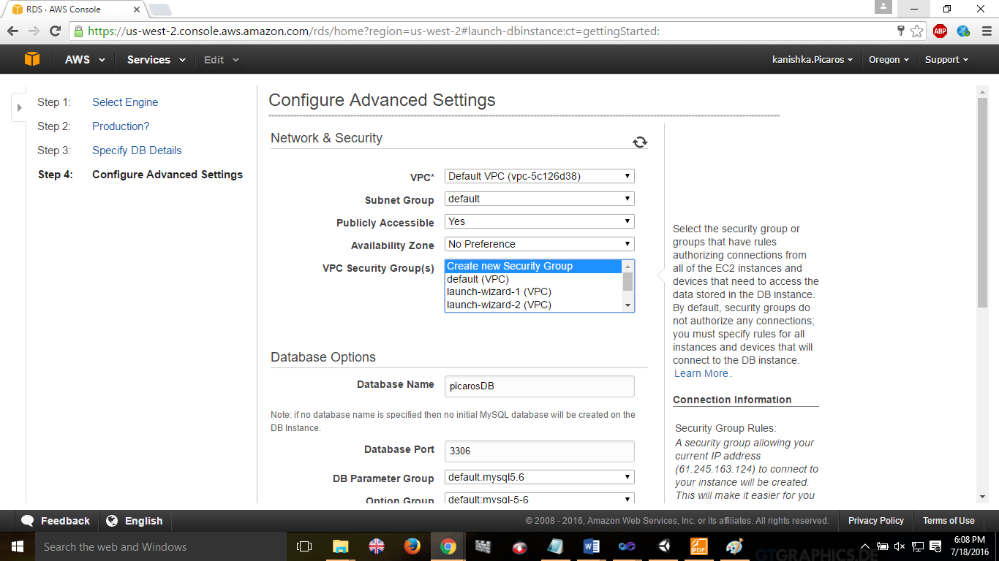

Successfully created database

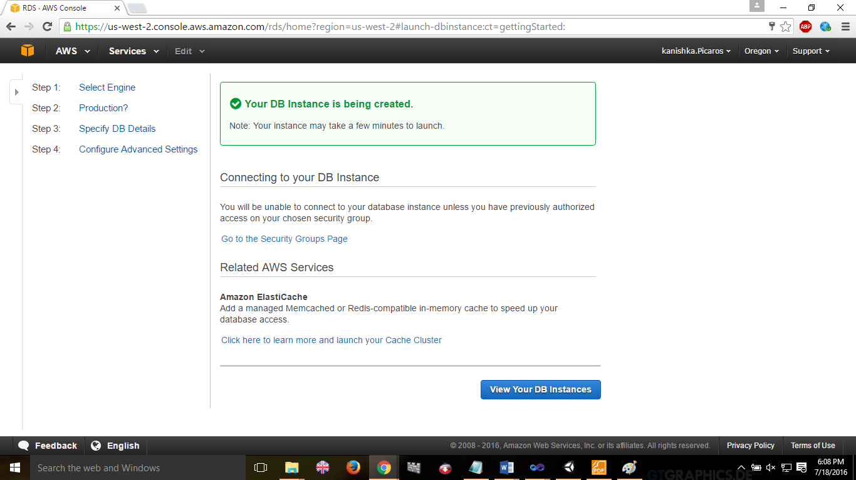

View instance

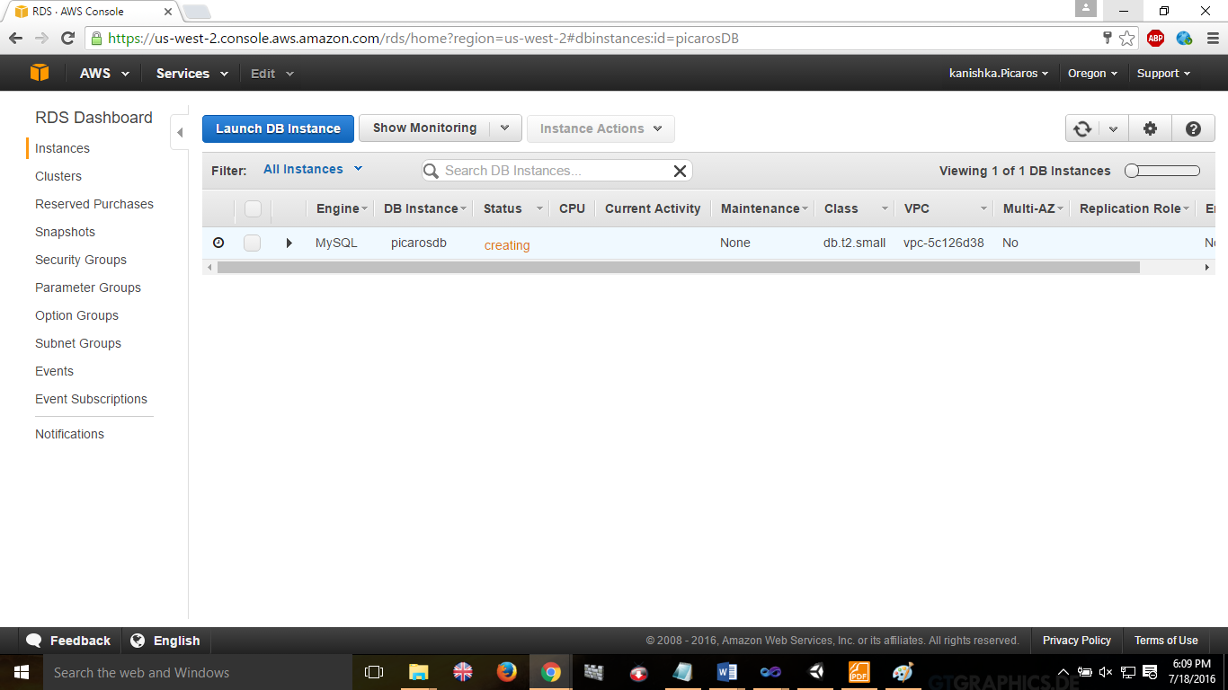

Install MySQL Workbench to use database service easily

Create connection by entering instance url

Then create

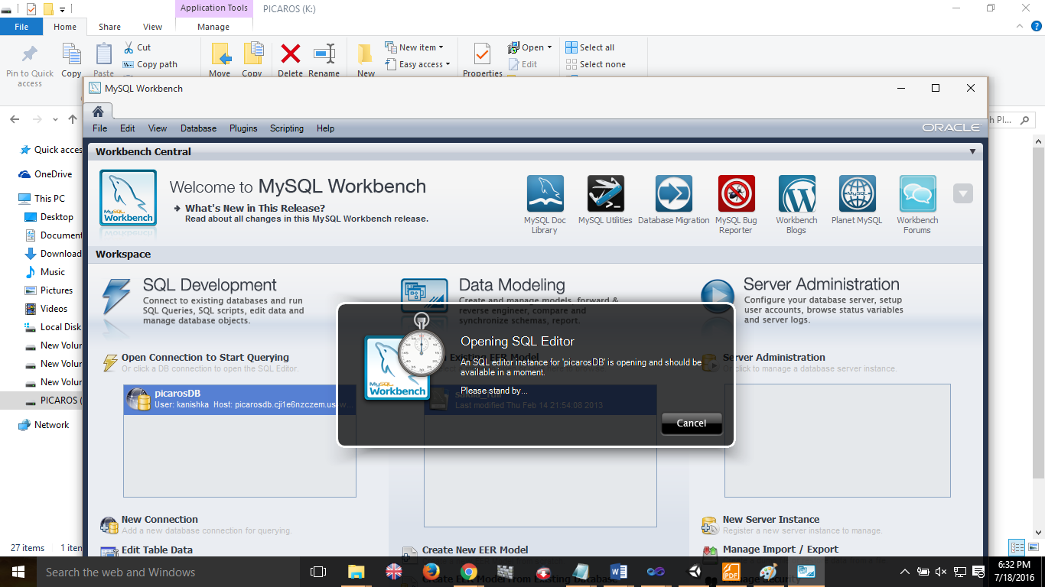

Successfully launce the database services.

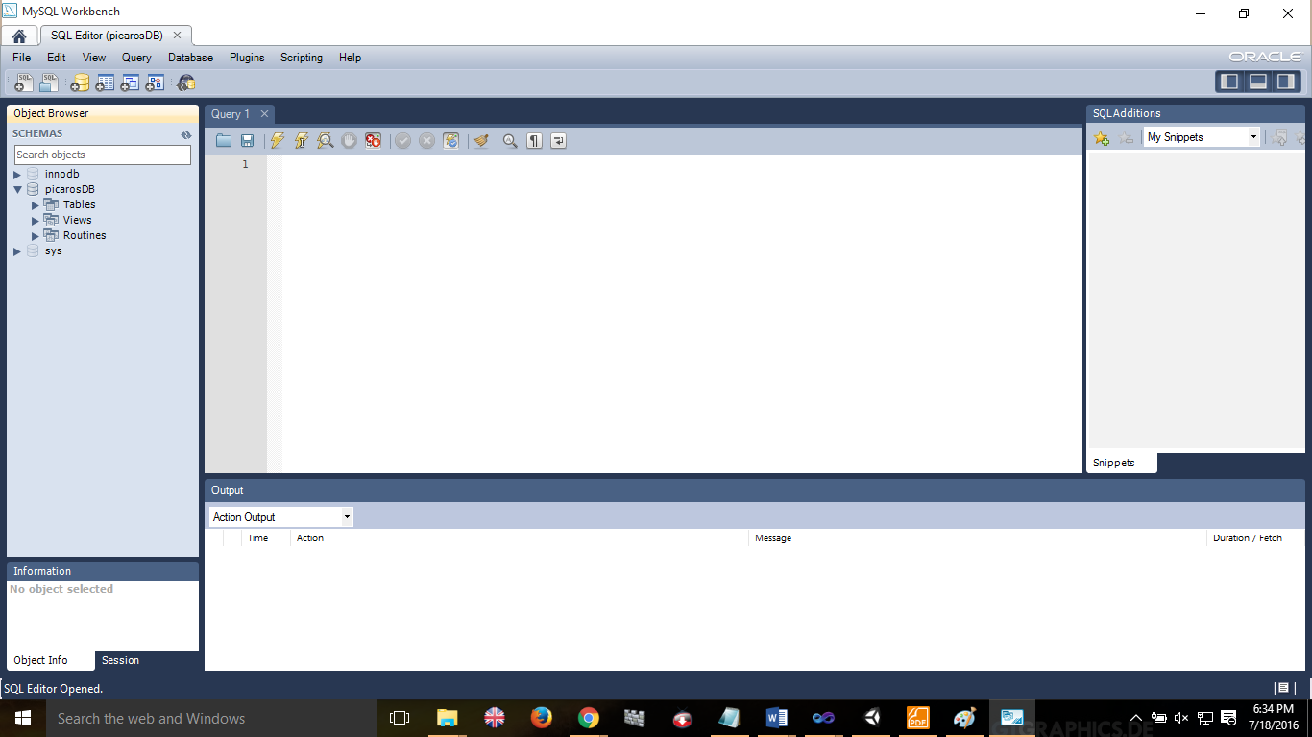

Execute db commands in commandline

