OLA RIDE INSIGHTS

Project Submitted To | GUVI Geek Networks
Domain | Data Analytics
Technologies Used | SQL, SQLiteCloud, Python, Power BI, Streamlit
Prepared By | Kanishka Thiyagarajan

Contents
ABSTRACT 3
PROBLEM STATEMENT 4
SYSTEM DESIGN 5
DATABASE DESIGN 6
PROCEDURE 7
DASHBOARD 18
TESTING 24
ADVANTAGES 25
FUTURE ENHANCEMENTS 26
Conclusion 27

ABSTRACT

The OLA Ride Insights Dashboard is an end-to-end data analytics solution designed to analyze ride-booking data and generate actionable business insights. The project leverages SQL for data extraction, Python for data processing, SQLite Cloud as the cloud database, Power BI for interactive dashboard visualization, and Streamlit for web deployment.
The dashboard enables stakeholders to monitor booking trends, revenue performance, customer behavior, driver performance, ride cancellations, and payment preferences. Through interactive visualizations and KPI tracking, the solution supports data-driven decision-making and operational optimization.

PROBLEM STATEMENT

Ride-sharing companies generate large volumes of transactional data daily. Analyzing this data manually is challenging and time-consuming.
The business requires a centralized analytics platform to:
- Monitor booking activity.
- Track revenue generation.
- Identify cancellation patterns.
- Evaluate driver performance.
- Understand customer behavior.
- Improve operational efficiency.
The objective is to transform raw ride data into meaningful business insights through an interactive analytics dashboard.

SYSTEM DESIGN

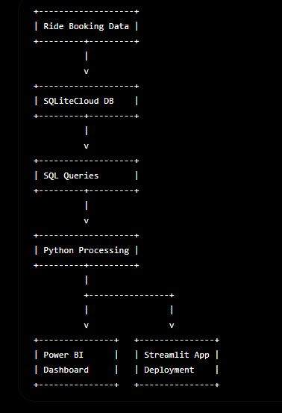

DATABASE DESIGN

Database : MySQL
Table : Ola_Bookings
Key Attributes

Column Name | Description
Booking_ID | Unique booking identifier
Customer_ID | Customer identifier
Driver_ID | Driver identifier
Booking_Status | Ride status
Vehicle_Type | Vehicle category
Payment_Method | Payment mode
Ride_Distance | Distance travelled
Booking_Value | Revenue generated
Customer_Rating | Customer rating
Driver_Rating | Driver rating
Cancellation_Reason | Cancellation explanation
Booking_Date | Ride booking date

PROCEDURE

The following preprocessing steps were performed:
Phase 1: Data Loading
Steps
- Read CSV file.
- Create MySQL database named OLARideInsights
- Load records into Ola_Bookings table.
- Verify schema and row count.

Phase 2: Data Processing and Cleaning
- Missing Value Handling
- Removed incomplete records.
- Replaced null values where applicable.
- Data Type Conversion
- Converted date fields.
- Standardized numerical fields.

Phase 3: Advanced SQL Analytics
Query 1: Retrieve all successful bookings
It displays all ride bookings that were completed successfully. Analyzing successful bookings helps identify ride demand, customer usage patterns, revenue trends, and overall operational performance.
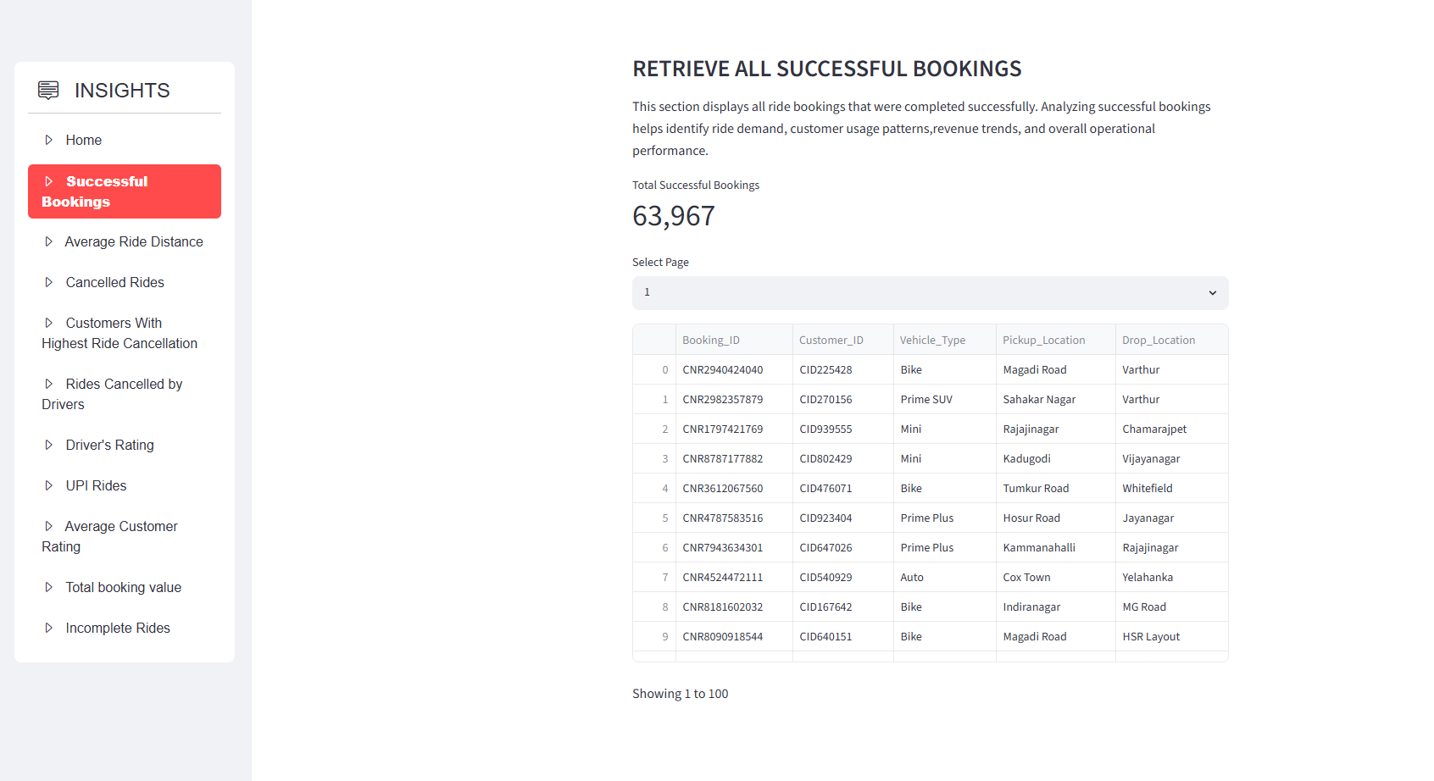

SQL Query:
SELECT BOOKING_id, CUSTOMER_ID, VEHICLE_TYPE, PICKUP_LOCATION, DROP_LOCATION, BOOKING_VALUE
FROM ola_bookings
WHERE Booking_Status = 'Success';

Query 2: Find the average ride distance for each vehicle type:
This analyzes the average ride distance covered by each vehicle type. Comparing average trip lengths across vehicle categories helps identify customer preferences, vehicle utilization patterns, and demand trends. These insights can support fleet management, pricing strategies, and operational planning.

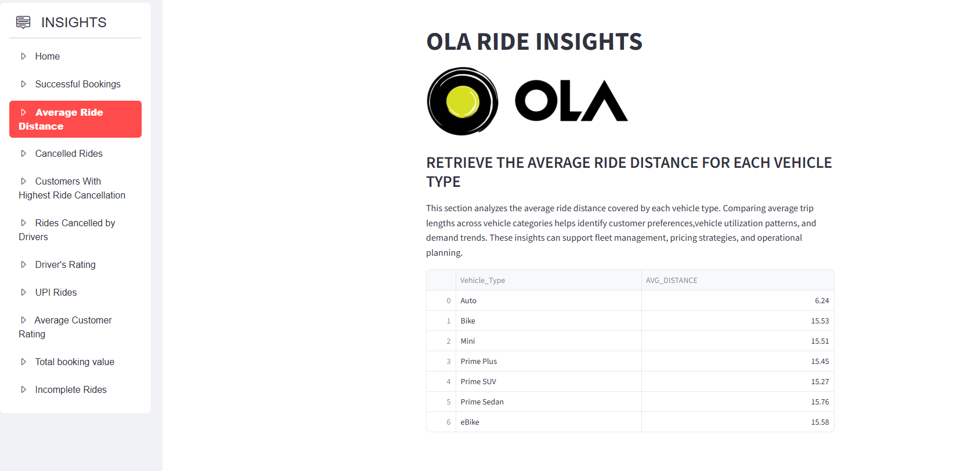

SQL Query:
SELECT Vehicle_Type, ROUND(AVG(Ride_Distance), 2) AS Avg_Distance
FROM ola_bookings
GROUP BY Vehicle_Type
ORDER BY Vehicle_Type ASC;

Query 3: Get the total number of cancelled rides by customers:
This section displays the total number of rides cancelled by customers. These insights can be used to improve customer satisfaction and reduce cancellation frequency.

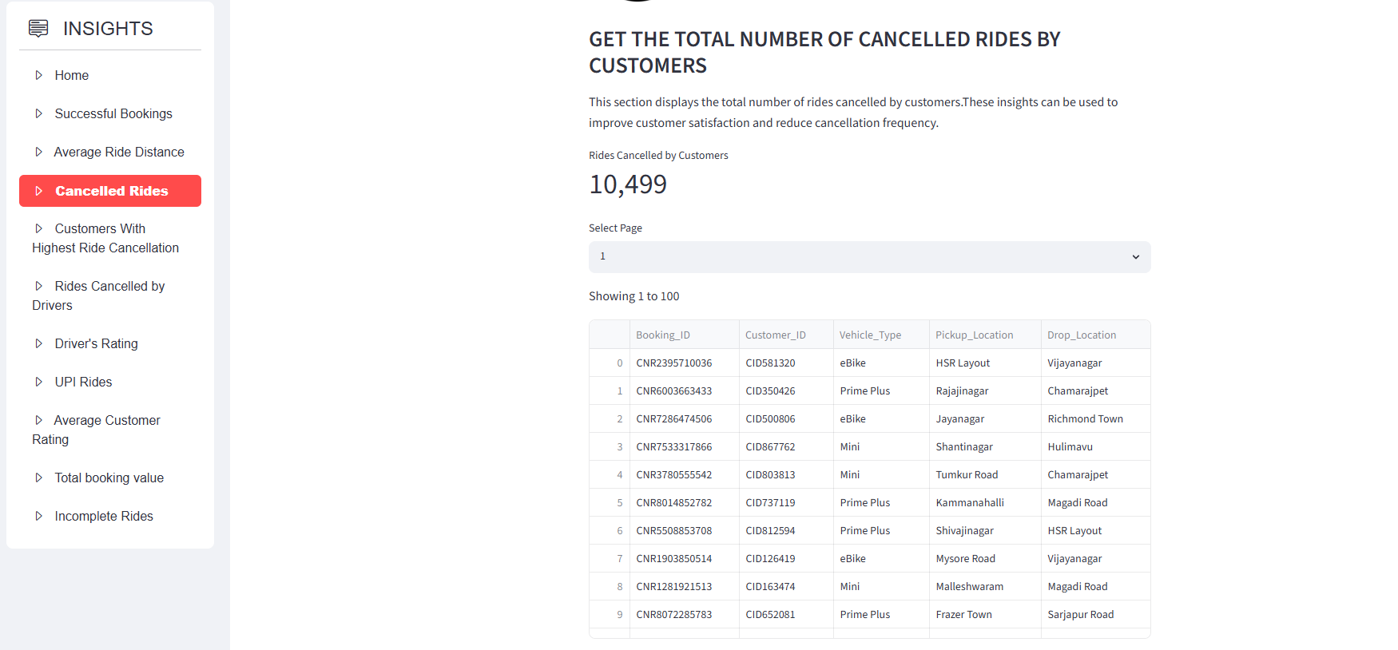

SQL Query:
SELECT COUNT(*) AS Customer_Cancellations FROM ola_bookings
WHERE Booking_Status='Canceled by Customer';

SELECT Booking_ID, Customer_ID, Vehicle_Type, Pickup_Location, Drop_Location
FROM ola_bookings WHERE Booking_Status='Canceled by Customer’;

Query 4: List the top 5 customers who booked the highest number of rides:
This analysis identifies the five customers with the highest ride booking frequency. These insights can support targeted marketing campaigns, reward programs, and customer retention strategies.

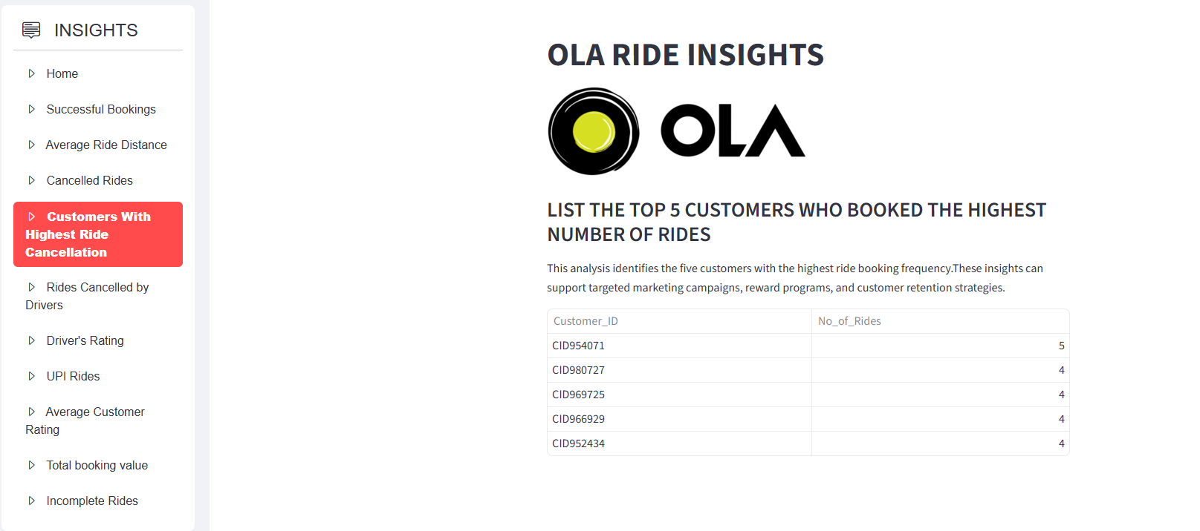

SQL Query:
SELECT Customer_ID, count(*) as No_of_Rides
FROM ola_bookings
GROUP BY Customer_ID
ORDER BY No_of_Rides DESC
LIMIT 5;

Query 5 : Get the number of rides cancelled by drivers due to personal and car-related issues:
This analysis calculates the total number of rides cancelled by drivers because of personal reasons or vehicle-related issues.The insights can be used to improve driver support, vehicle maintenance processes, and overall customer satisfaction.
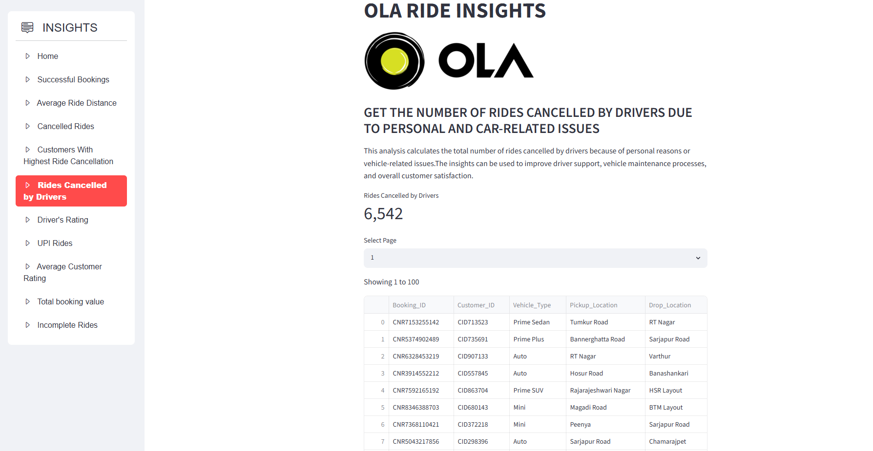

SQL Query:
SELECT COUNT(*) AS Customer_Cancellations FROM ola_bookings
WHERE Booking_Status='Canceled by Driver'
AND Canceled_Rides_by_Driver ='Personal & Car related issue';

SELECT Booking_ID, Customer_ID, Vehicle_Type, Pickup_Location, Drop_Location
FROM ola_bookings WHERE Booking_Status='Canceled by Driver'
AND Canceled_Rides_by_Driver='Personal & Car related issue';
Query 6: Find the maximum and minimum driver ratings for Prime Sedan bookings
This analysis retrieves the highest and lowest driver ratings recorded for Prime Sedan bookings. These insights can support performance monitoring, driver training initiatives, and service quality improvements.

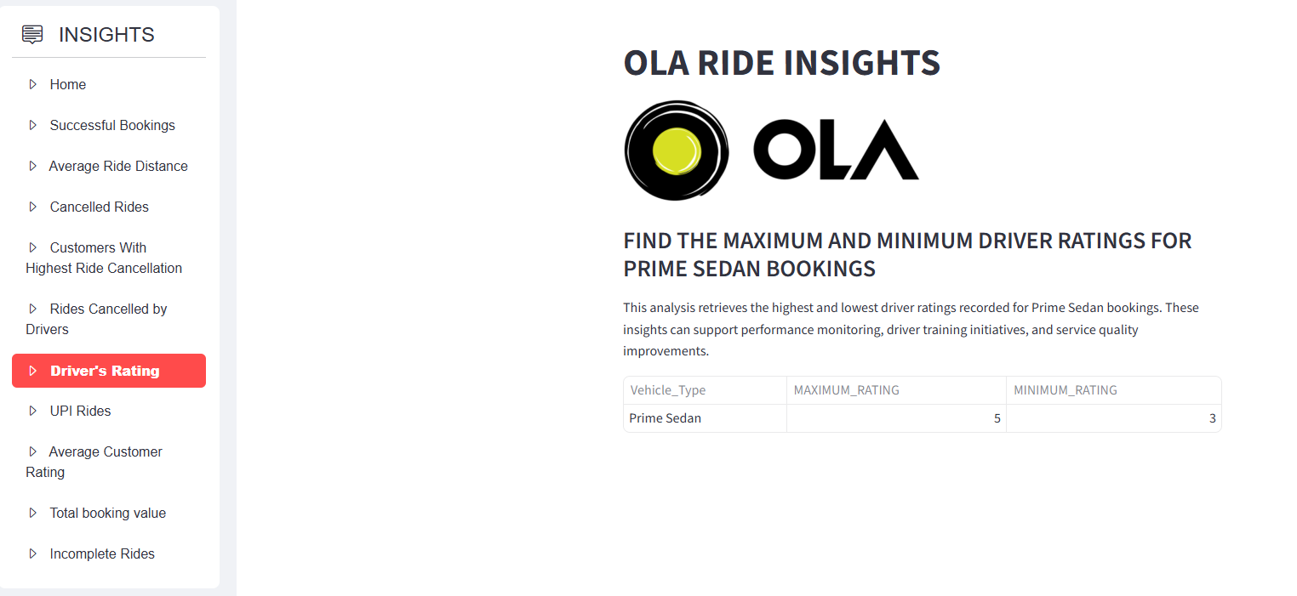

SQL Query:
SELECT Vehicle_Type,MAX(Driver_Ratings) AS MAXIMUM_RATING ,MIN(Driver_Ratings) AS MINIMUM_RATING
FROM ola_bookings
WHERE Vehicle_Type ='Prime Sedan';

Query 7: Retrieve all rides where payment was made using UPI:
This analysis displays all ride bookings for which the payment method was UPI. These insights can support payment strategy decisions and enhance the overall customer payment experience.

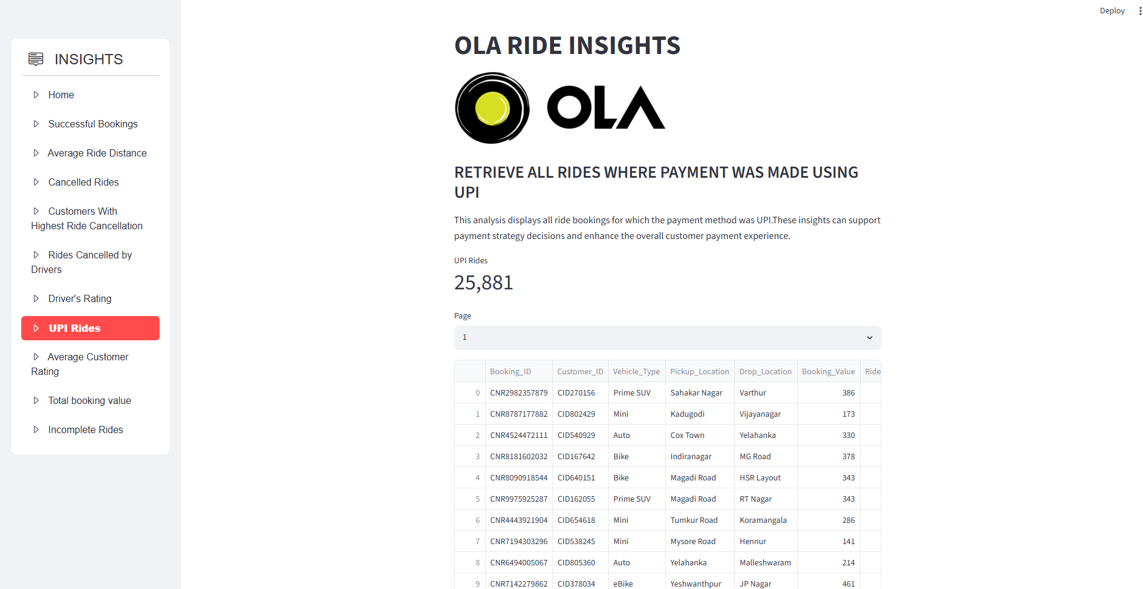

SQL Query:
SELECT Booking_ID, Customer_ID, Vehicle_Type, Pickup_Location, Drop_Location, Booking_Value, Ride_Distance
FROM ola_bookings
WHERE Payment_Method ='UPI';

Query 8: Find the average customer rating per vehicle type:
This analysis calculates the average customer rating for each vehicle type. Comparing ratings across vehicle categories helps evaluate customer satisfaction levels, identify high-performing services, and understand customer preferences.

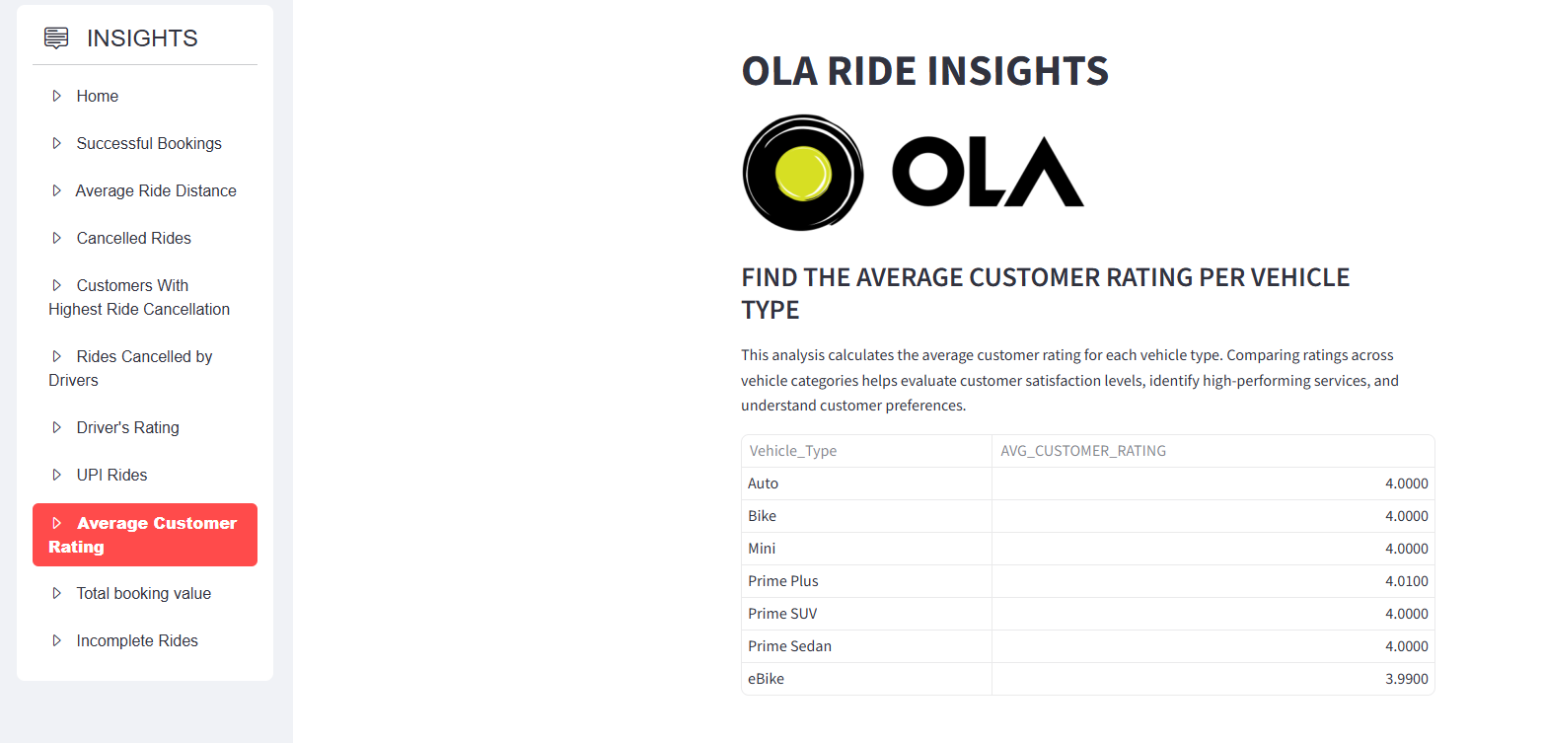

SQL Query:
SELECT Vehicle_Type, ROUND(AVG(Customer_Rating),2) AS AVG_CUSTOMER_RATING
FROM ola_bookings
GROUP BY Vehicle_Type
ORDER BY Vehicle_Type;

Query 9: Calculate the total booking value of rides completed successfully
This analysis computes the total booking value generated from rides that were completed successfully. Measuring revenue from completed rides helps assess business performance, track earnings, and evaluate operational efficiency.

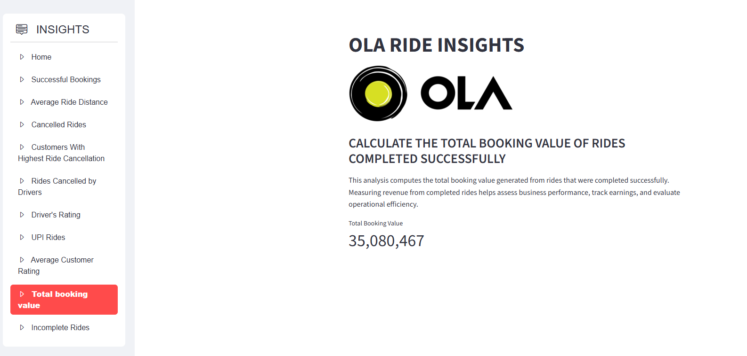

SQL Query:
SELECT SUM(Booking_Value) AS TOTAL_BOOKING_VALUE
FROM ola_bookings
WHERE Booking_Status ='Success' ;

Query 10: List all incomplete rides along with the reason
This analysis retrieves all rides that were not completed and displays the corresponding reason for each incomplete booking. These insights can support process improvements, reduce ride cancellations, and enhance overall service reliability.

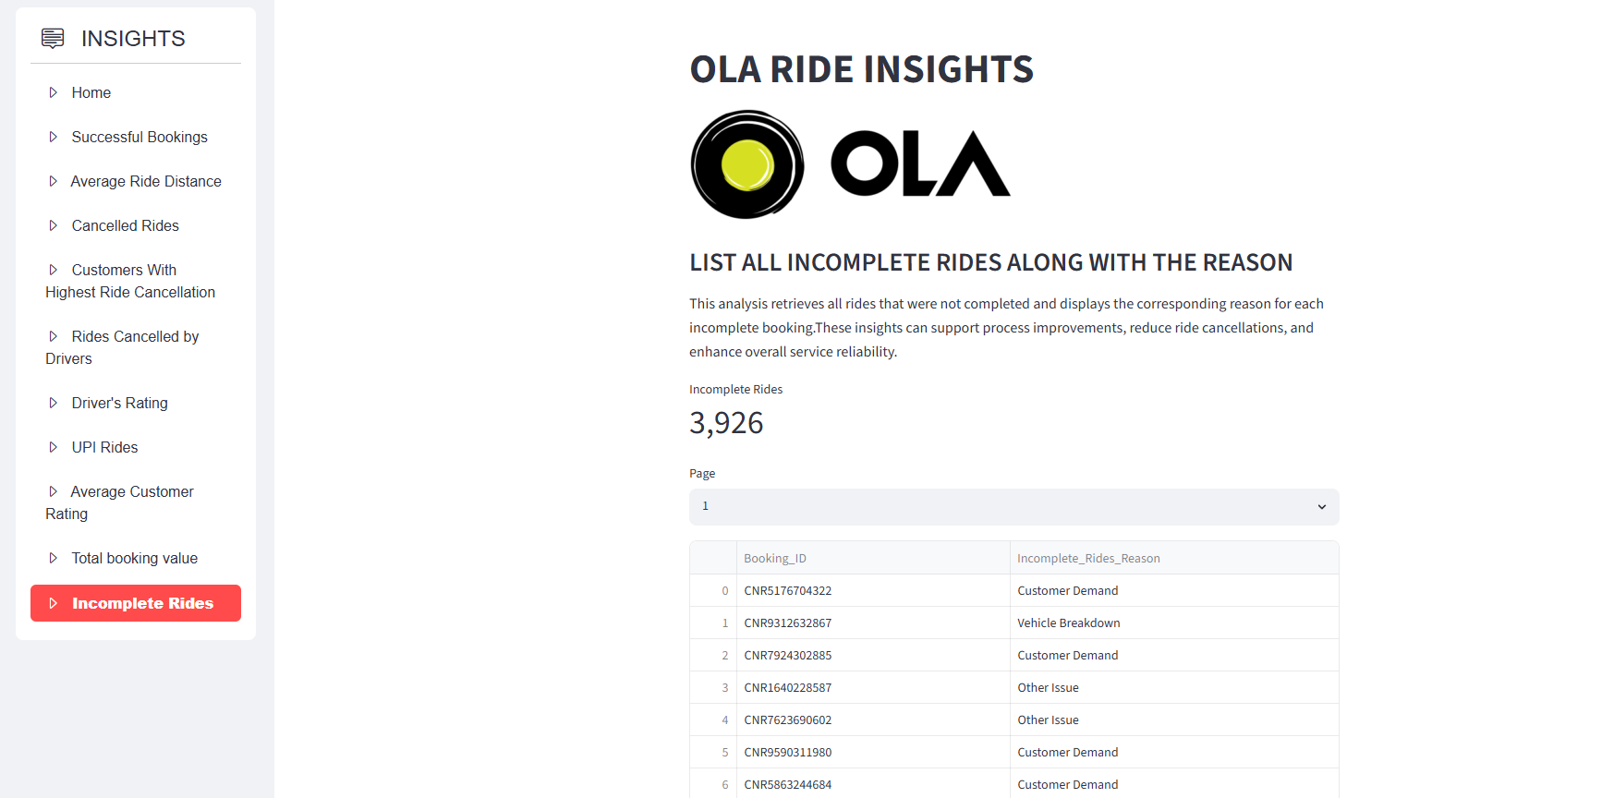

SQL Query:
SELECT Booking_ID,Incomplete_Rides_Reason
FROM ola_bookings
WHERE Incomplete_Rides ='Yes';

DASHBOARD

1. Home Page
Purpose
Provides navigation to all analytical pages using interactive buttons.
Features
- OLA branding/logo
- Dashboard navigation buttons
- Landing page for users
Business Value
Acts as a centralized entry point for stakeholders.

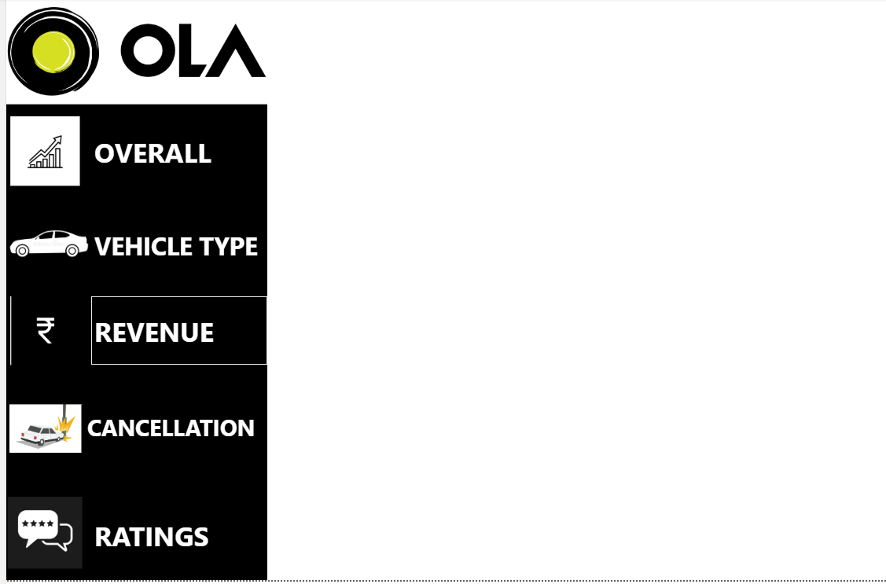

2. Overall Dashboard
Visuals Identified
- Column Chart
- Donut Chart
Key Metrics Covered
- Total Bookings
- Successful Rides
- Cancelled Rides
- Booking Distribution
Business Insights
- Measures overall business performance.
- Helps management track ride activity and booking success rates.
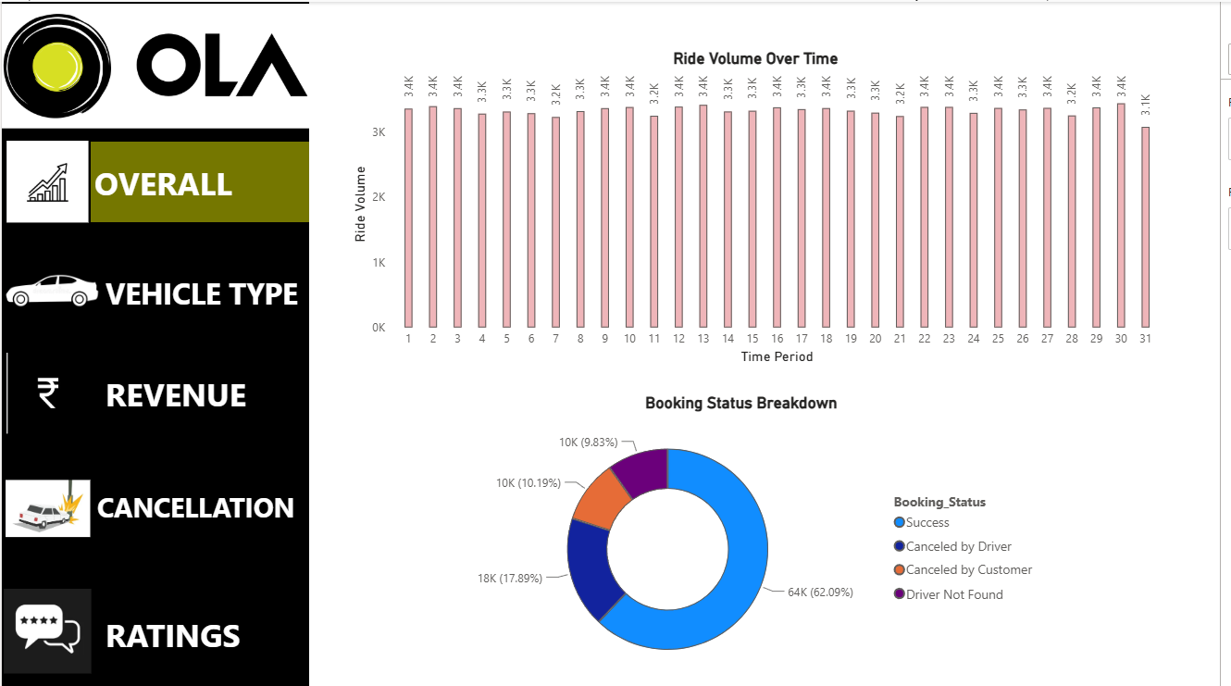

3. Vehicle Type Analysis
Visuals Identified
- Pivot Table
Key Analysis
- Ride volume by vehicle category
- Revenue by vehicle type
- Vehicle performance comparison
Business Insights
- Identifies the most frequently used vehicle categories.
- Helps optimize fleet allocation.

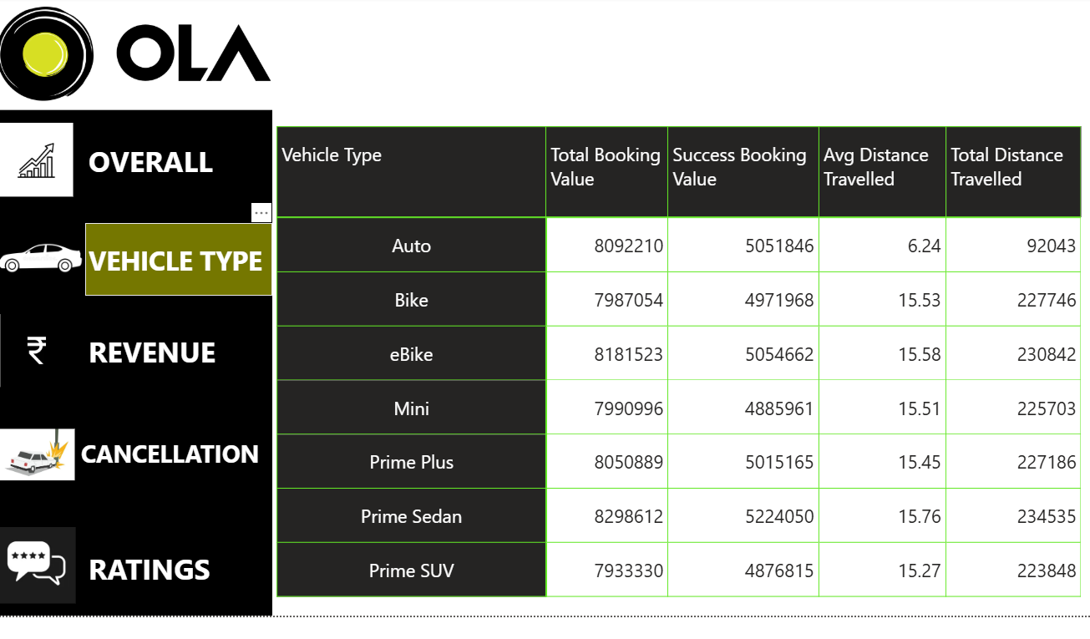

4. Revenue Analysis
Visuals Identified
- Column Chart
- Bar Chart
- Column Chart
Key Analysis
- Revenue by Payment Method
- Revenue Trends
- Revenue Contribution Analysis
Business Insights
- Identifies highest revenue-generating channels.
- Tracks financial performance across ride categories.

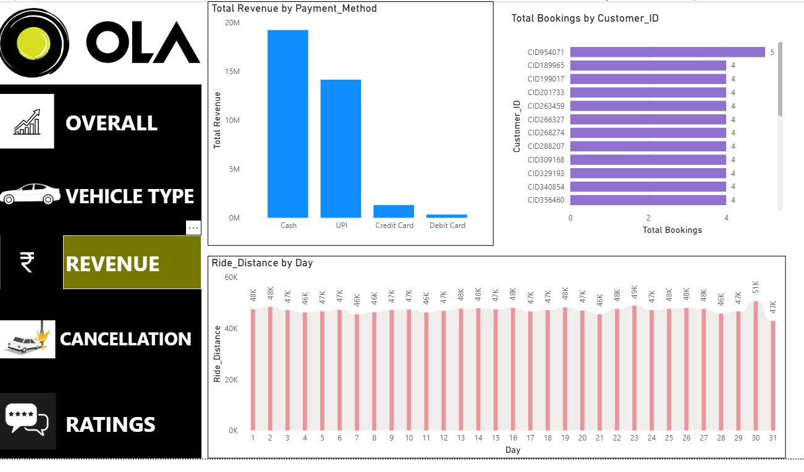
5. Cancellation Analysis
Visuals Identified
- Pie Chart
- Pie Chart
Key Analysis
- Customer Cancellation Reasons
- Driver Cancellation Reasons
Business Insights
- Detects operational bottlenecks.
- Helps reduce ride cancellations.
- Improves customer satisfaction.

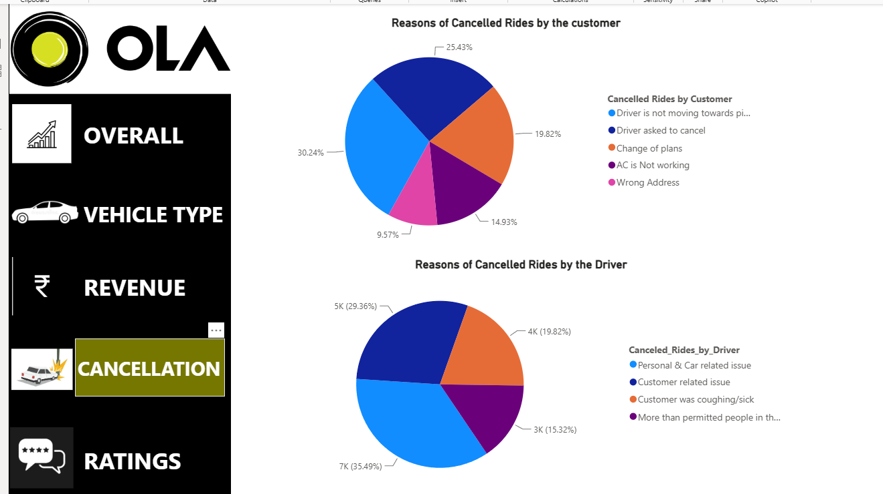

6. Ratings Analysis
Visuals Identified
- Line Chart
- Line Chart
Key Analysis
- Customer Ratings Trend
- Driver Ratings Trend
Business Insights
- Measures service quality.
- Evaluates driver performance.
- Identifies customer experience issues.

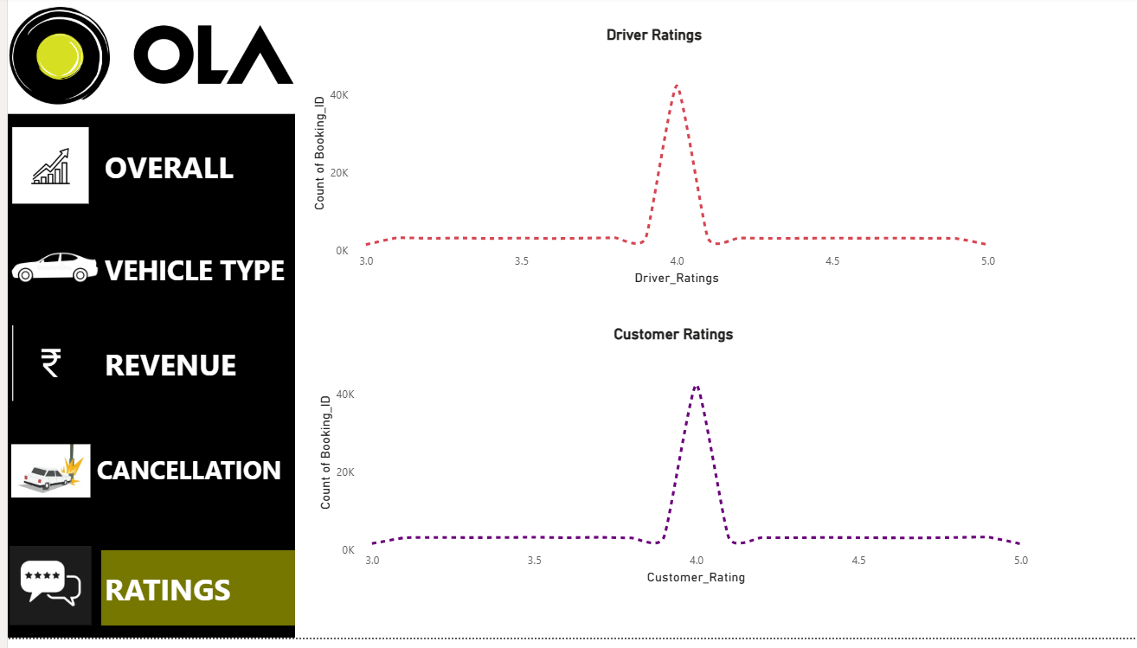

TESTING
Functional Testing

Test Case | Expected Result
Data Loading | Records inserted
Database Connection | Successful
Query Execution | Correct output
Dashboard Rendering | Table displayed
User Selection | Correct filter

Performance Testing

Parameter | Result
Data Volume | 100K+ Records
Query Execution | Successful
Dashboard Response | Acceptable

ADVANTAGES

Revenue Insights
- Digital payments generated the highest revenue.
- Revenue is concentrated among a small percentage of customers.
Customer Insights
- Frequent users contribute significantly to revenue.
- Customer cancellations are often related to delays.
Driver Insights
- Highly rated drivers have lower cancellation rates.
- Driver availability directly affects ride completion.
Ride Insights
- Short-distance rides account for the majority of bookings.
- Peak demand occurs during commuting hours.

FUTURE ENHANCEMENTS

Machine Learning Integration
- Ride Demand Forecasting
- Revenue Prediction
- Driver Performance Prediction
Advanced Analytics
- Customer Churn Analysis
- Route Optimization
- Dynamic Pricing Engine
Real-Time Processing
- Live Ride Monitoring
- Real-Time KPI Updates

CONCLUSION
The OLA Ride Insights Dashboard successfully transforms raw ride-booking data into actionable business intelligence. By integrating SQL, Python, SQLiteCloud, Power BI, and Streamlit, the project delivers a scalable analytics solution capable of monitoring operational performance, customer behavior, driver efficiency, and revenue generation.
The dashboard empowers stakeholders with data-driven insights, enabling better decision-making, improved customer experience, and enhanced business performance.

