Name: Kanishka S Roll no:240701227

Setting up Zoho creator account and exploring the platform architecture and interface

Aim:
To understand the Zoho Creator platform by setting up a sample application, creating forms, reports, and dashboards, and exploring the platform architecture and interface components such as Develop, Deploy, and Manage.

Setting up zoho creator :
- Create the Sample Application:
  - Sign in to Zoho Creator.
  - Select the Demo Application provided during sign-up or create a new sample application.
  - Give the application a name and description.
  - Add forms to collect data.
  - Save and run the application.
- Screen shot for Creating form , report and dash board:

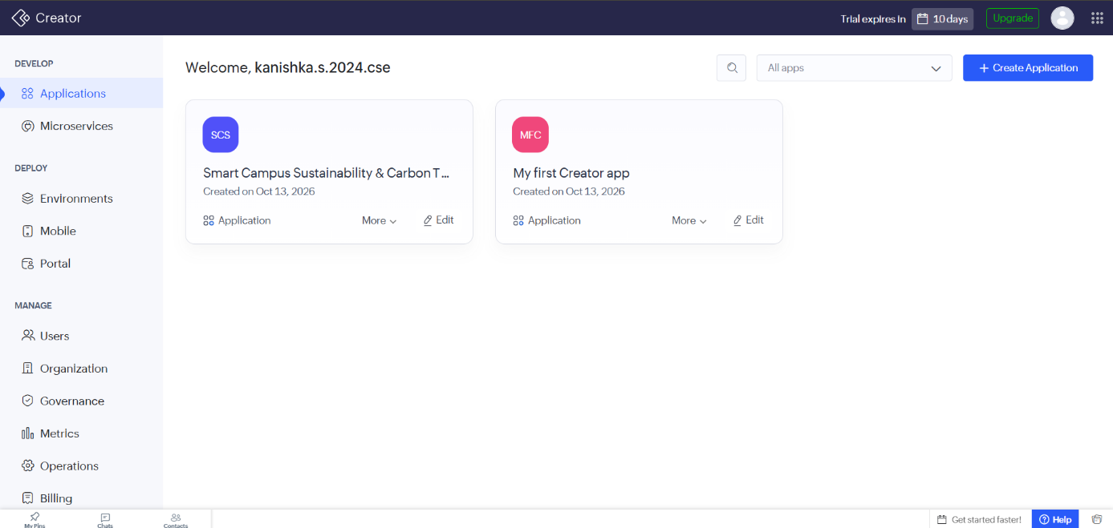

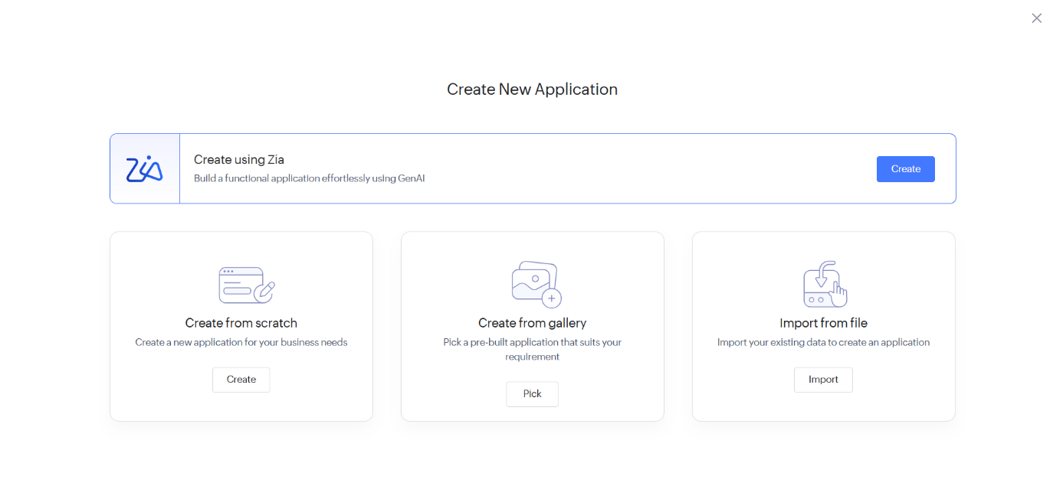

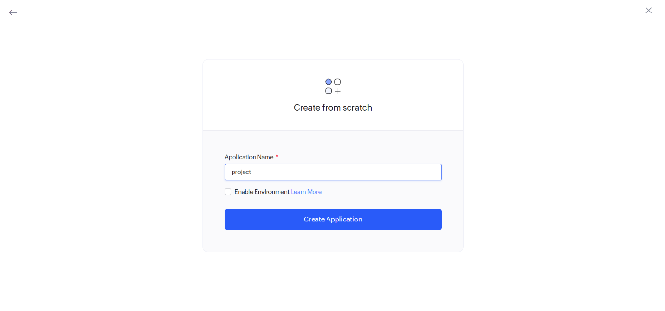

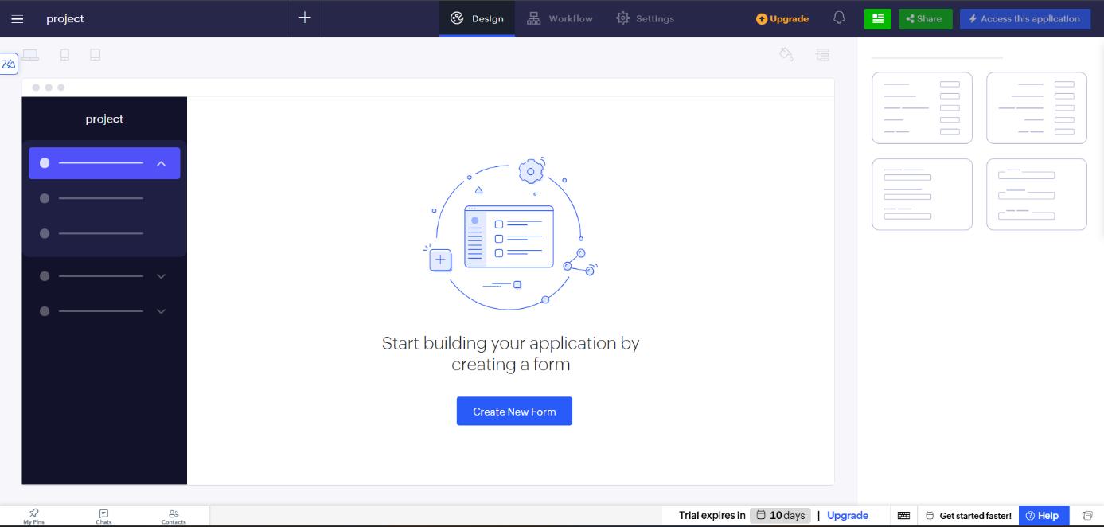

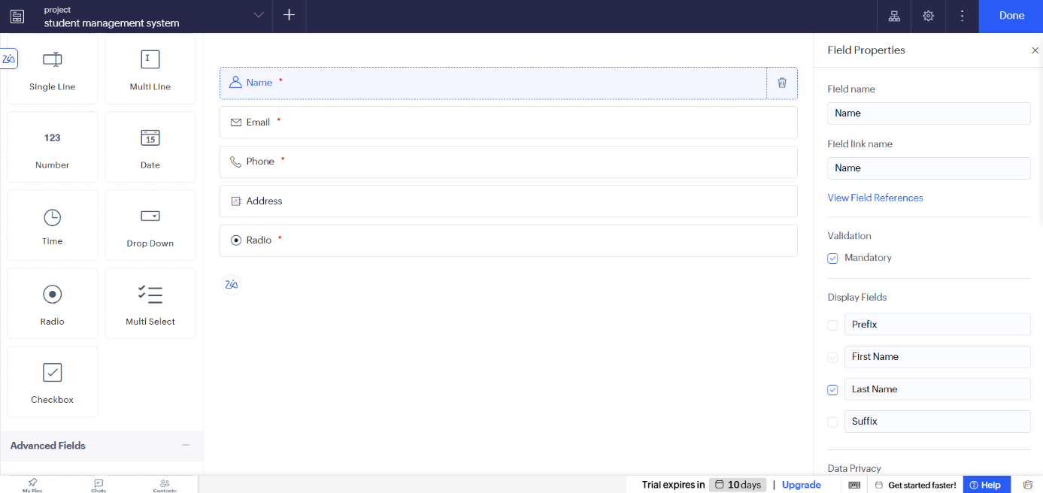

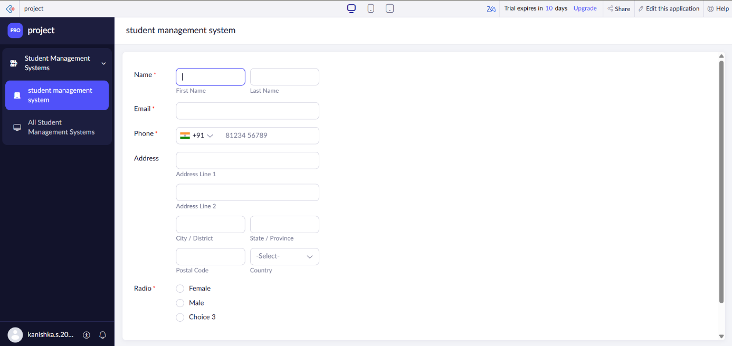

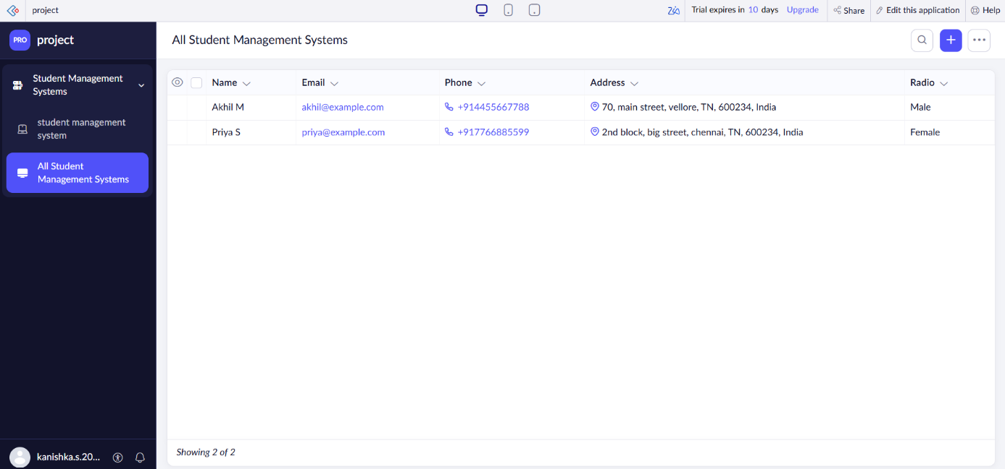

Exploring the Platform Architecture and Interface:
Zoho Creator provides three main sections for application development and management:

Develop
The Develop section is used to build and customize applications. Components:
  - Forms: Used to collect and store user data.
  - Reports: Used to view, filter, and analyze stored data.
  - Pages: Custom interfaces that combine multiple components.
  - Workflows: Automate tasks based on predefined conditions.
  - Functions: Custom scripts written using Deluge language.
  - Dashboards: Visual representation of data using charts and reports.

Deploy
The Deploy section is used to publish and share applications with users. Components:
  - User Access: Controls who can access the application.
  - Permissions: Defines what actions users can perform.
  - Publishing: Makes the application available on web or mobile platforms.
  - Sharing: Allows applications to be shared with teams or external users.

Manage
The Manage section is used for administration and maintenance of applications. Components:
  - Users: Manage application users and roles.
  - Data Management: Import, export, and maintain records.
  - Audit Logs: Track user activities and system changes.
  - Backup & Restore: Protect application data from loss.
  - Settings: Configure application preferences and security options.
  - Performance Monitoring: Monitor application usage and efficiency.

Result:
The Zoho Creator platform was successfully explored by creating a sample application, form, report, and dashboard. The Develop, Deploy, and Manage modules were studied, and their functionalities in low-code application development were understood successfully.

