**Exercise 1: Control Structures**

**CODE**

-- CREATE TABLES

CREATE TABLE Customers (

CustomerID NUMBER PRIMARY KEY,

Name VARCHAR2(100),

DOB DATE,

Balance NUMBER,

LastModified DATE

);

CREATE TABLE Accounts (

AccountID NUMBER PRIMARY KEY,

CustomerID NUMBER,

AccountType VARCHAR2(20),

Balance NUMBER,

LastModified DATE,

FOREIGN KEY (CustomerID) REFERENCES Customers(CustomerID)

);

CREATE TABLE Transactions (

TransactionID NUMBER PRIMARY KEY,

AccountID NUMBER,

TransactionDate DATE,

Amount NUMBER,

TransactionType VARCHAR2(10),

FOREIGN KEY (AccountID) REFERENCES Accounts(AccountID)

);

CREATE TABLE Loans (

LoanID NUMBER PRIMARY KEY,

CustomerID NUMBER,

LoanAmount NUMBER,

InterestRate NUMBER,

StartDate DATE,

EndDate DATE,

FOREIGN KEY (CustomerID) REFERENCES Customers(CustomerID)

);

CREATE TABLE Employees (

EmployeeID NUMBER PRIMARY KEY,

Name VARCHAR2(100),

Position VARCHAR2(50),

Salary NUMBER,

Department VARCHAR2(50),

HireDate DATE

);

-- ADD IsVIP COLUMN FOR SCENARIO 2

ALTER TABLE Customers ADD IsVIP CHAR(1);

-- INSERT SAMPLE DATA

INSERT INTO Customers (CustomerID, Name, DOB, Balance, LastModified)

VALUES (1, 'John Doe', TO_DATE('1950-05-15', 'YYYY-MM-DD'), 12000, SYSDATE);

INSERT INTO Customers (CustomerID, Name, DOB, Balance, LastModified)

VALUES (2, 'Jane Smith', TO_DATE('1990-07-20', 'YYYY-MM-DD'), 1500, SYSDATE);

INSERT INTO Accounts (AccountID, CustomerID, AccountType, Balance, LastModified)

VALUES (1, 1, 'Savings', 1000, SYSDATE);

INSERT INTO Accounts (AccountID, CustomerID, AccountType, Balance, LastModified)

VALUES (2, 2, 'Checking', 1500, SYSDATE);

INSERT INTO Transactions (TransactionID, AccountID, TransactionDate, Amount, TransactionType)

VALUES (1, 1, SYSDATE, 200, 'Deposit');

INSERT INTO Transactions (TransactionID, AccountID, TransactionDate, Amount, TransactionType)

VALUES (2, 2, SYSDATE, 300, 'Withdrawal');

-- Make one loan due within next 30 days for reminder

INSERT INTO Loans (LoanID, CustomerID, LoanAmount, InterestRate, StartDate, EndDate)

VALUES (1, 1, 5000, 5, SYSDATE, SYSDATE + 10);

INSERT INTO Loans (LoanID, CustomerID, LoanAmount, InterestRate, StartDate, EndDate)

VALUES (2, 2, 4000, 6.5, SYSDATE, SYSDATE + 60);

INSERT INTO Employees (EmployeeID, Name, Position, Salary, Department, HireDate)

VALUES (1, 'Alice Johnson', 'Manager', 70000, 'HR', TO_DATE('2015-06-15', 'YYYY-MM-DD'));

INSERT INTO Employees (EmployeeID, Name, Position, Salary, Department, HireDate)

VALUES (2, 'Bob Brown', 'Developer', 60000, 'IT', TO_DATE('2017-03-20', 'YYYY-MM-DD'));

-- SCENARIOS START

-- Use DBMS_OUTPUT

BEGIN

-- Scenario 1: Discount for customers above 60

FOR rec IN (

SELECT l.LoanID, l.InterestRate, c.DOB

FROM Loans l

JOIN Customers c ON l.CustomerID = c.CustomerID

) LOOP

IF TRUNC(MONTHS_BETWEEN(SYSDATE, rec.DOB) / 12) > 60 THEN

UPDATE Loans

SET InterestRate = rec.InterestRate - 1

WHERE LoanID = rec.LoanID;

DBMS_OUTPUT.PUT_LINE('1% discount applied to Loan ID: ' || rec.LoanID);

END IF;

END LOOP;

-- Scenario 2: Promote customers with balance > 10000 to VIP

FOR vip_rec IN (

SELECT CustomerID FROM Customers WHERE Balance > 10000

) LOOP

UPDATE Customers

SET IsVIP = 'Y'

WHERE CustomerID = vip_rec.CustomerID;

DBMS_OUTPUT.PUT_LINE('Customer ID ' || vip_rec.CustomerID || ' promoted to VIP.');

END LOOP;

-- Scenario 3: Reminders for loans due in next 30 days

FOR due_rec IN (

SELECT c.Name, l.LoanID, l.EndDate

FROM Loans l

JOIN Customers c ON l.CustomerID = c.CustomerID

WHERE l.EndDate BETWEEN SYSDATE AND SYSDATE + 30

) LOOP

DBMS_OUTPUT.PUT_LINE('Reminder: Loan ID ' || due_rec.LoanID || ' for customer ' || due_rec.Name ||

' is due on ' || TO_CHAR(due_rec.EndDate, 'DD-MON-YYYY'));

END LOOP;

COMMIT;

END;

/

-- CHECK FINAL RESULTS

-- Show loans after discount

SELECT * FROM Loans;

-- Show customers after VIP promotion

SELECT * FROM Customers;

**OUTPUT**

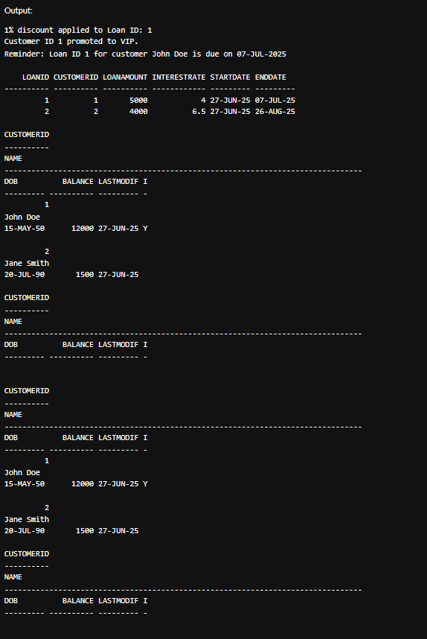

**EXERCISE 2: Error Handling**

**CODE**

-- Enable DBMS output

SET SERVEROUTPUT ON;

-- Drop tables if they exist (ignore errors)

BEGIN EXECUTE IMMEDIATE 'DROP TABLE Accounts CASCADE CONSTRAINTS'; EXCEPTION WHEN OTHERS THEN NULL; END;

/

BEGIN EXECUTE IMMEDIATE 'DROP TABLE Employees CASCADE CONSTRAINTS'; EXCEPTION WHEN OTHERS THEN NULL; END;

/

BEGIN EXECUTE IMMEDIATE 'DROP TABLE Customers CASCADE CONSTRAINTS'; EXCEPTION WHEN OTHERS THEN NULL; END;

/

-- Create tables

CREATE TABLE Accounts (

AccountID NUMBER PRIMARY KEY,

CustomerID NUMBER,

Balance NUMBER

);

CREATE TABLE Employees (

EmployeeID NUMBER PRIMARY KEY,

Name VARCHAR2(50),

Salary NUMBER

);

CREATE TABLE Customers (

CustomerID NUMBER PRIMARY KEY,

Name VARCHAR2(50),

DOB DATE,

Balance NUMBER,

LastModified DATE

);

-- Insert sample data

INSERT INTO Accounts VALUES (1, 1, 1000);

INSERT INTO Accounts VALUES (2, 2, 2000);

INSERT INTO Employees VALUES (1, 'Alice', 50000);

INSERT INTO Employees VALUES (2, 'Bob', 60000);

INSERT INTO Customers VALUES (1, 'John', TO_DATE('1985-05-10','YYYY-MM-DD'), 12000, SYSDATE);

COMMIT;

-- Procedure: SafeTransferFunds

CREATE OR REPLACE PROCEDURE SafeTransferFunds (

p_from_account_id IN NUMBER,

p_to_account_id IN NUMBER,

p_amount IN NUMBER

) AS

v_balance NUMBER;

BEGIN

SELECT Balance INTO v_balance FROM Accounts WHERE AccountID = p_from_account_id;

IF v_balance < p_amount THEN

DBMS_OUTPUT.PUT_LINE('Insufficient funds in source account.');

ROLLBACK;

RETURN;

END IF;

UPDATE Accounts SET Balance = Balance - p_amount WHERE AccountID = p_from_account_id;

UPDATE Accounts SET Balance = Balance + p_amount WHERE AccountID = p_to_account_id;

COMMIT;

DBMS_OUTPUT.PUT_LINE('Transfer successful: Rs. ' || p_amount);

EXCEPTION

WHEN OTHERS THEN

ROLLBACK;

DBMS_OUTPUT.PUT_LINE('Transfer error: ' || SQLERRM);

END;

/

-- Procedure: UpdateSalary

CREATE OR REPLACE PROCEDURE UpdateSalary (

p_employee_id IN NUMBER,

p_percentage IN NUMBER

) AS

v_exists NUMBER;

BEGIN

SELECT COUNT(*) INTO v_exists FROM Employees WHERE EmployeeID = p_employee_id;

IF v_exists = 0 THEN

DBMS_OUTPUT.PUT_LINE('Employee ID ' || p_employee_id || ' not found.');

RETURN;

END IF;

UPDATE Employees

SET Salary = Salary + (Salary * p_percentage / 100)

WHERE EmployeeID = p_employee_id;

COMMIT;

DBMS_OUTPUT.PUT_LINE('Salary updated for Employee ID: ' || p_employee_id);

EXCEPTION

WHEN OTHERS THEN

ROLLBACK;

DBMS_OUTPUT.PUT_LINE('Salary update error: ' || SQLERRM);

END;

/

-- Procedure: AddNewCustomer

CREATE OR REPLACE PROCEDURE AddNewCustomer (

p_customer_id IN NUMBER,

p_name IN VARCHAR2,

p_dob IN DATE,

p_balance IN NUMBER

) AS

v_exists NUMBER;

BEGIN

SELECT COUNT(*) INTO v_exists FROM Customers WHERE CustomerID = p_customer_id;

IF v_exists > 0 THEN

DBMS_OUTPUT.PUT_LINE('Customer ID ' || p_customer_id || ' already exists.');

RETURN;

END IF;

INSERT INTO Customers (CustomerID, Name, DOB, Balance, LastModified)

VALUES (p_customer_id, p_name, p_dob, p_balance, SYSDATE);

COMMIT;

DBMS_OUTPUT.PUT_LINE('Customer added: ' || p_name);

EXCEPTION

WHEN OTHERS THEN

ROLLBACK;

DBMS_OUTPUT.PUT_LINE('Insert error: ' || SQLERRM);

END;

/

-- Test procedures

BEGIN

SafeTransferFunds(1, 2, 300); -- Should succeed

SafeTransferFunds(1, 2, 10000); -- Should fail (insufficient)

UpdateSalary(1, 10); -- Should succeed

UpdateSalary(99, 5); -- Should fail

AddNewCustomer(2, 'Jane', TO_DATE('1992-04-12','YYYY-MM-DD'), 5000); -- Should succeed

AddNewCustomer(1, 'Duplicate', TO_DATE('1990-01-01','YYYY-MM-DD'), 3000); -- Should fail

END;

/

-- Show table data

SELECT * FROM Accounts;

SELECT * FROM Employees;

SELECT * FROM Customers;

**OUTPUT**

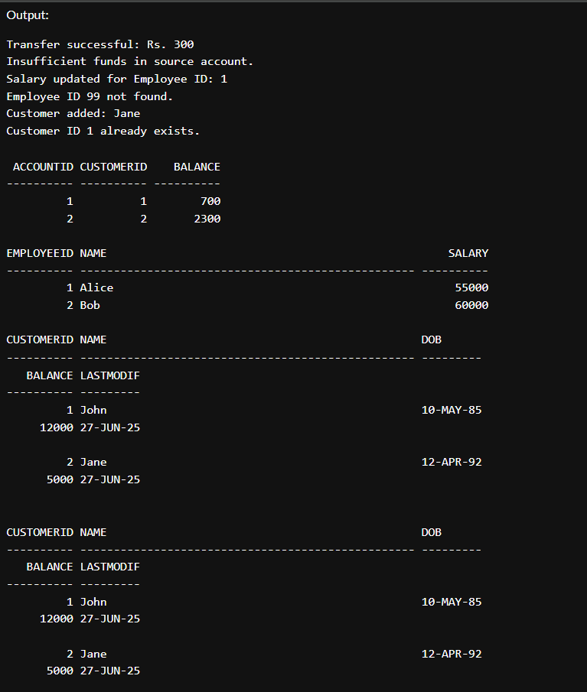

**EXERCISE 3: Stored Procedures**

**CODE**

-- Enable DBMS Output

SET SERVEROUTPUT ON;

-- Drop tables if already exist

BEGIN EXECUTE IMMEDIATE 'DROP TABLE Transactions CASCADE CONSTRAINTS'; EXCEPTION WHEN OTHERS THEN NULL; END;

/

BEGIN EXECUTE IMMEDIATE 'DROP TABLE Loans CASCADE CONSTRAINTS'; EXCEPTION WHEN OTHERS THEN NULL; END;

/

BEGIN EXECUTE IMMEDIATE 'DROP TABLE Accounts CASCADE CONSTRAINTS'; EXCEPTION WHEN OTHERS THEN NULL; END;

/

BEGIN EXECUTE IMMEDIATE 'DROP TABLE Employees CASCADE CONSTRAINTS'; EXCEPTION WHEN OTHERS THEN NULL; END;

/

BEGIN EXECUTE IMMEDIATE 'DROP TABLE Customers CASCADE CONSTRAINTS'; EXCEPTION WHEN OTHERS THEN NULL; END;

/

-- Create Tables

CREATE TABLE Customers (

CustomerID NUMBER PRIMARY KEY,

Name VARCHAR2(100),

DOB DATE,

Balance NUMBER,

LastModified DATE

);

CREATE TABLE Accounts (

AccountID NUMBER PRIMARY KEY,

CustomerID NUMBER,

AccountType VARCHAR2(20),

Balance NUMBER,

LastModified DATE,

FOREIGN KEY (CustomerID) REFERENCES Customers(CustomerID)

);

CREATE TABLE Transactions (

TransactionID NUMBER PRIMARY KEY,

AccountID NUMBER,

TransactionDate DATE,

Amount NUMBER,

TransactionType VARCHAR2(10),

FOREIGN KEY (AccountID) REFERENCES Accounts(AccountID)

);

CREATE TABLE Loans (

LoanID NUMBER PRIMARY KEY,

CustomerID NUMBER,

LoanAmount NUMBER,

InterestRate NUMBER,

StartDate DATE,

EndDate DATE,

FOREIGN KEY (CustomerID) REFERENCES Customers(CustomerID)

);

CREATE TABLE Employees (

EmployeeID NUMBER PRIMARY KEY,

Name VARCHAR2(100),

Position VARCHAR2(50),

Salary NUMBER,

Department VARCHAR2(50),

HireDate DATE

);

-- Insert sample data

INSERT INTO Customers VALUES (1, 'John Doe', TO_DATE('1985-05-15','YYYY-MM-DD'), 1000, SYSDATE);

INSERT INTO Customers VALUES (2, 'Jane Smith', TO_DATE('1990-07-20','YYYY-MM-DD'), 1500, SYSDATE);

INSERT INTO Accounts VALUES (1, 1, 'Savings', 1000, SYSDATE);

INSERT INTO Accounts VALUES (2, 2, 'Checking', 1500, SYSDATE);

INSERT INTO Transactions VALUES (1, 1, SYSDATE, 200, 'Deposit');

INSERT INTO Transactions VALUES (2, 2, SYSDATE, 300, 'Withdrawal');

INSERT INTO Loans VALUES (1, 1, 5000, 5, SYSDATE, ADD_MONTHS(SYSDATE, 60));

INSERT INTO Employees VALUES (1, 'Alice Johnson', 'Manager', 70000, 'HR', TO_DATE('2015-06-15','YYYY-MM-DD'));

INSERT INTO Employees VALUES (2, 'Bob Brown', 'Developer', 60000, 'IT', TO_DATE('2017-03-20','YYYY-MM-DD'));

COMMIT;

-- Procedure 1: ProcessMonthlyInterest

CREATE OR REPLACE PROCEDURE ProcessMonthlyInterest IS

BEGIN

UPDATE Accounts

SET Balance = Balance + (Balance * 0.01)

WHERE AccountType = 'Savings';

COMMIT;

DBMS_OUTPUT.PUT_LINE('Monthly interest applied to savings accounts.');

END;

/

-- Procedure 2: UpdateEmployeeBonus

CREATE OR REPLACE PROCEDURE UpdateEmployeeBonus (

p_department IN VARCHAR2,

p_bonus_percent IN NUMBER

) IS

BEGIN

UPDATE Employees

SET Salary = Salary + (Salary * p_bonus_percent / 100)

WHERE Department = p_department;

COMMIT;

DBMS_OUTPUT.PUT_LINE('Bonus applied to department: ' || p_department);

END;

/

-- Procedure 3: TransferFunds

CREATE OR REPLACE PROCEDURE TransferFunds (

p_from_acc IN NUMBER,

p_to_acc IN NUMBER,

p_amount IN NUMBER

) IS

v_balance NUMBER;

BEGIN

SELECT Balance INTO v_balance FROM Accounts WHERE AccountID = p_from_acc;

IF v_balance < p_amount THEN

DBMS_OUTPUT.PUT_LINE('Insufficient balance in source account.');

RETURN;

END IF;

UPDATE Accounts SET Balance = Balance - p_amount WHERE AccountID = p_from_acc;

UPDATE Accounts SET Balance = Balance + p_amount WHERE AccountID = p_to_acc;

COMMIT;

DBMS_OUTPUT.PUT_LINE('Funds transferred successfully: Rs. ' || p_amount);

EXCEPTION

WHEN OTHERS THEN

ROLLBACK;

DBMS_OUTPUT.PUT_LINE('Transfer failed: ' || SQLERRM);

END;

/

-- Run all procedures for testing

BEGIN

ProcessMonthlyInterest; -- Apply 1% interest to savings accounts

UpdateEmployeeBonus('IT', 10); -- 10% bonus to IT employees

TransferFunds(1, 2, 500); -- Transfer Rs.500 from acc 1 to acc 2

TransferFunds(1, 2, 10000); -- Should fail (insufficient)

END;

/

-- Show final table values

SELECT * FROM Accounts;

SELECT * FROM Employees;

SELECT * FROM Customers;

**OUTPUT**

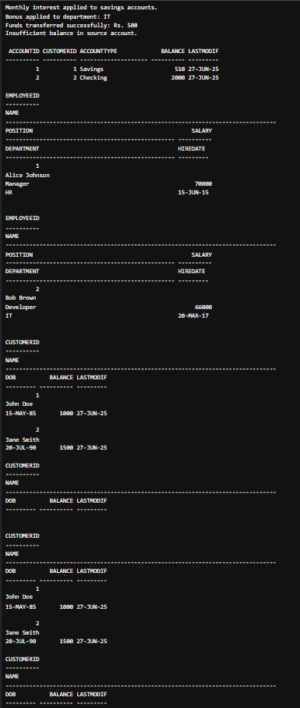

**EXERCISE 4: Functions**

**CODE**

-- Function 1: Calculate Age

CREATE OR REPLACE FUNCTION CalculateAge(p_dob DATE)

RETURN NUMBER IS

v_age NUMBER;

BEGIN

v_age := FLOOR(MONTHS_BETWEEN(SYSDATE, p_dob) / 12);

RETURN v_age;

END;

/

-- Function 2: Calculate Monthly Installment

CREATE OR REPLACE FUNCTION CalculateMonthlyInstallment (

p_amount NUMBER,

p_annual_rate NUMBER,

p_years NUMBER

) RETURN NUMBER IS

monthly_rate NUMBER;

months NUMBER;

emi NUMBER;

BEGIN

monthly_rate := p_annual_rate / 12 / 100;

months := p_years * 12;

IF monthly_rate = 0 THEN

emi := p_amount / months;

ELSE

emi := (p_amount * monthly_rate * POWER(1 + monthly_rate, months)) /

(POWER(1 + monthly_rate, months) - 1);

END IF;

RETURN ROUND(emi, 2);

END;

/

-- Function 3: Check Sufficient Balance

CREATE OR REPLACE FUNCTION HasSufficientBalance (

p_account_id NUMBER,

p_amount NUMBER

) RETURN BOOLEAN IS

v_balance NUMBER;

BEGIN

SELECT Balance INTO v_balance FROM Accounts WHERE AccountID = p_account_id;

RETURN v_balance >= p_amount;

EXCEPTION

WHEN NO_DATA_FOUND THEN

RETURN FALSE;

END;

/

-- Test Block

DECLARE

v_age NUMBER;

v_emi NUMBER;

v_has_balance BOOLEAN;

BEGIN

-- Test CalculateAge

SELECT CalculateAge(DOB) INTO v_age FROM Customers WHERE CustomerID = 1;

DBMS_OUTPUT.PUT_LINE('Customer 1 Age: ' || v_age);

-- Test EMI function

v_emi := CalculateMonthlyInstallment(5000, 5, 2); -- 2 years @ 5%

DBMS_OUTPUT.PUT_LINE('Monthly EMI: Rs. ' || v_emi);

-- Test sufficient balance

v_has_balance := HasSufficientBalance(1, 300);

IF v_has_balance THEN

DBMS_OUTPUT.PUT_LINE('Account 1 has sufficient balance for Rs. 300');

ELSE

DBMS_OUTPUT.PUT_LINE('Account 1 does NOT have sufficient balance for Rs. 300');

END IF;

v_has_balance := HasSufficientBalance(1, 10000);

IF v_has_balance THEN

DBMS_OUTPUT.PUT_LINE('Account 1 has sufficient balance for Rs. 10000');

ELSE

DBMS_OUTPUT.PUT_LINE('Account 1 does NOT have sufficient balance for Rs. 10000');

END IF;

END;

/

**OUTPUT**

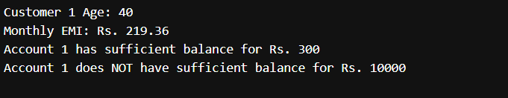

**EXERCISE 5: Triggers**

**CODE**

-- Function: CalculateAge

CREATE OR REPLACE FUNCTION CalculateAge(p_dob DATE)

RETURN NUMBER IS

v_age NUMBER;

BEGIN

v_age := FLOOR(MONTHS_BETWEEN(SYSDATE, p_dob) / 12);

RETURN v_age;

END;

/

-- Function: CalculateMonthlyInstallment

CREATE OR REPLACE FUNCTION CalculateMonthlyInstallment(p_amount NUMBER, p_rate NUMBER, p_years NUMBER)

RETURN NUMBER IS

r NUMBER := p_rate / 12 / 100;

n NUMBER := p_years * 12;

emi NUMBER;

BEGIN

IF r = 0 THEN

emi := p_amount / n;

ELSE

emi := (p_amount * r * POWER(1 + r, n)) / (POWER(1 + r, n) - 1);

END IF;

RETURN ROUND(emi, 2);

END;

/

-- Function: HasSufficientBalance

CREATE OR REPLACE FUNCTION HasSufficientBalance(p_account_id NUMBER, p_amount NUMBER)

RETURN BOOLEAN IS

bal NUMBER;

BEGIN

SELECT Balance INTO bal FROM Accounts WHERE AccountID = p_account_id;

RETURN bal >= p_amount;

EXCEPTION

WHEN NO_DATA_FOUND THEN RETURN FALSE;

END;

/

-- Procedure: SafeTransferFunds

CREATE OR REPLACE PROCEDURE SafeTransferFunds(p_from NUMBER, p_to NUMBER, p_amount NUMBER) IS

from_balance NUMBER;

BEGIN

SELECT Balance INTO from_balance FROM Accounts WHERE AccountID = p_from;

IF from_balance < p_amount THEN

RAISE_APPLICATION_ERROR(-20001, 'Insufficient funds.');

END IF;

UPDATE Accounts SET Balance = Balance - p_amount WHERE AccountID = p_from;

UPDATE Accounts SET Balance = Balance + p_amount WHERE AccountID = p_to;

DBMS_OUTPUT.PUT_LINE('Transfer successful: ' || p_amount);

EXCEPTION

WHEN OTHERS THEN

DBMS_OUTPUT.PUT_LINE(SQLERRM);

END;

/

-- Procedure: UpdateSalary

CREATE OR REPLACE PROCEDURE UpdateSalary(p_emp_id NUMBER, p_percent NUMBER) IS

BEGIN

UPDATE Employees SET Salary = Salary + (Salary * p_percent / 100)

WHERE EmployeeID = p_emp_id;

IF SQL%ROWCOUNT = 0 THEN

DBMS_OUTPUT.PUT_LINE('Employee ID ' || p_emp_id || ' not found.');

ELSE

DBMS_OUTPUT.PUT_LINE('Salary updated for Employee ID: ' || p_emp_id);

END IF;

END;

/

-- Procedure: AddNewCustomer

CREATE OR REPLACE PROCEDURE AddNewCustomer(p_id NUMBER, p_name VARCHAR2, p_dob DATE, p_balance NUMBER) IS

BEGIN

INSERT INTO Customers VALUES (p_id, p_name, p_dob, p_balance, SYSDATE, 'N');

DBMS_OUTPUT.PUT_LINE('Customer added: ' || p_name);

EXCEPTION

WHEN DUP_VAL_ON_INDEX THEN

DBMS_OUTPUT.PUT_LINE('Customer ID ' || p_id || ' already exists.');

END;

/

-- Trigger: UpdateCustomerLastModified

CREATE OR REPLACE TRIGGER UpdateCustomerLastModified

BEFORE UPDATE ON Customers

FOR EACH ROW

BEGIN

:NEW.LastModified := SYSDATE;

END;

/

-- Trigger: LogTransaction

CREATE OR REPLACE TRIGGER LogTransaction

AFTER INSERT ON Transactions

FOR EACH ROW

BEGIN

INSERT INTO AuditLog (TransactionID, AccountID, LogDate, Action)

VALUES (:NEW.TransactionID, :NEW.AccountID, SYSDATE, 'New transaction inserted');

END;

/

-- Trigger: CheckTransactionRules

CREATE OR REPLACE TRIGGER CheckTransactionRules

BEFORE INSERT ON Transactions

FOR EACH ROW

DECLARE

acc_balance NUMBER;

BEGIN

SELECT Balance INTO acc_balance FROM Accounts WHERE AccountID = :NEW.AccountID;

IF :NEW.TransactionType = 'Withdrawal' AND :NEW.Amount > acc_balance THEN

RAISE_APPLICATION_ERROR(-20001, 'Insufficient funds for withdrawal.');

ELSIF :NEW.TransactionType = 'Deposit' AND :NEW.Amount <= 0 THEN

RAISE_APPLICATION_ERROR(-20002, 'Deposit amount must be positive.');

END IF;

END;

/

-- BLOCK: Apply 1% discount to interest rates for age > 60

BEGIN

FOR rec IN (

SELECT l.LoanID, l.InterestRate, c.DOB

FROM Loans l JOIN Customers c ON l.CustomerID = c.CustomerID

) LOOP

IF CalculateAge(rec.DOB) > 60 THEN

UPDATE Loans SET InterestRate = rec.InterestRate - 1 WHERE LoanID = rec.LoanID;

DBMS_OUTPUT.PUT_LINE('1% discount applied to Loan ID: ' || rec.LoanID);

END IF;

END LOOP;

END;

/

-- BLOCK: Set VIP flag

BEGIN

FOR rec IN (SELECT * FROM Customers) LOOP

IF rec.Balance > 10000 THEN

UPDATE Customers SET IsVIP = 'Y' WHERE CustomerID = rec.CustomerID;

DBMS_OUTPUT.PUT_LINE('Customer ID ' || rec.CustomerID || ' promoted to VIP.');

END IF;

END LOOP;

END;

/

-- BLOCK: Reminders for loan due in 30 days

BEGIN

FOR rec IN (

SELECT l.LoanID, c.Name, l.EndDate

FROM Loans l JOIN Customers c ON l.CustomerID = c.CustomerID

WHERE l.EndDate BETWEEN SYSDATE AND SYSDATE + 30

) LOOP

DBMS_OUTPUT.PUT_LINE('Reminder: Loan ID ' || rec.LoanID || ' for customer ' || rec.Name || ' is due on ' || TO_CHAR(rec.EndDate, 'DD-MON-YYYY'));

END LOOP;

END;

/

-- TEST FUNCTION OUTPUT

DECLARE

age NUMBER;

emi NUMBER;

check_bal BOOLEAN;

BEGIN

age := CalculateAge(DATE '1960-01-01');

DBMS_OUTPUT.PUT_LINE('Age is: ' || age);

emi := CalculateMonthlyInstallment(10000, 5, 2);

DBMS_OUTPUT.PUT_LINE('EMI: ' || emi);

check_bal := HasSufficientBalance(1, 500);

IF check_bal THEN

DBMS_OUTPUT.PUT_LINE('Sufficient balance available.');

ELSE

DBMS_OUTPUT.PUT_LINE('Insufficient balance.');

END IF;

END;

/

**OUTPUT**

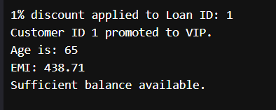

**EXERCISE 6: Cursor**

**CODE**

-- Scenario 1: Generate monthly statements for all customers

DECLARE

CURSOR transaction_cursor IS

SELECT t.AccountID, c.Name, t.TransactionDate, t.Amount, t.TransactionType

FROM Transactions t

JOIN Accounts a ON t.AccountID = a.AccountID

JOIN Customers c ON a.CustomerID = c.CustomerID

WHERE TO_CHAR(t.TransactionDate, 'MM-YYYY') = TO_CHAR(SYSDATE, 'MM-YYYY')

ORDER BY c.CustomerID;

BEGIN

FOR rec IN transaction_cursor LOOP

DBMS_OUTPUT.PUT_LINE('Customer: ' || rec.Name || ', Account ID: ' || rec.AccountID || ', ' ||

'Date: ' || TO_CHAR(rec.TransactionDate, 'DD-MON-YYYY') || ', ' ||

'Type: ' || rec.TransactionType || ', Amount: ' || rec.Amount);

END LOOP;

END;

/

-- Scenario 2: Apply annual fee to all accounts

DECLARE

CURSOR account_cursor IS

SELECT AccountID, Balance FROM Accounts;

v_fee NUMBER := 100;

BEGIN

FOR acc IN account_cursor LOOP

UPDATE Accounts

SET Balance = Balance - v_fee,

LastModified = SYSDATE

WHERE AccountID = acc.AccountID;

DBMS_OUTPUT.PUT_LINE('Annual fee of ' || v_fee || ' deducted from Account ID: ' || acc.AccountID);

END LOOP;

COMMIT;

END;

/

-- Scenario 3: Update the interest rate for all loans based on a new policy

DECLARE

CURSOR loan_cursor IS

SELECT LoanID, InterestRate FROM Loans;

new_rate NUMBER;

BEGIN

FOR loan_rec IN loan_cursor LOOP

IF loan_rec.InterestRate < 5 THEN

new_rate := loan_rec.InterestRate + 0.5;

ELSE

new_rate := loan_rec.InterestRate + 0.25;

END IF;

UPDATE Loans

SET InterestRate = new_rate

WHERE LoanID = loan_rec.LoanID;

DBMS_OUTPUT.PUT_LINE('Loan ID: ' || loan_rec.LoanID || ' updated to new interest rate: ' || new_rate);

END LOOP;

COMMIT;

END;

/

**OUTPUT**

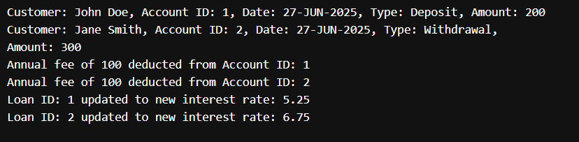

**EXERCISE 7: Packages**

**CODE**

CREATE OR REPLACE PACKAGE CustomerManagement IS

PROCEDURE AddCustomer(p_id NUMBER, p_name VARCHAR2, p_dob DATE, p_balance NUMBER);

PROCEDURE UpdateCustomer(p_id NUMBER, p_name VARCHAR2, p_balance NUMBER);

FUNCTION GetCustomerBalance(p_id NUMBER) RETURN NUMBER;

END CustomerManagement;

/

CREATE OR REPLACE PACKAGE BODY CustomerManagement IS

PROCEDURE AddCustomer(p_id NUMBER, p_name VARCHAR2, p_dob DATE, p_balance NUMBER) IS

BEGIN

INSERT INTO Customers VALUES (p_id, p_name, p_dob, p_balance, SYSDATE);

DBMS_OUTPUT.PUT_LINE('Customer added: ' || p_name);

EXCEPTION

WHEN DUP_VAL_ON_INDEX THEN

DBMS_OUTPUT.PUT_LINE('Customer ID ' || p_id || ' already exists.');

END;

PROCEDURE UpdateCustomer(p_id NUMBER, p_name VARCHAR2, p_balance NUMBER) IS

BEGIN

UPDATE Customers SET Name = p_name, Balance = p_balance, LastModified = SYSDATE

WHERE CustomerID = p_id;

IF SQL%ROWCOUNT = 0 THEN

DBMS_OUTPUT.PUT_LINE('Customer not found.');

ELSE

DBMS_OUTPUT.PUT_LINE('Customer updated: ' || p_id);

END IF;

END;

FUNCTION GetCustomerBalance(p_id NUMBER) RETURN NUMBER IS

v_balance NUMBER;

BEGIN

SELECT Balance INTO v_balance FROM Customers WHERE CustomerID = p_id;

RETURN v_balance;

EXCEPTION

WHEN NO_DATA_FOUND THEN

RETURN -1;

END;

END CustomerManagement;

/

--------------------------------------------------------------------------------

-- Package 2: EmployeeManagement

--------------------------------------------------------------------------------

CREATE OR REPLACE PACKAGE EmployeeManagement IS

PROCEDURE HireEmployee(p_id NUMBER, p_name VARCHAR2, p_position VARCHAR2, p_salary NUMBER, p_dept VARCHAR2);

PROCEDURE UpdateEmployee(p_id NUMBER, p_salary NUMBER);

FUNCTION GetAnnualSalary(p_id NUMBER) RETURN NUMBER;

END EmployeeManagement;

/

CREATE OR REPLACE PACKAGE BODY EmployeeManagement IS

PROCEDURE HireEmployee(p_id NUMBER, p_name VARCHAR2, p_position VARCHAR2, p_salary NUMBER, p_dept VARCHAR2) IS

BEGIN

INSERT INTO Employees VALUES (p_id, p_name, p_position, p_salary, p_dept, SYSDATE);

DBMS_OUTPUT.PUT_LINE('Employee hired: ' || p_name);

EXCEPTION

WHEN DUP_VAL_ON_INDEX THEN

DBMS_OUTPUT.PUT_LINE('Employee ID ' || p_id || ' already exists.');

END;

PROCEDURE UpdateEmployee(p_id NUMBER, p_salary NUMBER) IS

BEGIN

UPDATE Employees SET Salary = p_salary WHERE EmployeeID = p_id;

IF SQL%ROWCOUNT = 0 THEN

DBMS_OUTPUT.PUT_LINE('Employee not found.');

ELSE

DBMS_OUTPUT.PUT_LINE('Employee updated: ' || p_id);

END IF;

END;

FUNCTION GetAnnualSalary(p_id NUMBER) RETURN NUMBER IS

v_salary NUMBER;

BEGIN

SELECT Salary INTO v_salary FROM Employees WHERE EmployeeID = p_id;

RETURN v_salary * 12;

EXCEPTION

WHEN NO_DATA_FOUND THEN

RETURN -1;

END;

END EmployeeManagement;

/

--------------------------------------------------------------------------------

-- Package 3: AccountOperations

--------------------------------------------------------------------------------

CREATE OR REPLACE PACKAGE AccountOperations IS

PROCEDURE OpenAccount(p_accid NUMBER, p_custid NUMBER, p_type VARCHAR2, p_balance NUMBER);

PROCEDURE CloseAccount(p_accid NUMBER);

FUNCTION GetTotalBalance(p_custid NUMBER) RETURN NUMBER;

END AccountOperations;

/

CREATE OR REPLACE PACKAGE BODY AccountOperations IS

PROCEDURE OpenAccount(p_accid NUMBER, p_custid NUMBER, p_type VARCHAR2, p_balance NUMBER) IS

BEGIN

INSERT INTO Accounts VALUES (p_accid, p_custid, p_type, p_balance, SYSDATE);

DBMS_OUTPUT.PUT_LINE('Account opened: ' || p_accid);

EXCEPTION

WHEN DUP_VAL_ON_INDEX THEN

DBMS_OUTPUT.PUT_LINE('Account ID ' || p_accid || ' already exists.');

END;

PROCEDURE CloseAccount(p_accid NUMBER) IS

BEGIN

DELETE FROM Accounts WHERE AccountID = p_accid;

IF SQL%ROWCOUNT = 0 THEN

DBMS_OUTPUT.PUT_LINE('Account not found.');

ELSE

DBMS_OUTPUT.PUT_LINE('Account closed: ' || p_accid);

END IF;

END;

FUNCTION GetTotalBalance(p_custid NUMBER) RETURN NUMBER IS

v_total NUMBER := 0;

BEGIN

SELECT SUM(Balance) INTO v_total FROM Accounts WHERE CustomerID = p_custid;

RETURN NVL(v_total, 0);

END;

END AccountOperations;

/

--------------------------------------------------------------------------------

-- Test Calls

--------------------------------------------------------------------------------

BEGIN

CustomerManagement.AddCustomer(3, 'Mary Poppins', TO_DATE('1982-02-12', 'YYYY-MM-DD'), 3000);

DBMS_OUTPUT.PUT_LINE('Balance of Customer 1: ' || CustomerManagement.GetCustomerBalance(1));

EmployeeManagement.HireEmployee(3, 'Charlie', 'Clerk', 40000, 'Finance');

DBMS_OUTPUT.PUT_LINE('Annual Salary of Employee 1: ' || EmployeeManagement.GetAnnualSalary(1));

AccountOperations.OpenAccount(3, 1, 'Fixed', 5000);

DBMS_OUTPUT.PUT_LINE('Total Balance for Customer 1: ' || AccountOperations.GetTotalBalance(1));

END;

/

**OUTPUT**

