**HISTOGRAM**

**A MINI PROJECT REPORT**

*SUBMITTED BY*

**KANISHKASHREE.D**

**PRAVEENA.A**

**MUTHULAKSHMI.M**

**BACHELOR OF ENGINEERNING**

**IN**

COMPUTER SCIENCE AND ENGINEERNING

RAMCO INSTITUTE OF TECHNOLOGY,

RAJAPALAYAM

**JANUARY 2023**

**BONAFIDE CERTIFICATE**

Certified that this mini project report”HISTOGRAM” is the bonafide work of “A.Praveena(953621104033**),D.kanishkashree**(953621104012), **M.Muthulakshmi**(953621104030)”.Who carried out the mini project work under my supervision.

**SIGNATURE**  **SIGNATURE**

Dr.K.Vijalakshmi M.E.,Ph.D. Mr.R.Balaji Ganesh B.E.,M.Tech.

**HEAD OF THE DEPARTMENT**  **FACULTY IN-CHARGE**

Department of Comnputer Science and Assistant Professor

Engineering Department of Computer Science &

Ramco Institute Of Technology Engineering

North Venganallur Village Ramco Institute Of Technology

Rajapalayam-626117 North Vengallur Village

Rajapalayam-626117

**INTERNAL EXAMINER** **EXTERNAL EXAMINER**

**ABSTRACT**

This program uses the JavaFX

library to create a graphical representation of

midterm scores in the form of a histogram. The

user inputs the scores and the program will

automatically create the histogram with bars

representing the frequency of each score range.

The program utilizes the JavaFX Canvas class to

draw the histogram and the Scene class to display

it in the window. The program also has a clear

button to clear the histogram, a label showing the

total number of scores and a textfield to input the

scores

**TABLE OF CONTENTS**

|  |  |  |
| --- | --- | --- |
| **CHAPTER NO.** | **TITLE** | **PAGE NO.** |
| 1 | INTRODUCTION | 5 |
|  | * 1. Uses of Histogram in JavaFx application | 6 |
|  | 1.2 Project Objectives | 6 |
|  | 1.3 Project Specification | 7 |
|  | 1.4 Modules in the Project | 8 |
| 2 | System Specification  2.1 Hardware Specification  2.2 Software Specification | 8 |
| 3 | System Design and Implementation | 9 |
| 4 | Conclusion | 9 |
| 5 | Appendix  5.1 Source code  5.2 Screenshot | 10  11  12 |

**CHAPTER 1**

**INTRODUCTION:**

A histogram is a graphical representation of data that shows the frequency of different values in a data set.It is used to visualize the distribution of continuous or numerical variable.In a histrogram,the x-axis represents the frequency of those values.The data is divided into “bins”,or ranges of values,and a bar is ceated for each bin.The height of the bar represents the frequency of the data point that fall within the bin’s range of values.

The x-axis represents the values of the data,the y-axis represents the count of the number of data points that fall within the specified range (bin)of x-axis values.

It is helpful to understand the different between a histogram and a bar chart.While both types of charts use bars to display data,a histogram is used for continuous data and a bar chart is used for categorical data.In other words,a histrogram is used to display the distribution of a continuous variable,while a bar chart is used to display the comparison of discrete categories.

Additionally,histogram are useful in identifying patterns and trends in the data.for example,if a histogram has a bell-shaped curve,it can indicate that the data is normally distributed.If the histogram is skewed,it can indicates that the data is not distributed normally.

Histogram can be used in different types of data analaysis,such as image processing,signal processing,and statistical data analaysis,the main goal of histograma is to represent the distributive of data and reveal hidden patterns.

**1.1Use of Histogram in Javafx application:**

Javafx is a java used for library used for building cross-platform desktop and mobile application with a rich user interface.Histogram can be used in a JavaFx application to provide visual representation of data distribution in a number of ways.

JavaFx provides the package javafx.scene.chart which have some classes (Barchart,Histogram,etc)which can be use to plot the histogram.By using these classes,developer can create a histogram,set the data amd customize the appearance.

**1.2 Project Objectives:**

Our project introduces a creating interactive histogram ie: the application should allow the user to view the histogram and interact with it.The main objective are as follow

* Loading and Processing the nesscessary file for creating histogram.
* The file should contain the Midterm score of the student (“MidtermScore.txt”).
* Data visualization:The application allow us to visualize the data in the way of histogram

**1.3 Project Specification:**

This project aims at development of histogram with the file using JavaFx application and it also makes the data as easier way to understand by visualizing ie(‘*’)

This project includes the following :

1. File creation
2. Visualizing

**1.4Modules in the project:**

1.Filecreation:

Creating a file which contain Midterm score of the student and passing the file to visualize the data in the histogram.

2.Visualizing:

Using Javafx application Creating scene with the necessary node and passing the scene to the stage and visualize the stage which contains scene

**CHAPTER 2**

**SYSTEM SPECIFICATION**

**2.1 HARDWARE SPECIFICATION:**

* **Processor :**Intel dual core
* **Processor speed :**1.04GHZ
* **Ram :**1GB
* **Hard disc :**20GB Hard disc
* **Monitor :** LCD
* **Keyboard :** MM Keyboard(Usb)
* **Mouse :**Optical mouse(Usb)

**2.2 SOFTWARE SPECIFICATION:**

* Os : Microsoft Windows 10
* Language : JAVA
* Complier :NetBeans IDE 8.1

**3.SYSTEM DESIGN AND IMPLENATION:**

**PROCEDURE:**

STEP 1: CREATING THE FILE NAMED MIDETERM SCORES

STEP 2:GIVE THE RESPECTED DETAILS IN THE FILE

STEP 3:CREATING THE SCENE WITH THE NECESSARY NODES

STEP 4:PASSING THE SCENE TO THE STAGE

STEP 5:HISTOGRAM USING JAVAFX CREATED

**4.CONCLUSION:**

Rather than designing manullay we have made use of computer once that data are input it performs accurate function. There is no chance of fault or miscalculation if the data are given correctly.Use of the computers has solved many problems,which are faced while manual calculation .This is not the end but beginings of the versatile,efficient and good way for creating the histogram in an application format. This is one which is compatible to all operating system.By making this project we made a small step towards the path of creating the program as the required format.

**5. APPENDIX:**

**5.1.SOURCE CODE:**

import javafx.application.Application;

import javafx.scene.Scene;

import javafx.scene.control.Label;

import javafx.scene.layout.VBox;

import javafx.stage.FileChooser;

import javafx.stage.Stage;

import java.io.*;

import java.util.Scanner;

public class Histogram extends Application {

@Override

public void start(Stage primaryStage) {

VBox root = new VBox();

int[] histogramArray = new int[11];

for (int i = 0; i <= 10; i++) {

histogramArray[i] = 0;

}

try {

FileChooser fileChooser = new FileChooser();

fileChooser.setTitle("Select the file with the midterm scores.");

File file = fileChooser.showOpenDialog(primaryStage);

Scanner scanner = new Scanner(file);

while (scanner.hasNextLine()) {

String line = scanner.nextLine();

int score = Integer.parseInt(line);

if (score < 0 || score > 100

) {

throw new IllegalArgumentException("That score is out of range");

} else {

int range = score / 10;

histogramArray[range]++;

}

}

for (int range = 0; range <= 10; range++) {

String label;

switch (range) {

case 0:

label = "00-09";

break;

case 10:

label = " 100";

break;

default:

label = (10 * range) + "-" + (10 * range + 9);

break;

}

StringBuilder stars = new StringBuilder();

for (int i = 0; i < histogramArray[range]; i++) {

stars.append("*");

}

Label histogramRow = new Label(label + ": " + stars.toString());

root.getChildren().add(histogramRow);

}

} catch (FileNotFoundException e) {

e.printStackTrace();

} Scene scene = new Scene(root,500,500);

primaryStage.setTitle("Histogram");

primaryStage.setScene(scene);

primaryStage.show();

}

Public static void main(String[] args) {

launch(args);

}

}

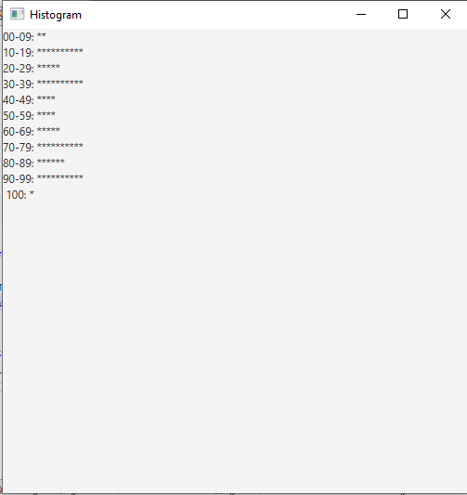**5.2 SCREENSHOT:**