**VIVEKANANDA INSTITUTE OF PROFESSIONAL STUDIES**

**VIVEKANANDA SCHOOL OF INFORMATION TECHNOLOGY**

**BACHELOR OF COMPUTER APPLICATION**

**Python Programming Lab File**

**BCA**

**Guru Gobind Singh Indraprastha University**

 **Sector - 16C, Dwarka, Delhi - 110078**

**SUBMITTED TO:                                           SUBMITTED BY:**

Dr. Neetu Goel Pranjal Tiwari

Assistant Professor                                         07629802021

VSIT                                                                   BCA-III (EB)

Practical Index

|  |  |  |  |  |
| --- | --- | --- | --- | --- |
| S.No. | Program | Page no | Date | Signature­ |
| 1. |  |  |  |  |
| 2 |  |  |  |  |
| 3. |  |  |  |  |
| 4. |  |  |  |  |
| 5. |  |  |  |  |
| 6. |  |  |  |  |
| 7. |  |  |  |  |
| 8. |  |  |  |  |
| 9. |  |  |  |  |
| 10. |  |  |  |  |
| 11. |  |  |  |  |
| 12. |  |  |  |  |
| 13. |  |  |  |  |
| 14. |  |  |  |  |
| 15. |  |  |  |  |
| 16. |  |  |  |  |
| 17. |  |  |  |  |
| 18. |  |  |  |  |
| 19. |  |  |  |  |
| 20. |  |  |  |  |

Assignment 2

Q-1 Write a python program to accept a temperature in Fahrenheit degree and convert it into Centigraide degrees and print both temperatures.

Code and Output:

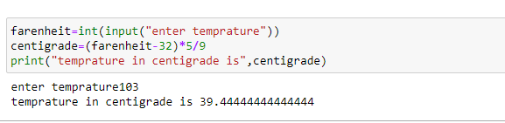

Q-2 A grocery shop decides to give its customers a discount on the total purchases if it exceeds Rs. 1000. The quantity purchased and price per item is entered through a keyboard. Write a program to calculate final sales bill.

Code and Output:

Q-3 A company insures its drivers in the following cases:

* If the driver is married.
* If the driver is unmarried, male and above 30 years of age.
* If the driver is unmarried, female and above 25 years of age.
* In all other cases, the driver is not insured. If the martial status, sex and age of the driver are the inputs.

Write a program to determine whether driver should be insured or not.

Code and Output:

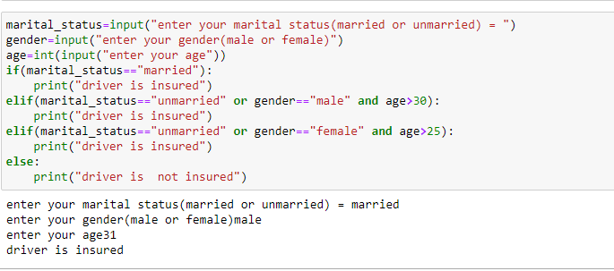

Q-4 Write a program to find out given number is odd or even.

Code and Output:

Q-5 Write a program to find out the greatest in two numbers using if and conditional operator.

Code and Output:

Q-6 Accept a non-zero integer as input. Print positive if it is greater than zero and negative if it is less than zero

Code and Output:

Q-7 In a company a employee is paid as under:

* If his basic salary is less than Rs. 1500, then HRA = 10% of basic salary and DA=90% of basic salary.
* If his salary is either equal to or above Rs.1500, then HRA=Rs.500 and DA=98% of basic salary.

If the employee’s salary is input through the keyboard write a program to find his gross salary.

Code and Output:

Q-8 Percentage marks obtained by a student are input through the keyboard. The student gets a division as per the following rules:

* Percentage above or equal to 60 - First Division
* Percentage between 50 and 59 - First Division
* Percentage between 40 and 49 - First Division
* Percentage less than 40 - Fail

Write a program to calculate the division obtained by a student

Code and Output:

Q-9 Given a number n we wish to do the following:

* If n is positive - print n*n, set a flag to true.
* If n is negative – print n*n*n, set a flag to true.
* If n is 0 – do nothing

Code and Output:

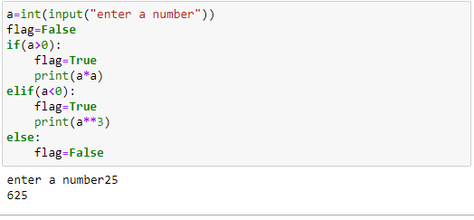

Q-10 Write a program to find out input year is leap year or not.

Code and Output:

Assignment 3

Q-1 Write a program using while loop that asks the user for a number, and prints a countdown from that number to zero.

Code and Output:

Q-2 Accept a positive integer n as input and print all the factors of n, one number on each line.

Code and Output:

Q-3 Write a python program to read an integer > 1000 and reverse the integer.

Code and Output:

Q-4 Accept a positive integer n as input and print the sum of digits in the number.

Code and Output:

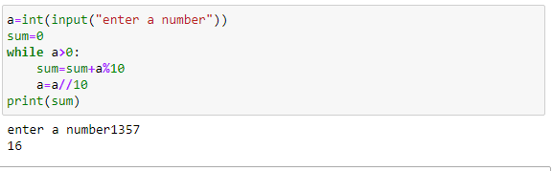

Q-5 Write a program to print out all the Armstrong numbers between 100 and 500. If sum of cubes of each digit of the number is equal to the number itself, the it is called an Armstrong no.

Code and Output:

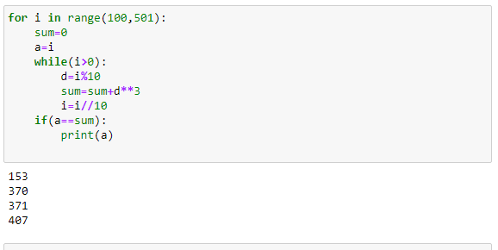

Q-6 Write a program to print the sum of all primes between two ranges.

Code and Output:

Q-7 Write a python program to print the following patterns :

|  |  |  |  |  |  |  |
| --- | --- | --- | --- | --- | --- | --- |
| 0 |  | 01234 |  | 0 |  | 01234 |
| 01 |  | 0123 |  | 01 |  | 0123 |
| 012 |  | 012 |  | 012 |  | 012 |
| 0123 |  | 012 |  | 0123 |  | 01 |
| 01234 |  | 01 |  | 01234 |  | 0 |

*

* * *

* * * * *

* * * * * * *

* * * * *

* * *

*

1

2 4

3 6 9

4 8 12 16

5 10 15 20 25

1 2 3 4 5

2 2 3 4 5

3 3 3 4 5

4 4 4 4 5

5 5 5 5 5

Code and Output:



