Assignment 7

Q1 Write a Python program to get the maximum and minimum value in a dictionary.

Code and Output:

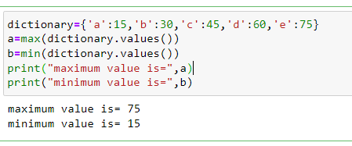

Q2 Write a Python program to sum all the items in a dictionary

Code and Output:

Q3 Write a Python program to merge two Python dictionaries.

Code and Output:

Q4 Write a Python program to generate and print a dictionary that

contains all even numbers (between 1 and n) in the form (x, x^3).

Code and Output:

Q5 Write a Python program to remove a key from a dictionary.

Code and Output:

Q6 Write a Python program to remove duplicates from Dictionary.

Code and Output:

Q7 Write a Python program to combine two dictionaries adding values for common keys

for example: d1= {1: 10, 2: 20, 3: 30,5:10}

d2 = {4: 40, 5: 50, 6: 60,2:10}

output: {1:10, 2:30, 3:30, 4:40, 5:60, 6:60}

Code and Output:

Q8 Write a python program to find out the key based on the value.

Code and Output:

Q9 Write a python program for dictionary of names of students and a list of their marks in 4 subjects. create another dictionary from this dictionary that has name of the students and their total marks. find out the topper and his/her marks.

Code and Output:

Q10 Write a python program to reverse the dictionary values.

Code and Output:

Q11 Write a python program to accept a string from user, to find the frequency of each character with the help of dictionary.

Code and Output:

Q12 Write a python program to accept a string from user, to find the frequency of each word with the help of dictionary.

Code and Output:

