2.2
源代码：
package first;
import java.util.*;
public class First{
public static void main(String args[]){
Scanner ss=new Scanner(System.in);
System.out.println("请输入一个半径和一个高");
double banjing=ss.nextDouble();
double gao=ss.nextDouble();
double mianji=banjing*banjing*3.14159;
double tiji=gao*mianji;
System.out.println("圆柱体的面积为"+mianji+"\n"+"圆柱体的体积为"+tiji);
}

}
输出结果：
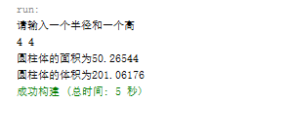
2.3
源代码：
package first;
import java.util.*;
public class First{
public static void main(String args[]){
Scanner ss=new Scanner(System.in);
System.out.println("请输入一个英尺");
double yingchi=ss.nextDouble();
double meter=0.305*yingchi;
System.out.println("输入的英尺数转换为米为"+meter+"米");
}

输出结果：
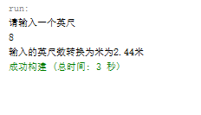

2.6
源代码：
package first;
import java.util.*;
public class First{
public static void main(String args[]){
Scanner ss=new Scanner(System.in);
System.out.println("请输入一个以分钟为单位的时间长度");
int minute=ss.nextInt();
int hour=minute/60;
int days=hour/24;
int years=days/365;
minute=minute%60;
hour=hour%24;
days=days%365;
System.out.println("输入的时间为大致为："+"\n"+years+"年"+days+"天"+hour+"小时"+minute+"分钟");
}
}

输出结果：
