高级语言程序设计实验报告

1. 程序清单运行

源代码:

import java.util.Scanner;

public class First{

public static void main(String[] args){

int number=(int)(Math.random()\*101);

Scanner input=new Scanner(System.in);

System.out.println("Guess a magic number between 0 and 100");

int guess= -1;

while(guess!=number){

guess=input.nextInt();

if(guess==number)

System.out.println("Yes,the number is"+number);

else if(guess>number)

System.out.println("You guess is too high");

else

System.out.println("Your guess is too low");

}

}

}

运行结果:

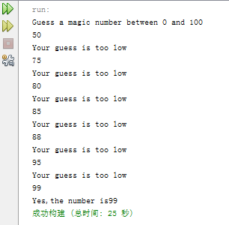

1. 十进制转二进制代码编写

源代码：

import java.util.Scanner;

public class First{

public static void main(String args[]){

Scanner ss=new Scanner(System.in);

System.out.println("请输入一个十进制的整数");

int number=ss.nextInt();

int[] two=new int[100];

Boolean boo=true;

int yu,i=0,length=0;

while(boo){

yu=number%2;

number/=2;

two[i]=yu;

i++;

if(number==0){

boo=false;

}

length++;

}

System.out.println("二进制输出为：");

for(i=length-1;i>=0;i--){

System.out.print(two[i]);

}

}

}

运行结果:

