3.10

源代码：

import java.util.\*;

public class First{

public static void main(String args[]){

Scanner ss=new Scanner(System.in);

int num1=(int)(Math.random()\*100);

int num2=(int)(Math.random()\*100);

if(num1<num2){

int temp=num1;

num1=num2;

num2=temp;

}

System.out.println("what is"+num1+"+"+num2+"?");

int answer=ss.nextInt();

if(num1+num2==answer)

System.out.println("you are correct!");

else{

System.out.println("you are wrong.");

System.out.println(num1+"+"+num2+"should be"+(num1+num2));

}

}

}

输出结果：

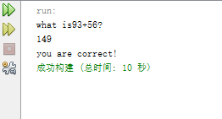

3.12

源代码：

import java.util.\*;

public class First{

public static void main(String args[]){

Scanner ss=new Scanner(System.in);

System.out.println("please enter a number");

int result=ss.nextInt();

int gw=(result%100)%10;

int bw=result/100;

if(gw==bw)

System.out.println(result+" is a palindrome");

else

System.out.println(result+" is not a palindrome");

}

}

输出结果：

