9.7

源代码：

package testaccount;

public class TestAccount{

public static void main(String args[]){

Account ss=new Account(1122,20000);

ss.setannualInterestRate(4.5);

ss.withDraw(2500);

ss.deposit(3000);

System.out.println("The ss's id is "+ ss.getid());

System.out.println("The ss's balance is "+ ss.getbalance());

System.out.println("The ss's dateCreated is "+ ss.getdateCreated());

}

}

class Account{

private int id=0;

private double balance=0;

private double annualInterestRate=0;

private java.util.Date dateCreated=new java.util.Date();

public Account(){

}

public Account(int newid,int newbalance){

id=newid;

balance=newbalance;

}

public int getid(){

return id;

}

public double getbalance(){

return balance;

}

public double getannualInterestRate(){

return annualInterestRate;

}

public void setid(int newid){

id=newid;

}

public void setbalance(double newbalance){

balance=newbalance;

}

public void setannualInterestRate(double newannualInterestRate){

annualInterestRate=newannualInterestRate;

}

public double getMonthlyInterest(){

return (annualInterestRate/12)/100;

}

public String getdateCreated(){

return dateCreated.toString();

}

public void withDraw(double draw){

balance-=draw;

}

public void deposit(double draw){

balance+=draw;

}

}

运行结果：

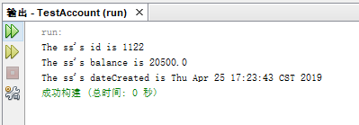

UML图

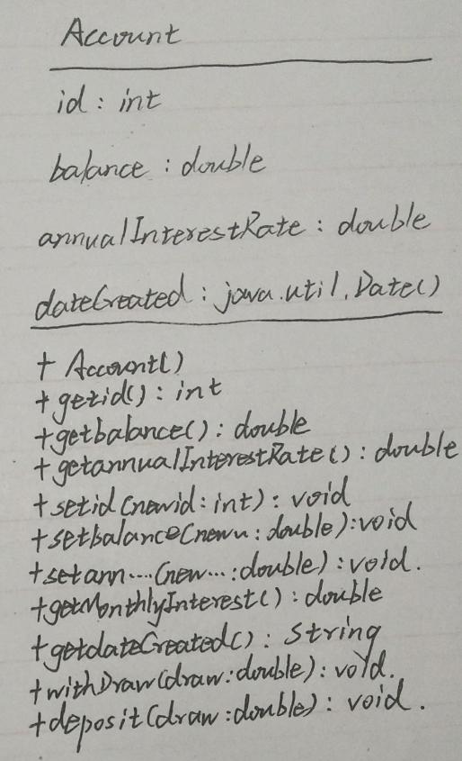

9.8

源代码：

public class TestFan {

public static void main(String[] args) {

Fan o1=new Fan();

Fan o2=new Fan();

o1.setspeed(o1.FAST);

o1.setradius(10);

o1.setcolor("yellow");

o1.seton(true);

o2.setspeed(o1.MEDIUM);

o2.setradius(5);

o2.setcolor("blue");

o2.seton(false);

System.out.println(o1.toString());

System.out.println(o2.toString());

}

}

class Fan{

int SLOW=1,MEDIUM=2,FAST=3;

private int speed=SLOW;

private boolean on=false;

private double radius=5;

String color="blue";

public Fan(){

}

public void setspeed(int newspeed){

speed=newspeed;

}

public void seton(boolean newon){

on=newon;

}

public void setradius(double newradius){

radius=newradius;

}

public void setcolor(String newcolor){

color=newcolor;

}

public int getspeed(){

return speed;

}

public boolean geton(){

return on;

}

public double getradius(){

return radius;

}

public String getcolor(){

return color;

}

public String toString(){

if(on){

return speed+" "+color+" "+radius;

}

else{

return "fan is off";

}

}

}

运行结果：

