高级语言程序设计实验报告

1. 实验题目

<1>编程显示当前计算机系统日期

<2>为二次方程设计一个类（符合题目要求的）并且画出UML图

1. 实验过程

<1>源代码：  
public class Date{

public static void main(String args[]){

java.util.Date date=new java.util.Date();

System.out.println("The elapsed time since Jan 1,1970 is "+date.getTime()+" milliseconds");

System.out.println(date.toString());

}

}

运行结果：

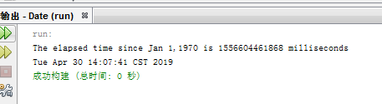

<2>源代码：

import java.util.\*;

public class TestQuadraticEquation {

public static void main(String[] args) {

Scanner ss=new Scanner(System.in);

System.out.println("please input a,b,c");

int a=ss.nextInt();

int b=ss.nextInt();

int c=ss.nextInt();

QuadraticEquation CC=new QuadraticEquation(a,b,c);

System.out.println(CC.getDiscriminant());

if(CC.getDiscriminant()>0){

System.out.println("the first root is "+CC.getRoot1());

System.out.println("the second root is "+CC.getRoot2());

}

else if(CC.getDiscriminant()==0){

System.out.println("the root is "+CC.getRoot1());

}

else{

System.out.println("The equation has no roots");

}

}

}

class QuadraticEquation{

private int a=1;

private int b=1;

private int c=1;

public QuadraticEquation(int a,int b,int c){

this.a=a;

this.b=b;

this.c=c;

}

public int geta(){

return a;

}

public int getb(){

return b;

}

public int getc(){

return c;

}

public int getDiscriminant(){

if((b\*b-4\*a\*c)<0){

return 0;

}

return b\*b-4\*a\*c;

}

public int getRoot1(){

if((b\*b-4\*a\*c)<0){

return 0;

}

return ((-b)+(int)Math.sqrt(b\*b-4\*a\*c))/2\*a;

}

public int getRoot2(){

if((b\*b-4\*a\*c)<0){

return 0;

}

return ((-b)-(int)Math.sqrt(b\*b-4\*a\*c))/2\*a;

}

}

运行结果：

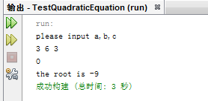

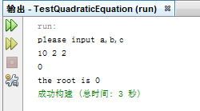

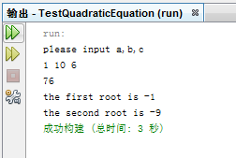

UML图

