5.5

源代码：

public class First{

public static void main(String args[]){

System.out.println("Kilograms Pounds | Pounds Kilograms");

int x;

int y;

for(x=1,y=20;x<=199;x+=2,y+=5){

double p=2.2\*x;

double k=y/2.2;

System.out.printf("%-3d %6.1f | %-6d %9.2f",x,p,y,k);

System.out.print("\n");

}

}

}

运行结果：

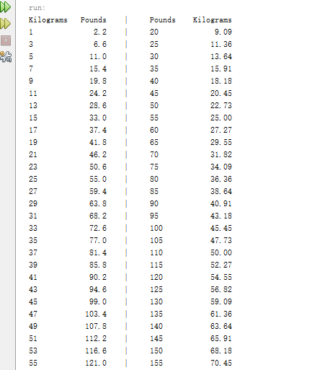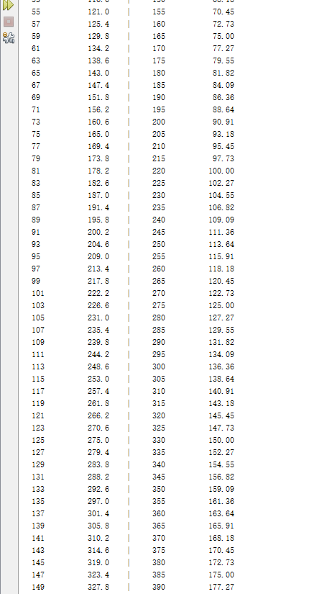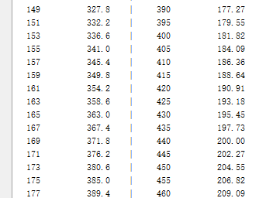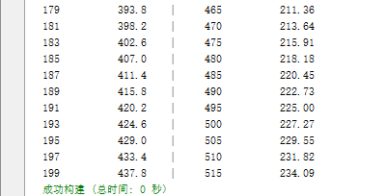

5.11

源代码：

public class First{

public static void main(String args[]){

int ss=100;

int suu=0;

while(ss<=200){

if(ss%5==0||ss%6==0){

System.out.print(ss+" ");

suu++;

if(suu%10==0)

System.out.print("\n");

}

ss++;

}

}

}

运行结果：

